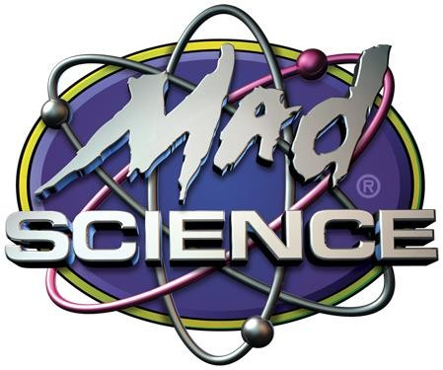

**FRANCHISE DISCLOSURE DOCUMENT MAD SCIENCE GROUP INC.**

## (A Canadian Corporation) 8360 Bougainville Street, Suite 201

## Montreal, Quebec, Canada, H4P 2G1

## (514) 344-4181

## [http://www.madscience.org](http://www.madscience.org/)

### The franchise will offer children's education and entertainment specializing in interactive science activities and scientific demonstrations.

### The total investment necessary to begin operation of a Mad Science franchised business is

### $132,331 to $191,959. This includes $58,000 to $94,779 that must be paid to the franchisor or its affiliates.

### This Disclosure Document summarizes certain provisions of your franchise agreement and other information in plain English. Read this Disclosure Document and all accompanying agreements carefully. You must receive this Disclosure Document at least 14 calendar-days before you sign a binding agreement with, or make any payment to, the franchisor or an affiliate in connection with the proposed franchise sale. **Note, however, that no governmental agency has verified the information contained in this document.**

### You may wish to receive your Disclosure Document on another format that is more convenient for you. To discuss the availability of disclosures in different formats, contact Tom DuFore, BSF Consultants, Inc., 2400 Old Milton Parkway, #156, Alpharetta, Georgia 30009, 770-628-2828.

### The terms of your contract will govern your franchise relationship. Don’t rely on the Disclosure Document alone to understand your contract. Read all of your contract carefully. Show your contract and this Disclosure Document to an advisor, like a lawyer or an accountant.

### Buying a franchise is a complex investment. The information in this Disclosure Document can help you make up your mind. More information on franchising, such as “A Consumer’s Guide to Buying a Franchise,” which can help you understand how to use this Disclosure Document, is available from the Federal Trade Commission. You can contact the FTC at 1-877-FTC-HELP or by writing to the FTC at 600 Pennsylvania Avenue, NW, Washington, D.C. 20580. You can also visit the FTC’s home page at [www.ftc.gov](http://www.ftc.gov/) for additional information. Call your state agency or visit your public library for other sources of information on franchising.

### There may also be laws on franchising in your state. Ask your state agencies about them.

### Date of Issuance: July 12, 2024

**How to Use This Franchise Disclosure Document**

Here are some questions you may be asking about buying a franchise and tips on how to find more information.

|  |  |
| --- | --- |
| **QUESTION** | **WHERE TO FIND INFORMATION** |
| **How much can I earn?** | Item 19 may give you information about outlet sales, costs, profits or losses. You should also try to obtain this information from others, like current and former franchisees. You can find their names and contact information in Item 20 or Exhibit H. |
| **How much will I need to invest?** | Items 5 and 6 list fees you will be paying to the franchisor or at the franchisor’s direction. Item 7 lists the initial investment to open. Item 8 describes the suppliers you must use. |
| **Does the franchisor have the financial ability to provide support**  **to my business?** | Item 21 or Exhibit A includes financial statements. Review these statements carefully. |
| **Is the franchise system stable,**  **growing, or shrinking?** | Item 20 summarizes the recent history of the number of company-owned and franchise outlets. |
| **Will my business be the only Mad Science business in my**  **area?** | Item 12 and the “territory” provisions in the franchise agreement describe whether the franchisor and other  franchisees can compete with you. |
| **Does the franchisor have a troubled legal history?** | Items 3 and 4 tell you whether the franchisor or its management have been involved in material litigation or bankruptcy proceedings. |
| **What’s it like to be a Mad Science franchisee?** | Item 20 or Exhibit H lists current and former franchisees. You can contact them to ask about their experiences. |
| **What else should I know?** | These questions are only a few things you should look for. Review all 23 Items and all Exhibits in this disclosure document to better understand this franchise opportunity. See the table of contents. |

**What You Need to Know About Franchising *Generally***

**Continuing responsibility to pay fees**. You may have to pay royalties and other fees even if you are losing money.

**Business model can change**. The franchise agreement may allow the franchisor to change its manuals and business model without your consent. These changes may require you to make additional investments in your franchise business or may harm your franchise business.

**Supplier restrictions**. You may have to buy or lease items from the franchisor or a limited group of suppliers the franchisor designates. These items may be more expensive than similar items you could buy on your own.

**Operating restrictions**. The franchise agreement may prohibit you from operating a similar business during the term of the franchise. There are usually other restrictions. Some examples may include controlling your location, your access to customers, what you sell, how you market, and your hours of operation.

**Competition from franchisor**. Even if the franchise agreement grants you a territory, the franchisor may have the right to compete with you in your territory.

**Renewal**. Your franchise agreement may not permit you to renew. Even if it does, you may have to sign a new agreement with different terms and conditions in order to continue to operate your franchise business.

**When your franchise ends**. The franchise agreement may prohibit you from operating a similar business after your franchise ends even if you still have obligations to your landlord or other creditors.

**Some States Require Registration**

Your state may have a franchise law, or other law, that requires franchisors to register before offering or selling franchises in the state. Registration does not mean that the state recommends the franchise or has verified the information in this document. To find out if your state has a registration requirement, or to contact your state, use the agency information in Exhibit C.

Your state also may have laws that require special disclosures or amendments be made to your franchise agreement. If so, you should check the State Specific Addenda. See the Table of Contents for the location of the State Specific Addenda.

**Special Risks to Consider About *This* Franchise**

Certain states require that the following risk(s) be highlighted**:**

1. **Out-of-State Dispute Resolution.** The Franchise Agreement requires you to resolve disputes with the franchisor by arbitration only in Quebec. Out-of-country arbitration may force you to accept a less favorable settlement for disputes. It may also cost you more to arbitrate with franchisor in Quebec than in your own state**.**
2. **Spousal Liability.** Your spouse must sign a document that makes your spouse liable for all financial obligations under the franchise agreement even though your spouse has no ownership interest in the franchise. This guarantee will place both your and your spouse’s marital and personal assets, perhaps including your house, at risk if your franchise fails.
3. **Sales Performance Required.** You must maintain minimum sales performance levels. Your inability to maintain these levels may result in loss of any territorial rights you are granted, termination of your franchise, and loss of your investment.
4. **Supplier Control**. You must purchase all or nearly all of the inventory or supplies that are necessary to operate your business from the franchisor, its affiliates, or suppliers that the franchisor designates, at prices the franchisor or they set. These prices may be higher than prices you could obtain elsewhere for the same or similar goods. This may reduce the anticipated profit of your franchise business.
5. **Turnover Rate**. In the last year, a high percentage of franchised outlets were terminated, transferred, or ceased operations for other reasons. This franchise could be a higher risk investment than a franchise in a system with a lower turnover rate.

Certain states may require other risks to be highlighted. Check the “State Specific Addenda” (if any) to see whether your state requires other risks to be highlighted.

**DISCLOSURES REQUIRED BY MICHIGAN LAW**

#### THE STATE OF MICHIGAN PROHIBITS CERTAIN UNFAIR PROVISIONS THAT ARE SOMETIMES IN FRANCHISE DOCUMENTS. IF ANY OF THE FOLLOWING PROVISIONS ARE IN THESE FRANCHISE DOCUMENTS, THE PROVISIONS ARE VOID AND CANNOT BE ENFORCED AGAINST YOU.

##### A prohibition on the right of a franchisee to join an association of franchisees.

##### A requirement that a franchisee assent to a release, assignment, novation, waiver or estoppel which deprives a franchisee of rights and protections provided in this act. This shall not preclude a franchisee, after entering into a franchise agreement, from settling any and all claims.

##### A provision that permits a franchisor to terminate a franchise prior to the expiration of its term except for good cause. Good cause shall include the failure of the franchisee to comply with any lawful provision of the franchise agreement and to cure such failure after being given written notice thereof and a reasonable opportunity, which in no event need be more than 30 days, to cure such failure.

##### A provision that permits a franchisor to refuse to renew a franchise without fairly compensating the franchisee by repurchase or other means for the fair market value at the time of expiration of the franchisee’s inventory, supplies, equipment, fixtures, and furnishings. Personalized materials which have no value to the franchisor and inventory, supplies, equipment, fixtures, and furnishings not reasonably required in the conduct of the franchised business are not subject to compensation. This subsection applies only if: (i) The term of the franchise is less than 5 years and (ii) the franchisee is prohibited by the franchise or other agreement from continuing to conduct substantially the same business under another trademark, service mark, trade name, logotype, advertising, or other commercial symbol in the same area subsequent to the expiration of the franchise or the franchisee does not receive at least 6 months advance notice of the franchisor’s intent not to renew the franchise.

##### A provision that permits the franchisor to refuse to renew a franchise on terms generally available to other franchisees of the same class or type under similar circumstances. This section does not require a renewal provision.

##### A provision requiring that arbitration or litigation be conducted outside this state. This shall not preclude the franchisee from entering into an agreement, at the time of arbitration, to conduct arbitration at a location outside this state.

##### A provision which permits a franchisor to refuse to permit a transfer of ownership of a franchise, except for good cause. This subdivision does not prevent a franchisor from exercising a right of first refusal to purchase the franchise. Good cause shall include, but is not limited to:

##### The failure of the proposed transferee to meet the franchisor’s then current reasonable qualifications or standards.

##### The fact that the proposed transferee is a competitor of the franchisor or sub- franchisor.

##### The unwillingness of the proposed transferee to agree in writing to comply

##### with all lawful obligations.

##### The failure of the franchisee or proposed transferee to pay any sums owing to the franchisor or to cure any default in the franchise agreement existing at the time of the proposed transfer.

##### A provision that requires the franchisee to resell to the franchisor items that are not uniquely identified with the franchisor. This subdivision does not prohibit a provision that grants to a franchisor a right of first refusal to purchase the assets of a franchise on the same terms and conditions as a bona fide third party willing and able to purchase those assets, nor does this subdivision prohibit a provision that grants the franchisor the right to acquire the assets of a franchise for the market or appraised value of such assets if the franchisee has breached the lawful provisions of the franchise agreement and has failed to cure the breach in the manner provided in subdivision (c).

##### A provision which permits the franchisor to directly or indirectly convey, assign, or otherwise transfer its obligations to fulfill contractual obligations to the franchisee unless provision has been made for providing the required contractual services.

#### THE FACT THAT THERE IS A NOTICE OF THIS OFFERING ON FILE WITH THE ATTORNEY GENERAL DOES NOT CONSTITUTE APPROVAL, RECOMMENDATION, OR ENDORSEMENT BY THE ATTORNEY GENERAL.

##### Michigan law provides that a franchisor whose most recent statements are un-audited and which show a net worth of less than $100,000 shall, at the request of a franchisee, arrange for the escrow of initial investment and other funds paid by the franchisee or sub-franchisor until the obligations to provide real estate, improvements, equipment, inventory, training, or other items included in the franchise offering are fulfilled. At the option of the franchisor, a surety bond may be provided in place of escrow. In the event that an escrow is so established, the escrow agent shall be a financial institution authorized to do business in the State of Michigan. The escrow agent may release to the franchisor those amounts of the escrowed funds applicable to a specific franchisee or sub-franchisor upon presentation of an affidavit executed by the franchisee and an affidavit executed by the franchisor stating that the franchisor has fulfilled its obligation to provide real estate, improvements, equipment, inventory, training, or other items. This portion of the Michigan law does not prohibit a partial release of escrowed funds upon receipt of affidavits of partial fulfillment of the franchisor’s obligation.

#### SHOULD THE PROSPECTIVE FRANCHISEE HAVE ANY QUESTIONS REGARDING THE NOTICE OF THIS FILING WITH THE ATTORNEY GENERAL, SUCH QUESTIONS SHOULD BE ADDRESSED TO:

#### MICHIGAN ATTORNEY GENERAL’S OFFICE ADMINISTRATOR

#### CONSUMER PROTECTION DIVISION FRANCHISE UNIT

##### 525 W. OTTAWA, 1st FLOOR LANSING, MICHIGAN 48913

##### (517) 335-7567

##### Despite subparagraph (f) above, we intend to enforce fully the provisions of the arbitration section contained in our Franchise Agreement. We believe that subparagraph (f) is unlawful and cannot preclude us from enforcing our arbitration section. You acknowledge that we will seek to enforce that section as written.

### TABLE OF CONTENTS

### PAGE

ITEM 1. THE FRANCHISOR, AND ANY PARENTS, PREDECESSORS AND AFFILIATES 8

ITEM 2. BUSINESS EXPERIENCE 10

ITEM 3. LITIGATION 11

ITEM 4. BANKRUPTCY 12

ITEM 5. INITIAL FEES 12

ITEM 6. OTHER FEES 13

ITEM 7. ESTIMATED INITIAL INVESTMENT 19

ITEM 8. RESTRICTIONS ON SOURCES OF PRODUCTS AND SERVICES 23

ITEM 9. FRANCHISEE'S OBLIGATIONS 25

ITEM 10. FINANCING 27

ITEM 11. FRANCHISOR'S ASSISTANCE, ADVERTISING, COMPUTER SYSTEMS AND TRAINING 27

ITEM 12. TERRITORY 36

ITEM 13. TRADEMARKS 39

ITEM 14. PATENTS, COPYRIGHTS AND PROPRIETARY INFORMATION 41

ITEM 15. OBLIGATION TO PARTICIPATE IN THE ACTUAL OPERATION OF THE FRANCHISED BUSINESS 43

ITEM 16. RESTRICTIONS ON WHAT THE FRANCHISEE MAY SELL 44

ITEM 17. RENEWAL, TERMINATION, TRANSFER AND DISPUTE RESOLUTION 46

ITEM 18. PUBLIC FIGURES 59

ITEM 19. FINANCIAL PERFORMANCE REPRESENTATIONS 59

ITEM 20. OUTLETS AND FRANCHISEE INFORMATION 64

ITEM 21. FINANCIAL STATEMENTS 69

ITEM 22. CONTRACTS 69

ITEM 23. RECEIPT 70

EXHIBITS:

1. FINANCIAL STATEMENTS
2. FRANCHISE AGREEMENT
3. LIST OF STATE AGENTS FOR SERVICE OF PROCESS AND STATE ADMINISTRATORS
4. TABLE OF CONTENTS OF CONFIDENTIAL OPERATIONS MANUAL AND STANDARD OPERATING POLICY MANUAL
5. STATE ADDENDA
6. AUTHORIZATION TO TRANSFER
7. NONDISCLOSURE AGREEMENT
8. LISTS OF CURRENT AND FORMER FRANCHISEES
9. OPTIONAL COMPLEMENTARY PROGRAM ADDENDUM
10. APPLICATION FEE RECEIPT STATE EFFECTIVE DATES RECEIPTS

# ITEM 1. THE FRANCHISOR, AND ANY PARENTS, PREDECESSORS AND AFFILIATES

### To simplify the language in this Disclosure Document, "We" and " Mad Science Group" mean Mad Science Group Inc., formerly named 2946033 CANADA, INC., the franchisor of this business. "You" means the person (or persons), corporation, partnership, limited liability company or other legal entity that is granted the franchise.

### The Franchisor

### We were incorporated in the country of Canada on August 16, 1993 and changed our name on April 2, 2014. Our principal business address is 8360 Bougainville Street, Suite 201, Montreal, Quebec, Canada, H4P 2G1. We do business under the name "Mad Science”. A list of our agents for service of process in various states is contained in Exhibit C to this Disclosure Document. Terms used in this Disclosure Document have the same meaning as they do in the Franchise Agreement attached as Exhibit B to this Disclosure Document.

### Parents, Predecessors and Affiliates

### Our parent company is 3908160 Canada Inc., which also has its principal place of business at 8360 Bougainville Street, Suite 201, Montreal, Quebec, Canada, H4P 2G1. Our parent company does not exercise control over the policies and direction of the franchise system. It does not operate a business of the type being franchised under the Mad Science trademark and has never offered franchises in any line of business. We have no predecessors.

### Our Affiliate, Mad Science Licensing Inc., a Canadian corporation formed August 16, 1993, owns the Mad Science System and Marks and has licensed us to grant franchises allowing for their use in the operation of Mad Science businesses. Its principal place of business is 8360 Bougainville Street, Suite 201, Montreal, Quebec, Canada, H4P 2G1. It was previously named Mad Science Productions Inc., does not operate a business of the type being franchised under the Mad Science trademark and has never offered franchises in any line of business.

### Our Affiliate, Imagine Arts Academy, Inc., a Canadian corporation formed June 5, 2018, has been established for the purpose of granting franchises for children's art enrichment businesses which service Birthday Parties, After School Programs, Pre-School Programs, Workshops, Camps and Special Events for children from 3 to 12 years old ("Imagine Arts Academy). It launched its Imagine Arts Academy franchise program in late 2018. It does not operate a business of the type being franchised under the Mad Science trademark. Its principal place of business is 8360 Bougainville Street, Suite 201, Montreal, Quebec, Canada, H4P 2G1

### Our Business Activities

### Our business activities include the granting of franchises establishing, developing and operating children's science education and entertainment businesses which service Birthday Parties, After School Programs, Pre-School Programs, Workshops, Camps and Special Events for children from 3 to 12 years old ("Mad Science Franchise" or “Franchised Business”). We have offered a NASA branded after-school enrichment program since 2004, and the program was expanded in 2006 to include summer camps and birthday parties. We also offer Mad Science franchisees an opportunity to participate in the optional Schoolhouse Chess and Brixology program offerings.

### Franchisees choosing to participate will sign the pertinent optional addendum to the Franchise Agreement attached as Schedules I and J. We also may implement in the future programs for children’s enrichment services/products which are not necessarily science-based and which are optional for franchisees. If we do, franchisees choosing to participate will sign the optional complementary program addendum to the Franchise Agreement (a template addendum is attached as Exhibit I to this Disclosure Document).

### We have offered Mad Science Franchises since March 1995 but have never offered franchises in any other business.

### The Mad Science Franchise and Businesses to be Offered

### Each Mad Science Franchise is licensed to use a distinctive System ("System"). The distinguishing characteristics of the System include specially scripted and outlined interactive science activities for children; specially developed course materials; exclusively designed signage and materials; the Mad Science Confidential Operations Manual, the Standard Operating Policies Manual and other written specifications/standards from us (combined as the “Manuals”), methods for inventory and cost controls, record keeping and reporting, personnel management, purchasing, sales promotion, and advertising. We may change the System periodically.

### The Mad Science Franchise will operate under the service mark, “MAD SCIENCE”, associated logos, commercial symbols and other trade names, service marks and trademarks designated by us as part of the System ("Mark[s]").

### Market and Competition

### The Mad Science Franchise will target its services to the general public, but primarily to parents, schools for pre-kindergarten through grade 6, pre-schools, recreational facilities, summer camps, scouting organizations, and other non-educational institutions involving children. The Mad Science Franchise will compete with other businesses offering children's education and entertainment services. We believe the market for children's education and entertainment services is developing.

### Industry-Specific Laws and Regulations

### Due to the extensive contact that Mad Science Franchise instructors have with children, you must conduct criminal record checks and/or fingerprinting on all instructors employed by the Mad Science Franchise as prescribed by and to the extent permitted by applicable law. Other than these requirements, we do not believe that the Mad Science Franchise is subject to any industry-specific laws and regulations beyond those affecting business generally. However, you should consult with your attorney and local, state and federal government agencies before buying your Mad Science Franchise or any business to determine all legal requirements that you must comply with and consider their effects on you and related costs of compliance. It is your sole responsibility, on an ongoing basis, to investigate and satisfy all local, state and federal laws, regulations and ordinances, including privacy, since they vary from place to place and can change over time.

# ITEM 2. BUSINESS EXPERIENCE

## Chief Executive Officer and Director: Ariel Shlien

### Mr. Shlien has been our Director since 1986 and our Chief Executive Officer since August 1993. He was President from August 1993 to August 2003. He has served as Director of our Affiliate Imagine Arts Academy, Inc. since June 5, 2018.

## President, In-House Counsel: Shafik Mina

### Mr. Mina has been our President since June 2012. He has also served as our In-House Counsel since July 2009. He has served as President for our Affiliate Imagine Arts Academy, Inc. since June 5, 2018.

## Chief Innovation Officer: Ron Shlien

### Mr. Shlien has been our Chief Innovation Officer since our inception in 1995. He has served as Director of our Affiliate Imagine Arts Academy, Inc. since June 5, 2018.

## Vice President of Research & Development and Operations: Sharon King

### Ms. King has been our Vice President of Research & Development and Operations since October, 2017. Ms. King was named Program Development Manager in September 2006 and Director of Research and Development in 2013.

## Director of Information Technology: Arek Alszko

### Mr. Alszko has been our Director of Information Technology since October 1998.

## Director of Marketing: Christina Sklavenitis

### Ms. Sklavenitis has been our Director of Marketing since April 2024. Prior to joining us, she was self employed at Christina Sklavenitis Consulting in Montreal, Quebec from September 2015 until March 2024.

## Director of Information: Bassem Aboukhater

### Mr. Aboukhater has been our Director of Information since April 2024. Prior to joining us, he held the position of Director, Technology Services for Y Partners in Montreal, Quebec from February, 2022 until march of 2024 and he held the position of Director, Network Services, AMER Region for Publicis Groupe/ReSources Canada, located in Monteal, Quebec from June, 2015 until December 2021.

# ITEM 3. LITIGATION

## Administrative Actions

### In the Matter of 2946033 CANADA, INC., d.b.a. The Mad Science Group, Case No. 2012-0433 (Consent Order entered into with the Securities Division of the Office of the Attorney General of Maryland, March 7, 2013). We were contacted in October, 2012 by the Securities Division of the Office of the Attorney General of Maryland (the “Division”) about an inquiry begun by the Division regarding our franchising activities in the state. We responded to the Division’s requests for information about five Maryland franchise transactions, franchise marketing materials and franchise offers in the state. The Division alleged that our activities violated multiple provisions of the Maryland Franchise Law and related regulations. Alleged violations include the making of unregistered franchise offers, the failure to register a Maryland compliant disclosure document and to deliver the same to prospective franchisees, the failure to maintain franchise sales records and documents as required under the statute and by regulation, and the failure to register franchise advertising and to meet advertising standards regulations. Without admitting or denying any violation of law, The Mad Science Group entered into a Consent Order agreeing to: i) cease and desist from offering or selling franchises in violation of the Maryland Franchise Law, ii) pursue our franchise registration application in Maryland, iii) offer rescission to 2 franchisees, iv) refund a $13,500 initial franchise fee to a former Maryland franchisee and v) pay a $5,000 monetary penalty.

## Arbitration:

### On or about July 2, 2020, a notice of arbitration was filed in the matter of, *55459552 Kramer Van Koophandel Zuid-Limburg v. Mad Science Group Inc.,* with the Arbitration and Dispute Resolution Institute of Canada. The Claimant was a party to a Development Agreement with Mad Science Group, Inc. with rights to the Netherlands. It claims that the Development Agreement and related franchise agreements were improperly terminated by Mad Science Group, Inc. resulting in loss of continued royalty revenue to the Claimant. The Claimant alleged breach of contract and sought specific performance reinstating the agreements. In the alternative, the Claimant sought damages for lost fees in an amount of approximately 2,600,000 Euros (currently 1 Euro = 1.18 US Dollars) plus attorneys fees. Mad Science Group filed a response on August 14, 2020 presenting a counterclaim in its statement of defense that the Development Agreement expired and was not renewed or extended, inter alia claiming loss of profits and other damages caused by Claimant’s lack of cooperation; damages to Respondent Franchisor’s reputation caused by Claimant and for Claimant’s failure to comply with its post- termination obligations. Franchisor sought the reimbursement of its costs and expenses, including its reasonable accounting and attorney’ fees incurred in the arbitration, in an amount to be quantified. On April 29, 2022 an arbitration decision was made whereby all claims by and between Claimant and Mad Science Group were dismissed. The matter is now closed.

## Litigation:

### Fun Science Ciencia Divertida & Sté Activites Ludoeducatives Avancees, a competitor, brought claims against Mad Science Group, Inc in the Paris Commercial Court on November 4, 2020; case number D2203, alleging that Mad Science Group disrupted its franchise network in France and damaged its reputation. Damages are sought for lost earnings, loss of reputation, and

### compensation for mitigation measures, totalling approximately 3,260,000 Euros (currently 1 Euro = 1.18 US Dollars). Mad Science Group filed a response and a hearing was scheduled for March 24, 2021. The Complainant failed to appear at the hearing and the court suspended the matter. The Complainant reinstated the matter and hearings took place on February 15, 2023 and March 29, 2023. A final determination from the Court is pending.

### Except for the above, no litigation is required to be disclosed in this Item.

# ITEM 4. BANKRUPTCY

### No bankruptcy information is required to be disclosed in this Item.

# ITEM 5. INITIAL FEES

### When you sign the Franchise Agreement, you must pay to us a non-refundable initial Franchise Fee ("Franchise Fee") in the amount of $49,000. The initial franchise fee is due in full at the time you sign the Franchise Agreement. "Dollars" and any reference to money throughout this Disclosure Document means the legal currency of the United States.

### If you are a Mad Science franchisee whose Franchise Agreement is scheduled to expire within the next 9 months, you may apply for another Mad Science Franchise to take effect at expiration. If you meet our then-current qualifications and are accepted as a franchisee, you will sign our then-current Franchise Agreement which may have terms that are materially different than those in the original Franchise Agreement, including different fees and a restructured or redefined territory. However, we will not charge you the Initial Franchise Fee in connection with signing the new agreement, rather a renewal fee will be charged.

### You must also pay a non-refundable Application Fee of $1,000. If we offer you a franchise and you accept, we will credit the Application Fee against the initial Franchise Fee due for your territory. The Application Fee payment does not obligate you or us to offer/accept a franchise or enter into a franchise relationship.

### The initial Franchise Fee is non-refundable under any circumstances.

### Except as provided above, the Franchise Fee is uniform to all franchisees under this offering.

### You must purchase a start-up equipment package ("Original Equipment Package" or “OEP”) from us containing the items necessary to initially market and conduct parties, programs, classes, and related events. The OEP includes program materials such as party kits and science equipment, specifically:

### 3 After-School programs, with an initial supply of 9,650 branded products

### 2 different Birthday Parties

### 2 different Special Events

### Professional lab-ware, sturdy carrying cases, lab coats and a Mad Science retractable banner

### The cost of the OEP is $28,000 and it is non-refundable and is payable on signing the Franchise Agreement. We will prepare the equipment package (and any other equipment) for shipping. We

### ship the OEP to you generally about 1 week after we receive your signed Franchise Agreement and payment.

### If you choose to participate in the optional Schoolhouse Chess program, there is an additional non-refundable program fee of $10,000 and you must purchase a product package specifically for use with this program. The cost of the products is approximately $5,000 as of the date of this Disclosure Document and includes magnetic chess sets, chess pieces, vinyl chess boards, giant chess boards, tripods, bags, chess demonstration boards, carrying bags, vests, books and posters. The magnetic chess sets are purchased from us at a cost of approximately $1,620, and this amount is non-refundable. The remaining items are purchased from approved suppliers and subject to their respective refund policies.

### If you choose to participate in the optional Brixology program, you must purchase equipment and branded products specifically for use with this program. The cost of the equipment and branded products is approximately $5,159 as of the date of this Disclosure Document and is non-refundable.

# ITEM 6. OTHER FEES

|  |  |  |  |
| --- | --- | --- | --- |
| **Name of Fee** | **Amount** | **Due Date** | **Remarks** |
| Royalty Fees | 8% of Gross Revenues | Payable monthly on or before the 10th day of each subsequent  month. | See Definition of Gross Revenues**1**. |
| Audit**2** | Cost of audit plus an understatement fee equal to 10% of the total amount of understated Gross Revenue, in addition to the amount of the underpayment plus interest at 1% per month or the maximum rate allowed by law if less. | On demand  On demand | The audit costs and understatement fee are payable if audit by us shows that you understated Gross Revenues by at least 2% and in instances described in footnote 2.  You must also pay for costs we incur if we (or a designee) choose to perform a pre- renewal or pre-transfer operations/financial audit, including audit costs, transportation, lodging and  meals and related expenses. |

|  |  |  |  |
| --- | --- | --- | --- |
| **Name of Fee** | **Amount** | **Due Date** | **Remarks** |
| Marketing and Advertising Audit2 | Cost of audit plus an underpayment fee of 10% of the total amount of underpayment, in addition to the amount of the underpayment. | On demand | The audit costs and understatement fee are payable if an audit by us shows that you underpaid the Marketing Fund or failed to spend the amount required on advertising by at least 2%. |
| Late Fees,  Interest,  Costs of Collection, and Costs of Enforcement**3** | Then current fee (Currently $120)  1% per month interest on overdue amounts or the maximum rate allowed by law, if less.  All costs of collection and all costs and attorneys’ fees | On demand  On demand  On demand | Applies to late payment of Royalty Fees reported more than 2 business days after due date. Late Fees will continue to accrue monthly.  All overdue payments.  Payable if we prevail in any action between you and us or if we exercise Step-In rights or if any audit reveals an understatement of 2% or  more. |
| Accounting Program/ System Fee | As established | On demand | If we implement a new accounting system, you will have to adopt it. We have the right to charge a fee for any accounting program/system we or our designee provide to you. No fee is charged as of the date of this Disclosure  Document. |
| Maintenance Costs | Cost of correction | On demand | Applies if you fail or refuse to correct deficiencies in the Mad Science Franchise within 30 days after receiving notice and we choose to correct the deficiencies on  your behalf. |

|  |  |  |  |
| --- | --- | --- | --- |
| **Name of Fee** | **Amount** | **Due Date** | **Remarks** |
| Transfer Fee | $10,000 per Territory | At the time of transfer.  On request and prior to transfer | Transfer is subject to conditions and restrictions.  You must also make an advance payment in an amount we determine towards the purchase of Mad Science Equipment, Products and Services we deem necessary to meet current  System standards. |
| Indemnification | Varies | As incurred | You must defend at your own cost and indemnify us and our designees from and against all loss, costs, expenses, damages and liabilities connected with your  Mad Science Franchise. |
| Conference Fee | Our then-current fee (currently up to $1,000 per outlet). | Annually | We may elect not to charge this fee. You are responsible for all travel, hotel, food and living expenses. Fee amount and fee maximum is subject  to change. |
| Non- Attendance Fee | Then-current fee (Currently up to $1,000 per outlet). | On demand | You are required to attend the Annual Franchisee Conference or regional meeting organized by the Franchisor. This Fee may be  charged if you do not attend. |
| Possible Fines for Breach | Then-current fee (Currently up to $500 per  occurrence). | On demand | If you breach the Franchise Agreement. |
| Service Fee for Additional Training | Currently $500 per day. | At the time of the additional training | Service fee subject to change.  You are responsible for all costs including your and our transportation, lodging, meals and personal expenses, as  applicable. |

|  |  |  |  |
| --- | --- | --- | --- |
| **Name of Fee** | **Amount** | **Due Date** | **Remarks** |
| National Marketing Fund Contribution | The greater of $2,000 per year or up to 3% (currently 2%) of your previous year’s Gross Revenues. | Payable monthly in equal installments on or before the 10th day of each month. | We can change this fee, as published in the Manuals or other written instruction from us. This fee is payable at the same time and in the same manner as the Royalty Fee,  unless otherwise directed. |
| Technology Access Fee4 | Currently $227-$500 per month (but we can change it) | Payable monthly on or before the 10th day of each subsequent month. | We can change these fees, as published in the Manuals or other written instruction from us. This fee is payable at the same time and in the same manner as the Royalty Fee, unless otherwise  directed. |
| Web Page Service Fee4 | Currently $150 per month (but we can change it) | Payable monthly on or before the 10th day of each subsequent month. | Payable if you have established a webpage for your business (with our consent). This fee is payable at the same time and in the same manner as the Royalty Fee, unless otherwise  directed. |
| Marketing Access Fee | Currently $100 per month (but we can change it) | Payable monthly on or before the 10th day of each subsequent month. | We can change this fee, as published in the Manuals or other written instruction from us. This fee is payable at the same time and in the same manner as the Royalty Fee,  unless otherwise directed. |
| Renewal Fee | $5,000 per Territory | At the time of renewal  On request prior to expiration | Renewal is subject to conditions and restrictions.  You must also make an advance payment in an amount we determine towards the purchase of Mad Science Equipment, Products and Services we determine necessary to meet current  System standards. |

|  |  |  |  |
| --- | --- | --- | --- |
| **Name of Fee** | **Amount** | **Due Date** | **Remarks** |
| Late Renewal Charge | Then-current fee (Currently $500 per month for each month all renewal conditions remain unmet after expiration of a franchise  agreement). | As incurred. | Charged if a franchisee allows a franchise agreement to expire before timely completing the renewal process, if we have consented to their request to  renew. |
| Administration Charge for documentation change | Then-current fee (Currently $500) | At the time of the requested change. | Charged if a franchisee requires documentation modifications subsequent to a change of shareholders, or change in corporate entity or any other change which requires the redrafting of documentation already in place or drafting of new  documentation. |
| Fee for Review of New Product or Supplier | Currently $100-$200 (estimated) | As incurred | The fee can be charged if you propose to purchase, use or offer items or suppliers not  previously approved by us. |
| Management Fee | In the event we must operate the Franchised Business you must pay us our then-current management fee. The management fee is currently equal to 10% of the business’ monthly Gross Revenues. In addition, you are also required to pay our expenses and other fees, such as royalties. | As incurred | We have the right to operate the Franchised Business under certain circumstances. |
| Bank Charges and Administrative Costs | Our then-current fees. | Upon invoice. | We may charge fees to cover bank charges and administration costs if an electronic funds transfer attempt is unsuccessful or you close your operating account, or any check or other payment is returned not paid or we must  make any changes requested by you. |
| Insurance | Cost of Insurance | Upon invoice | Payable if you fail to obtain required insurance and we obtain it on your behalf. This is in addition to any fines we may  charge for your default. |

### * All fees and expenses described in this Item 6 are nonrefundable. These fees may not be uniform for franchisees signing the Franchise Agreement.

### 1 Gross Revenues. "Gross Revenues" means the total of all revenues and income from Birthday Parties, After-School Programs, Pre-School Programs, Workshops, NASA Programs, Camps, Special Events, merchandise, government grants, sponsorships, trade transactions and other sums derived from providing educational and entertainment services and related merchandise to your customers or any other source, whether or not sold or performed at or from the Mad Science Franchise and whether received in cash, in services, as barter, on credit (whether or not payment is received), or otherwise. The amount of all free passes to non-profit groups, tips, sales tax receipts or similar tax receipts which, by law, are chargeable to customers, if these taxes are separately stated when the customer is charged and paid to the appropriate taxing authority, will be deductions from Gross Revenues for purposes of computation. There will also be deducted from Gross Revenues the amount of any documented refunds, charge-backs, credits and allowances given in good faith to customers. In addition to the Royalty Fee payment, you must also provide us with a correct statement of your Gross Revenues for the month just ended and any monthly reports outlined in the Manuals. You will also allow us to reasonably inspect your original books and records. We may require that you pay the Royalty Fee weekly and/or that Royalty Fees, advertising contributions, amounts due for your purchases from us, and other amounts which you owe to us be paid through electronic funds transfer, or as otherwise mandated by us, as will be described in the Manuals. All amounts owed to us must be paid in accordance with the procedures described in the Manuals or other written instruction from us. If you participate in the Schoolhouse Chess and the Brixology program your revenues from the program are included in your franchise’s Gross Revenues for purposes of calculating your royalties and other applicable amounts. These and other optional programs may have independent reporting requirements for revenues generated under the applicable program.

### 2 Audit. If an inspection or audit of your books and records reveals that any royalties due to us have been understated in any report then you must pay us on demand the understated amount plus interest on the amount of the deficiency from the date this amount was due until paid. If the understatement is 2% or more, or if you have failed to report or make payments for any 2 reporting periods, or have not made books and materials available to us, then you must also reimburse us for all costs and expenses, including accounting and attorneys' fees, connected with the inspection or audit no later than 14 days after completion of the audit, together with interest and an underpayment fee equal to 10% of the total amount of the understated Gross Revenue. In addition, in the event of a non-curable or uncured breach of the Franchise Agreement, we may conduct an audit of your books and records and you will reimburse us for all costs and expenses, including accounting and attorneys’ fees, connected with the inspection or audit no later than 14 days after completion of the audit. We may also conduct audits of your books and records and of the condition of the Mad Science Equipment, Products and Services in use at the Franchised Business when the Franchised Business is transferred or the Franchise Agreement is renewed. Further we may conduct a marketing and/or advertising audit. If any audit reveals you have not paid the requisite amount to the Marketing Fund or have not spent the requisite amount on advertising you must make the deficient payment/expenditure. If the deficiency is by two percent (2%) or more, or if you fail to submit complete Reports and/or remittances to us, or do not make these materials available, you must pay (i) the reasonable cost of the audit and/or inspection, including the cost of auditors and attorneys, incurred by us,

### (ii) an underpayment fee equal to 10% of the total amount that was owed but was not

### paid/spent, (iii) interest; and (iv) the difference between what was owed and what was paid/spent, no later than thirty (30) days after the completion of such audit.

### 3 Late Fees. We apply your payments to specific invoices as directed by you or, alternatively, to the oldest unpaid invoice.

### 4 Technology Access Fee. We have instituted a Technology Access Fee for the creation of Mad Science customized software applications. In general, the Technology Access Fee is intended to provide franchisees with technology related tools to help you more effectively manage your Mad Science Franchise. You must pay this Fee every calendar month, once you open for business. In addition, if we have granted your request to establish a webpage separate from the one we operate, you will be required to pay the Webpage Service Fee to cover our costs of monitoring your webpage for compliance with our standards. We have the right to change the amount of these fees.

### All fees are imposed by and are payable to us, and are non-refundable, unless otherwise noted. We can elect to and may waive and/or credit, reduce or defer payment of any and all fees and charges of any kind in connection with a franchise on a case-by-case basis, as we consider appropriate and as permitted by law.

### If we have any fees, taxes, or other assessments imposed on us because of payments you make to us, then we can require that you pay us an additional amount so that the net amount we actually receive after the deduction, payment or withholding is the full amount of the royalty, fee or other amount we are entitled to be paid under the Franchise Agreement.

# ITEM 7. ESTIMATED INITIAL INVESTMENT

**YOUR ESTIMATED INITIAL INVESTMENT**

|  |  |  |  |  |
| --- | --- | --- | --- | --- |
| **Name**  **of Expenditure** | **Estimated Amount or Estimated Low-**  **High Range** | **Method of**  **Payment** | **When Due** | **TO WHOM PAYMENT IS MADE8** |
| Initial Franchise Fee1 | $49,000 | Lump Sum | Upon Signing  Franchise Agreement | Us |
| Equipment Package2 | $28,000 | Lump Sum | Upon Signing  Franchise Agreement | Us |
| Lease of Office/Training/Party Room/Warehouse Space and Leasehold  Improvements3 | $33,600 -  $56,000 | As arranged | As arranged | Lessor (Landlord) Contractors, Vendors and Approved Suppliers |

|  |  |  |  |  |
| --- | --- | --- | --- | --- |
| **Name**  **of Expenditure** | **Estimated Amount or Estimated Low-**  **High Range** | **Method of**  **Payment** | **When Due** | **TO WHOM PAYMENT IS MADE8** |
| SchoolHouse Chess Program Fee | $0-$10,000 | Lump Sum | On Signing Program Addendum- Participation in this Program is  optional | Us |
| SchoolHouse Chess Program Equipment2 | $0 - $5,000 | Lump Sum | On Signing Program Addendum- Participation in this Program is  optional | Us and Approved Suppliers |
| Brixology Program Equipment and Branded Products2 | $0 - $5,159 | Lump Sum | On Signing Program Addendum- Participation in this Program is  optional | Us |
| Insurance4 | $2,000 - $3,500 | As Arranged | Annually as Arranged | Insurance Carrier |
| Local Advertising5 | $250 - $1,000 | As Arranged | As Arranged | Advertisers |
| Office Equipment/ Supplies6 | $3,000 - $6,000 | As Arranged | As Arranged | Approved Suppliers as Applicable |
| Technology Access Fee | $681 - $1,500 | As Incurred | Monthly | Us |
| Security and Utility Deposits, Business Licenses and other  prepaid expenses | $1,000 - $2,500 | As Incurred | As Incurred | Landlord, State, City, etc. |
| Legal and  Accounting / Bookkeeping Fees | $1,000 - $3,500 | As Incurred | As Incurred | Attorney, Accountant |
| Additional Funds7 (3 months) | $13,800 -  $20,800 | As Arranged | As Incurred | As Applicable |
| TOTAL8 | $132,331 -  $191,959 |  |  |  |

### NOTES

### 1 Franchise Fee. This fee includes the $1,000 Franchise Application Fee that is credited to your Initial Franchise Fee if you sign the Franchise Agreement.

### 2.Equipment Packages. You must purchase an Original Equipment Package from us which includes the items necessary to initially market and conduct parties, programs, classes, and related events. If you want to offer the Schoolhouse Chess Program as part of your Mad Science Franchise, you must sign the optional Schoolhouse Chess Addendum attached as Schedule I to the Franchise Agreement. The optional program participants also must purchase the equipment and programming necessary to deliver the program. Participants in the Schoolhouse Chess Program will spend an estimated $5,000 as of the date of this Disclosure Document for the optional program package in addition to the $28,000 charged for the basic Mad Science Equipment Package. Product pricing for the Schoolhouse Chess Program is subject to change and we recommend you contact the suppliers for cost information before signing the Addendum. If you want to offer the Brixology Program as part of your Mad Science Franchise, you must sign the optional Brixology Program Addendum attached as Schedule J to the Franchise Agreement. Participants in the Brixology Program will spend an estimated $5,159 as of the date of this Disclosure Document for the optional program package in addition to the

### $28,000 charged for the basic Mad Science Equipment Package. Product pricing for the Brixology Program is subject to change and we recommend you contact the suppliers for cost information before signing the Addendum. Mad Science Franchisees can request to participate in a program at any time. Upon acceptance by us, they will be required to sign the addendum and purchase the necessary items. We may sometimes introduce additional optional programs that you can offer under your Mad Science Franchise, some of which may be offered on a short term or experimental basis. If we do, we may require at our option that franchisees who choose to participate sign an Optional Complementary Program Addendum similar to the one attached to this Disclosure Document as Exhibit I. We anticipate that most if not all optional programs also will require participating franchisees to purchase additional equipment and programming materials to offer the selected program.

### Lease of Office/Training/Party Room/Warehouse Space. You must establish and maintain premises within the Territory, unless you already have an existing Mad Science or Imagine Arts Academy franchised location outside of the Territory and we permit you to operate the business from that location. Your location must be approved by us in advance and meet our then current facility size requirements and standards as provided in the Manuals. The size of your premises will depend on the size of your territory and the type of facility:

### Industrial warehouse without a party room – minimum 1200 sq. ft.

### Industrial warehouse with party room – minimum 2000 sq. ft.

### Depending on the size of your territory, you may choose a larger space, or we may approve a smaller space (a minimum of 900 square feet). At least 500 square feet of your space must be reserved for equipment. The preferred premises is in a commercial building, which most likely will be in a warehouse location. We recommend a loading dock off of the equipment area. The equipment storage area should include a sink and proper ventilation for chemical storage and be able maintain a temperature of between 41 and 75 degrees.

### The estimated range reflects a one-month security deposit and three months of rent, including the cost of the leasehold improvements; the low end of the range is for a 1,200 square foot industrial warehouse facility; the high end is for a 2,000 square foot industrial warehouse facility. To estimate real estate costs in your desired area we suggest obtaining a range of costs per square foot in likely commercial spaces and calculating your estimated lease costs based on the

### square footage described above. You are responsible for identifying your costs and should do so before making any payments or commitments to us or others. We recommend that you: i) independently research your local real estate market conditions and applicable laws and regulations, involving or affecting the Franchised Business, and ii) consult your own attorney and real estate professionals before signing any binding documents or making any investments or other commitments.

### Insurance. You will obtain insurance coverage with the limits we require as described in the Manuals from time to time and have us and Mad Science Licensing, Inc. each named as an additional insured. You must give us a certificate of coverage before operating your business and annually at each renewal. This figure represents an estimate of your annual premium payment. We may require you to purchase other insurance and may change the required minimums to reflect inflation or experience with claims. If you do not obtain and maintain the required insurance coverage, we may obtain the insurance coverage and charge our costs to you, plus a fine for your default. You must pay these costs to us immediately upon notice. Our current minimum insurance requirements are:

### General Aggregate (must include abuse and molestation coverage) $1,000,000.00 Products/Completed Operations Aggregate $1,000,000.00

### Personal and Advertising Injury $1,000,000.00

### Each Occurrence $1,000,000.00

### Automobile Liability $500,000.00

### Fire Damage (any one fire) $300,000.00

### Medical Expense (any one person) $5,000.00

### Accident Policy $5,000.00

### Cyber Insurance $500,000.00

### Initial Marketing Activities. You are required to spend $3,000 per year on Local Advertising during the first two years of operation. We recommend that you spend at least $1,000 of your first year’s Local Advertising expenditure during the first 3 months of operation of the Mad Science Franchise. In the third and subsequent years, you will be required to spend the greater of $3,000 or 3% (currently) of your previous year’s Gross Revenues.

### Office Equipment and Supplies. You must lease or purchase various office equipment and supplies for the operation of the Mad Science Franchise as specified in the Manuals, including a personal computer and software, printer, facsimile machine, scanner, telephone, internet connection, industrial shelving units, an inventory of miscellaneous chemicals, chemical cabinet, and related miscellaneous items.

### Additional Funds. Additional Funds is an estimate of the funds needed to cover business (not personal) expenses during the first 3 months of operation of the Mad Science Franchise, including payroll expenses (but not an owner’s draw). You will need capital to support ongoing costs of your Mad Science Franchise. The estimates presented relate only to costs associated with the Franchised Business and do not cover any personal, living or other expenses you may have. Additional Funds does include a car allowance of $750-$1500, which is an estimate of 3 months of auto lease or loan payments for an economy car or a mid-price sedan, licensing and related costs. The costs you incur may be higher, depending on the type of vehicle you select and the financing/lease terms you obtain. No provision has been made for capital or other reserve funds necessary for you to reach break-even or any other financial position, nor do any

### of these estimates include any finance charges, royalties, marketing fees, interest or debt service obligation, taxes, or an owner’s draw. We relied on our prior experience in operating similar businesses since 1995 and that of our franchisees in compiling this estimate. We strongly recommend that you obtain, before purchasing a franchise or making any other expenditures or commitments, independent estimates in your local jurisdiction with respect to additional fund items and consult your accountant.

### Payments to us are non-refundable. Any vendor refunds are subject to terms and conditions established by the vendor.

# ITEM 8. RESTRICTIONS ON SOURCES OF PRODUCTS AND SERVICES

### Nature of Restrictions and Items Subject to Restriction

### You are required to only use those brands, types and/or models of equipment (including electronic equipment), products, technology tools, and other items to the extent we specify them and must purchase (or lease) those items only from suppliers we approve, if designated. We and our affiliates can be designated suppliers.

### How We Issue and Modify Standards and Approvals of Suppliers and Related Items

### We will make available to you a list of approved manufacturers, suppliers and distributors authorized to supply products for the Mad Science Franchise ("Approved Suppliers List") and a list of approved products, equipment, stationery, supplies and other items or services necessary to operate the Mad Science Franchise ("Approved Supplies List"). You must offer all programs, products and services that we require. We may also occasionally offer you the opportunity to participate in various additional programs on an optional, voluntary basis. If you choose to do so, then we require you to purchase the equipment and supplies necessary to deliver the program that you selected. At our option, we may require you to sign an Optional Complementary Program Addendum similar to that attached as Exhibit I as a condition to participating in some optional programs.

### Any item used in the Mad Science Franchise must conform to our standards and specifications. When certain product(s) are integrated with specific programs, you must use the designated product in association with the specified program and may not replace, modify or substitute the product. Currently, these products are limited to Mad Science branded products used as take- homes given to program participants, which may include items related to a subject covered in the program.

### We may approve a single supplier or limited number of suppliers for any designated equipment, marketing material, products and services, or other items. We may also concentrate purchases with one or more suppliers to obtain lower prices and/or advertising support and/or other benefits for any group of Mad Science businesses franchised and/or operated by us or for other reasons that seem appropriate to us in our judgment.

### We apply the following general criteria in approving a proposed supplier:

### Ability to purchase product in bulk;

### Quality of services;

### Production and delivery capability;

### Price;

### Proximity to Mad Science Franchises in order to be able to make timely deliveries of product; and

### Dependability of the supplier.

### We estimate we will need 1 to 2 weeks to approve a new product or supplier. We may charge a reasonable fee currently estimated to range from $100 to $200 for review and evaluation of a new product or supplier. We will give you written notice if we revoke our approval of a product or supplier.

### There are pre-approved and standardized equipment items in the Mad Science System, based on safety, quality, availability, pricing and other criteria. When duplicating or replacing equipment, you must follow the specifications that we have established in the Equipment Reference Manual.

### None of our officers currently owns any interest in an approved supplier other than us.

### Items for Which We or Our Affiliates Are Approved Suppliers or the Only Suppliers and Related Revenues

### We are the only approved supplier of the Original Equipment Package described in Item 5 and certain designated take-home products and materials used in the sale and delivery of programming, including the NASA Program. Most of the items in the Original Equipment Package are reusable. Should you need more of the equipment or other items that we sell to you, you may purchase them from us or an approved supplier, if we designate one. Other non- branded consumables may be obtained from any source as long as the equipment meets our specifications. We (or a designee of ours) are the exclusive supplier for specific branded items. You will be required to purchase the specified items/services exclusively from us or a designated supplier, if we select one, including products, services and materials for the optional SchoolHouse Chess and Brixology Programs and any other optional program we might introduce. You must comply with any product/service shipping and/or distribution requirements we establish, including an e-order system or other electronic means of product order distribution.

### We charge a markup or commission on products which you purchase from us (currently approximately 20% to 40%, but we can change it). As of March 31, 2024, out of total revenues of $4,418,119, we received $914,112 from US franchisee purchases of Equipment Packages, branded products, marketing materials and the other items noted above, which was approximately 20.7% of our revenues for the fiscal year. We may be an approved supplier for additional items in the future. No persons affiliated with us are currently approved suppliers or receive any revenue connected with sales of approved goods or services to our franchisees.

### Computer Hardware and Software

### You must purchase a personal computer running the latest Windows Operating System, Microsoft Office, a printer/scanner and the QuickBooks accounting software. You may purchase the computer hardware and software from any supplier, if the equipment meets our specifications. We estimate the cost of such a system to range from $2,500 to $4,000.

### Our Revenues Based on Your Use of Approved Items

### We and any Franchisor-Related Person/Entity has the right to receive rebates, incentive amounts, discounts and other economic benefits from designated and other suppliers and to profit on any sales of equipment, materials, goods and services we and/or a Franchisor-Related Person/Entity may make to you.

### Proportions of Required Purchases

### We estimate that the proportion of your purchases and leases of good and services from us or an affiliate, from approved suppliers or of products that meet our specifications will be approximately 25% of your purchases and leases in establishing your Mad Science Franchise and approximately 7% of your ongoing costs of operation.

### Negotiation of Purchase Arrangements

### We have negotiated group rates for purchases of certain products and materials with suppliers, but are not required to do so.

### Benefits Based on Use of Designated or Approved Suppliers

### We do not condition providing benefits (such as the award of a successor or additional franchise) on use of designated or approved sources. However, failure to use approved items might, like other matters, be a default under the Franchise Agreement and, in general, any franchisee in default would not be awarded a successor or additional franchise and might even be subject to termination.

### Purchasing or Distribution Cooperatives

### There are no formal or mandatory purchasing or distribution cooperatives in the Mad Science System.

# ITEM 9. FRANCHISEE'S OBLIGATIONS

## This table lists your principal obligations under the franchise and other agreements. It will help you find more detailed information about your obligations in these agreements and in other items of the Disclosure Document.

|  |  |  |
| --- | --- | --- |
| **Obligation** | **Paragraph In The Franchise And Other Agreements** | **Item in The Disclosure Document** |
| a. Site Selection and Acquisition/ Lease | 4.10 | Item 11 |
| b. Pre-Opening Purchases/Leases | Section 16, Schedule I Recitals  and Appendix 1, and Schedule J Recitals and Appendix 1 | Items 5 and 7 |
| c. Site Development and Other Pre-Opening Requirements | Sections 6 and 16 | Items 5, 7 and 11 |

|  |  |  |
| --- | --- | --- |
| **Obligation** | **Paragraph In The Franchise And Other Agreements** | **Item in The Disclosure Document** |
| d. Initial and Ongoing Training | Sections 6 and 16, Section 2.3 of Schedule I, Section 2.3 and Appendix 1 of Schedule J, and  Section 2.3 of Exhibit I | Items 7 and 11 |
| e. Opening | Section 16.2 | Item 11 |
| f. Fees | Sections 4, 5, 6, 11, 12, 14, 15,  16, 18, 20; Section 4 of Schedule A; Section 2.4 of Schedule I; Section 2.4 of Schedule J and  Section 2.4 of Exhibit I | Items 5, 6, 11 and 17 |
| g. Compliance with Standards and Policies/Operating Manual | Sections 8, 9, 10, 11, 13, 14 15,  16, 18; Section 2 of Schedule E; Section 3 of Schedule G; Section 2 of Schedule I; Sections 2 and 9 of Schedule J; and  Section 2 of Exhibit I | Items 8 and 11 |
| h. Trademarks and Proprietary Information | Sections 4.7, 7, 8, 9, and  Sections 2 and 3.2 of Schedule E, Section 2.5 of Schedule I, Sections 2.5,3 and Appendix 1 of Schedule J, and  Section 2.5 and Appendix 1 of  Exhibit I | Items 13 and 14 |
| i. Restrictions on Products/ Services Offered | Sections 10 and 16, Sections  2.2 to 2.3 of Schedule E,  Sections 1, 2.1 to 2.3 of Schedule I, and Sections 2.1 to 2.3, 2.7 and 9 of Schedule J, and  Sections 1, 2.1 – 2.3 and 2.7 of  Exhibit I | Items 8 and 16 |
| j. Warranty and Customer Service Requirements | Not Applicable | Not Applicable |
| k. Territorial Development and Sales Quotas | Section 22.5 | Items 12 and 17 |
| l. On-going Product/Service Purchases | Sections 5.3, 10, 16.5, and  16.6, Section 2 of Schedule E, Section 2.3 of Schedule I, Sections 2.3 and 2.6 of Schedule J, and  Sections 2.3 and 2.6 of Exhibit I | Items 6, 8, 11 and 17 |
| m. Maintenance, Appearance and Remodeling Requirements | Sections 5.3, 16 and 20.3 | Items 6, 11 and 17 |
| n. Insurance | Section 18 | Item 7 |

|  |  |  |
| --- | --- | --- |
| **Obligation** | **Paragraph In The Franchise And Other Agreements** | **Item in The Disclosure Document** |
| o. Advertising | Section 11 and Section 3.4 of Schedule E | Items 6, 7 and 11 |
| p. Indemnification | Section 24.5, Section 4.4 of Schedule E, Section 4.5 of Schedule I, and Section 5.6 of Schedule J  Section 4.6 of Exhibit I | Item 6 |
| q. Owner's Participation/ Management/Staffing | Section 16.10 | Item 15 |
| r. Records/Reports | Section 15 and Section 3.3 of Schedule E | Items 11 and 16 |
| s. Inspections/Audits | Sections 5.3, 7.5, 15, 20.4 | Items 6 and 11 |
| t. Transfer | Section 20, Schedule A and Authorization to Transfer | Items 6, 17 and Exhibit F |
| u. Renewal | Section 5 and Section 5 of Schedule A | Items 6 and 17 |
| v. Post-Termination Obligations | Section 23, Section 4.3 of  Schedule E, Sections 2 and 3 of Schedule G, Section 5.5 of Schedule J, and  Section 4.5 of Exhibit I | Item 17 |
| w. Non-Competition Covenants | Section 19  and Sections 2 and 3 of Schedule G | Item 17 |
| x. Dispute Resolution | Section 26 | Item 17 |
| y. Personal Guaranty | Section 25.1 and Schedules C and D | Item 15 |

# ITEM 10. FINANCING

### We and our Affiliates do not offer direct or indirect financing. We and our Affiliates do not guarantee your note, lease or obligation.

# ITEM 11. FRANCHISOR'S ASSISTANCE, ADVERTISING, COMPUTER SYSTEMS AND TRAINING

## Except as listed below, Mad Science is not required to provide you with any assistance.

### Our Obligations Before the Mad Science Franchise Opens:

### Train you (or your managing owner) and your manager (if we consent to one) before beginning operations of the Mad Science Franchise for approximately 4 to 10 days. If you own more than 1 franchise, this assistance will only be provided for the first franchise that you purchase. (Sections 6.1, 17.1 and 17.2 of the Franchise Agreement)

### Provide you with a copy of all of the specifications, the Approved Supplies List, the Approved Suppliers List, and the Manuals once the Franchise Agreement is signed and you have paid us the Franchise Fee. (Section 17.1 of the Franchise Agreement)

### On receipt of payment from you, provide you with an Original Equipment Package. (Section 16.3 of the Franchise Agreement)

### Review and respond to your request for our consideration of your proposed premises. (Section 4.10 of the Franchise Agreement)

### We may, but are not obligated to, assist you in establishing prices, such as setting minimum and/or maximum prices at which you must sell products and services. (Section 17.1 of the Franchise Agreement).

### Our Obligations During the Operation of the Mad Science Franchise:

### We will provide you access to the necessary Manuals via the Extranet or other electronic means (or in another method of our choosing). The Manuals contain mandatory and suggested specifications, standards and procedures, and course program manuals. These Manuals are confidential and remain our property. We may modify the Manuals. The Table of Contents of the Standard Operating Policies Manual is attached to this Disclosure Document as Exhibit D and currently contains 44 pages without appendices. (Section 17.2 of the Franchise Agreement)

### Coordinate, approve or disapprove your advertising materials, advertising strategies and promotional programs. (Section 17.2 of the Franchise Agreement)

### We will supply you with or inform you of any written updates to the Manuals and our other written policies. (Section 17.2 of the Franchise Agreement)

### We will update the Approved Supplies and Approved Suppliers Lists as necessary. (Section 17.2 of the Franchise Agreement)

### We will provide ongoing training and support in the manner and to the extent we consider appropriate. (Sections 6.2, 6.3 and 17.2 of the Franchise Agreement)

### We will regulate quality standards and products throughout the network of Mad Science franchises. (Section 17.2 of the Franchise Agreement)

### We will negotiate group rates for purchases of products and materials as we consider necessary and appropriate. (Section 17.2 of the Franchise Agreement)

### We will assist with ongoing research and training of new instructional programs, procedures and techniques, new products and materials, and other enhancements to the System as we consider appropriate. (Section 17.2 of the Franchise Agreement)

### We will organize an annual franchisee conference or regional meeting, as we deem appropriate. (Section 17.2 of the Franchise Agreement)

### We will use the Technology Access Fee for adopting and implementing computer network record-keeping systems and/or other technology-related tools and for other business purposes as we deem appropriate. (Section 12.1 of the Franchise Agreement.

### Methods Used to Select the Location of the Mad Science Franchise:

### All Mad Science programs presented by you or your instructors are delivered at your premises or other sites, including locations such as schools, camps, libraries and parties. The premises of your Mad Science Franchise may be anywhere in your Territory, or we may permit you to operate from an existing Mad Science or Imagine Arts Academy franchised location outside of the Territory. You must propose to us a site for your Mad Science Business. Before you sign any lease for that site, or occupy the premises, you must provide us with a description of the location along with any other information we request, and allow us to accept or reject it. The primary factor we consider in approving your premises is a central location so you have the ability to service the entire Territory. We are not required to approve or disapprove a proposed location within any particular time, but expect that we will notify franchisees approximately 30 days after they submit site information to us. If we are unable to agree on a site within 120 days of the Franchise Agreement Effective Date, and we have not granted a written time extension, we may cancel the Franchise Agreement. We do not typically own or lease any real estate to franchisees but we reserve our right to do so.

### Typical Length of Time Before Operation:

### The typical length of time between the signing of the Franchise Agreement and the time you open the Mad Science Franchise depends on when your office is established, you receive your Original Equipment Package and you can complete training.

### We estimate the typical time to open to be approximately 3 to 4 months. We recommend you be open for business at the start of the fall term in September, the winter term in January, the spring term in April, or other month designated by the school districts in your Territory as the start of school terms, however, your Mad Science Franchise must open within 120 days after the Franchise Agreement is signed.

### Before opening, you must have (i) paid the initial franchise fee and other amounts due to us, (ii) successfully completed initial training to our satisfaction, (iii) received all necessary permits, licenses, and approvals, (iv) hired and trained personnel, (v) made all leasehold improvements (if any), (vi) purchased initial inventory; (vii) provided us with certificates of insurance for all required insurance policies; and (viii) received approval from us to open.

### Because complete and detailed uniformity under many varying conditions may not be possible or practical, we may vary System standards for any franchisee based upon the peculiarity of the particular site or circumstance, density of population, business potential, population of trade area, existing business practices, or any other condition which we deem to be of importance to the successful operation of the franchisee's business. You cannot require us to grant you a like or similar variation.

### Training:

### You (or your managing owner) and your manager (if we consent to one) must successfully complete all phases of the initial training program to our satisfaction before you are permitted to operate the Mad Science Franchise. All training will be conducted by our training staff. Our trainers will use the Manuals and marketing and promotional materials during the training. Each trainer will have more than 1 year of experience in the Mad Science System and in the subjects taught.

### For new franchisees, your training will occur virtually or, at our discretion, onsite at your location, or another location that we may specify in our discretion, a minimum of 3 weeks after your Original Equipment Package has cleared customs and been received at your office. This will allow you time to properly prepare the equipment for training. In case of possible delays, we cannot confirm your training date or book travel until you have received your OEP. However, we will work with you to determine preferred dates once you sign the Franchise Agreement, and we will do our best to schedule the training accordingly.

### For transfers of ownership, we will discuss preferred training dates with you once the transfer has taken place, and we will schedule your initial training at the earliest mutually acceptable time. Training will occur virtually or, at our discretion, onsite at your location. We will provide you (or your managing owner) and your manager (if we consent to one), at our expense, with training as we determine necessary, to be conducted by a representative of ours. The training program will include history; general economics of the business; science demonstration techniques; financial controls; deployment of labor, maintenance of quality standards; an understanding of the Manuals; marketing and advertising; recruiting and training personnel; and accounting procedures. During the training, our representative will also assist in establishing and standardizing procedures and techniques essential to the operation of the Mad Science Franchise and in training your instructors. If you own more than 1 franchise, this assistance will only be provided for the first franchise that you purchase.

### If you or your managing owner request additional assistance from us and if we, in our sole and absolute discretion, deem it necessary, feasible and appropriate to comply with your request, you will reimburse us for the expense of us providing this additional assistance, including our then-current service fee, described in the Manuals.

### If you cancel a scheduled training or are absent from any significant portion of it, as determined by us, you will be required to reimburse our travel, lodging and other costs.

### Training is provided on an as-needed basis. We do not conduct our initial training programs according to a set calendar schedule.

**TRAINING PROGRAM PART I**

## For New Franchisees &Transfers of Ownership

|  |  |  |  |
| --- | --- | --- | --- |
| **Subject** | **Hours of Classroom Training** | **Hours of On- The-Job Training** | **Location** |
| - Training Overview | 0 | 1 | Onsite at Franchisee’s Location or Virtually |
| * Documentation Review   + SOPM   + Safety Guide   + Sample Employee Manual   + Inventory Management Guide | 0 | 4-5 |
| - Location & Equipment Review | 0 | 1 |
| - Human Resources (Staff & Instructors) | 0 | 1-2 |
| - Instructor Orientation Process | 0 | 1-2 |
| * Marketing, Sales and Ops by Area of Business:   + After-School Programs   + Workshops   + Pre-School Workshops   + Camps   + Birthday Parties   + Special Events | 0 | 3-4 |
| - 1st Year Sales Projections | 0 | 3-4 |
| * Communications & Technology   + Mad Science Extranet   + Contact Management   + Social Media   + Website Management   + The Web-Based Scheduling Tool & Online Registration | 0 | 9-12 |
| - Legal Issues & Program Compliance | 0 | 1-2 |
| - Accounting & Reporting | 0 | 1-2 |

## For New Franchisees only

|  |  |  |  |
| --- | --- | --- | --- |
| **Subject** | **Hours of Classroom Training** | **Hours of On- The-Job Training** | **Location** |
| * In-Depth Overview of each Area of Business   + After-School Programs   + Workshops   + Pre-School Workshops   + Camps   + Birthday Parties   + Special Events | 0 | 2-4 | Onsite at Franchisee’s Location or Virtually |
| - Location & Office Review | 0 | 1-4 |
| * Equipment Verification & Operations   + Equipment Reference Manuals   + Review of items received in OEP   + Ensure training kits are prepared (complete as necessary)   + Ready to Pull Equipment Management   + General Purchasing Processes   + Chemical Safety | 0 | 8-12 |
| - Group Interview Process | 0 | 1 |
| - Live Group Interview | 0 | 2-4 |
| - Training Processes | 0 | 1-2 |
| - Review of Manuals and Guides | 0 | 1-4 |
| - Review of Program Concepts | 0 | 1-2 |
| * Hands-On Program Training   + After-School Program (8 Weeks)   + Birthday Parties (2 Parties)   + Special Events (2 Events) | 0 | 8-12 |

### Your employees must complete all training required by us for their positions, to our satisfaction. We may at your request or as we require, schedule additional training and/or assistance at your cost in order to help you in the operations of the Mad Science Franchise. You will pay all costs of any additional training, including your and our transportation, lodging, meals and personal expenses, as applicable, incurred in connection with this additional training and our then-current service fee. (Sections 6.2 and 6.3 of the Franchise Agreement) Participants in the optional Schoolhouse Chess program are not required to participate in any additional training under the Optional Schoolhouse Chess Addendum (Schedule I of the Franchise Agreement). Participants in the Optional Brixology program must participate in and complete additional training to our

### satisfaction. The training is offered online (Schedule J of the Franchise Agreement). It is possible that optional complementary programs we offer to Mad Science franchisees at a later date, if any, will involve additional training, and the requirements will be included on the appendix to any applicable Optional Complementary Program Addendum (Exhibit I).

### The entire training program is subject to change due to updates in materials, methods, manuals and personnel without notice to you.

### You must attend all annual franchisee conferences or regional meetings at your cost including transportation, lodging, meals, personal expenses and conference fee. Failure to do so may result in a fee.

### Computer Hardware and Software:

### You must purchase a personal computer running the latest Windows Operating System, Microsoft Office and certain other hardware and software, such as a printer/scanner and the QuickBooks accounting software.

### This equipment will be used for recording all sales and related activities, Gross Revenues, and customer information. You must record all sales by business category (Birthday Parties, After- School Programs, Pre-School Programs, Workshops, Camps and Special Events) and related activities. You may purchase the computer hardware and software from any supplier, if the equipment meets our specifications. We estimate the costs of such a system to range from

### $2,500 to $4,000. We will have access to all of your information and data, and there are no contractual limitations on our right to access the information and data or to share it with the system or other third parties. If we implement a new accounting program or system, you will have 12 months to fully integrate the new program/system into your operations. We can require you to pay a fee for any accounting program/system you receive through us. We also can require that you use and keep updated approved contact management software to track customer information. We do not currently charge a separate fee specifically for any particular accounting, contact management or record keeping software but we reserve the right to do so. We do not have any contractual obligation to provide ongoing maintenance, repairs, upgrades or updates to your computer system.

### If we adopt and implement a computer network record-keeping system and/or other technology- related tools to allow you to more effectively manage your Mad Science Franchise, to allow us to have instant online access to your records, and/or for other business purposes, you must purchase the required equipment, input all required information related to the new systems, equipment or tools, participate as required in any new program, and pay any applicable technology fees charged by us or our designee, to assist in covering costs of the applicable program/system. We charge a Technology Access Fee for the creation of Mad Science customized software applications. The Technology Access Fee is currently between $227-$500 per month, which we can change.

### You must upgrade or add any hardware component or software program that we require during the term of the Franchise Agreement. We have no obligation to provide assistance to you in obtaining the computer hardware and software, other than providing the specifications for these items.

### Marketing and Advertising:

### Currently, we provide all content needed to produce marketing materials used by franchisees for local advertising. If we develop marketing materials for the optional Schoolhouse Chess program or another Optional Complementary Program, we may require you to purchase the materials from us or our designated supplier. You may use your own marketing and advertising materials which have been approved by us.

### Each calendar month you will spend funds on advertising and promotion, for a total annual expenditure, in the first two years of operation, of at least $3,000, and in the third and subsequent years, of the greater of $3,000 or 3% (currently) of the Gross Revenues of your Mad Science Franchise from the previous fiscal year. We recommend that you spend at least

### $1,000 of the first year’s advertising requirement in the first three months of operation. If requested by us, you will provide confirmation of your expenditures, including receipts. We may require you to spend all or part of these funds in a particular manner as we direct and may request you pay all or part of the funds to us for our use.

### We will administer the National Marketing Fund. You are required to contribute to the National Marketing Fund, in an annual amount equal to the greater of $2,000 or up to 3% (currently 2%) of your Gross Revenues from the preceding fiscal year. The National Marketing Fund Fee is payable monthly in equal installments. We can change the amount of the percentage and maximum amount owed at our discretion by publishing a change in the Manuals or by other written instruction to you. We use the National Marketing Fund to create marketing initiatives that a single franchisee could not create on its own. We have established a National Marketing Committee, comprising franchisees, to make recommendations on marketing strategies, but we retain sole discretion in expenditures of the National Marketing Fund. (Franchise Agreement, Section 11.2). We reserve the right to use up to 10% of the Marketing Fund to solicit new franchise sales.

### We have no obligation to spend any portion of the National Marketing Fund in your Territory. We can spend these amounts in our discretion, including to meet costs of maintaining, administering, directing, conducting, and preparing advertising, marketing, public relations, and/or promotional programs and materials, and any other activities we believe will enhance the image of the System. These activities can include preparing and conducting radio, television, electronic and print advertising campaigns in any local, regional or national medium; utilizing networking media social sites, such as Facebook, Twitter, LinkedIn, Instagram, YouTube and on-line blogs and forums; developing, maintaining, and updating a World Wide Web or Internet site for the System; creating or maintaining a presence in virtual worlds; direct mail advertising; deploying social networking promotional initiatives through online media channels; marketing surveys; employing advertising and/or public relations agencies to provide assistance; purchasing promotional items; conducting and administering promotions and “mystery shopper” program(s); implementation and use of Customer Relationship Management software and solutions; and providing promotional and other marketing materials and services to Mad Science franchises. We can spend amounts in any fiscal year in an amount greater or less than the aggregate Mad Science franchisees’ contributions in that year and can accumulate funds. We can deny franchisees access to programs, materials and/or other benefits funded by these fees if they are in default of the Franchise Agreement. We can discontinue any marketing fund.

### In that case, the marketing payments made to us will be spent for marketing purposes consistent with the Franchise Agreement or returned to then current franchisees in good standing on a pro rata basis based on total amounts paid by each such franchisee to us in the

### 12 months immediately preceding the discontinuation of a fund. Mad Science businesses owned by us or our Affiliate may, but are not obligated to, make contributions to the National Marketing Fund.

### Upon your written request, we will provide you with un-audited fiscal year-end financial statements and accountings of National Marketing Fund expenditures. We may hold National Marketing Fund monies in a separate account or in our general account, but the monies will be accounted for separately.

### During the fiscal year ended 3/31/24, the Marketing Fund expenditures were $24,340.00 of which 94.5% was spent on software/technology and 5.5% was spent on administrative costs.

### We also require you to pay a Marketing Access Fee (currently set at $100 per month). We can change the amount of the Marketing Access Fee by publishing a change in the Manuals or by other written instruction to you. We can spend any Marketing Access Fee in our discretion. (Franchise Agreement, Section 11.1)

### The Marketing Access Fee is in addition to National Marketing Fund contributions and local marketing expenditures.

### The Franchise Agreement does not require that you participate in a local or regional cooperative, and none currently exist.

### You must prominently display on all business cards, publicity inserts, and stationery and other printed material and on signage within public view on or in the premises, a statement that clearly indicates that the Mad Science Franchise is independently owned and operated by you as our franchisee and not as our agent.

### You must follow all of our Internet/intranet procedures and guidelines including any involving Internet key word purchases, videos, pages, or other communications that can be accessed through electronic means, including, but not limited to, the Internet, World Wide Web, webpages, microsites, social networking sites (for example, Facebook, Twitter, LinkedIn, You Tube, Instagram, Google Plus, Pinterest, etc.), virtual worlds, blogs, vlogs, applications to be installed on mobile devices (for example, iPad or Android apps), and other applications, etc. (collectively “Online Sites”). All Online Sites must meet our specifications and we have the right to charge a webpage service fee. Online Sites are considered as “advertising” under the Franchise Agreement, and are subject (among other things) to our review and prior written approval before they may be used (as described above). You may neither establish nor permit any other party to establish an Online Site relating to the Franchise Business, Proprietary Marks, us, or the System. Additionally, you may not offer, promote, or sell any products or services, or make any use of the Proprietary Marks, through an Online Site without our prior written approval. If we decide to grant our consent, we have the right to require that you adhere to certain rules and standards concerning any Online Site. These may include: (1) before establishing any Online Site, you must submit to us, for our prior written approval, a sample of the proposed Online Site, including its domain name, format, visible content (including, without limitation, proposed screen shots), and non-visible content (including meta tags), in the form and manner we may require; (2) you must not use or modify an Online Site without our prior written approval; (3) you must comply with the standards and specifications for Online Sites that we may

### periodically prescribe in the Manuals or otherwise in writing; (4) if we require, you must establish hyperlinks to our Online Site and other Online Sites; and (5) we may require you to make us the sole administrator of any social networking pages that you maintain or that are maintained on your behalf. You must use and advertise a domain name specified by us.

### We may establish special promotional programs and You are required to participate in those special promotional programs. You may not offer any special promotional programs without our prior written consent. You must participate in all rebate programs and must offer all discounts required by us. (Section 11.5 the Franchise Agreement).

# ITEM 12. TERRITORY

### You will receive non-exclusive rights in a geographic territory ("Territory"). Territories granted to franchisees will vary in size and dimension depending on the territory you choose. Currently, a Standard Territory contains a population between 200,000 to 300,000 people.

### You may locate or relocate your office anywhere in the Territory (or in premises outside of the Territory where you operate a Mad Science or Imagine Arts Academy Franchised Business, if we so permit), with our approval, as long as it is centrally located so you are able to service the entire Territory. You must limit your promotional activities to your Territory and must not actively market or direct solicitations outside of your Territory. The Territory will be defined by zip code boundaries, county boundaries, highways, physical landforms and other factors we deem appropriate. The number of children in a Territory is determined by the elementary school population of public and private schools obtained from The United States Department of Education National Center for Education Statistics and occasionally from the census bureau and state governments for more detailed information on ages and grade levels. You will operate the Mad Science Franchise only within the Territory as defined in the Franchise Agreement.

### You will not receive an exclusive territory. You may face competition from other franchisees, from outlets we own, or from other channels of distribution or competitive brands that we control.

### Your Territory is protected to the extent that we will not enter into a Franchise Agreement licensing a Mad Science Franchise, or open a Franchisor-owned Mad Science Franchise, inside your Territory, subject to our rights as described in the Franchise Agreement. The Franchise Agreement does not grant you any rights with respect to other and/or related businesses, products and/or services, in which we or any Franchisor-Related Persons/Entities may be involved, now or in the future. The Mad Science Franchise will compete with other businesses offering children's education and entertainment services, including possibly Imagine Arts Academy franchises offered by our Affiliate.

### We and the Franchisor-Related Persons/Entities have reserved a variety of rights in the Territory. We and they can own and operate and authorize others to own and/or operate any kind of business using any trademarks outside of the Territory. We and they can own and operate and authorize others to own and operate any kind of business inside of the Territory, except for a Mad Science Franchise. We and they are not limited in any way in the types of transactions we want to engage in, like mergers, acquisitions or sales of our intellectual property. We and they also can sell Mad Science-branded products/services in the Territory, as

### well as items under other brands, and/or engage in dual branding and award franchises in connection with same. These sales can be made through any channel of distribution other than a Mad Science Franchise located in the Territory, including the internet, and can include competitive products. We have an affiliate, 10729990 Canada Inc., which plans to sell Mad Science branded and other brands of science related toys activities and games online through the Mad Science website. It does not operate a business of the type being franchised under the Mad Science trademark and has never offered franchises in any line of business.

### We and our Affiliates can service certain corporate or institutional accounts ("Corporate Accounts"), irrespective of where the customer is located or the services or products delivered. Corporate Accounts are arrangements with corporate entities that have facilities located in more than one territory, cruise ship programs, hotels, resorts, vacation programs, national and/or international Corporations, theatrical productions, and the distribution of trademarked products through retail, wholesale and/or Internet or other electronic-based distribution networks. We do not have to pay you any compensation for soliciting or accepting orders inside your Territory.

### The term “Mad Science Franchise” does not include non-Mad Science franchises, businesses or other distribution opportunities. A non-Mad Science franchise or business concept may include sales at retail or wholesale of science kits, toys or other products. These sales can be made from any retail location, including supermarkets and discount stores, or by direct mail, internet, television, Corporate Accounts and any other channel of distribution.

### You must limit your promotional activities to your Territory and must not actively market or direct solicitations outside of your Territory. You do not have the right to use other channels of distribution, such as the Internet, catalog sales, telemarketing, or other direct marketing to solicit customers outside of your Territory. We and our affiliates have the right to solicit and make sales in the Territory, under our principal trademarks or different trademarks, and through alternative channels of distribution of any kind, including the Internet. We do not have to compensate you for soliciting or accepting orders inside your Territory.

### You are not entitled to any automatic option, right of first refusal or any similar right to acquire additional franchises within the Territory or contiguous territories, but we reserve the right to offer franchisees such rights, in our discretion.

### If we notify you that we do not intend to renew your franchise, you should notify us within 10 days if you plan to try to transfer your Mad Science Franchise before it expires. We can market all or a portion of your Territory for resale pending the expiration of your term if you don’t actively try to locate a buyer.

### We have the right to split into 2 territories the geographical area of your Territory if it exceeds 400,000 in population. In that case, both split territories are subject to the terms of your Franchise Agreement, except that i) no initial Franchise Fee is due for the 2nd territory when the split occurs; ii) a single transfer fee is payable if there is a transfer during the initial term of the Franchise Agreement, even if the transfer involves both of the split territories; and iii) a single renewal fee is payable for each renewal term under your Agreement. The execution of a separate Franchise Agreement for each of the 2 split territories is required upon the occurrence of a transfer or a renewal.

### Performance Obligations

### You must meet certain Gross Revenue Standards or you are in default of the Franchise Agreement. The application of the standard is based upon the actual operating history of the applicable Mad Science Franchise, regardless of whether you are entering the Franchise Agreement as a renewing Franchisee, or if you are a transferee of a pre-existing Mad Science Franchise.

### First Year Standard – Performance Clause: As of the first anniversary date of the initial opening of your Mad Science Franchise, the cumulative Gross Revenues for the immediately preceding 12 month period (the “First Operating Year”) must be a minimum of $75,000 USD. You will be deemed to be on probation if you fail to meet the First Year Standard. A subsequent failure to meet the Second Year Standard, as defined below, is good cause for immediate termination of the Franchise Agreement. We may, but are not required to, implement the correction process described below if you fail to meet a yearly standard. We may choose immediate termination in lieu of probation/correction.

### Second Year Standard Performance Clause: As of the second anniversary date of the initial opening of your Mad Science Franchise, the cumulative Gross Revenues for the immediately preceding 12 month period (the “Second Operating Year”) must be a minimum of $100,000 USD. You will be deemed to be on probation if you fail to meet the Second Year Standard. A subsequent failure to meet the Third Year Standard, as defined below, is good cause for immediate termination of the Franchise Agreement. We may, but are not required to, implement the correction process described below if you fail to meet a yearly standard. We may choose immediate termination in lieu of probation/correction.

### Third Year Standard – Performance Clause. As of the third anniversary date of the initial opening of your Mad Science Franchise, the cumulative Gross Revenues for the immediately preceding 12 month period (the “Third Operating Year”) must be a minimum of $150,000 USD (“Third Year Standard”). Failure to meet the Third Year Standard is good cause for immediate termination of the Franchise Agreement. We may, but are not required to, implement the correction process described below if you fail to meet a yearly standard. We may choose immediate termination in lieu of probation/correction.

### Ongoing Performance Standards. Beginning with the fourth year of operation and in each year afterwards, you must maintain a minimum Average Growth rate of 5% for your Mad Science Franchise. The “Average Growth” is the average of the annual growth rates for the 4 immediately preceding years. Each year is a 12 consecutive month period. We may, but are not required to, implement the correction process described below if you fail to meet a yearly standard. Franchisor may choose immediate termination in lieu of probation/correction.

### Correction Process: We may notify you of the failure to meet the applicable performance obligation and you will have 12 months after the receipt of the notice to meet the applicable performance obligation based on your Gross Revenues for the 12 months commencing on the date that you receive the notice (“Correction Period”). Our assistance in achieving this performance requirement may, in our discretion, include on- site consultations, meetings at our headquarters, and/or retraining activities or programs at designated locations and any other assistance stipulated in the Manuals, all at your cost.

### Termination: If your cumulative Gross Revenues for the applicable Correction Period are again less than the performance obligation, then you shall be deemed to have committed a material, non-curable default of this Agreement for which we shall have the right to terminate this Agreement immediately upon delivery of written notice to you. For avoidance of doubt, your failure to achieve the performance standards shall be a material breach of this Agreement subject to immediate termination and the offer of a Correction Period is optional for us. The fact that any correction process is ongoing will not prevent us from exercising any other rights and/or remedies, including any right to terminate this Agreement for another default under this or any other agreement.

# ITEM 13. TRADEMARKS

### We assigned "MAD SCIENCE®" and other Marks, Manuals and miscellaneous intellectual property to our affiliate, Mad Science Licensing Inc., on March 31, 2014, as part of a restructure among related companies. Mad Science Licensing, Inc. (our “licensor”) granted us a license on April 2, 2014 to use the transferred property for franchising purposes and to sublicense Mad Science franchisees according to their franchise agreements. The license agreement was for a period of 10 years, with an unlimited number of automatic renewal terms of 5 years each. The license agreement was renewed April 1, 2024 for a 5 year term. The license can be terminated if we cause an uncured breach, become insolvent or if we damage the brand. The license agreement also provides that if it is terminated or expires, the licensor may, if it chooses, take an assignment of some or all then existing Mad Science franchise agreements.

### We received registrations of the Marks with the United States Patent and Trademark Office on the Principal Register and assigned registrations for the following Marks to Mad Science Licensing, Inc., which assignment was recorded October 3, 2014.

### Service Mark: "MAD SCIENCE” [Design plus words] Registration Dates: July 11, 1995 and March 18, 2003

### Registration Nos.: 1,904,688 and 2,698,225



### Service Mark: “MAD SCIENCE”

### Registration Dates: January 28, 1997 and March 25, 2003

### Registration Nos.: 2,033,733 and 2,700,855

### Service Mark: “MAD SCIENTIST”

### Registration Dates: January 21, 1997 and September 27, 2005

### Registration Nos.: 2,032,055 and 3,002,198

### Service Mark: “SCHOOLHOUSE CHESS”

### Registration Dates: December 20, 2005 and December 27, 2005

### Registration Nos.: 3,031,740 and 3,034,808

### There are currently no effective material determinations of the United States Patent and Trademark Office, the Trademark Trial and Appeal Board, the trademark administrator of any state or any court and no pending infringement, opposition or cancellation proceeding or any pending material litigation involving the Marks or other commercial symbols which are relevant to their use.

### All required affidavits have been filed and all marks have been renewed.

### In April 2022, we signed a memorandum and licensing agreement with NASA (National Aeronautics and Space Administration) Langley Research Center’s Office of Education renewing a relationship that originally started in 2006. This agreement was established to promote to the general public as well as K-6 educational institutions the pursuit of science related careers. The agreement grants NASA and Mad Science limited rights to use each party’s respective Marks, System and copyrights in association with content or product that Mad Science and NASA may supply to each other and to Mad Science customers pursuant to the agreement. The term of the agreement is 5 years, unless modified or cancelled due to an uncured breach of the agreement by either party or the failure to meet certain programming and/or performance standards. In addition, as NASA is a government entity, NASA could terminate the agreement at any time for any reason. To the extent a renewal is successfully negotiated, NASA and Mad Science’s activities under the licensing agreement, including the sale of branded products and programs, will be conducted in your Territory. Under the agreement, it is expected that both parties are authorized to create and distribute television programs and programs published in other media, including Internet-based media; market branded software, videos, interactive games, toys, books, science products and other children’s products; and engage in co-promotions with other sponsors engaged in other businesses, wherever located.

### Other than the licensing agreements described above, there are no other agreements currently in effect which significantly limit our rights to use or license the use of these Marks or other commercial symbols in any manner material to the franchise. However, there may be other agreements signed in the future that may limit our rights to use the Marks and symbols.

### There are no infringing uses actually known to us that could materially affect the use of these Marks or other commercial symbols in any state where the Franchised Business is to be located.

### You must notify us immediately when you learn about an infringement of or challenge to your use of the Marks. We/our licensor are not required to take action when you notify us of claims or infringements and have the right to control any litigation. You have the right to participate at your expense in the defense or settlement of any claim or suit, but we/our licensor control the defense and any settlement. We have no obligation to indemnify you or hold you harmless in an infringement matter relating to the Marks.

### You must modify or discontinue using any Mark, or add any substitute Mark, upon direction to do so from us and make any changes required at your expense within a reasonable time after receiving notice. You must submit all proposed uses of the Marks, including, use related to printed advertising and promotional materials, informational literature and other publications, and will obtain our prior written consent to the use.

# ITEM 14. PATENTS, COPYRIGHTS AND PROPRIETARY INFORMATION

### No patents or registered copyrights are material to the franchise. If it becomes advisable at any time in our sole discretion to acquire a patent or copyright, you must use this patent or copyright as we require.

### You may use the Confidential Information in the Manuals, the contents of which are confidential and proprietary to us or our licensor (Mad Science Licensing Inc.). Although we have not filed an application for copyright registration for the Manuals, we claim common law copyrights to the Manuals.

### Confidential Information is defined as any and all information, knowledge, know-how, techniques and data which we have developed and designated as confidential, including (1) business methods, standards, and Trade Secrets that comprise the System, including sales and marketing techniques, pricing, advertising, accounting systems, operation systems, policies, procedures, systems, compilations of information, records, specifications, exclusively designed signage and materials, specially scripted and outlined interactive science activities for children, and specially developed course materials, curriculum and lesson plans; (2) the Manuals, including the Mad Science Confidential Operations Manual, operating procedures, methods and techniques for cost controls, record keeping, reporting, purchasing, sales promotion and advertising, and the Standard Operating Policies Manual; (3) training materials and programs;

### (4) knowledge of specifications for and suppliers of, and methods of ordering, certain products, materials, equipment and supplies; (5) proprietary software; (6) all password-protected portions of our website, intranets and extranets and the information they contain (including the email addresses of our franchisees); (7) student lists and customer data; (8) knowledge of the operating results and financial performance of other Mad Science franchises; and all other information received by you from us to be used in the establishment and operation of a Mad Science Franchise and where the confidentiality of the information is required to protect the Mad Science franchise community, all of which may be changed, improved and further developed by us or our Affiliates and with which you will promptly and fully comply.

### You must promptly notify us when you learn of an unauthorized use of the Confidential Information or the Manuals. We/our licensor are not obligated to take any action against any unauthorized user of the Confidential Information or the Manuals, but will respond to this information as we/they think appropriate. We and licensor are not obligated to indemnify you for losses brought by a third party concerning your use of this information.

### We may authorize you to use certain copyrighted or copyrightable works. The copyrighted works are our valuable property or that of a related entity. Your rights to use the copyrighted works are granted solely on the condition that you comply with the Confidential Information section of the Franchise Agreement.

### We own or are the licensee of the copyrighted works and will create, acquire or obtain licenses for certain copyrights in various works of authorship used with Mad Science businesses, all of which will be considered copyrighted works. The copyrighted works include the Manuals, advertisements, promotional materials, posters, and signs, and may include all or part of the Marks, trade dress, and other portions of the System. We intend that all works of authorship concerning the System which are created in the future will be owned by us or a related entity.

### If you develop any new program, project, experiment, demonstration, work of art, or other material in the course of operating the Franchised Business and we approve the use and sale of this service in the Franchised Business, this new item or service will automatically become our property as though we developed the item or service ourselves and will be considered a work for hire made for us for the benefit of everyone using the System. If you develop any new item or service you must submit the new item or service to us, and if we approve it, the new item or service will be incorporated into the curriculum and distributed to everyone in the System at our cost. The purpose of this process is so that new ideas can be shared and everyone can assist in enhancing the System.

### Concerning our copyrighted works, you must notify us of claims or infringements. We/our licensor are not required to take action when you notify us of claims or infringements, and we/they have the right to control any litigation. We will, however, participate in your defense if you are involved in a proceeding involving the copyrighted works. You may continue to use any copyrighted work after it has been modified or discontinued only with our permission. We do not know of any infringing uses of the copyrighted works. There are no agreements which materially limit the use of copyrighted works. Copyrighted works currently licensed to us are owned by our principals or our affiliate.

### You must maintain a current listing of the names, addresses, ages of children, and activity statistics of the Franchised Business customers, subject to your compliance with local data privacy laws and the Mad Science Standard Operations and Procedures Manual. You will supply this list to us as required in the Manuals. We may require that you supply the list electronically. The list will at all times be our sole and exclusive property. You must maintain the confidentiality of the list, and you may not disclose, provide or sell the list to any person or entity other than us. We may use this information as we deem fit.

### You will receive Mad Science proprietary, confidential and trade secret information. You must maintain the confidentiality of the information unless otherwise authorized by us in writing. We require that prospective franchisees sign the Non-Disclosure Agreement attached to this Disclosure Document as Exhibit G as part of our prospect evaluation process. The Agreement is effective until superseded by a franchise agreement between you and us or for a period of 3 years, if you and we do not sign a franchise agreement. All of your independent contractors and employees having access to Confidential Information must sign confidentiality agreements in a form acceptable to us.

### You must install and maintain security measures and devices necessary to protect customer data from unauthorized access or disclosure and may not sell or disclose to anyone else any personal or aggregated information concerning any customers. You have the right to use the customer data only in connection with the Franchised Business and while the Franchise Agreement is in effect. You must comply with the then-current Payment Card Industry Data Security Standard and any revision to it adapted by the PCI Security Standards Council, LLC (the “PCI Council”) or any successor organization or standards we may specify. You will

### implement enhancements and security requirements and other requirements established by the PCI Council for merchants accepting payment by credit or debit cards.

### You are permitted to divulge Confidential Information only to employees who must know it to operate the Franchised Business. All information, knowledge and know-how that we designate as confidential will be deemed confidential for purposes of the Franchise Agreement, except for information which you can demonstrate lawfully came to your attention before disclosure of it by us, or which, at the time of our disclosure to you, had lawfully become a part of the public domain, or which, after our disclosure to you, lawfully becomes a part of the public domain.

### We will be entitled to equitable remedies, including restraining orders and injunctive relief, in order to protect our Confidential Information, Manuals, copyrights and Marks relating to the Mad Science System.

### The Manuals are proprietary and you must return them to us upon the expiration or termination of the Franchise Agreement. You must keep the Manuals updated and secured at the location of the Franchised Business. If there is a dispute with the contents of the Manuals, the terms of our master copy will control. You must not use the copyrighted materials in advertising or any other form of promotion without the appropriate notices required by law or us, including © or other copyright registration notice.

# ITEM 15. OBLIGATION TO PARTICIPATE IN THE ACTUAL OPERATION OF THE FRANCHISED BUSINESS

### You must directly supervise the Franchised Business. If you employ a trained and competent full-time manager with our approval, you must supervise the operations of the Franchised Business as agreed upon by us and you and you will remain ultimately responsible for compliance with all obligations and restrictions under the Franchise Agreement. You will not engage in any business that conflicts with your obligations to the Franchised Business.

### You, or at least 1 active managing owner (if you are a Business Entity) must attend and successfully complete our initial training program. If the Mad Science Franchise is owned by a business entity, the managing owner must personally supervise and work in the Franchise, unless we give you written permission to do otherwise. You or at least 1 active managing owner (if you are a Business Entity), must be primarily devoted to the management and operation of the Franchised Business.

### You must maintain accurate staff records, including name, addresses, job function, qualifications, date of employment, termination date and social security number. You must also have all employees, including your manager, sign a “Confidentiality Agreement”, a copy of which you will provide to us on request, and train all instructors of the Franchised Business according to our standards. Our right to review and approve any confidentiality agreement is solely to ensure that you adequately protect the Confidential Information.

### If you are a legal entity, each of the following individuals must sign our Guaranty: (i) each of your shareholders, and their spouses, if you are a corporation; (ii) each of your partners, and their spouses, if you are a general partnership; or (iii) each of your members and managers, and their spouses, if you are a limited liability company or (iv) your spouse if you are an individual

### and your spouse will not be an owner. All of the provisions of our Franchise Agreement (a copy of which is attached as Exhibit B to the Disclosure Document) will apply to you and to each individual who signs Guaranty. Each individual who signs the Guaranty must also agree to be bound by the confidentiality and non-competition covenants of the Franchise Agreement.

### If we determine in our sole judgment that the operation of your business is in jeopardy, or if a default occurs, then in order to prevent an interruption in operation of the Franchised Business, we may operate your business for as long as we deem necessary and practical. In our sole judgment, we may deem you incapable of operating the Franchised Business if, without limitation, you are absent or incapacitated by reason of illness or death; you have failed to pay when due or have failed to remove any and all liens or encumbrances of every kind placed upon or against your business; or we determine that operational problems require that we operate your Franchised Business for a period of time that we determine, in our sole discretion, to be necessary to maintain the operation of the business as a going concern. We shall keep in a separate account all monies generated by the operation of your Franchised Business, less our management fee, and our operating expenses, including reasonable compensation and expenses for our representatives. Your Franchised Business will still have to pay all costs under the Franchise Agreement, including royalties and Fund payments. You must hold us and our representatives harmless for all actions occurring during the course of such temporary operation. You must pay all of our reasonable attorneys’ fees and costs incurred.

# ITEM 16. RESTRICTIONS ON WHAT THE FRANCHISEE MAY SELL

### You must offer and sell only those goods and services that we have approved. You must provide services in all areas of business that we specify, including Birthday Parties, After-School Programs, Pre-School Programs, Workshops, Camps and Special Events. You may choose to offer programs in each business area from among those we authorize for the applicable business area.

### You must use in the operation of the Franchised Business only those programs and activities included in the Mad Science System, and only in the manner described by us. We have the right to add additional authorized services that you must offer. There are no limits on our right to do so.

### The only business that can be conducted from your Mad Science location is the Mad Science business you are authorized to offer, including under any NASA Program, optional Schoolhouse Chess Program, optional Brixology Program, or any other optional program that we allow you to offer. You are prohibited from teaching or using any programs, products, services, demonstrations, or other related activities not required or approved by us. You may not rent out any space utilized as part of your Mad Science business to a third party without our approval.

### You and/or your affiliates specifically may not, unless approved by us in writing:

### Create or offer for sale, any kind of good or service except that which is specifically provided or authorized by us;

### Conduct Theatrical Productions (as defined in the Franchise Agreement) within or outside the Territory;

### Create or produce any kind of program, activity, or any other form of live or pre- recorded session(s) of content associated with the Marks and Confidential Information on any linear media channel (television, radio), on the internet and non-linear media channels and/or device supports or media, such as, including but not limited to video platforms, on-demand channel(s), webpages, microsites, social networking sites (i.e. Facebook, Instagram, Twitter, LinkedIn, You Tube, Google Plus, Pinterest, etc.), virtual worlds, blogs, vlogs, applications to be installed on mobile devices (for example, iPad or Android apps), and other applications;

### Hold any online/virtual class, online programming or virtual session(s);

### Create or offer for sale any kind of goods or services not prescribed by us, including the opening of any kind of location-based facility, retail store, party center, pre-school, daycare, or any other type of childcare facility, without our prior written approval;

### Create, manufacture, purchase or subcontract the manufacture of Mad Science branded products or merchandise;

### Conduct services or sell products in connection with the Mad Science business other than those services and products authorized for sale by us or supplied by our authorized suppliers;

### Enter into any discussions with potential sponsors or promotional partners without our written approval;

### Publish or use a website in connection with your Mad Science business, other than the website provided and supported by us or our designee;

### Create, sell, offer or otherwise distribute any kind of Product or Service to other Mad Science Franchisees without our prior written approval;

### Create, sell, offer or otherwise distribute marketing materials without our prior written approval for any custom templates.

### You must maintain during the term of the Franchise Agreement and preserve for the time period specified in the Franchise Agreement or in the Manuals full, complete and accurate books, records and accounts in the manner required by us. Currently you must keep all books and records concerning the Mad Science Franchise for 6 years.

### You must submit to us any other periodic reports, forms and records in the manner and at the time specified in the Manuals or as we otherwise require in writing.

### REMAINDER OF PAGE LEFT BLANK INTENTIONALLY

# ITEM 17. RENEWAL, TERMINATION, TRANSFER AND DISPUTE RESOLUTION

## This table lists certain important provisions of the franchise and related agreements. You should read these provisions in the agreements attached to this Disclosure Document.

**THE FRANCHISE RELATIONSHIP**

|  |  |  |
| --- | --- | --- |
| **Provision** | **Paragraph In The Franchise or**  **Other Agreement** | **Summary** |
| a. Length of the franchise term | Subsection 5.1 | The term of the franchise is 10 years from the date the Franchise Agreement is signed. |
| Subsection 5.1 of Schedule A (Renewal/Transfer Addendum) | After the initial term we offer 2 renewal terms of 5 years each. |
| Subsection 4.1 of Schedule I (Optional Schoolhouse Chess Addendum) | Term of the addendum expires concurrently with Franchise Agreement. |
| Subsection 5.1 and Appendix 1 of Schedule J (Optional Brixology Addendum) | Earliest of the 5th anniversary of the effective date of the addendum or the date of expiration or termination of the Franchise Agreement. |
| Subsection 4.1 of Exhibit I (Optional Complementary Program Addendum) | May vary by program. |

|  |  |  |
| --- | --- | --- |
| **Provision** | **Paragraph In The Franchise or**  **Other Agreement** | **Summary** |
| b. Renewal or extension of term | Subsections 5.2 and 5.4 | If you have complied with all of the provisions in the Franchise Agreement, you can renew for up to 2 additional successive terms of 5 years each.  If we do not plan to renew your Franchise Agreement we will give you written notice and an explanation for our election not to renew your franchise at least 6 months before expiration of the term or such other time period as applicable state law may prescribe. |
| Subsection 5.2 of Schedule A (Renewal/Transfer Addendum) | If you have complied with all of the provisions in the Franchise Agreement and have previously renewed, you can renew for 1 more successive term of 5 years. |
| Subsection 4.1 of Schedule I (Optional Schoolhouse Chess Addendum)  Subsection 5.1 of Schedule J (Optional Brixology Addendum)  Subsection 4.1 of Exhibit I (Optional Complementary Program Addendum) | No right to renew under optional program addenda. |

|  |  |  |
| --- | --- | --- |
| **Provision** | **Paragraph In The Franchise or**  **Other Agreement** | **Summary** |
| c. Requirements for you to renew or extend | Subsections 5.3 and 5.4, and Subsection 5.2 of Schedule A (Renewal/Transfer Addendum) | You may renew the franchise at the end of the initial term and at the end of your first renewal term if you have complied with all of the Franchise Agreement provisions before the expiration of the current term of the franchise; are not in default under any terms of the Franchise Agreement or any renewal agreements; have brought the Franchised Business into compliance with our current standards; have given us 6 months’ notice of renewal; have satisfied all monetary obligations owed to us; have paid the renewal fee; have satisfied all obligations to third parties; have signed a new Franchise Agreement which may contain financial and other terms materially different from the original contract/Franchise Agreement and may contain a redefined or restructured territory; and have signed a general release. We or our designee may perform an audit of your Mad Science Franchise, to determine compliance with then current System standards. Any deficiencies must be satisfied before the expiration of the term. We will give you notice of non-renewal at least 6 months before your franchise term ends. You may be asked to sign a renewal Franchise Agreement with materially different terms and conditions from your original/current Franchise  Agreement. |

|  |  |  |
| --- | --- | --- |
| **Provision** | **Paragraph In The Franchise or**  **Other Agreement** | **Summary** |
| d. Termination by you | Subsection 22.1 | If we commit a material breach which is not cured after a 90 day notice period. If the breach is not susceptible to cure within 90 days, we can take action to begin to cure within a reasonable time  (subject to state law). |
| Subsection 5.3 of Schedule J (Optional Brixology Addendum)  Subsection 4.1 of Exhibit I (Optional Complementary Program Addendum) | You may cancel the Addendum on 30 calendar days notice to us (subject to state law). |
| e. Termination by us without cause | Not Applicable | The Franchise Agreement does not provide for termination without cause. |
| Subsection 4.5 of Schedule E (NASA Addendum) | We may terminate the Addendum if the program is terminated at NASA’s discretion. |
| Subsections 5.3 and 5.4 of Schedule J (Optional Brixology Addendum)  Subsections 4.1 and 4.4 of Exhibit I (Optional Complementary Program  Addendum) | We may cancel the Addendum on 30 calendar days notice to you.  We may terminate if any license or other legal authorization we require to offer the program  terminates/expires. |
| f. Termination by us with cause | Subsections 22.2, 22.3, 22.4 and  22.5 | We may terminate the Franchise Agreement upon delivery of notice. |
| Section 22 of Schedule A (Renewal/Transfer Addendum) | A renewing or transferee Franchisee has met obligations under Section 22.2 of the Franchise Agreement, so section  22.2 is deleted on a renewal or  transfer. |

|  |  |  |
| --- | --- | --- |
| **Provision** | **Paragraph In The Franchise or**  **Other Agreement** | **Summary** |
|  | Subsection 4.1 of Schedule E (NASA Addendum) Subsection 4.2 of Schedule I (Optional Schoolhouse Chess Addendum)  Subsection 5.2 of Schedule J (Optional Brixology Addendum) Subsection 4.1 of Exhibit I (Optional Complementary  Program Addendum) | We may terminate the Addendum for cause upon delivery of notice. |
| g. “Cause” defined defaults – curable | Subsections 22.4 and 22.5 | 10 day cure period for monetary defaults and 30 days for non- monetary defaults.  Failure to pay any amounts due to us; failure to file any required report or survey; failure to pay taxes when due and before delinquent; allowing unlawful activities to occur or unauthorized or illegal materials at your location; violation of any health, safety or sanitation law, or operation in a manner that presents a health or safety hazard and failure to cure the violation within 72 hours of receipt of notice; refusal to allow us to inspect, review or audit the Franchised Business; failure to pay any fee imposed in accordance with Section 22.6(g); or failure to comply with the Franchise Agreement or any other agreement with us, an affiliate, a vendor or any standard or procedure we require which does not provide for a shorter  notice period. |

|  |  |  |
| --- | --- | --- |
| **Provision** | **Paragraph In The Franchise or**  **Other Agreement** | **Summary** |
|  | Subsection 4.1 of Schedule E (NASA Addendum) Subsection 4.2 of Schedule I (Optional Schoolhouse Chess Addendum)  Subsection 5.2 of Schedule J (Optional Brixology Addendum) Subsection 4.2 of Exhibit I (Optional Complementary Program Addendum) | We may terminate the Franchise Agreement if you default under the NASA, Schoolhouse Chess, Brixology or Complementary Program Addendum. |
| h. "Cause" defined defaults - non-curable | Subsections 16.18, 22.2 and  22.3 and Subsections 2.8 and  4.1 of Schedule E (NASA Addendum) | The following events constitute non-curable defaults: failure to successfully complete training; failure to locate a site and begin operating within 120 days after signing the Franchise Agreement; material misrepresentation or omission in your application; conviction of or plea of no contest to a felony or other crime or offense that is likely to adversely affect the reputation of you, the Marks or the Mad Science Franchise; unauthorized use, disclosure or duplication of the Manual, trade secrets, or Confidential Information; material misuse of the Marks; use of bad faith in performing franchise obligations or material dishonesty; abandonment of the business for more than 10 consecutive days or failure to operate the business for more than 7 consecutive days without our approval; failure to comply with any law or regulation applicable to operation of the business for 10 days after notification; surrender of control of the business, its assets or an ownership interest; failure to submit or retain any records we require; failure to meet Performance Standards as  provided in Section 16.18; |

|  |  |  |
| --- | --- | --- |
| **Provision** | **Paragraph In The Franchise or**  **Other Agreement** | **Summary** |
|  |  | repeated or multiple defaults; default in performance under the NASA addendum; receipt of 3 or more customer complaints within a 12-month period; breach of in- term covenants not to compete bankruptcy or insolvency; (this provision may not be enforceable under federal bankruptcy law (11  U.S.C.A. Sec. 101 et seq.) |
| i. Your obligation on termination/non-renewal | Section 23 and Section 5 of Schedule F (Telephone Listing Agreement) | Your obligations mandate you stop operations of the Mad Science Franchise; stop using the Marks and items bearing the Marks in all media, including websites, web pages and social media; cancel or assign any assumed names to us; de- identify the premises; stop advertising as a Mad Science Franchise; pay all sums owed to us; return all manuals, customer lists, and other Confidential Information to us; return, remove or destroy all materials containing the Marks, as we specify; sell to us, at our option (subject to applicable law), all inventory, equipment, supplies and items bearing the Marks; assign your telephone numbers to us; instruct all online directories, search engines and other advertising publishers to take down and remove directory listings and advertisements using the Marks; and comply with the  covenants not to compete. |
| Subsection 4.2 of Schedule E (NASA Addendum) Subsection 4.4 of Schedule I (Optional Schoolhouse Chess Addendum)  Subsection 5.5 of Schedule J (Optional Brixology Addendum) Subsection 4.1 of Exhibit I  (Optional Complementary | You must stop using Program marks and return Program Products to us at your expense |

|  |  |  |
| --- | --- | --- |
| **Provision** | **Paragraph In The Franchise or**  **Other Agreement** | **Summary** |
|  | Program Addendum) |  |
| *i. Your obligation on*  *termination/non-renewal (continued)* | Sections 2 and 3 of Schedule G (Confidentiality, Non-Solicitation, Non-Use, and Noncompetition Agreement) | You maintain secrecy of Confidential Information and return all originals and copies. No involvement in Competitive Business within the Territory, and/or the Territory of any Mad Science Business; no solicitation or business with Mad Science customers or suppliers. |
| j. Assignment of contract by us | Section 3 (definitions)  Subsection 20.1,  Subsection 5.2 of Schedule I (Subsection 6.2 of Schedule J (Optional Brixology Addendum) Subsection 5.2 of Exhibit I (Optional Complementary  Program Addendum) | There is no restriction on our right to transfer. |
| k. "Transfer" by you definition | Section 3 (definitions)  and Subsection 20.2 | Includes sale, assignment, conveyance, pledge, mortgage or other encumbrance of any interest in the Franchise Agreement, the Mad Science Franchise or the Franchisee including any ownership restructuring of the Franchisee or  any owners of Franchisee. |
| l. Our approval of transfer | Subsections 20.3 and 20.5 | We have the right to approve all transfers by you; we may withhold or condition consent as we deem reasonably appropriate. We may revoke consent if the transfer is not completed in 60 days of our Authorization to Transfer, if you breach the Franchise Agreement, or if other  serious, unforeseen factors arise. |

|  |  |  |
| --- | --- | --- |
| **Provision** | **Paragraph In The Franchise or**  **Other Agreement** | **Summary** |
| m. Conditions for our approval of transfer | Subsections 20.3, 20.4, 20.5,  20.6 and 21.1 | Transferee must: meet our qualifications, successfully complete the training program, sign the current Franchise Agreement, obtain all required permits and licenses, and purchase any Equipment, Products or Services to meet current standards. You or transferee must pay a transfer fee. You must execute a release. You will pay all sums owed to us and submit all required reports, statements and documents, execute non-competition agreement, sign any then applicable consent to transfer form acceptable to us, give us 60 days notice of the proposed sale or transfer.  You must be in compliance with the Agreements. Mad Science Franchise must be brought into compliance with current standards.  We will conduct an on-site audit. Any deficiencies identified must be satisfied before the close of the Transfer transaction. You must purchase from us, our Affiliates or a third party (as applicable) Mad Science Equipment, Products or Services we determine are necessary to meet standards.  Transfer to a business entity also requires: our written consent; business entity executes all required documents; all Owners must personally guarantee and agree to ensure compliance by the business entity with the terms and obligations of Franchise Agreement; Owners must execute a general release; at least one Owner must personally supervise and work in the  Franchised Business unless we |

|  |  |  |
| --- | --- | --- |
| **Provision** | **Paragraph In The Franchise or**  **Other Agreement** | **Summary** |
|  |  | give written exception; deliver copies of the formation/governing documents of any proposed business entity assignee; and “Mad Science” or any other Mark cannot be used in the name of the business entity. |
| n. Our right to acquire your business | Subsection 21.1 | We do not have the right to acquire your business, however we have a right of first refusal if you decide to sell or transfer the Mad Science Franchise, Franchise Agreement or any ownership interests in the  Franchisee or its owners. |
| o. Our option to purchase your business | Subsections 21.1 and 23.3 | We have a right of first refusal if you decide to sell or transfer the Mad Science Franchise, Franchise Agreement or any ownership interests in the Franchisee or its owners. We may purchase certain assets of the Mad Science Franchise, according to the depreciation schedule described in the Franchise Agreement, within 30 days after expiration or termination of the Franchise  Agreement. |
| Subsection 4.4 of Schedule I (Optional Schoolhouse Chess Addendum)  Subsection 5.5 of Schedule J (Optional Brixology Addendum) Subsection 4.6 of Exhibit I (Optional Complementary  Program Addendum) | We have the option to purchase your Program Products. |
| p. Your death or disability | Subsection 21.5 | Your heirs or representative can apply to us to continue operation of the Mad Science Franchise, or sell or otherwise transfer interest in the Mad Science Franchise within 6 months of your death or incapacity. If they fail to do so, |

|  |  |  |
| --- | --- | --- |
| **Provision** | **Paragraph In The Franchise or**  **Other Agreement** | **Summary** |
|  |  | the Franchise Agreement will terminate and we will have the option to buy the Mad Science Franchise. |
| q. Non-competition covenants during the term of the franchise | Section 3 (definitions) and Subsection 19.1 | You must not divert or attempt to divert any business or customer to a competitor, or perform any act which may harm the goodwill associated with the Marks and the System; or have any interest in any children's education and entertainment business whether or not related to science, or educational science programs the same as or similar to any product or service provided through the System or in any company which grants franchises or licenses for any business competing with us. |
| Section 1 of Schedule G (Confidentiality, Non-Solicitation, Non-Use, and Non-Competition Agreement) | No involvement in Competitive Business or any company; no solicitation or business with Mad Science customers or suppliers; no disclosure of Trade Secrets, System processes or information in the Manuals. |

|  |  |  |
| --- | --- | --- |
| **Provision** | **Paragraph In The Franchise or**  **Other Agreement** | **Summary** |
| r. Non-competition covenants after the franchise is terminated or expires | Section 3 (definitions) and Subsection 23.5 | You must not own or operate a business which (i) offers children's education and entertainment whether or not related to science or educational science programs the same as or similar to any other product or service provided through the System in your Territory or any other Mad Science territory or within 50 miles of your Territory or any other Mad Science territory, for 2 years after the Franchise Agreement is terminated or expired or (ii) in any company which grants franchises or licenses for any business competing with us for 2 years after the Franchise Agreement is terminated or  expired. |
| Sections 2 and 3 of Schedule G (Confidentiality, Non-Solicitation, Non-Use, and Non-Competition Agreement) | For 2 years after termination: no solicitation, employment, contract or business with other Mad Science customers, suppliers, franchisees, employees, contractors; no involvement in Competitive Business within your Mad Science Franchise Territory or within 50 miles of your Mad Science Territory, within the territory of any other Mad Science Franchise or within 50 miles of any other Mad Science  Franchise territory. |

|  |  |  |
| --- | --- | --- |
| **Provision** | **Paragraph In The Franchise or**  **Other Agreement** | **Summary** |
| s. Modification of the Franchise Agreement | Subsection 25.10, and Section 7 of Schedule G (Confidentiality, Non-Solicitation, Non-Use, and Non-Competition Agreement) | The Franchise Agreement can be modified only by written agreement between you and us. We can modify or change the System through changes in the Manual.  We may reduce the scope of the covenants in the Confidentiality  Agreement. |
| Subsection 5.1 of Schedule E (NASA Addendum)  Subsection 5.1 of Schedule I (Optional Schoolhouse Chess Addendum)  Subsection 6.1 of Schedule J (Optional Brixology Addendum) Subsection 5.1 of Exhibit I (Optional Complementary  Program Addendum) | Changes to NASA, Schoolhouse Chess, Brixology or Complementary Addendum must be mutually agreed on in writing. |
| t. Integration/merger clause | Subsection 25.10 and | Only the terms of the Franchise Agreement and other related written agreements are binding (subject to applicable state law). No other representations or promises will be binding.  Nothing in the Franchise Agreement or in any other related written agreement is intended to disclaim representations made in the franchise disclosure  document. |
| u. Dispute resolution by arbitration or mediation | Subsection 25.7, and Section 26 | Except for a few types of claims, all disputes are resolved through arbitration in Montreal, Quebec, Canada; waiver of trial, class action and punitive damages (refer to state specific  Addendum). |
| v. Choice of forum | Section 26 | Arbitration in Montreal, Quebec, Canada, subject to state law (refer to state specific  Addendum). |

|  |  |  |
| --- | --- | --- |
| **Provision** | **Paragraph In The Franchise or**  **Other Agreement** | **Summary** |
| w. Choice of law | Subsection 25.6 | The laws of the Province of Quebec, subject to state law. (refer to state specific  Addendum) |
| Section 11 of Schedule G (Confidentiality, Non-Solicitation, Non-Use, and Non-Competition  Agreement) | The laws of the Province of Quebec, subject to state law (refer to state-specific  Addendum). |

# ITEM 18. PUBLIC FIGURES

### We do not use any public figures to promote our franchise.

# ITEM 19. FINANCIAL PERFORMANCE REPRESENTATIONS

### The FTC’s Franchise Rule permits us to provide information about actual or potential financial performance of our franchised and/or franchisor-owned outlets, if there is a reasonable basis for the information, and if the information is included in the disclosure document. Financial performance information that differs from that included in Item 19 may be given only if: (1) we provide the actual records of an existing outlet you are considering buying; or (2) we supplement the information provided in this Item 19, for example, by providing information about possible performance at a particular location or under particular circumstances.

### We had sixty-one (61) franchised locations as of 4/1/23. Fifty-nine (59) of those franchised locations operated for the full fiscal year ending 3/31/24. The below results show the profit margin and revenues of those locations during that period.

## Gross Profit Margin

### The below tables represent Gross Profit Margin achieved during the fiscal year ending 3/31/24 by the 59 franchisees that operated during the entire period.

|  |  |  |  |  |
| --- | --- | --- | --- | --- |
|  | Avg | **After School Programs** | | |
|  | Median | High | Low |
| **Revenue per job** | $2,122 | $1,785 | $4,068 | $1,840 |
| **Instructor Salary** | $374 | $360 | $320 | $400 |
| **Royalties** | $170 | $143 | $325 | $147 |
| **Supplies** | $212 | $150 | $180 | $240 |
| **Other costs** | $171 | $80 | $80 | $600 |
| **Gross Profit** | **$1,195** | **$1,052** | **$3,163** | **$453** |
| *Gross Profit Margin %* | *56%* | *59%* | *78%* | *25%* |

|  |  |  |  |  |
| --- | --- | --- | --- | --- |
|  | Avg | **Camps** | | |
|  | Median | High | Low |
| **Revenue per job** | $3,140 | $2,385 | $6,983 | $1,750 |
| **Instructor Salary** | $693 | $350 | $1,834 | $380 |
| **Royalties** | $251 | $191 | $559 | $140 |
| **Supplies** | $195 | $170 | $360 | $350 |
| **Other costs** | $137 | $30 | $330 | $100 |
| **Gross Profit** | **$1,862** | **$1,644** | **$3,901** | **$780** |
| *Gross Profit Margin %* | *59%* | *69%* | *56%* | *45%* |

|  |  |  |  |  |
| --- | --- | --- | --- | --- |
|  | Avg | **Workshops** | | |
|  | Median | High | Low |
| **Revenue per job** | $257 | $229 | $475 | $200 |
| **Instructor Salary** | $45 | $40 | $50 | $40 |
| **Royalties** | $21 | $18 | $38 | $16 |
| **Supplies** | $25 | $20 | $50 | $30 |
| **Other costs** | $10 | $10 | $10 | $25 |
| **Gross Profit** | **$157** | **$141** | **$327** | **$89** |
| *Gross Profit Margin %* | *61%* | *61%* | *69%* | *45%* |

|  |  |  |  |  |
| --- | --- | --- | --- | --- |
|  | Avg | **Workshops – Pre-K** | | |
|  | Median | High | Low |
| **Revenue per job** | $213 | $225 | $475 | $ 110 |
| **Instructor Salary** | $39 | $47 | $50 | $30 |
| **Royalties** | $17 | $18 | $38 | $9 |
| **Supplies** | $16 | $15 | $50 | $22 |
| **Other costs** | $9 | $20 | $10 | $6 |
| **Gross Profit** | **$132** | **$125** | **$327** | **$43** |
| *Gross Profit Margin %* | *62%* | *56%* | *69%* | *39%* |

*Only 51 out of the 59 franchisees fully responded to the survey for this chart

|  |  |  |  |  |
| --- | --- | --- | --- | --- |
|  | Avg | **Birthday Parties** | | |
|  | Median | High | Low |
| **Revenue per job** | $375 | $375 | $450 | $ 219 |
| **Instructor Salary** | $54 | $35 | $50 | $44 |
| **Royalties** | $30 | $30 | $36 | $17 |
| **Supplies** | $11 | $10 | $17 | $6 |
| **Other costs** | $25 | $35 | $10 | $9 |
| **Gross Profit** | **$255** | **$265** | **$337** | **$143** |
| *Gross Profit Margin %* | *68%* | *71%* | *75%* | *65%* |

|  |  |  |  |  |
| --- | --- | --- | --- | --- |
|  | Avg | **Events** | | |
|  | Median | High | Low |
| **Revenue per job** | $450 | $405 | $1,300 | $300 |
| **Instructor Salary** | $66 | $60 | $40 | $40 |
| **Royalties** | $36 | $32 | $104 | $24 |
| **Supplies** | $25 | $12 | $50 | $20 |
| **Other costs** | $16 | $15 | $75 | $50 |
| **Gross Profit** | **$307** | **$286** | **$1,031** | **$166** |
| *Gross Profit Margin %* | *68%* | *71%* | *79%* | *55%* |

*Only 58 out of the 59 franchisees fully responded to the survey for this chart

### Notes to Gross Profit Margin Tables:

### *Gross Profit* was calculated by the Revenue per Job less the Instructor’s Salary, Royalties, Supplies and Other Costs incurred by the Franchisee for such job.

### *Revenue per Job* was the amount of self-reported Gross Revenues that were received by the Franchisee for each job performed.

### *Instructor Salary* includes the wages, employment taxes, and other employee expenses paid to employees. Health benefits and retirement costs, if offered, are not included. Any expenses related to owner compensation are also not included.

### *Royalties* are the cost paid to us for the license granted under the Franchise Agreement.

### *Supplies* includes program materials such as party kits and art equipment.

1. *Other Costs* includes room rental fees and travel expenses.

### Each service sold may vary in length (# of class per booking) and volume (# of children per class). Franchisees answered the survey with their average scenario.

### Low & High figures are disclosing the revenues and related direct costs of the franchises with the lowest and highest Gross Profit per job, respectively

## Gross Revenues

### The below tables represent Gross Revenues achieved during the fiscal year ending 3/31/24 by the 59 franchisees that operated during that entire period.

|  |  |  |  |  |  |
| --- | --- | --- | --- | --- | --- |
| **Average Gross Revenue** | **High** | **Low** | **Median** | **# at or above average** | **% That Met or Exceeded Average** |
| $396,000 | $1,136,000 | $113,000 | $354,000 | 24 | 40.6% |

|  |  |  |  |  |  |  |  |
| --- | --- | --- | --- | --- | --- | --- | --- |
|  | **# of Franchisees** | **Average Gross Revenues** | **High** | **Low** | **Median** | **# at or above average** | **% That Met or Exceeded Average** |
| Top 10% | 5 | $887,000 | $1,136,000 | $689,000 | $795,000 | 3 | 60% |
| 1st Quartile | 14 | $707,000 | $1,136,000 | $550,000 | $688,000 | 3 | 21.4% |
| 2nd Quartile | 15 | $452,000 | $539,000 | $354,000 | $458,000 | 10 | 66.7% |
| 3rd Quartile | 15 | $288,000 | $354,000 | $219,000 | $286,000 | 7 | 46.7% |
| 4th Quartile | 15 | $158,000 | $371,000 | $113,000 | $131,000 | 4 | 26.7% |
| Bottom 10% | 6 | $119,000 | $129,000 | $113,000 | $114,000 | 2 | 33.3% |

### The below table represents annual year over year growth achieved by our franchisees that operated throughout our 2023 and 2024 fiscal year ends. The 2023 numbers include the 61 locations that operated during the entire fiscal year and the 2024 numbers include the 59 locations that operated during the entire fiscal year.

|  |  |  |  |  |  |
| --- | --- | --- | --- | --- | --- |
| **Fiscal Year** | **Total Gross Revenue** | **Average Gross Revenues** | **Median** | **High** | **Low** |
| **2023** | $2,107,100 | $345,000 | $322,000 | $834,000 | $76,000 |
| **2024** | $2,335,900 | $396,000 | $354,000 | $1,136,000 | $113,000 |
| **% Year Over Year**  **Revenue Growth** | 11% | 15% | 10% | 36% | 49% |

### Notes to Gross Revenues Tables:

### *Gross Revenues* means the total of all revenues and income from sales, fees, party charges, merchandise, government grants, sponsorships, trade transactions and other sums derived from providing educational and entertainment services and related merchandise to customers or any other source, whether or not sold or performed at or from the MSG Franchise and whether received in cash, in services, as barter, on credit (whether or not payment is received), or otherwise. Gross Revenues does not include free passes to non-profit groups, tips, sales tax receipts or similar tax receipts which, by law, are chargeable to customers, if these taxes were separately stated when the customer is charged and paid to the appropriate taxing authority.

### General Notes**:**

### These results are unaudited.

### These results represent services and products that will be available for franchisees to sell.

## Some outlets have earned this amount. Your individual results may differ. There is no assurance that you’ll earn as much.

### Written substantiation of the data used in preparing these sales figures will be made available to you upon reasonable request.

### Other than the preceding financial performance representation, Mad Science Group, Inc. does not make any financial performance representations. We do not authorize our employees or representatives to make any such representations either orally or in writing. If you are purchasing an existing outlet, however, we may provide you with the actual records of that outlet. If you receive any other financial performance information or projections of your future income, you should report it to the franchisor’s management by contacting the Legal

### Department, 8360 Bougainville Street, Suite 201, Montreal, Quebec, Canada, H4P 2G1, 514- 344-4181, the Federal Trade Commission, and the appropriate state regulatory agencies.

# ITEM 20. OUTLETS AND FRANCHISEE INFORMATION

## Table 1

## System-wide Outlet Summary

## For Fiscal Years Ending March 31, 2022, 2023 and 2024

|  |  |  |  |  |
| --- | --- | --- | --- | --- |
| **Outlet Type** | **Year** | **Outlets at the Start of Year** | **Outlets at the End of Year** | **Net Change** |
| Franchised | 2022 | 74 | 72 | -2 |
| 2023 | 72 | 61 | -11 |
| 2024 | 61 | 59 | -2 |
| Company- | 2022 | 5 | 9 | +4 |
| Owned | 2023 | 9 | 8 | -1 |
|  | 2024 | 8 | 9 | +1 |
| Total Outlets* | 2022 | 79 | 81 | +2 |
| 2023 | 81 | 69 | -12 |
| 2024 | 69 | 68 | -1 |

### * Mad Science franchisees do not operate retail locations. For purposes of Item 20 an “outlet” represents a sold franchise territory. In most instances, each territory is the subject of a separate franchise agreement and many franchisees own more than one franchise territory. On occasion, renewing and transferring franchisees have consolidated multiple franchise territories into a single territory under a single franchise agreement or have broken an existing territory into multiple territories under more than one franchise agreement.

## Table 2

## Transfers Of Outlets From Franchisees To New Owners (Other Than The Franchisor)

## For Fiscal Years Ending March 31, 2022, 2023 and 2024

|  |  |  |
| --- | --- | --- |
| **State** | **Year** | **Number of Transfers** |
| California | 2022 | 0 |
| 2023 | 1 |
| 2024 | 0 |
| North Carolina | 2022 | 0 |
| 2023 | 0 |
| 2024 | 0 |
| Total | 2022 | 0 |
| 2023 | 1 |
| 2024 | 0 |

## Table 3

## Status of Franchised Outlets*

## For Fiscal Years Ending March 31, 2022, 2023 and 2024

|  |  |  |  |  |  |  |  |  |
| --- | --- | --- | --- | --- | --- | --- | --- | --- |
| **State** | **Year** | **Outlets at Start of the Year** | **Outlets Opened** | **Terminations** | **Non- Renewals** | **Reacquired by Franchisor** | **Ceased Operations –**  **Other**  **Reasons** | **Outlets at End of the Year** |
| Arizona | 2022 | 2 | 1 | 0 | 0 | 0 | 0 | 3 |
| 2023 | 3 | 0 | 0 | 0 | 0 | 0 | 3 |
| 2024 | 3 | 0 | 0 | 0 | 0 | 0 | 3 |
| California2 | 2022 | 13 | 0 | 0 | 0 | 4 | 1 | 8 |
| 2023 | 8 | 2 | 3 | 0 | 0 | 1 | 6 |
| 2024 | 6 | 0 | 0 | 0 | 0 | 0 | 6 |
| Colorado | 2022 | 1 | 2 | 0 | 0 | 0 | 0 | 3 |
| 2023 | 3 | 0 | 0 | 0 | 0 | 0 | 3 |
| 2024 | 3 | 0 | 0 | 0 | 0 | 0 | 3 |
| Connecticut1 | 2022 | 1 | 0 | 0 | 0 | 0 | 0 | 1 |
| 2023 | 1 | 0 | 0 | 0 | 0 | 0 | 1 |
| 2024 | 1 | 0 | 0 | 0 | 0 | 0 | 1 |
| Delaware | 2022 | 1 | 0 | 0 | 0 | 0 | 0 | 1 |
| 2023 | 1 | 0 | 1 | 0 | 0 | 0 | 0 |
| 2024 | 0 | 0 | 0 | 0 | 0 | 0 | 0 |
| Florida | 2022 | 6 | 0 | 0 | 0 | 0 | 0 | 6 |
| 2023 | 6 | 0 | 0 | 0 | 0 | 1 | 5 |
| 2024 | 5 | 0 | 0 | 0 | 0 | 0 | 5 |
| Illinois | 2022 | 2 | 1 | 0 | 0 | 0 | 0 | 3 |
| 2023 | 3 | 0 | 0 | 0 | 0 | 2 | 1 |
| 2024 | 1 | 0 | 0 | 0 | 0 | 0 | 1 |
| Kansas1 | 2022 | 1 | 0 | 0 | 0 | 0 | 0 | 1 |
| 2023 | 1 | 0 | 0 | 0 | 0 | 0 | 1 |
| 2024 | 1 | 0 | 0 | 0 | 0 | 0 | 1 |
| Louisiana | 2022 | 1 | 0 | 0 | 0 | 0 | 0 | 1 |
| 2023 | 1 | 0 | 0 | 0 | 0 | 1 | 0 |
| 2024 | 0 | 0 | 0 | 0 | 0 | 0 | 0 |
| Maine | 2022 | 1 | 0 | 0 | 0 | 0 | 0 | 1 |
| 2023 | 1 | 0 | 0 | 0 | 0 | 0 | 1 |
| 2024 | 1 | 0 | 0 | 0 | 1 | 0 | 0 |
| Maryland1 & 2 | 2022 | 1 | 0 | 0 | 0 | 0 | 0 | 1 |
| 2023 | 1 | 1 | 0 | 0 | 0 | 0 | 2 |
| 2024 | 2 | 0 | 0 | 0 | 0 | 0 | 2 |
| Massachusetts1 | 2022 | 2 | 0 | 0 | 0 | 0 | 0 | 2 |
| 2023 | 2 | 0 | 0 | 0 | 0 | 0 | 2 |
| 2024 | 2 | 0 | 0 | 0 | 0 | 0 | 2 |

|  |  |  |  |  |  |  |  |  |
| --- | --- | --- | --- | --- | --- | --- | --- | --- |
| **State** | **Year** | **Outlets at Start of the Year** | **Outlets Opened** | **Terminations** | **Non- Renewals** | **Reacquired by Franchisor** | **Ceased Operations –**  **Other**  **Reasons** | **Outlets at End of the Year** |
| Michigan | 2022 | 2 | 0 | 0 | 0 | 0 | 0 | 2 |
| 2023 | 2 | 0 | 0 | 0 | 0 | 0 | 2 |
| 2024 | 2 | 0 | 0 | 0 | 0 | 0 | 2 |
| Missouri1 | 2022 | 2 | 0 | 0 | 0 | 0 | 1 | 1 |
| 2023 | 1 | 0 | 0 | 0 | 0 | 0 | 1 |
| 2024 | 1 | 0 | 0 | 0 | 0 | 0 | 1 |
| New Jersey1 | 2022 | 7 | 0 | 0 | 0 | 0 | 0 | 7 |
| 2023 | 7 | 0 | 0 | 0 | 0 | 2 | 5 |
| 2024 | 5 | 0 | 0 | 0 | 0 | 0 | 5 |
| New York2 | 2022 | 7 | 0 | 0 | 0 | 0 | 0 | 7 |
| 2023 | 7 | 2 | 0 | 0 | 0 | 2 | 7 |
| 2024 | 7 | 0 | 0 | 0 | 0 | 1 | 6 |
| North Carolina | 2022 | 3 | 0 | 0 | 0 | 0 | 0 | 3 |
| 2023 | 3 | 0 | 0 | 0 | 0 | 0 | 3 |
| 2024 | 3 | 0 | 0 | 0 | 0 | 0 | 3 |
| Ohio | 2022 | 2 | 0 | 0 | 0 | 0 | 0 | 2 |
| 2023 | 2 | 0 | 0 | 0 | 0 | 0 | 2 |
| 2024 | 2 | 0 | 0 | 0 | 0 | 0 | 2 |
| Oklahoma | 2022 | 1 | 0 | 0 | 0 | 0 | 0 | 1 |
| 2023 | 1 | 0 | 0 | 0 | 0 | 0 | 1 |
| 2024 | 1 | 0 | 0 | 0 | 0 | 0 | 1 |
| Oregon | 2022 | 1 | 0 | 0 | 0 | 0 | 0 | 1 |
| 2023 | 1 | 0 | 1 | 0 | 0 | 0 | 0 |
| 2024 | 0 | 0 | 0 | 0 | 0 | 0 | 0 |
| Pennsylvania1 | 2022 | 4 | 0 | 0 | 0 | 0 | 0 | 4 |
| 2023 | 4 | 0 | 0 | 0 | 0 | 2 | 2 |
| 2024 | 2 | 0 | 0 | 0 | 0 | 0 | 2 |
| South Carolina | 2022 | 1 | 0 | 0 | 0 | 0 | 0 | 1 |
| 2023 | 1 | 0 | 0 | 0 | 0 | 1 | 0 |
| 2024 | 0 | 0 | 0 | 0 | 0 | 0 | 0 |
| Texas | 2022 | 6 | 0 | 0 | 0 | 0 | 0 | 6 |
| 2023 | 6 | 0 | 0 | 0 | 0 | 0 | 6 |
| 2024 | 6 | 0 | 0 | 0 | 0 | 0 | 6 |
| Utah | 2022 | 1 | 0 | 0 | 0 | 0 | 0 | 1 |
| 2023 | 1 | 0 | 0 | 0 | 0 | 0 | 1 |
| 2024 | 1 | 0 | 0 | 0 | 0 | 0 | 1 |
| Virginia2 | 2022 | 2 | 0 | 0 | 0 | 0 | 0 | 2 |
| 2023 | 2 | 1 | 0 | 0 | 0 | 0 | 3 |
| 2024 | 3 | 0 | 0 | 0 | 0 | 0 | 3 |
| Washington2 | 2022 | 2 | 0 | 0 | 0 | 0 | 0 | 2 |

|  |  |  |  |  |  |  |  |  |
| --- | --- | --- | --- | --- | --- | --- | --- | --- |
| **State** | **Year** | **Outlets at Start of the Year** | **Outlets Opened** | **Terminations** | **Non- Renewals** | **Reacquired by Franchisor** | **Ceased Operations –**  **Other**  **Reasons** | **Outlets at End of the Year** |
|  | 2023 | 2 | 0 | 0 | 0 | 0 | 0 | 2 |
| 2024 | 2 | 0 | 0 | 0 | 0 | 0 | 2 |
| Wisconsin | 2022 | 1 | 0 | 0 | 0 | 0 | 0 | 1 |
| 2023 | 1 | 0 | 0 | 0 | 0 | 0 | 1 |
| 2024 | 1 | 0 | 0 | 0 | 0 | 0 | 1 |
| **United States** | **2022** | **74** | **4** | **0** | **0** | **4** | **2** | **72** |
| **Totals** | **2023** | **72** | **6** | **5** | **0** | **0** | **12** | **61** |
|  | **2024** | **61** | **0** | **0** | **0** | **1** | **1** | **59** |

### *Mad Science franchisees do not operate retail locations. For purposes of Item 20 an “outlet” represents a sold franchise territory. In most instances, each territory is the subject of a separate franchise agreement and many franchisees own more than one franchise territory. On occasion, renewing and transferring franchisees have consolidated multiple franchise territories into a single territory under a single franchise agreement or have broken an existing territories into multiple territories under more than one franchise agreement.

### Maryland Franchisee’s territory includes a portion of Washington DC. The Kansas Franchisee’s territory includes a portion of Missouri. The New Jersey Franchisee’s territories include a portion of Pennsylvania. The Massachusetts Franchisee’s territory includes a portion of Connecticut, Rhode, Island, Vermont, and New Hampshire. The Missouri Franchisee’s territory includes a portion of Illinois.

### In the fiscal year ending 3/31/23, some outlets were restructured resulting in the California Franchisee splitting 1 territory into 3; the NY franchisee splitting 1 territory into 3; and the Maryland franchisee splitting 1 territory into 3 (ending with 2 in Maryland and 1 in Virginia).

### REMAINDER OF PAGE LEFT BLANK INTENTIONALLY

## Table 4

## Status Of Company-Owned Outlets

## For Fiscal Years Ending March 31, 2022, 2023 and 2024

|  |  |  |  |  |  |  |  |
| --- | --- | --- | --- | --- | --- | --- | --- |
| **State** | **Year** | **Outlets at Start of the**  **Year** | **Outlets Opened** | **Outlets Reacquired from**  **Franchisees** | **Outlets Closed** | **Outlets Sold to Franchisees** | **Outlets at End of the**  **Year** |
| California | 2022 | 0 | 0 | 4 | 0 | 0 | 4 |
| 2023 | 4 | 0 | 0 | 1 | 0 | 3 |
| 2024 | 3 | 0 | 0 | 0 | 0 | 3 |
| Illinois | 2022 | 2 | 0 | 0 | 0 | 0 | 2 |
| 2023 | 2 | 0 | 0 | 0 | 0 | 2 |
| 2024 | 2 | 0 | 0 | 0 | 0 | 2 |
| Maine | 2022 | 0 | 0 | 0 | 0 | 0 | 0 |
| 2023 | 0 | 0 | 0 | 0 | 0 | 0 |
| 2024 | 0 | 0 | 1 | 0 | 0 | 1 |
| Massachusetts | 2022 | 1 | 0 | 0 | 0 | 0 | 1 |
| 2023 | 1 | 0 | 0 | 0 | 0 | 1 |
| 2024 | 1 | 0 | 0 | 0 | 0 | 1 |
| Minnesota | 2022 | 2 | 0 | 0 | 0 | 0 | 2 |
| 2023 | 2 | 0 | 0 | 0 | 0 | 2 |
| 2024 | 2 | 0 | 0 | 0 | 0 | 2 |
| Total | 2022 | 5 | 0 | 4 | 0 | 0 | 9 |
|  | 2023 | 9 | 0 | 0 | 1 | 0 | 8 |
|  | 2024 | 8 | 0 | 1 | 0 | 0 | 9 |

## Table 5

## Projected Openings* During Next Fiscal Year As Of April 1, 2024

|  |  |  |  |
| --- | --- | --- | --- |
| **State Or Province** | **Franchise Agreements Signed But Mad Science Business Not Operational** | **Projected Franchised New Mad Science Businesses During Next Fiscal Year** | **Projected Company- Owned Mad Science Businesses Opening During**  **Next Fiscal Year** |
| California | 0 | 1 | 0 |
| Illinois | 0 | 1 | 0 |
| New York | 0 | 1 | 1 |
| Texas | 0 | 1 | 0 |
| Totals: | 0 | 4 | 1 |

### “Projected Openings” refers to projected franchise territory sales.

### Attached as Exhibit H is a list of names, addresses and telephone numbers of all of our franchisees and their respective territories as of 3/31/24.

### Attached as Exhibit H is a list containing the name, city and state and the current business telephone number (or if unknown, the last known home telephone number) of franchisees who have had an outlet terminated, canceled, not renewed, or otherwise voluntarily or involuntarily ceased to do business under the franchise agreement during the most recently completed fiscal year or have not communicated with us within ten weeks of the date of this Disclosure Document. If you buy this franchise, your contact information may be disclosed to other buyers when you leave the franchise system.

### Some former franchisees have signed confidentiality agreements in the last 3 fiscal years. In some instances, current and former franchisees sign provisions restricting their ability to speak openly about their experience with the Mad Science system. You may wish to speak with current and former franchisees, but be aware that not all such franchisees will be able to communicate with you.

### We have created a franchisee advisory board (“FAB”) to help us in understanding franchisee priorities and obtaining franchisee feedback on a variety of matters. It is an informal advisory group that includes 6 franchisee members selected by their peers and a representative of ours. It is not a decision making body, and we have no group specific contact information, since it is an informal group, rather than a corporation or other legal business entity.

### The following organizations have asked to have their information included in this Disclosure Document: Franchisee Owners Group 2 Inspire

### American Association of Franchisees and Dealers 276 Hazard Ave., Suite 11

### Enfield, CT 06082

### Phone: 619-860-1682

### Email: [fog2i@aafdchapters.org](mailto:fog2i@aafdchapters.org)

# ITEM 21. FINANCIAL STATEMENTS

### Attached as Exhibit A are our audited financial statements for the fiscal years ended March 31, 2022, March 31, 2023, and March 31, 2024.

### Our fiscal year end is March 31.

# ITEM 22. CONTRACTS

### The following agreements are attached as exhibits to this Disclosure Document: Exhibit B Franchise Agreement with Schedules

### Schedule A Renewal or Transfer Addendum to the Franchise Agreement Schedule B Territory Map and Description

### Schedule C Principal Owner’s Guaranty Schedule D Principal Owner’s Statement

### Schedule E NASA Addendum to Franchise Agreement Schedule F Telephone Listing Agreement

### Schedule G-1 Confidentiality, Non-Solicitation, Non-Use and

### Non-Competition Agreement (For Use Outside of California) Schedule G-2 Confidentiality, Non-Solicitation, Non-Use and

### Non-Competition Agreement (For Use In California) Schedule H Statement of Prospective Franchisee

### Schedule I Optional Schoolhouse Chess Program Addendum Schedule J Optional Brixology Program Addendum

### Schedule K SBA Addendum

### Schedule L Electronic Fund Transfer Authorization Exhibit F Authorization to Transfer

### Exhibit G Non- Disclosure Agreement

### Exhibit I Optional Complementary Program Addendum Exhibit J Application Fee Receipt

### There are no other contracts or agreements provided by us to be signed by you.

# ITEM 23. RECEIPT

### A Receipt for this Disclosure Document attached as Exhibit K should be completed and returned upon receipt of this Disclosure Document.

**Exhibit A**

**FINANCIAL STATEMENTS**

**Mad Science Group, Inc.**

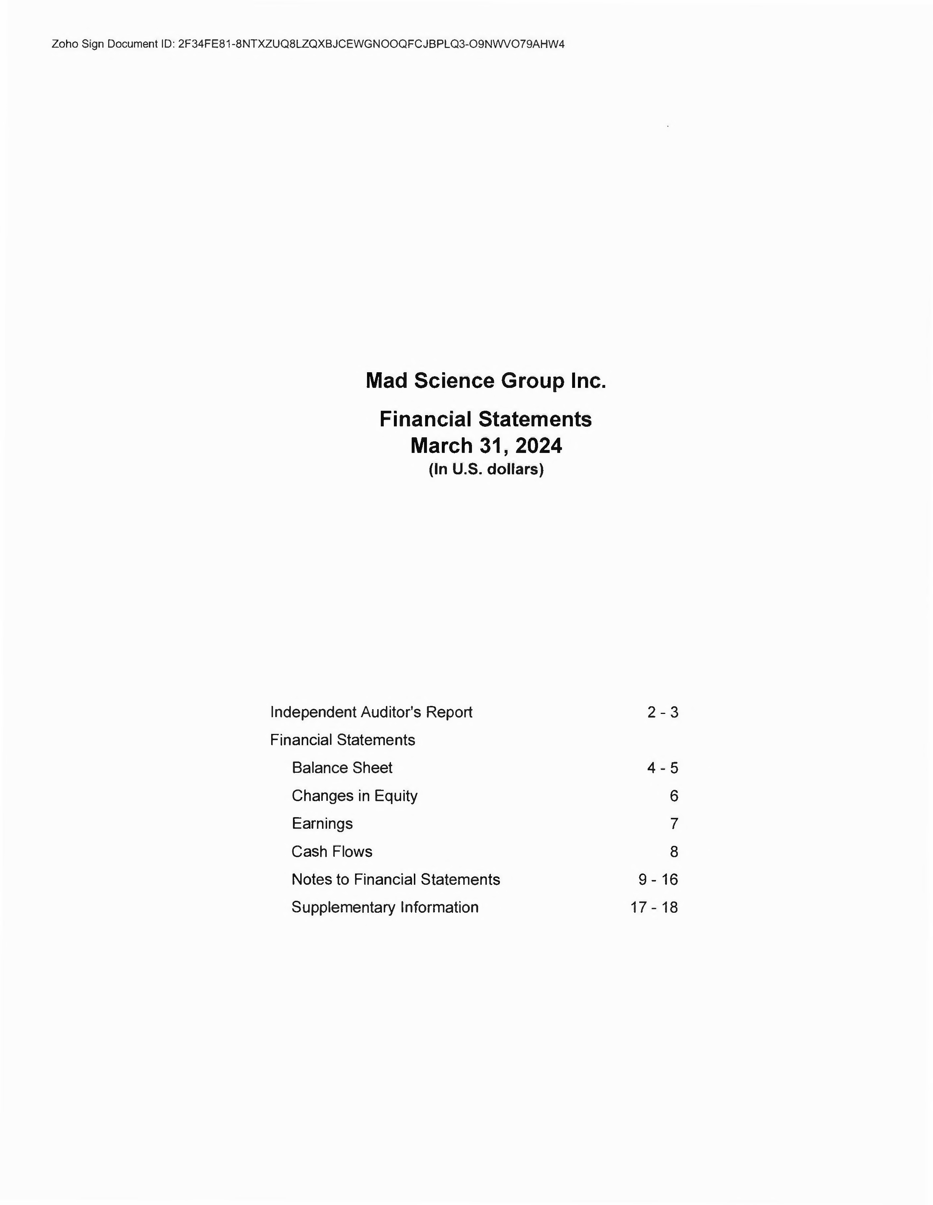

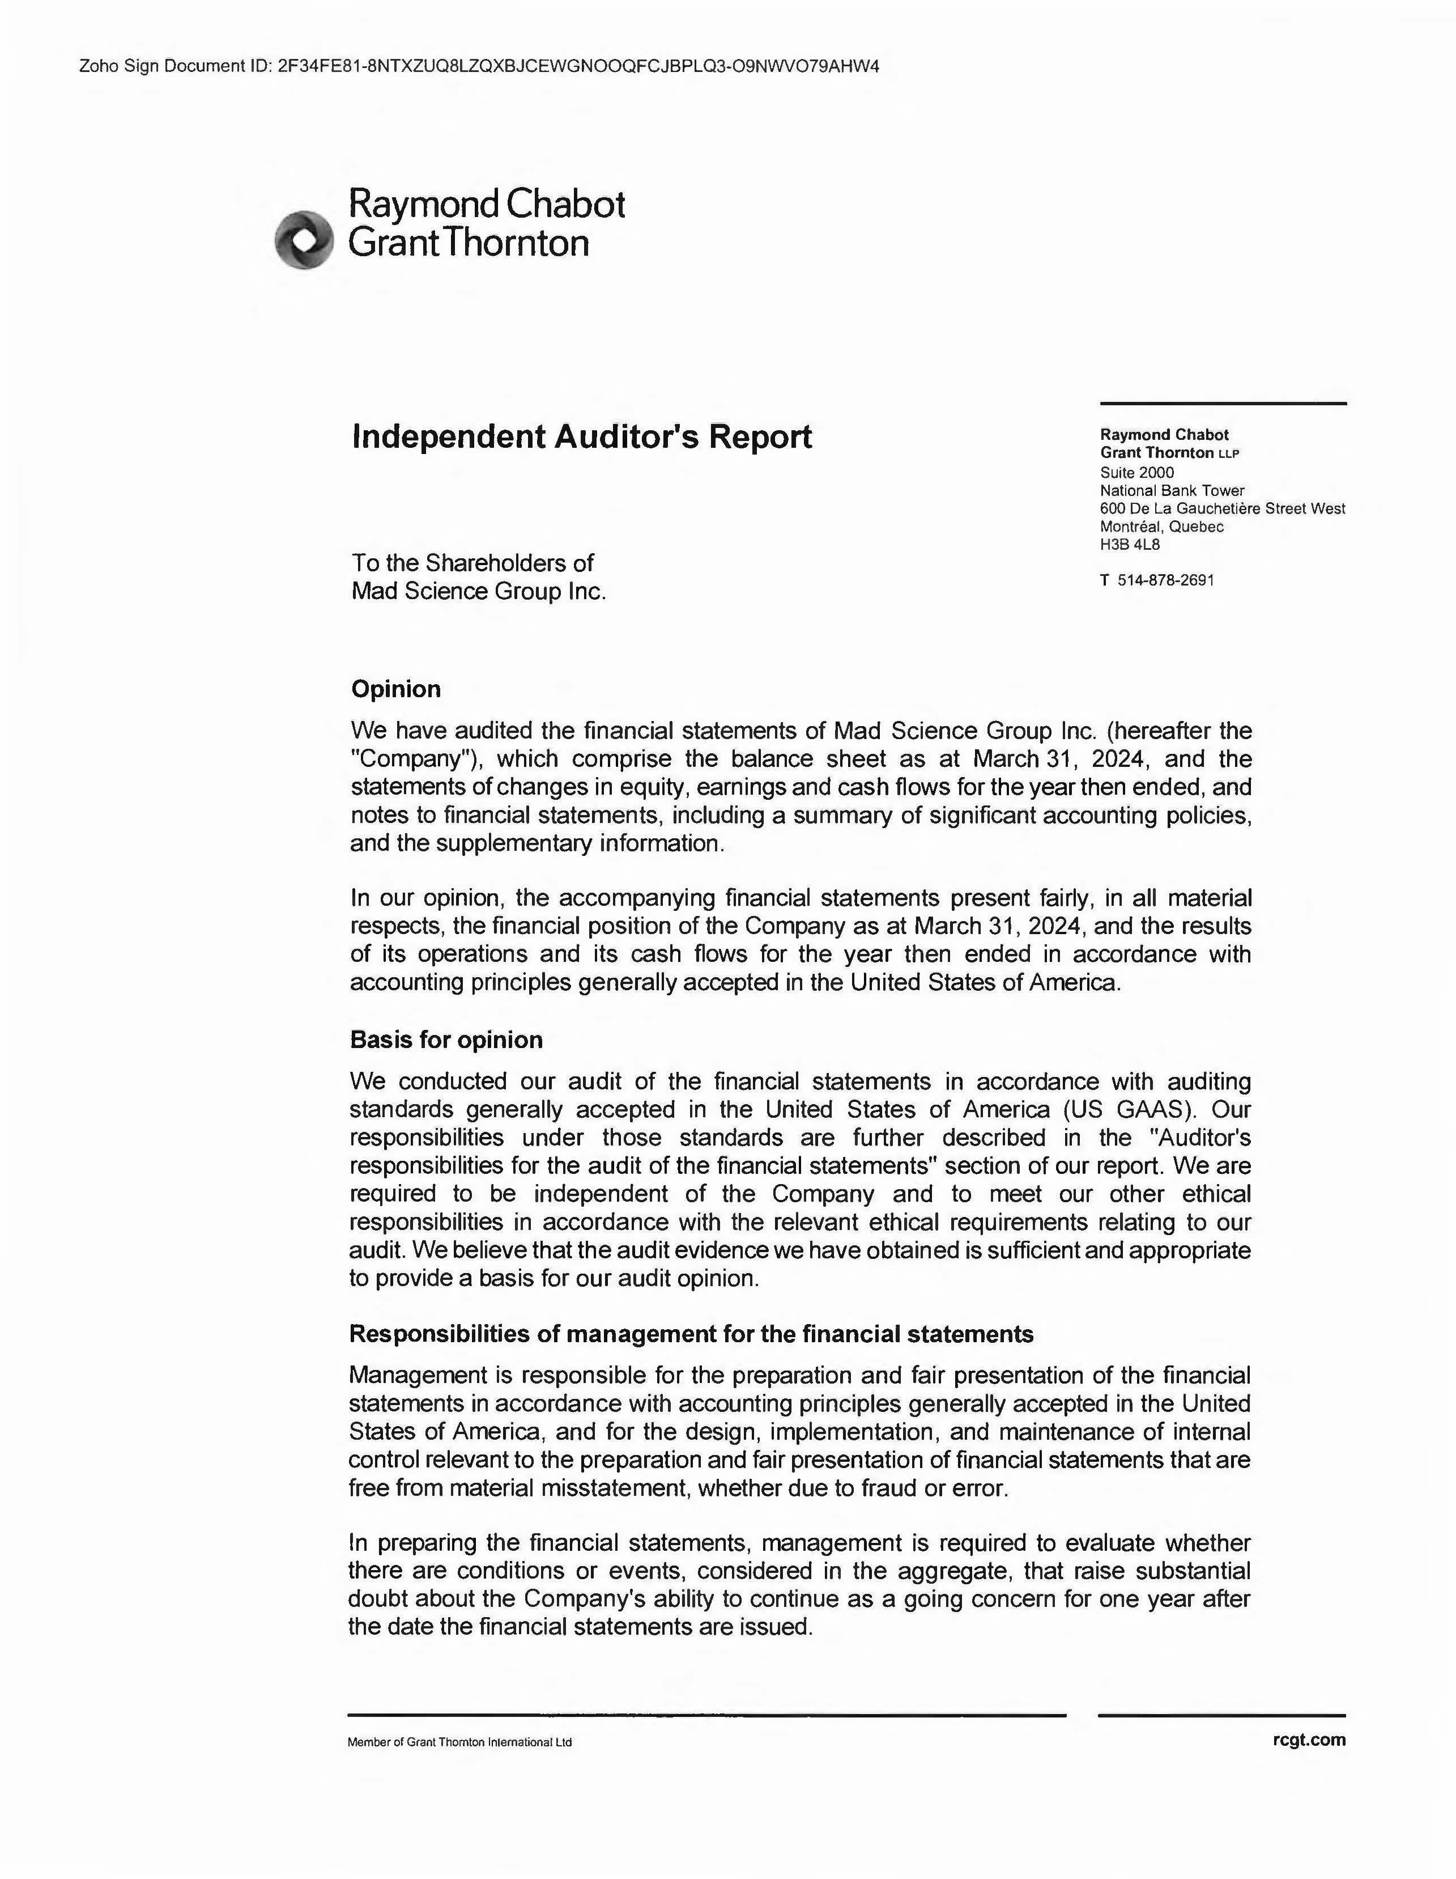

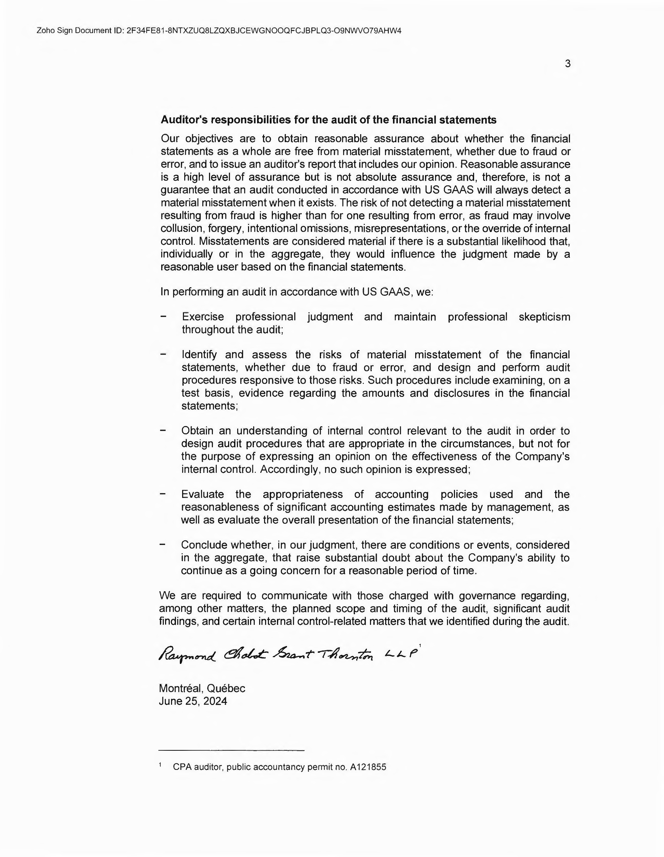

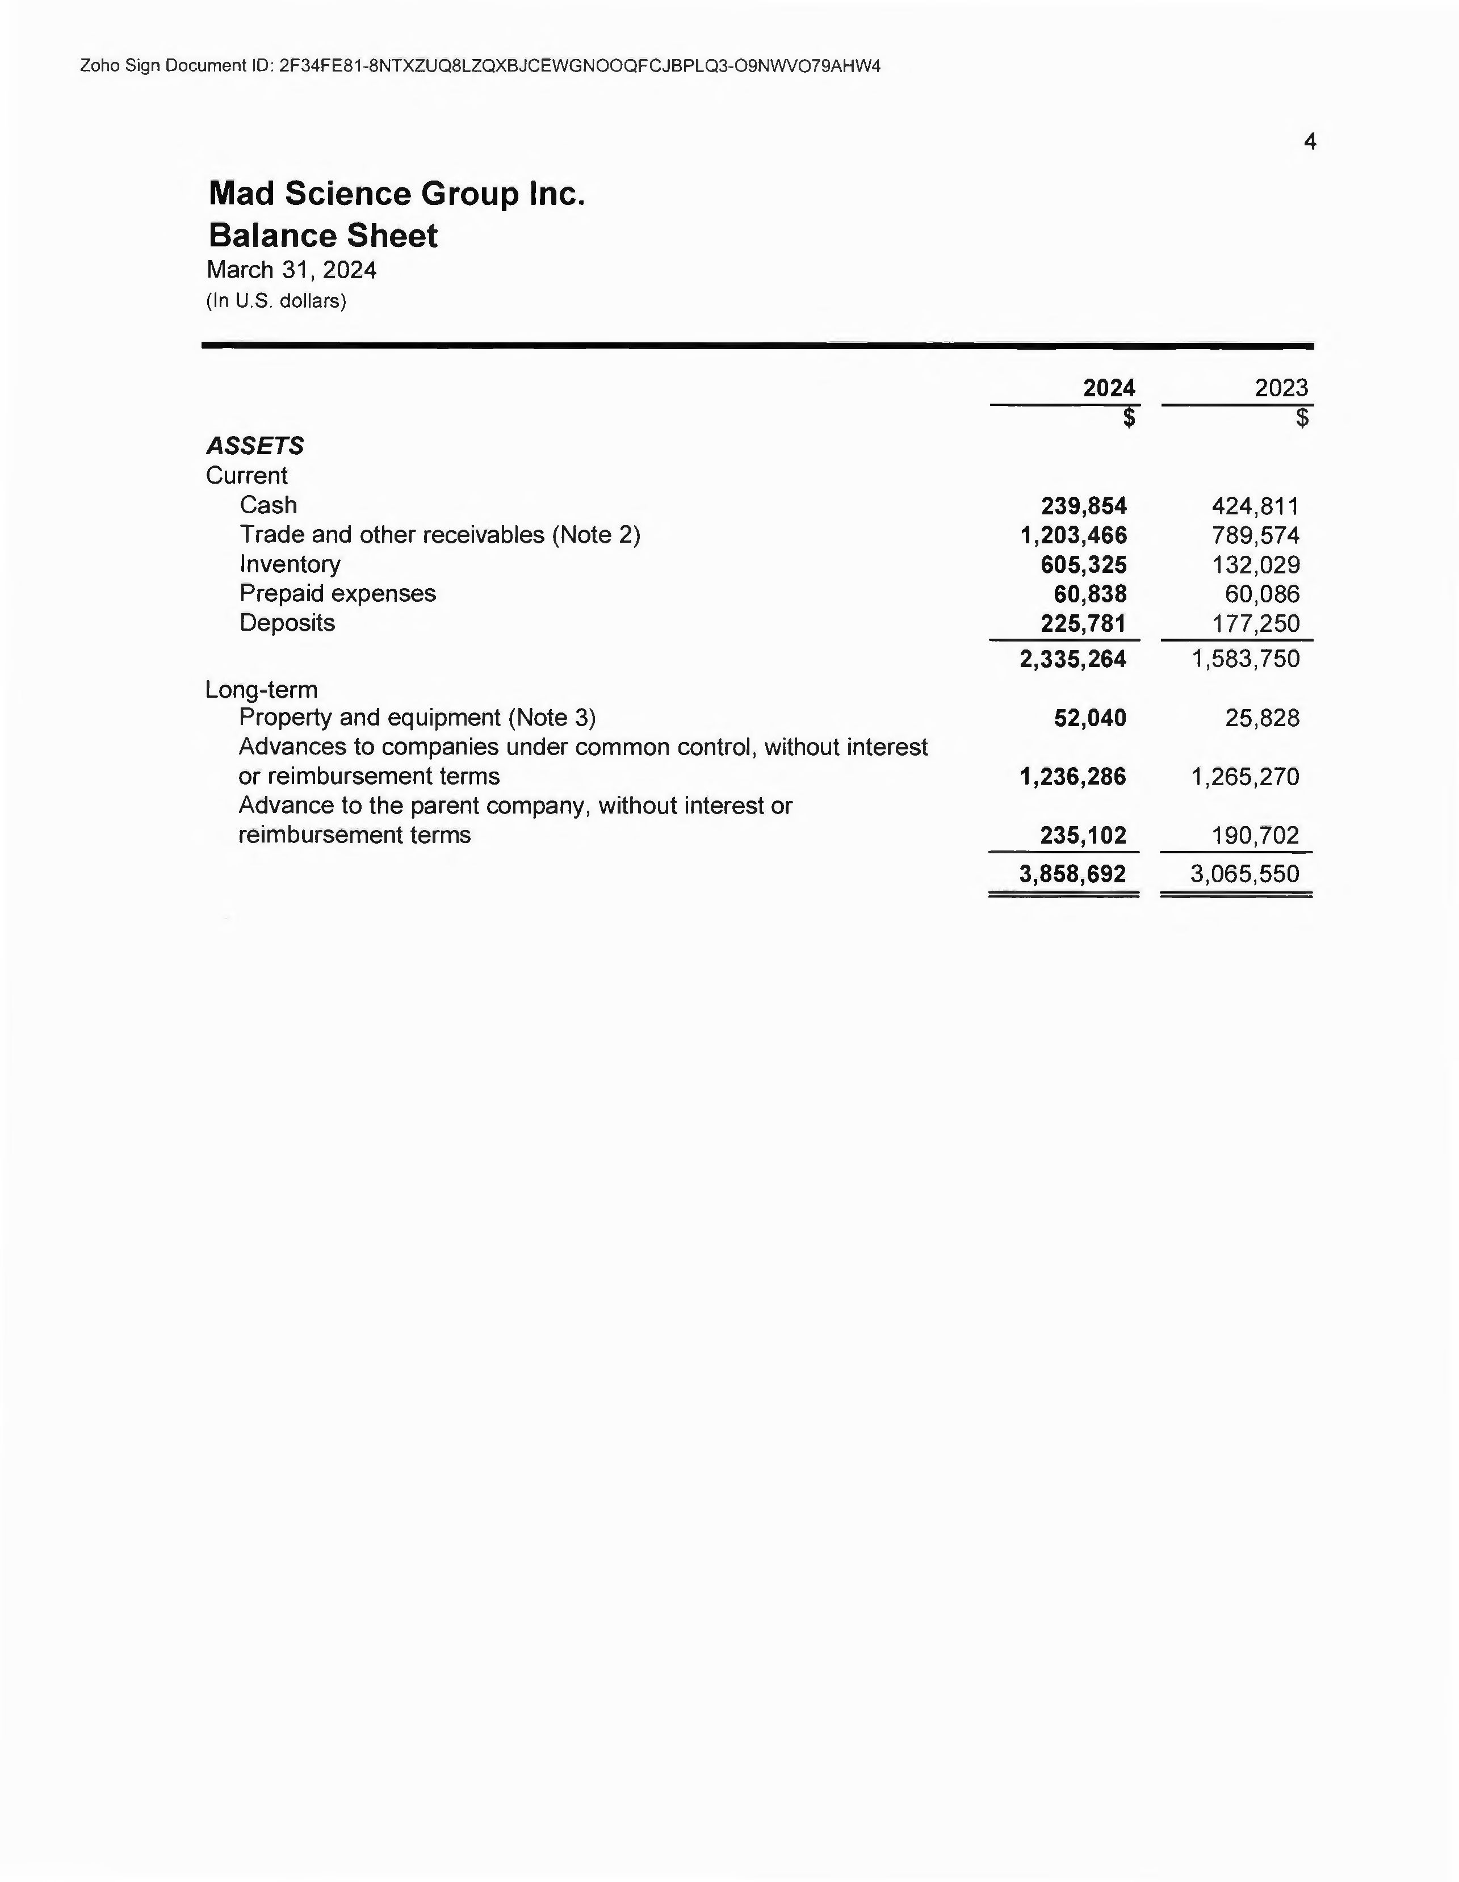

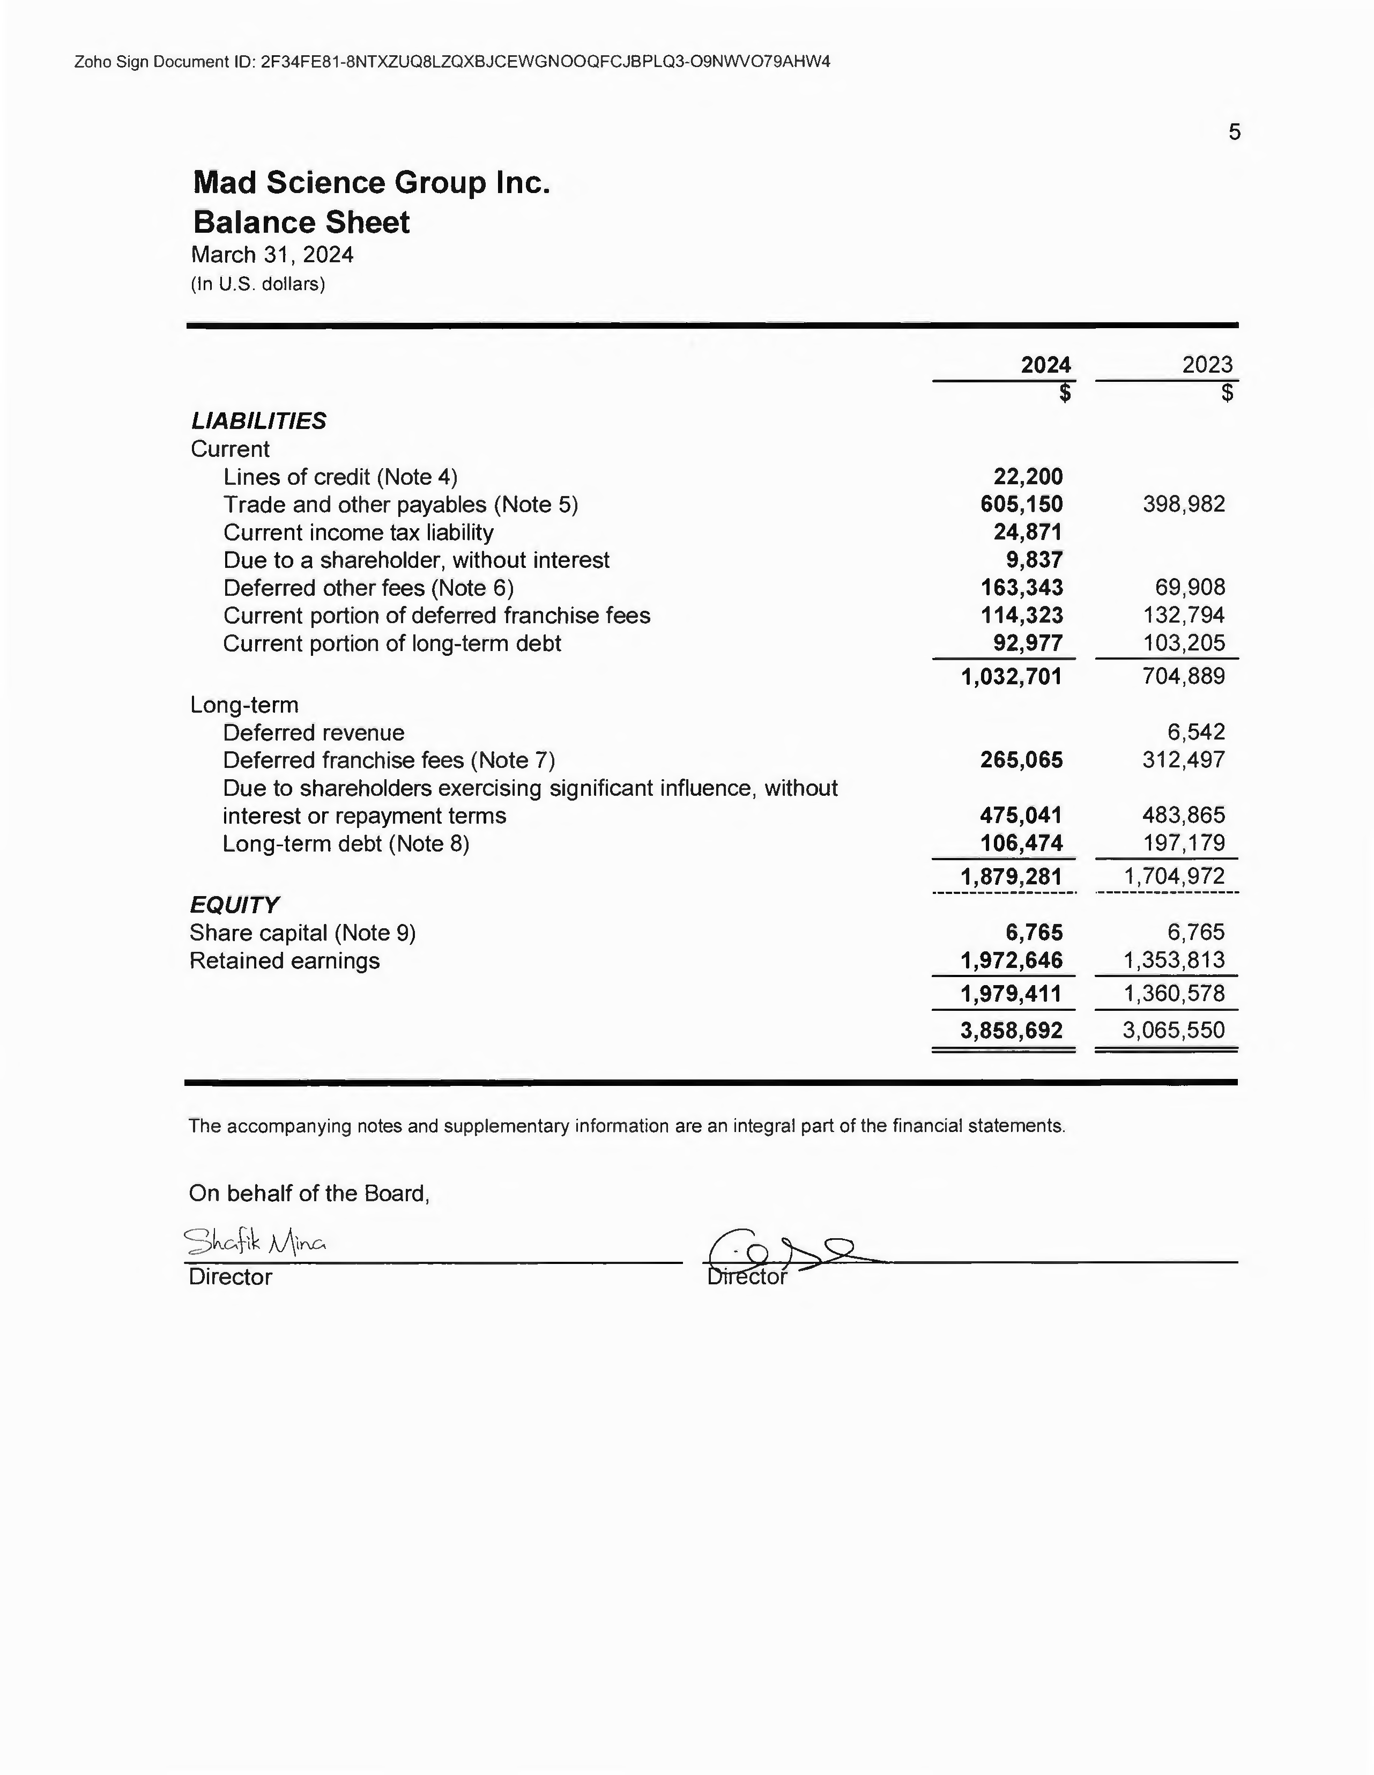

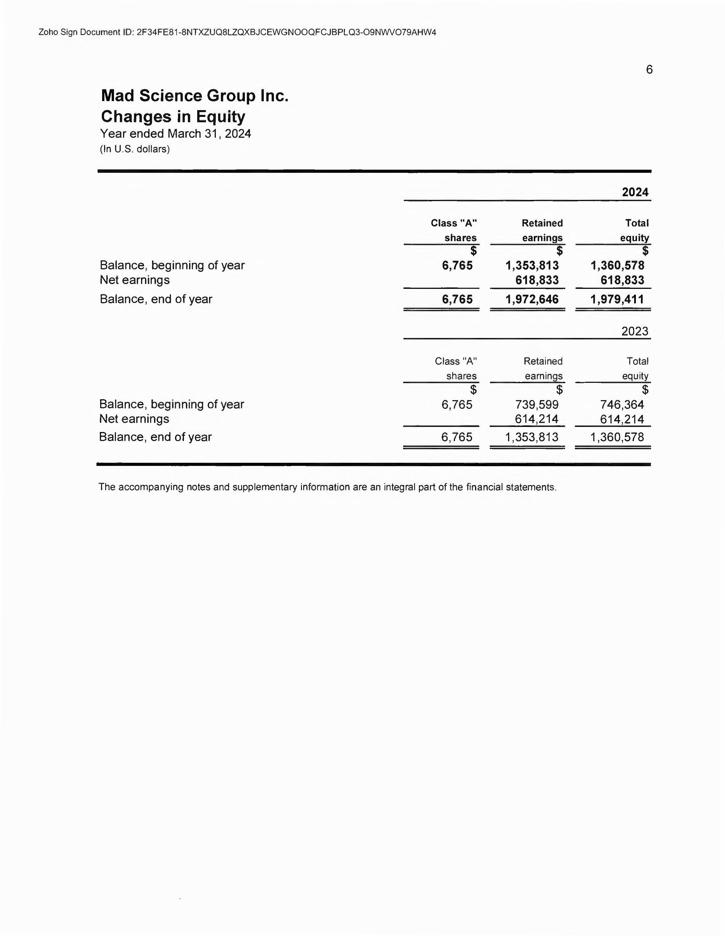

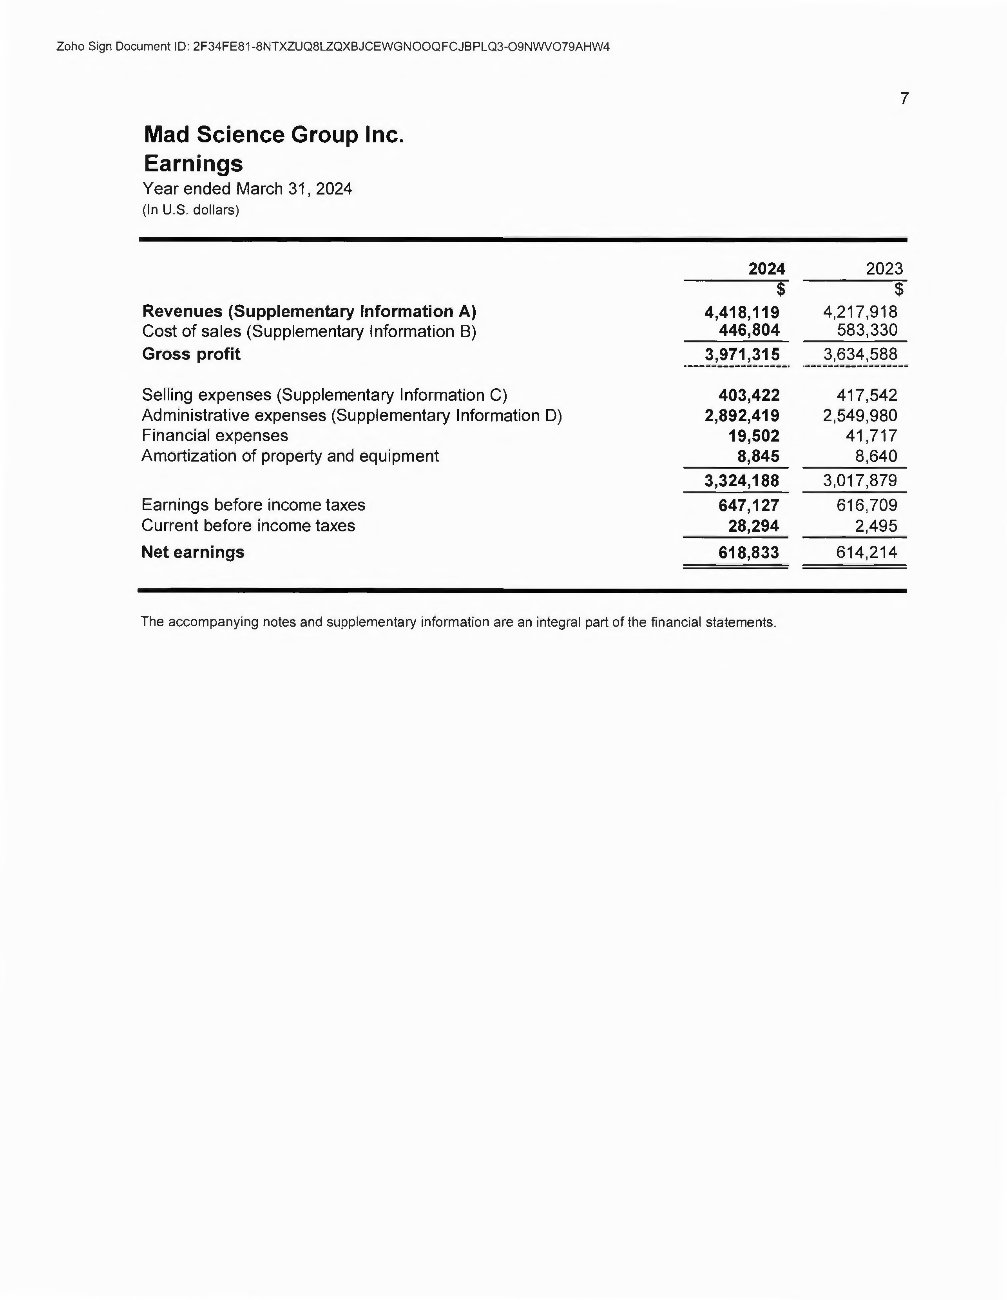

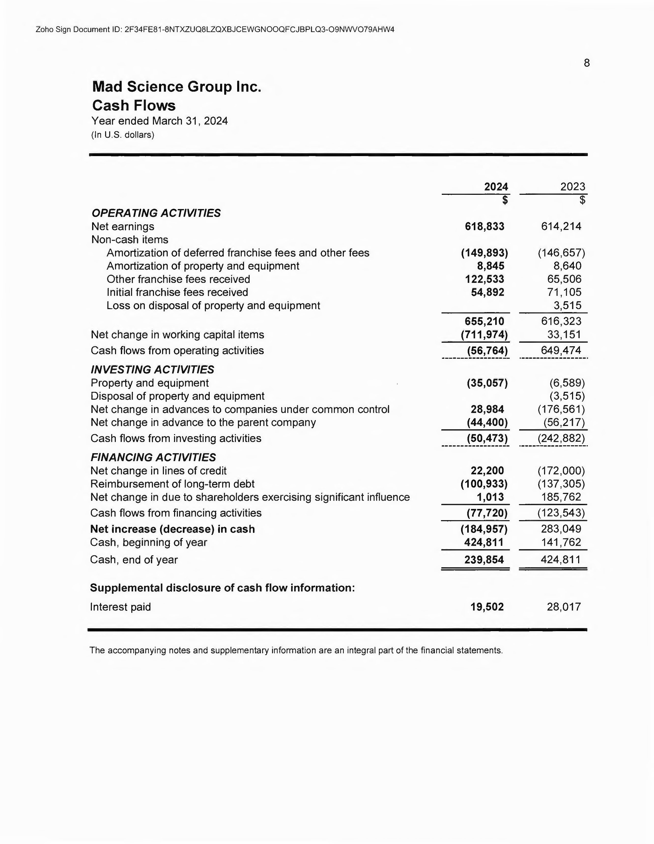

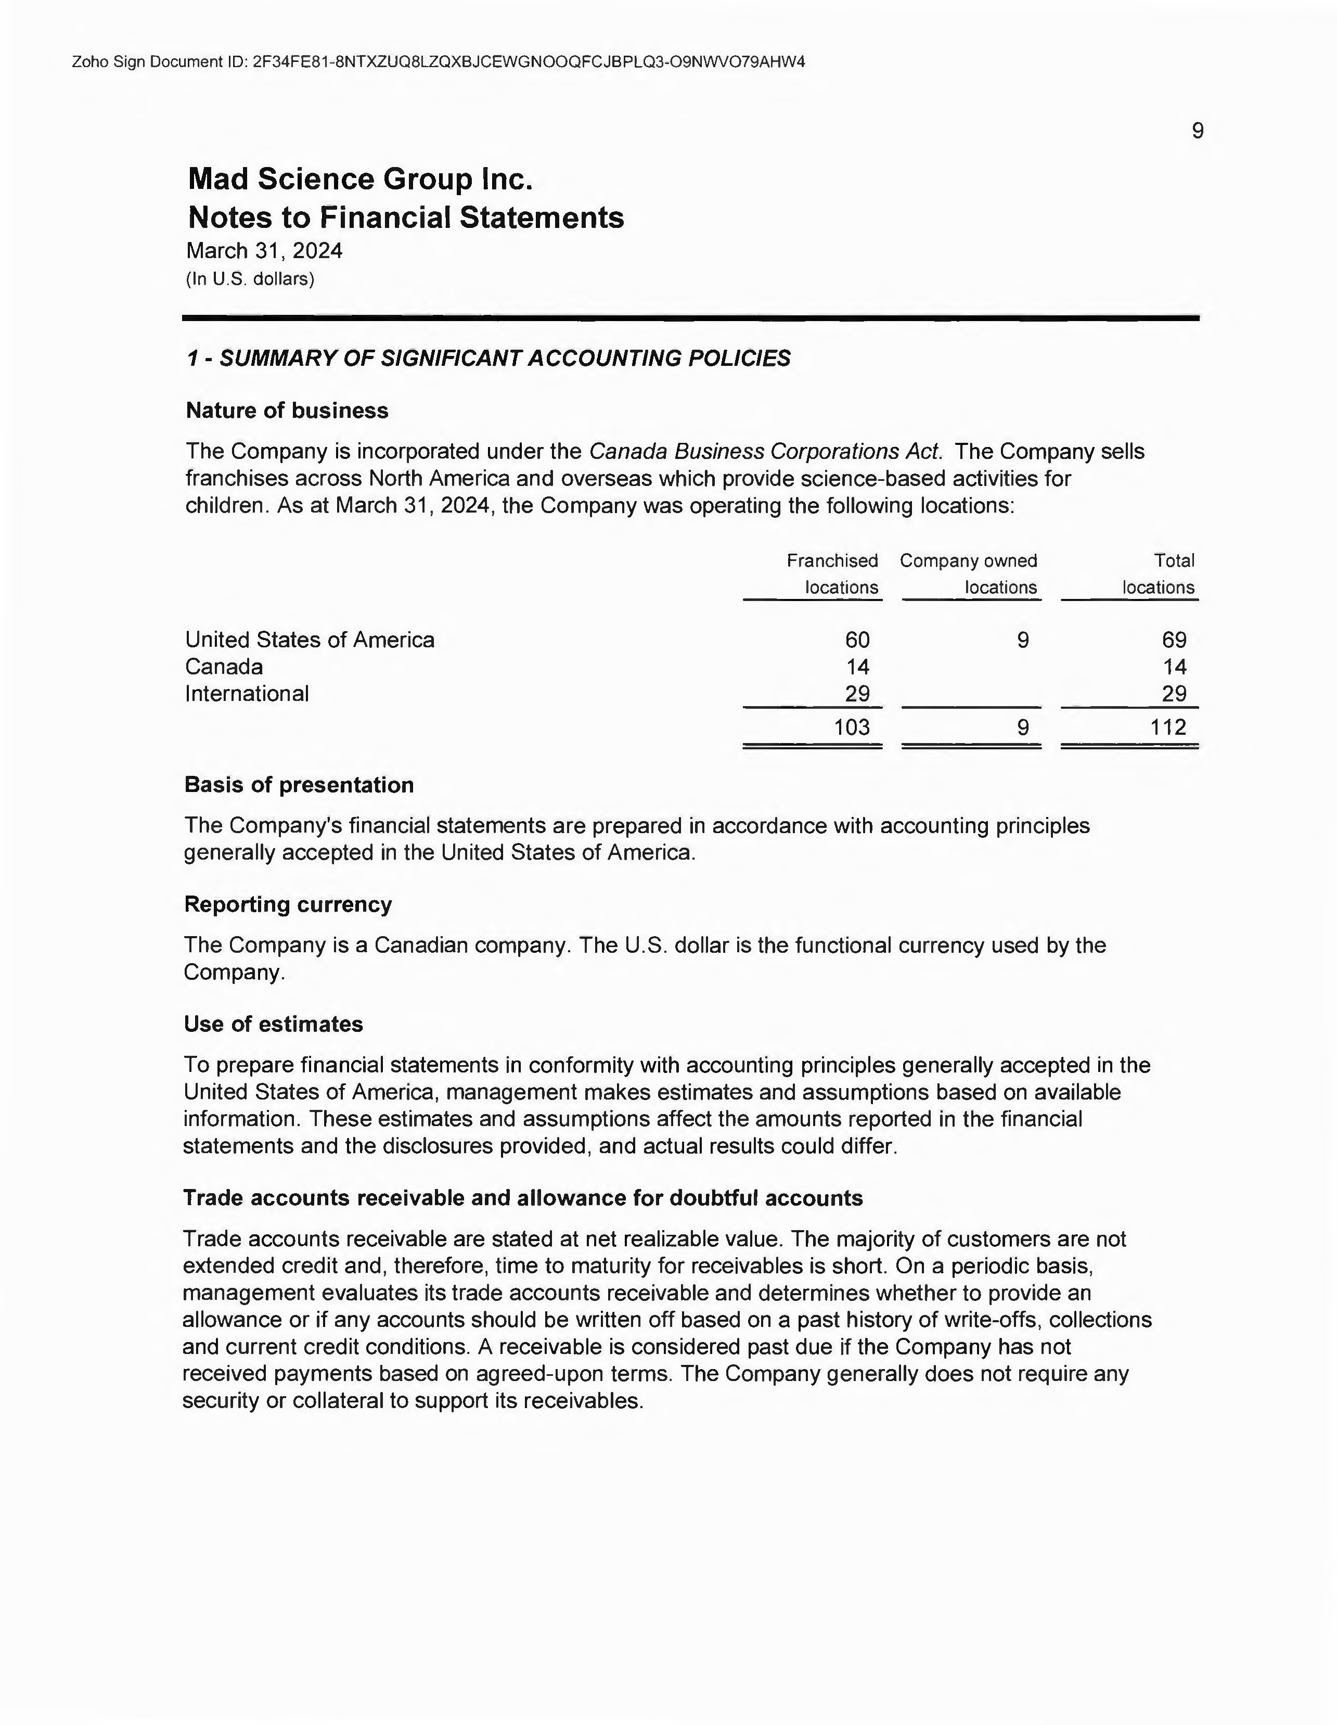

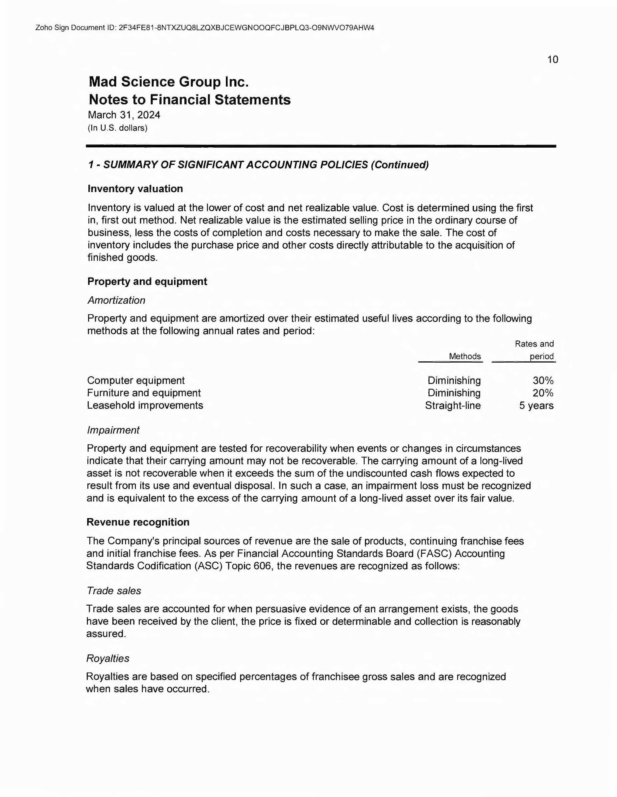

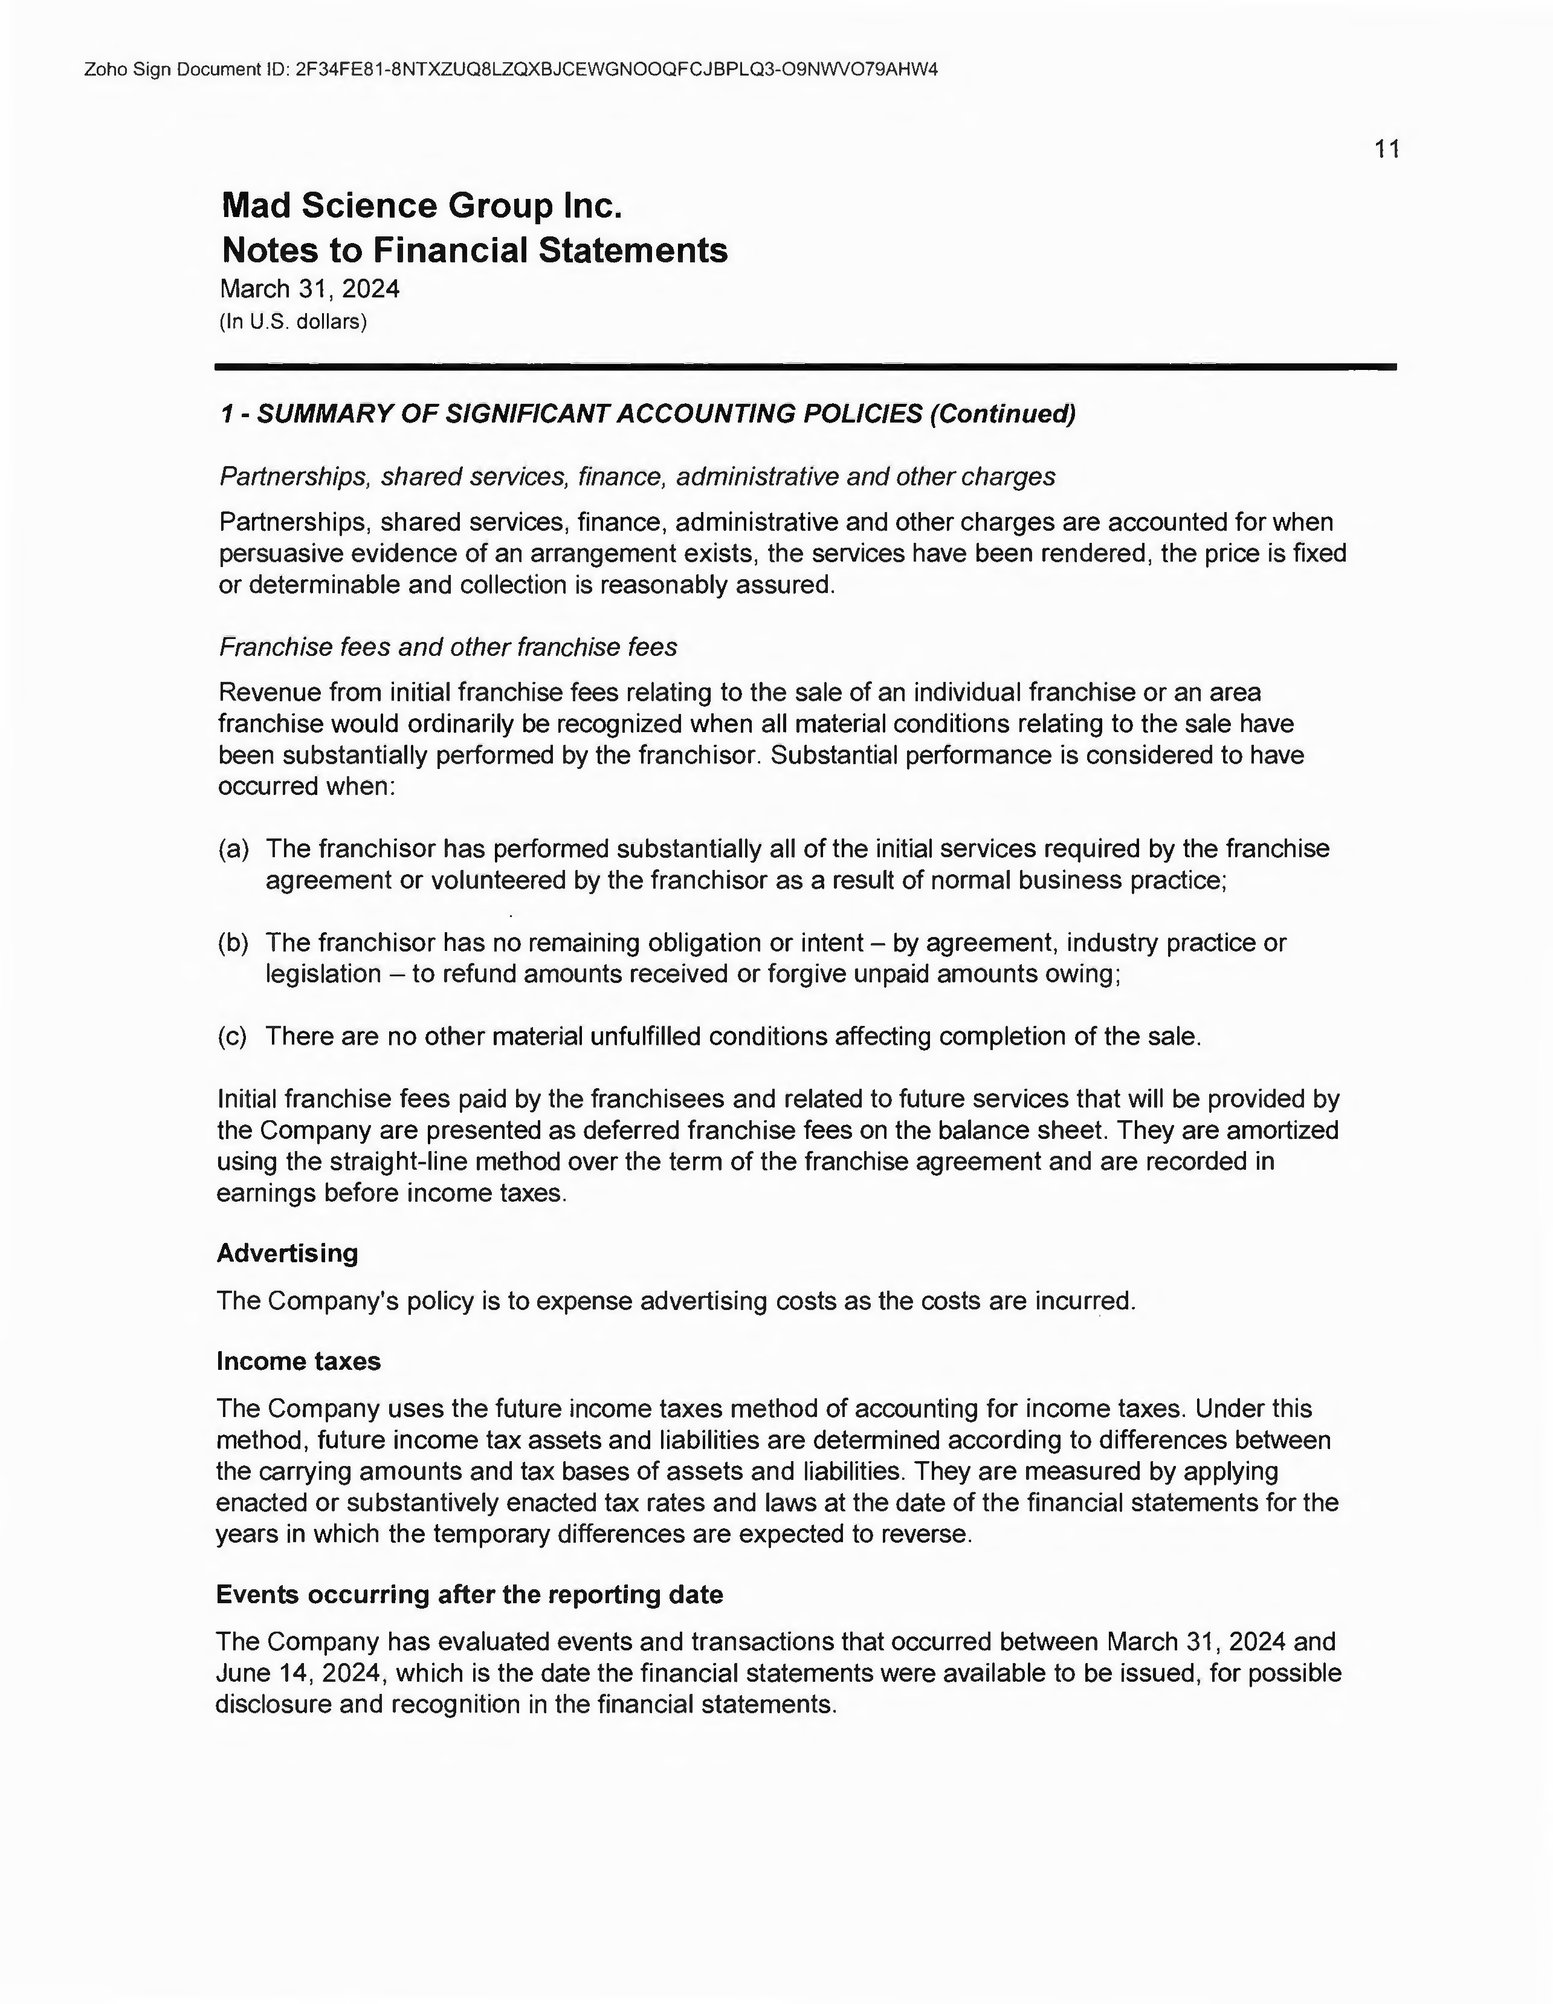

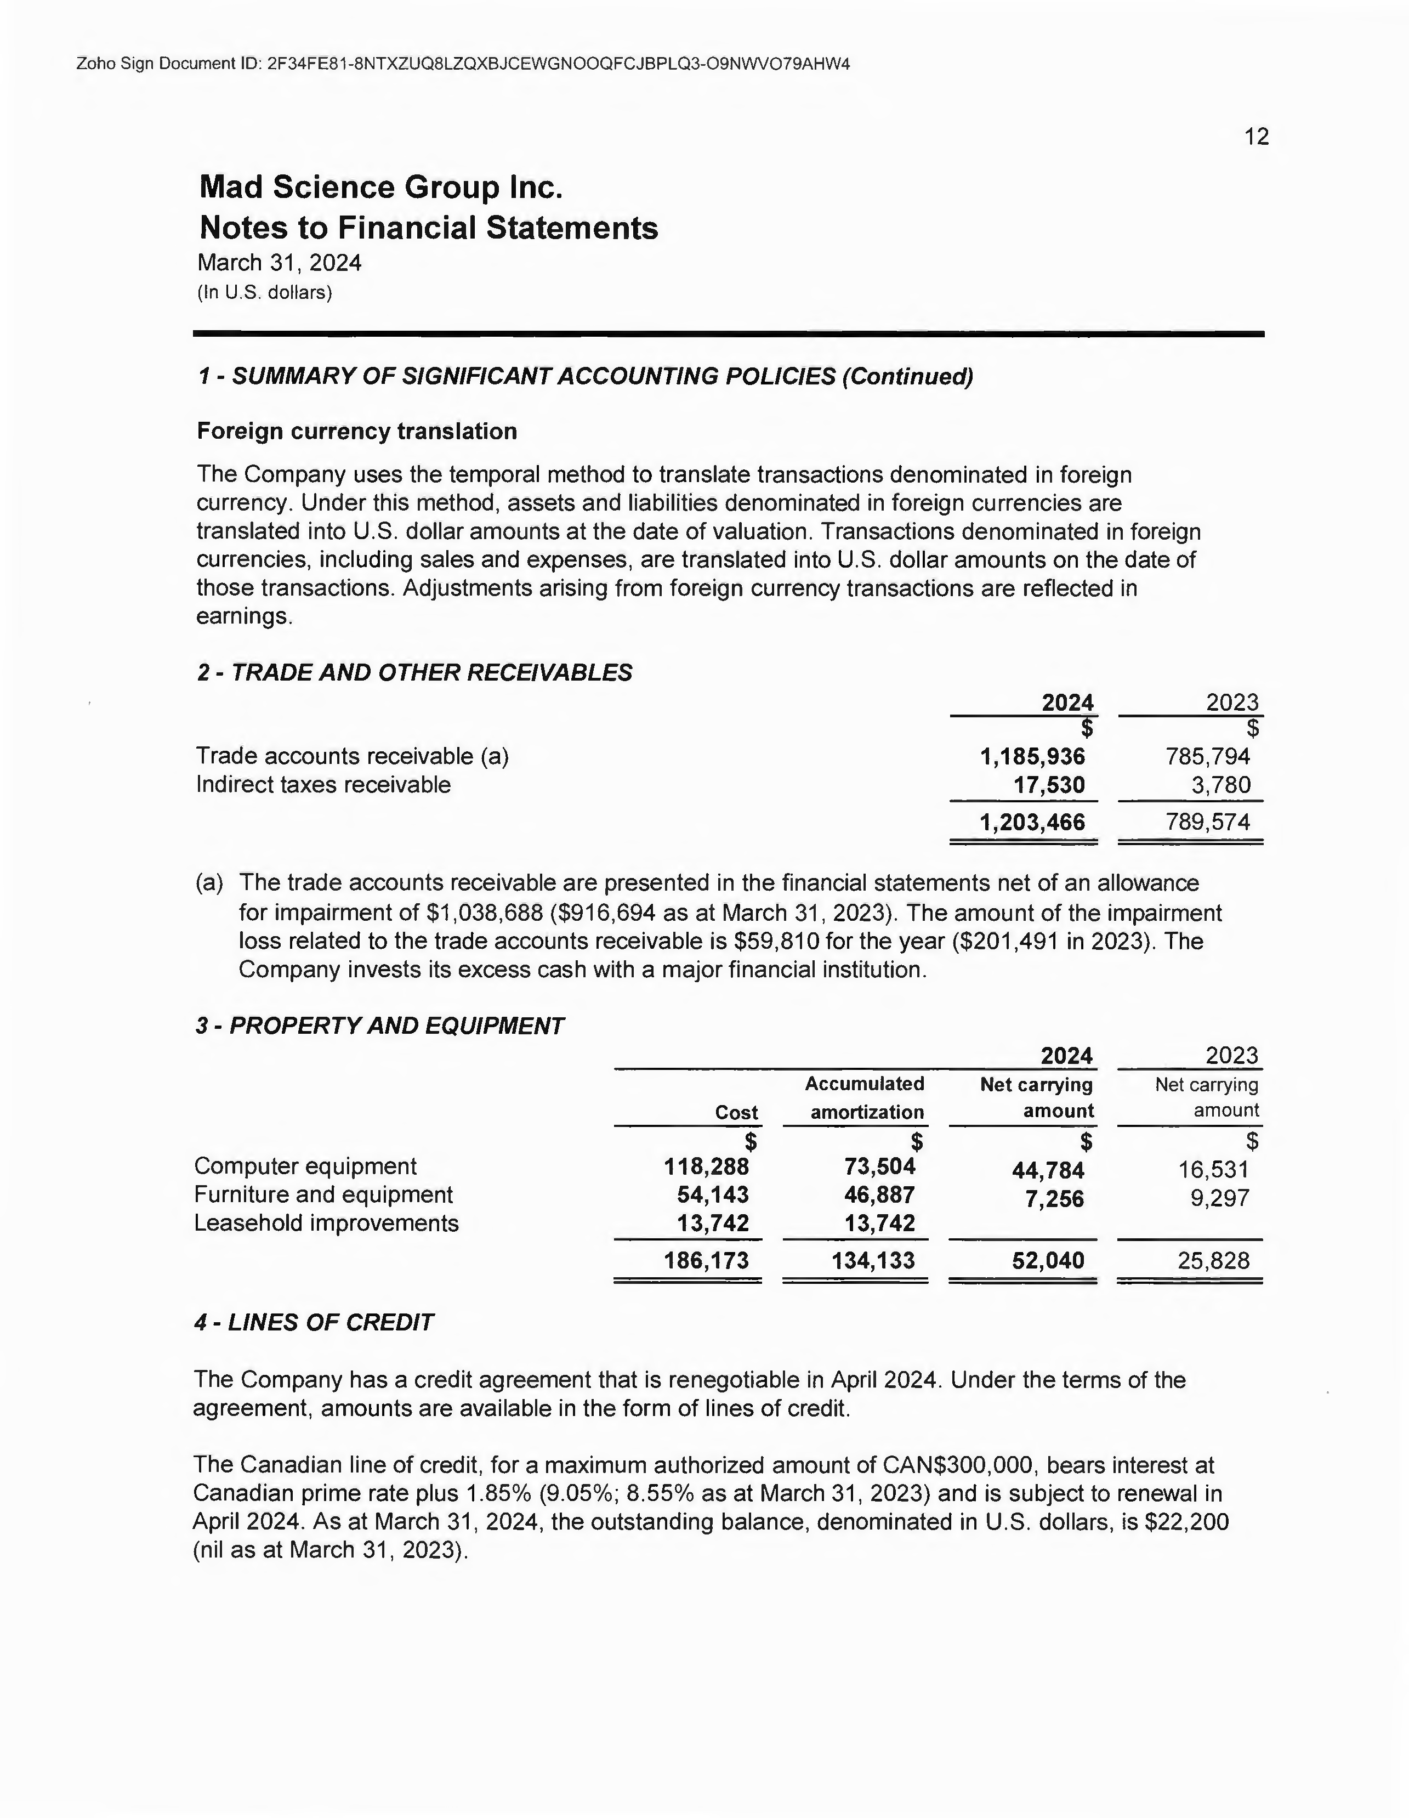

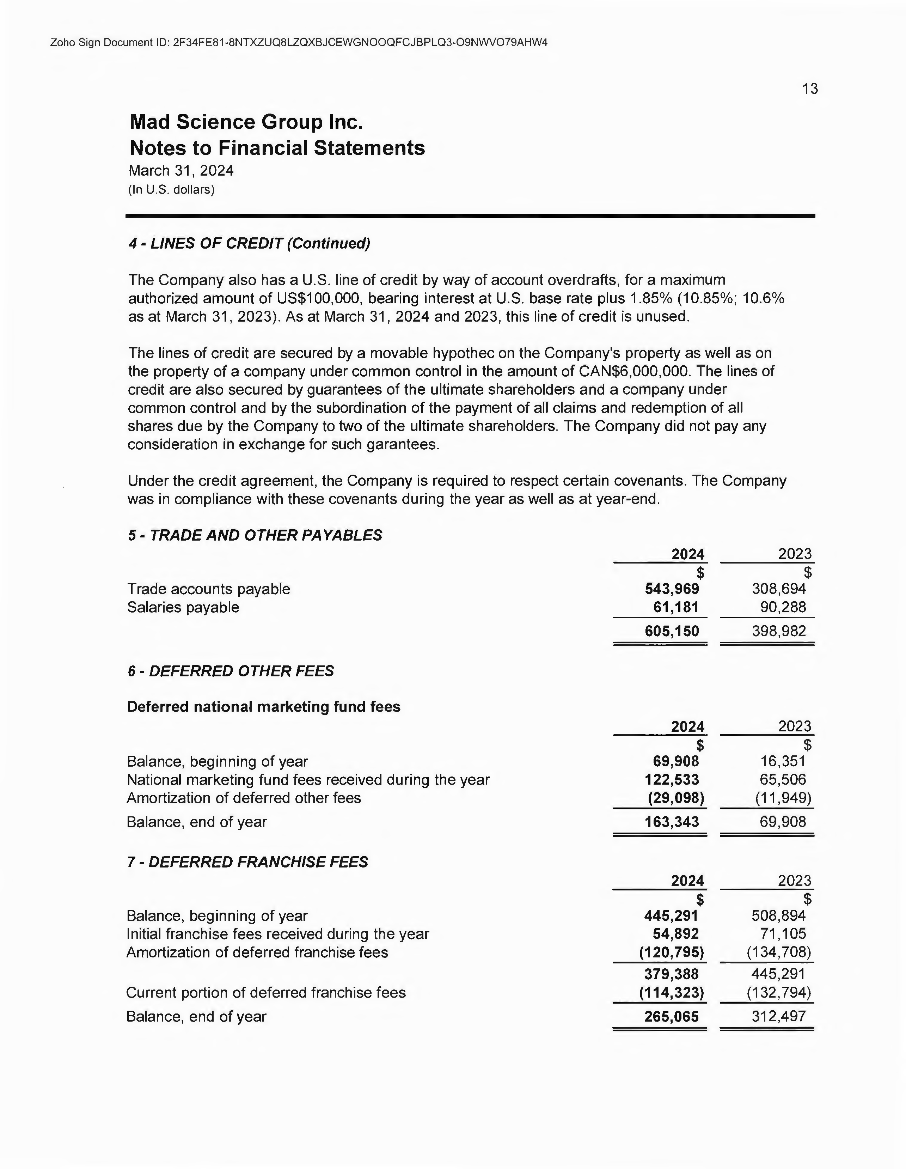

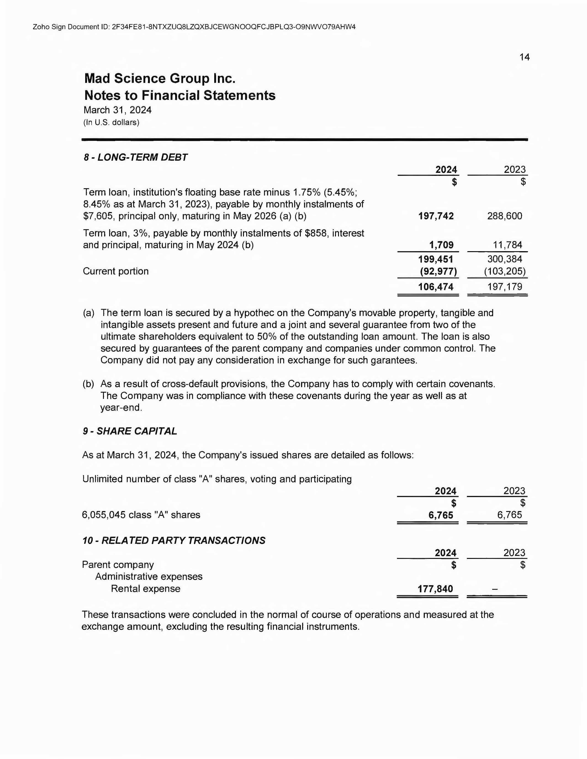

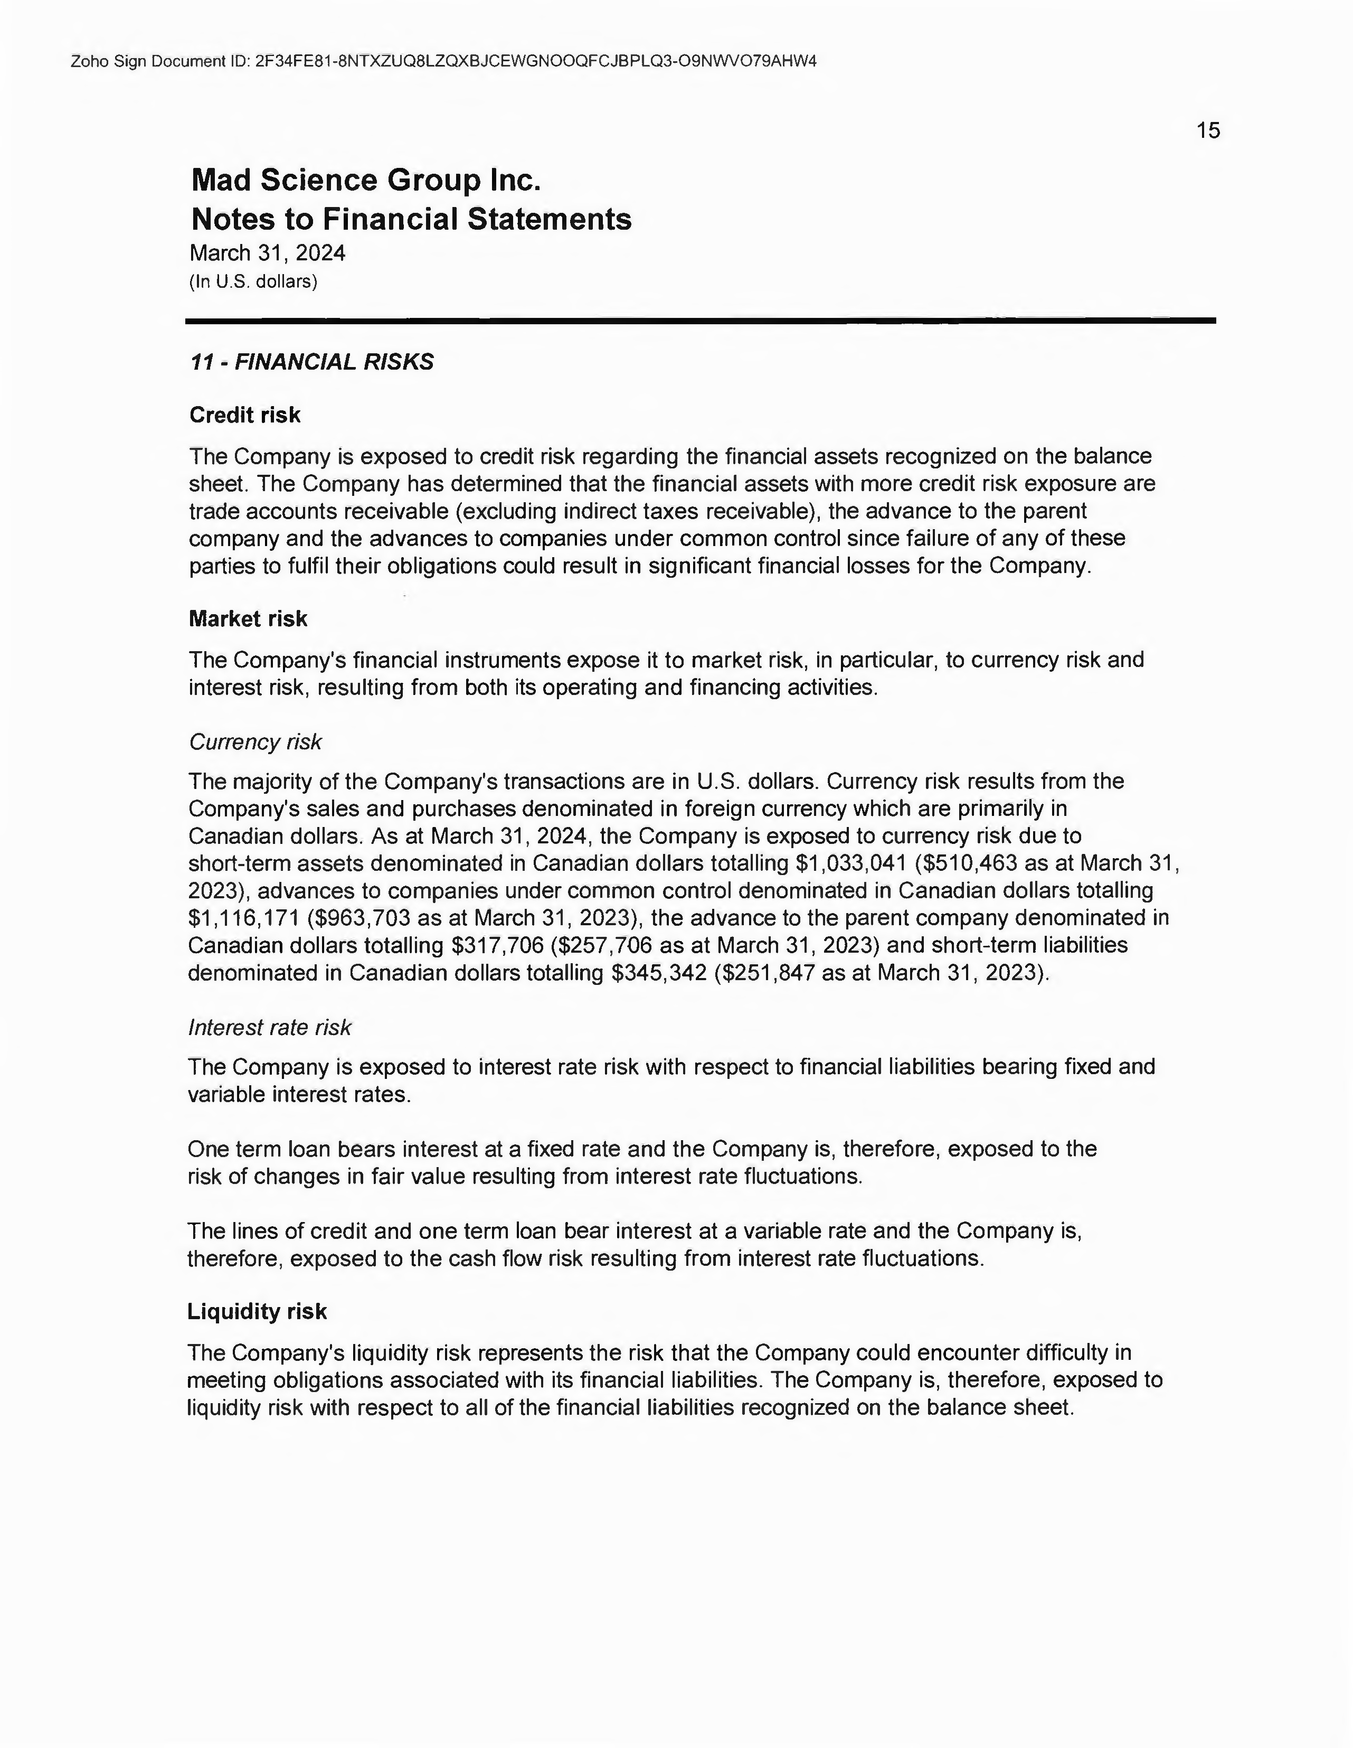

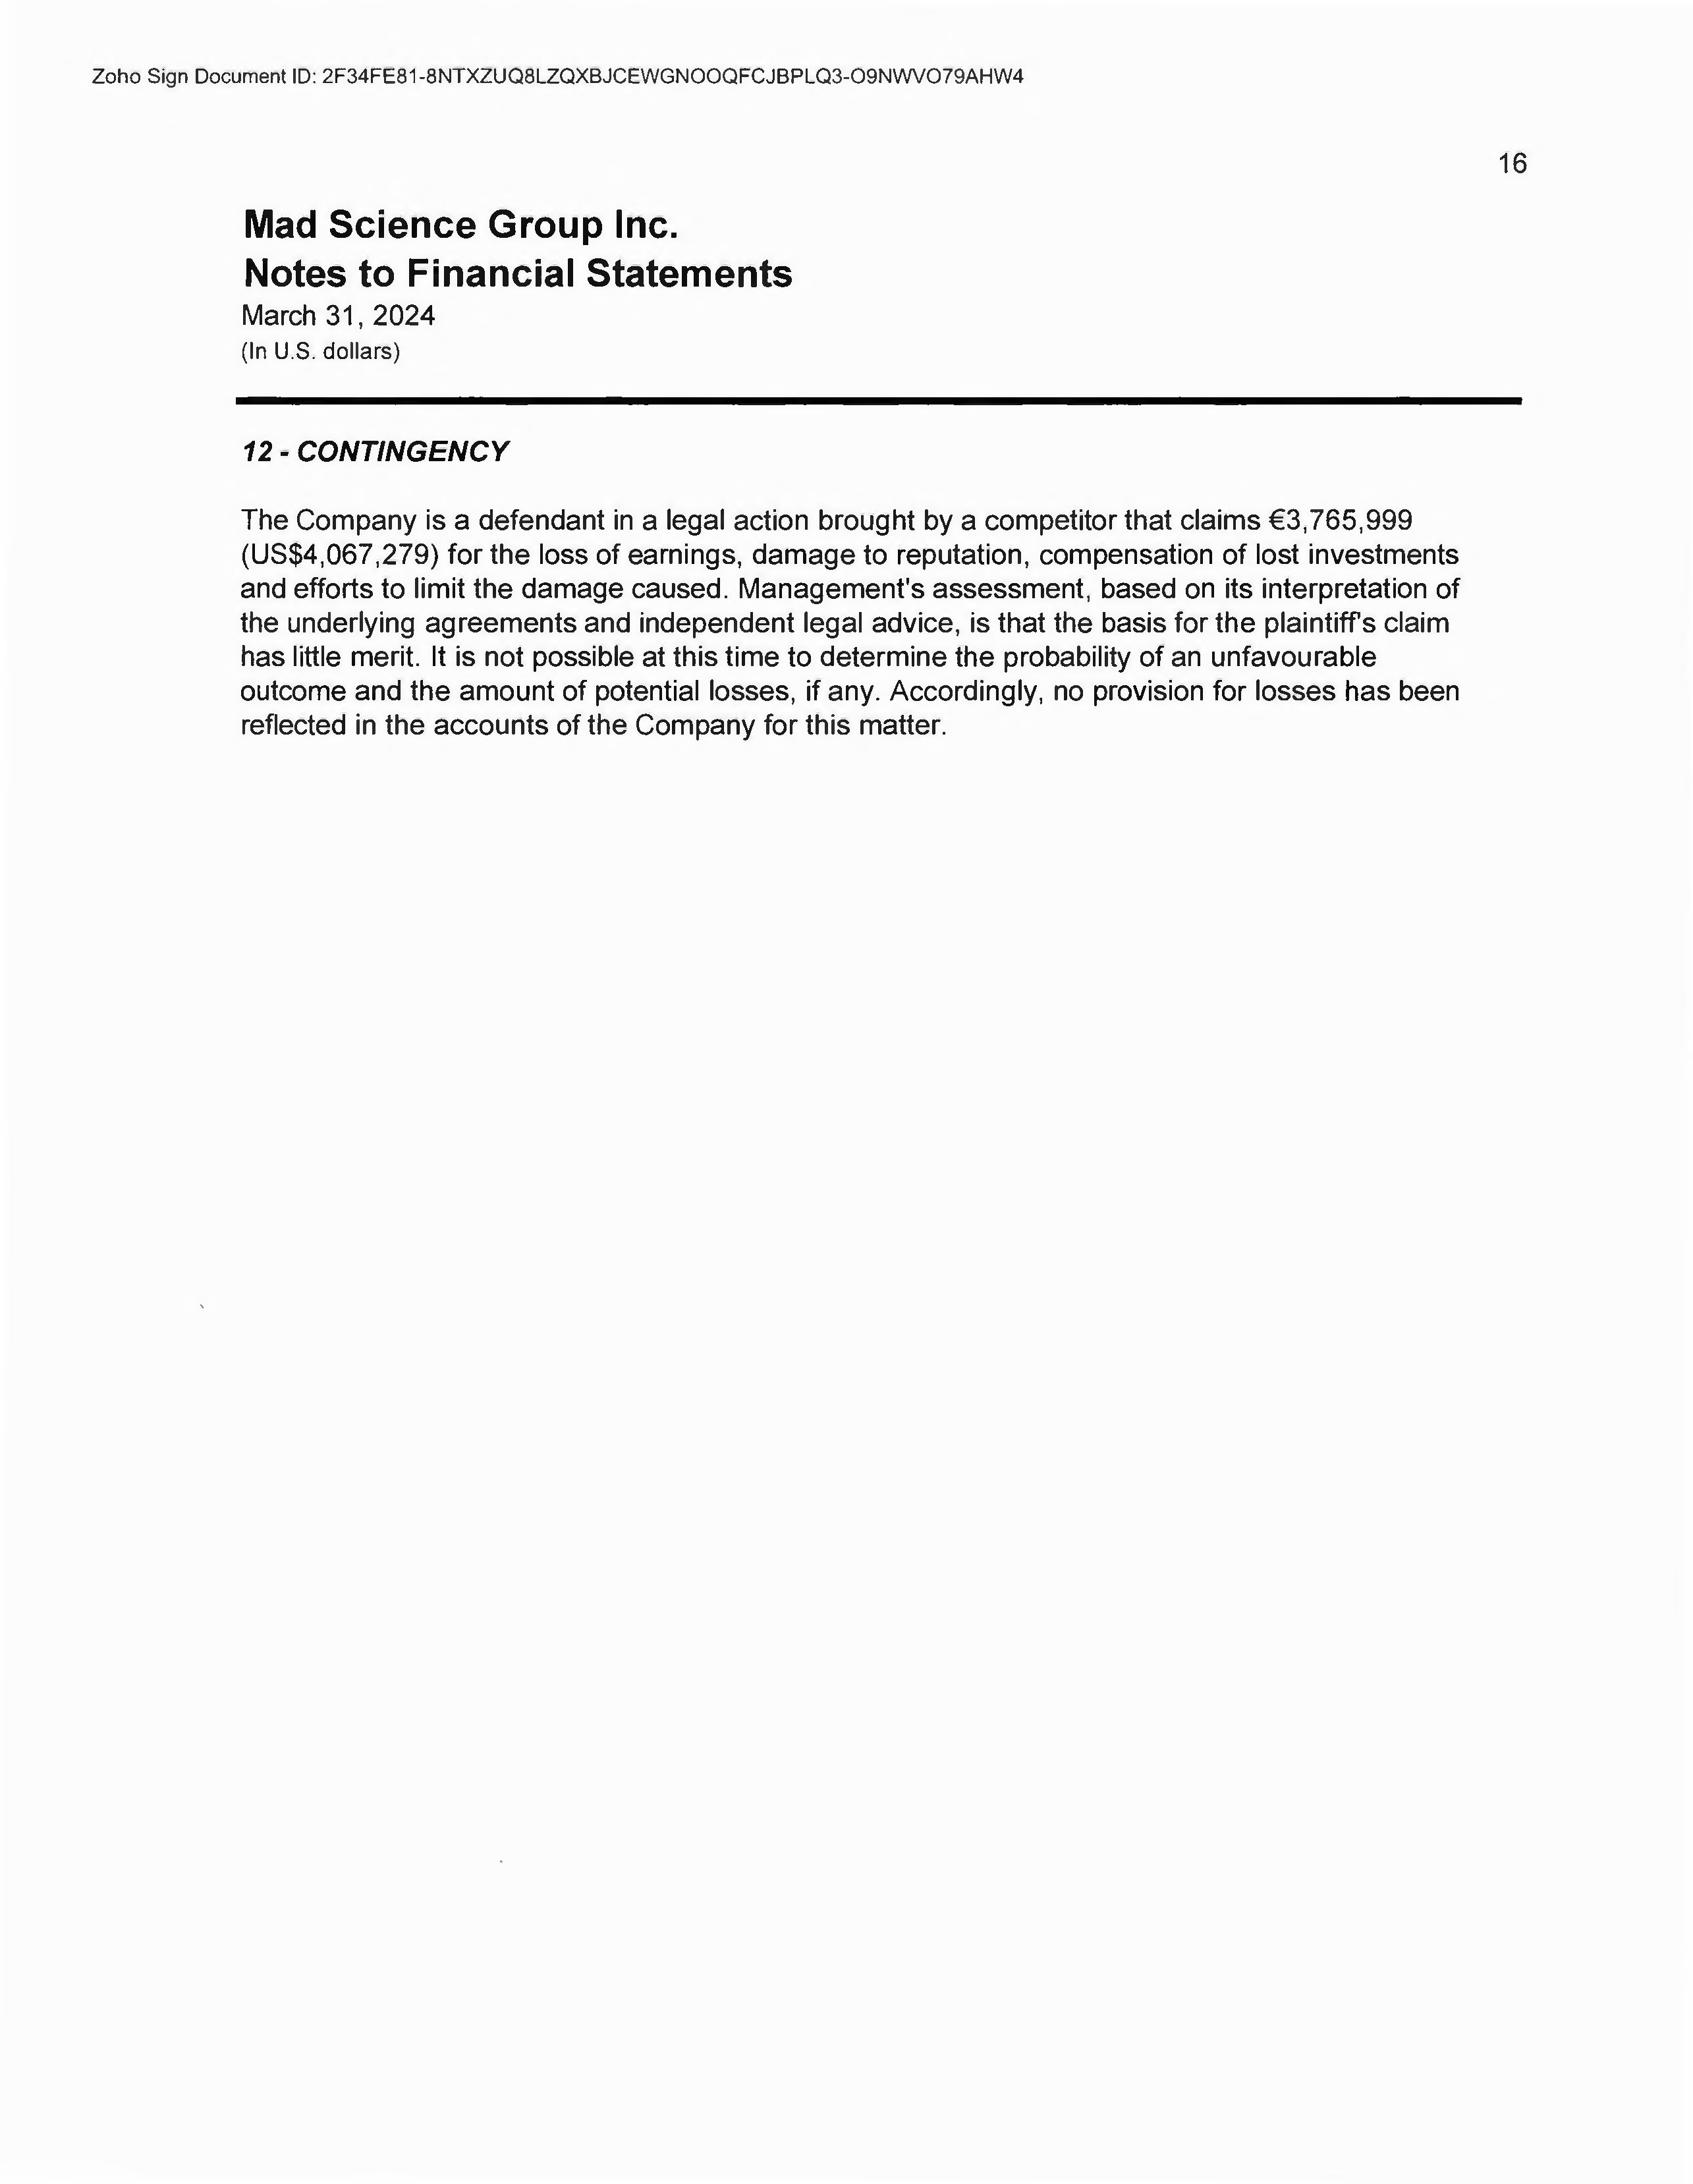

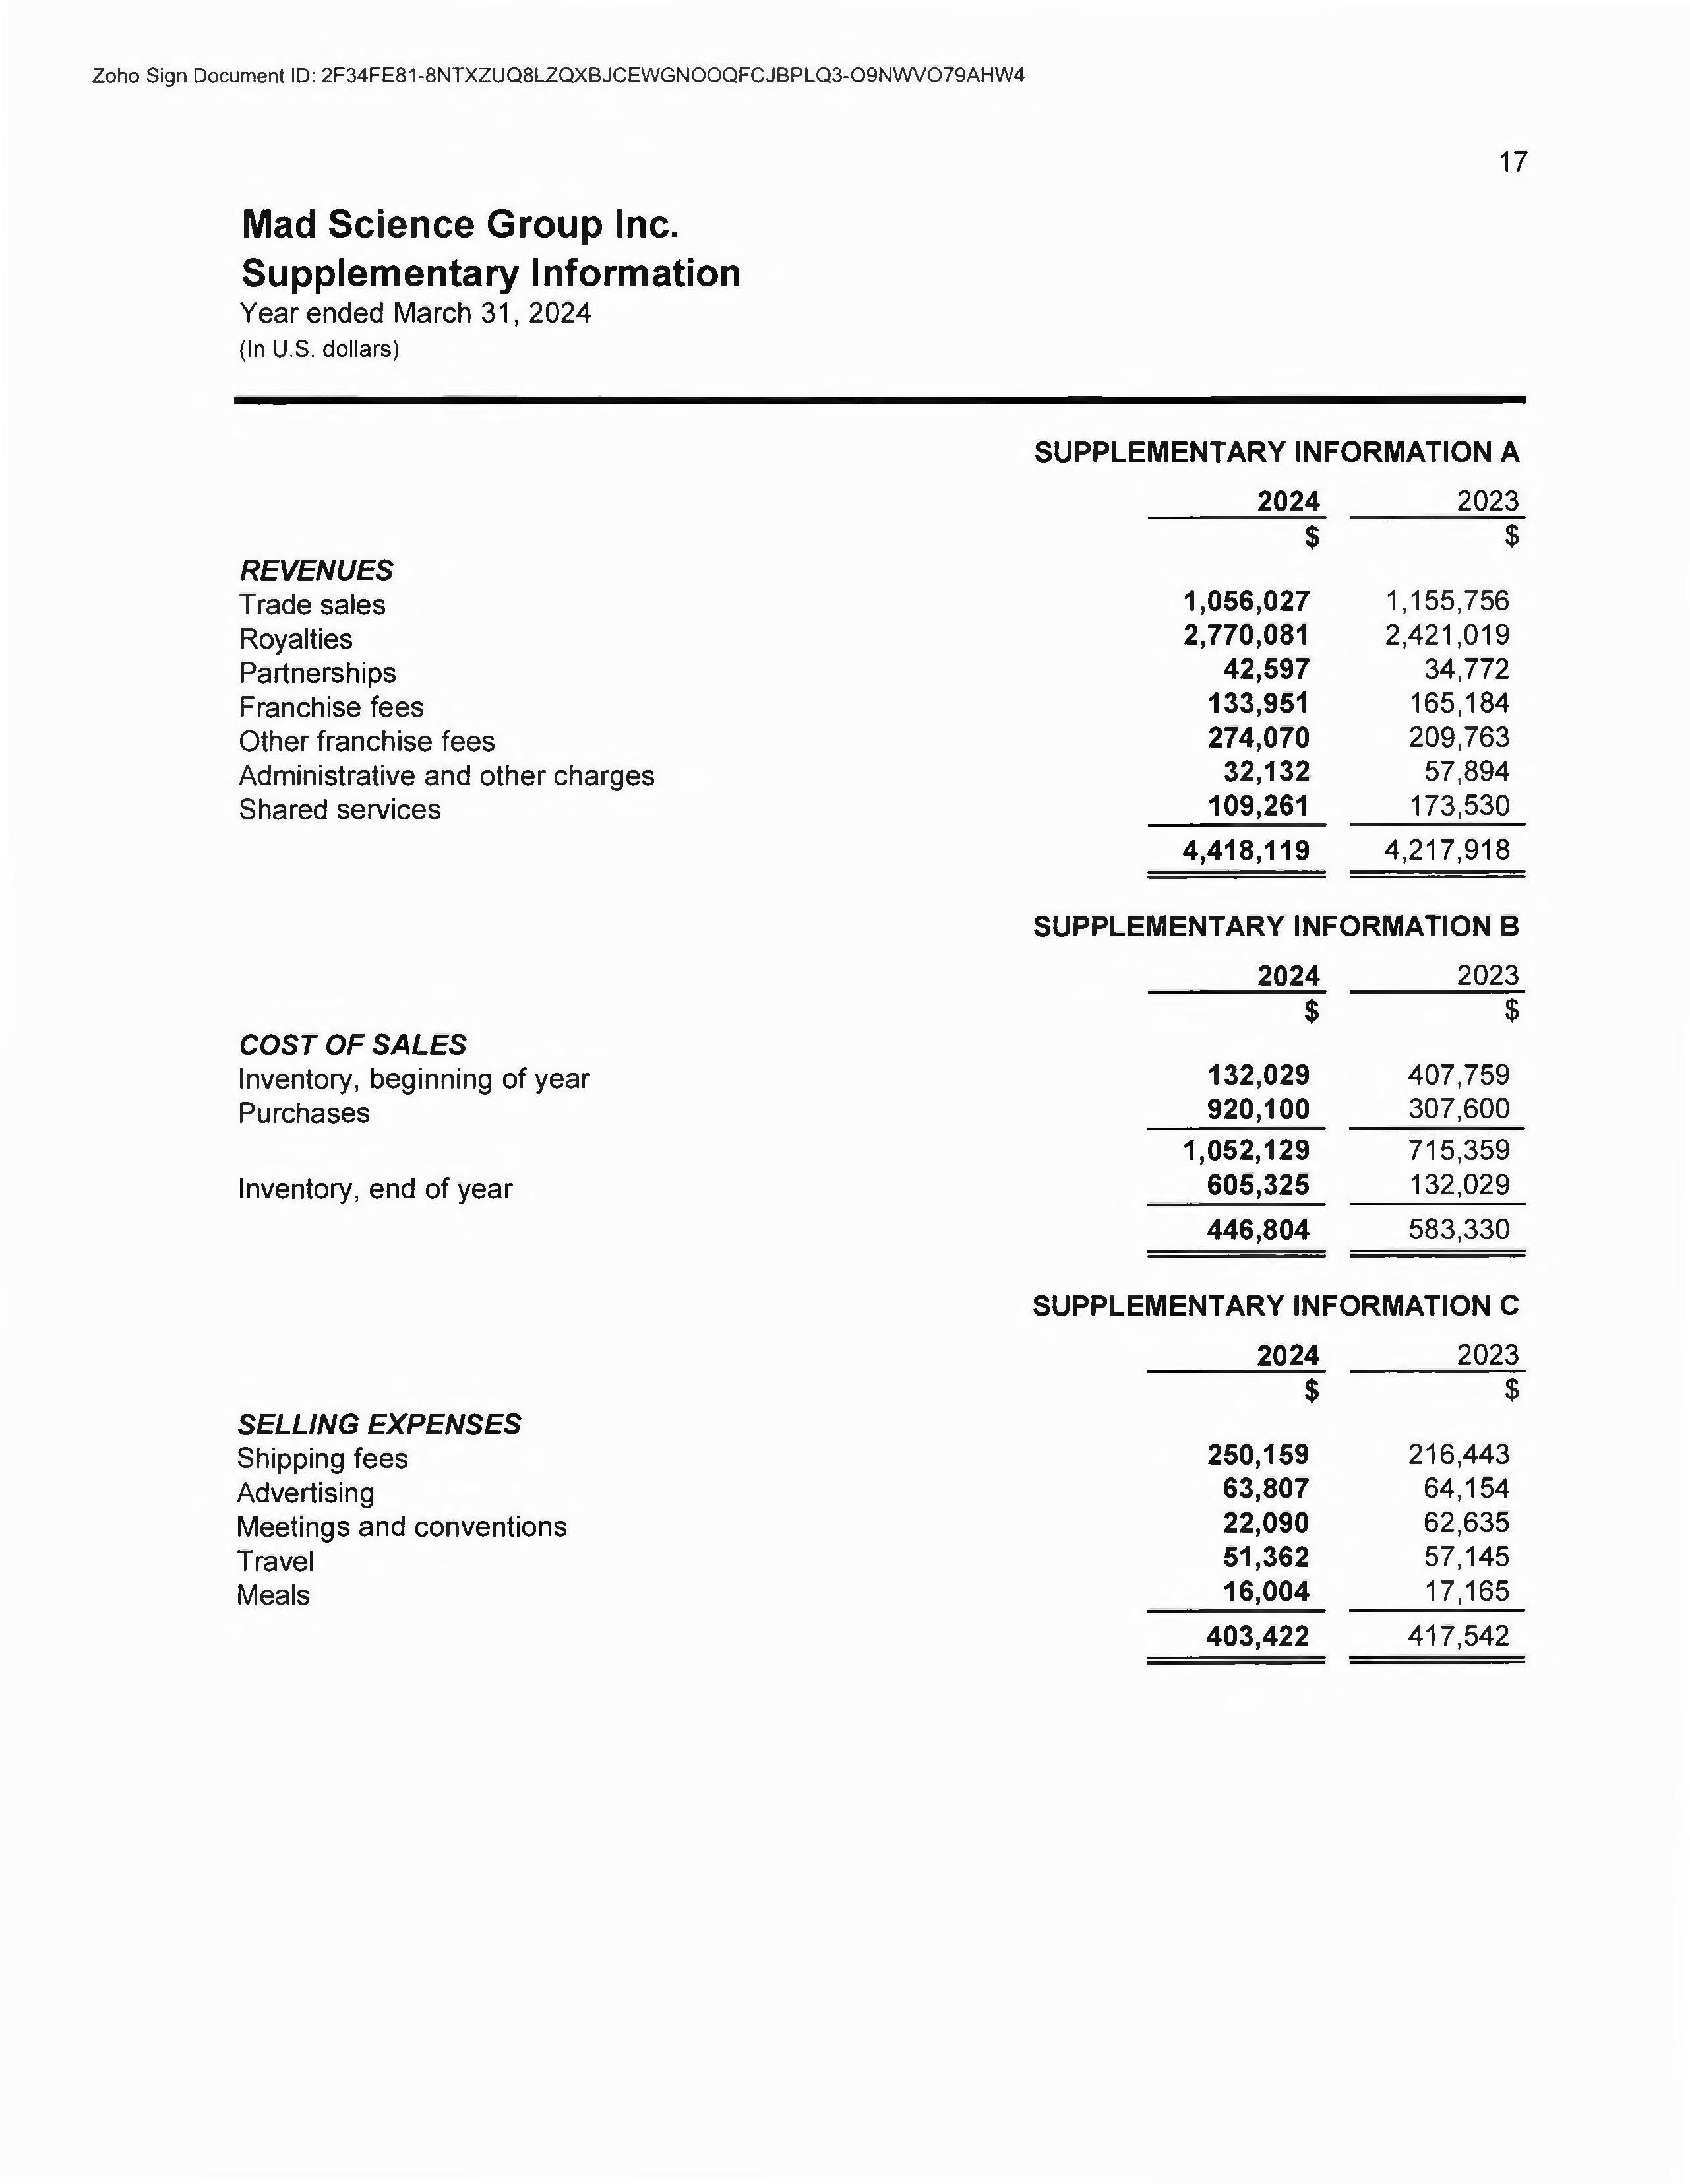

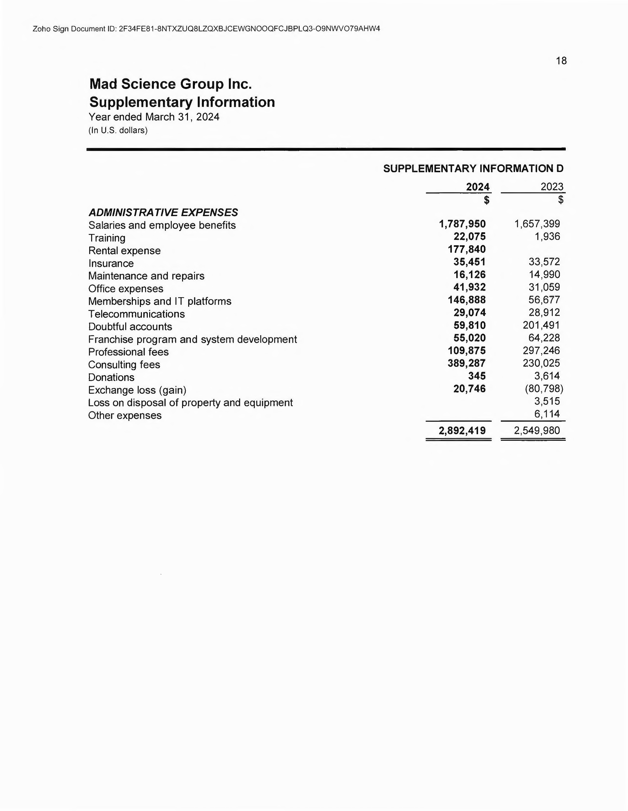

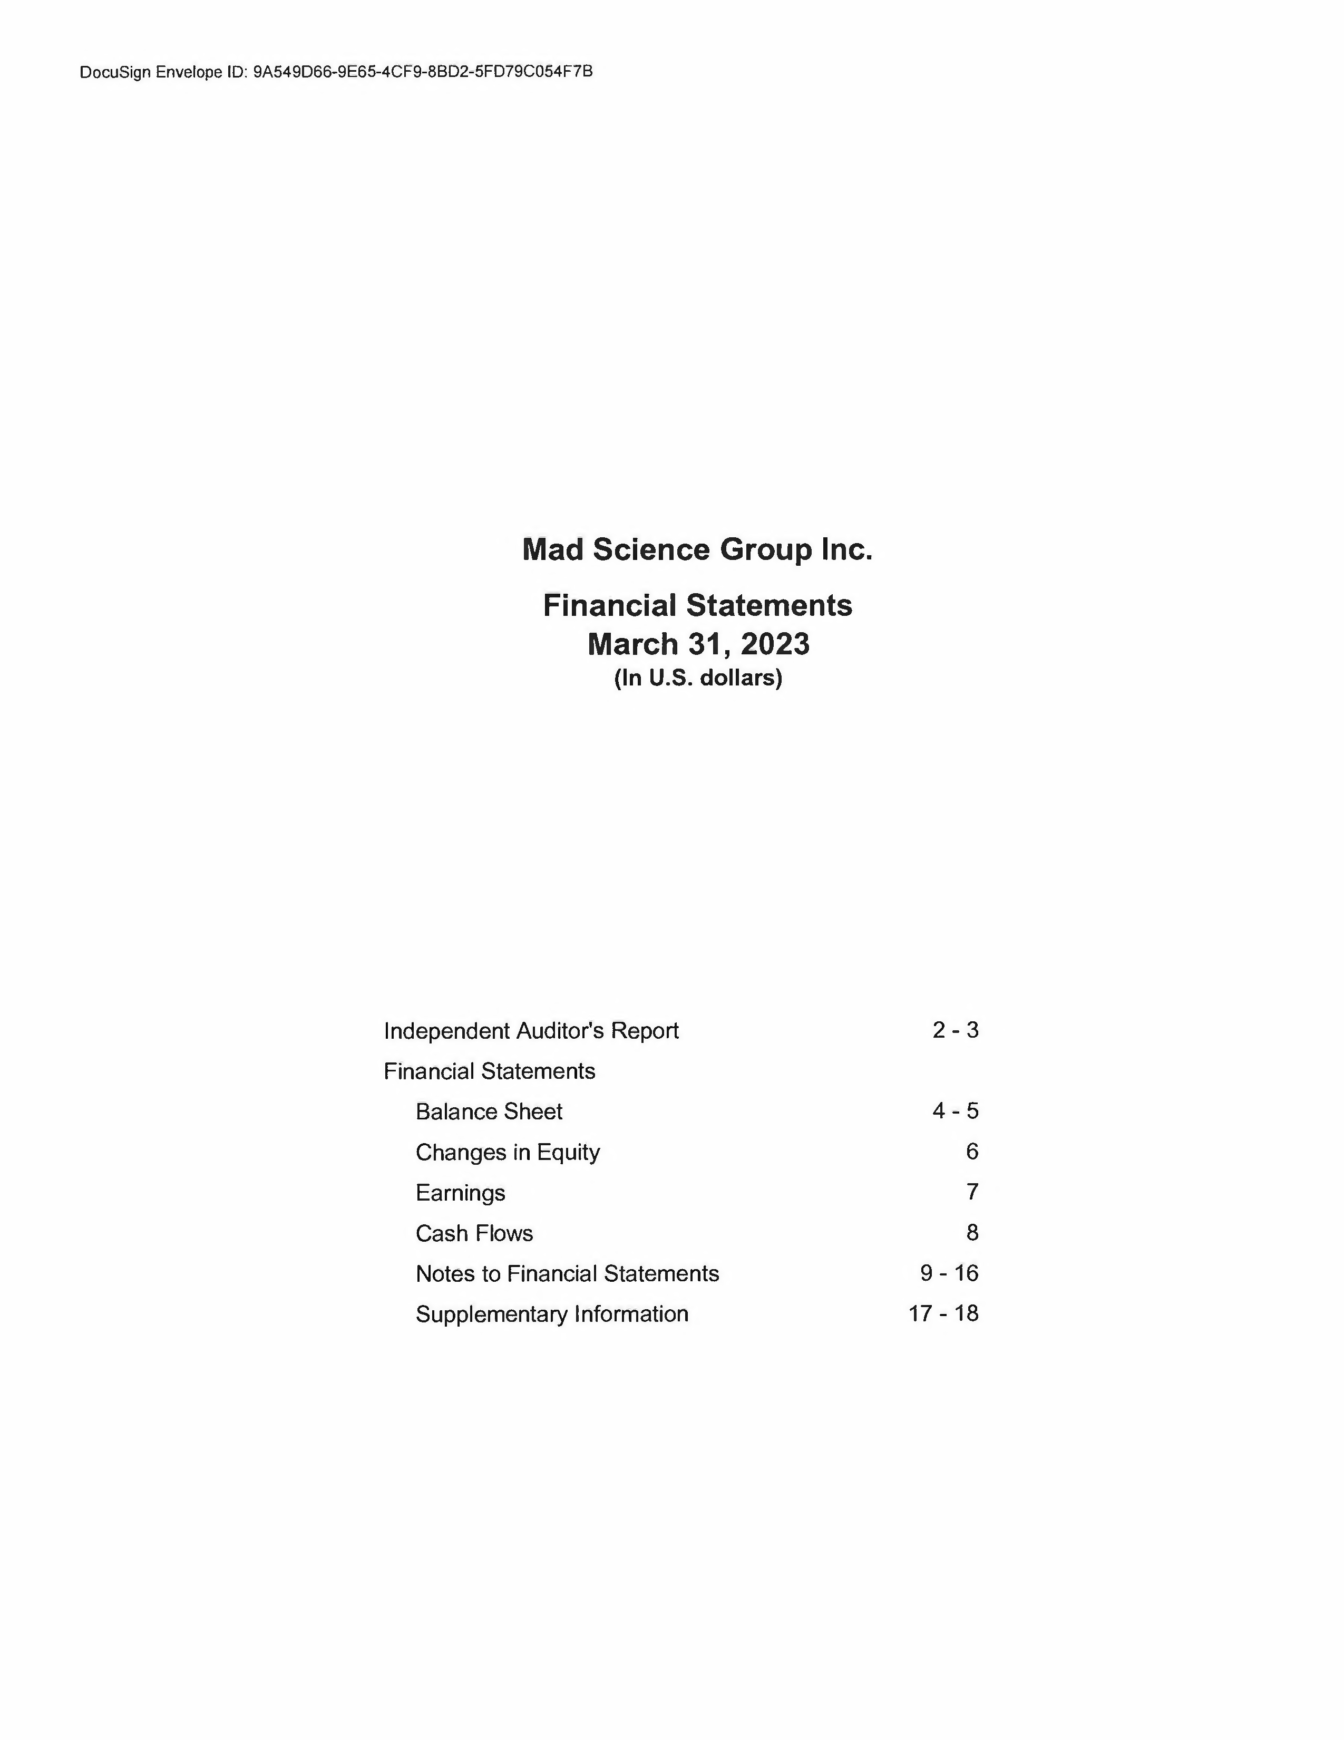

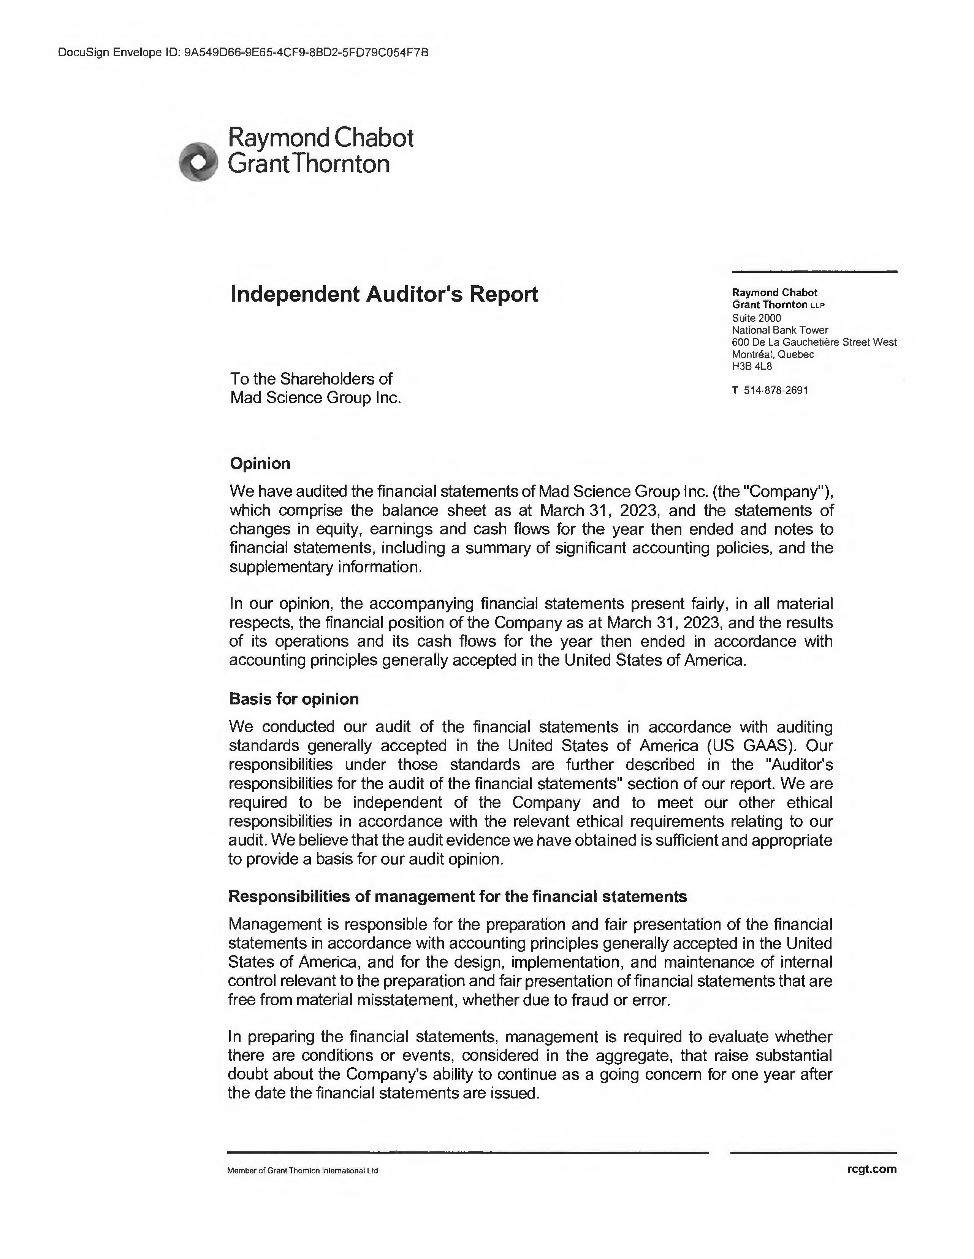

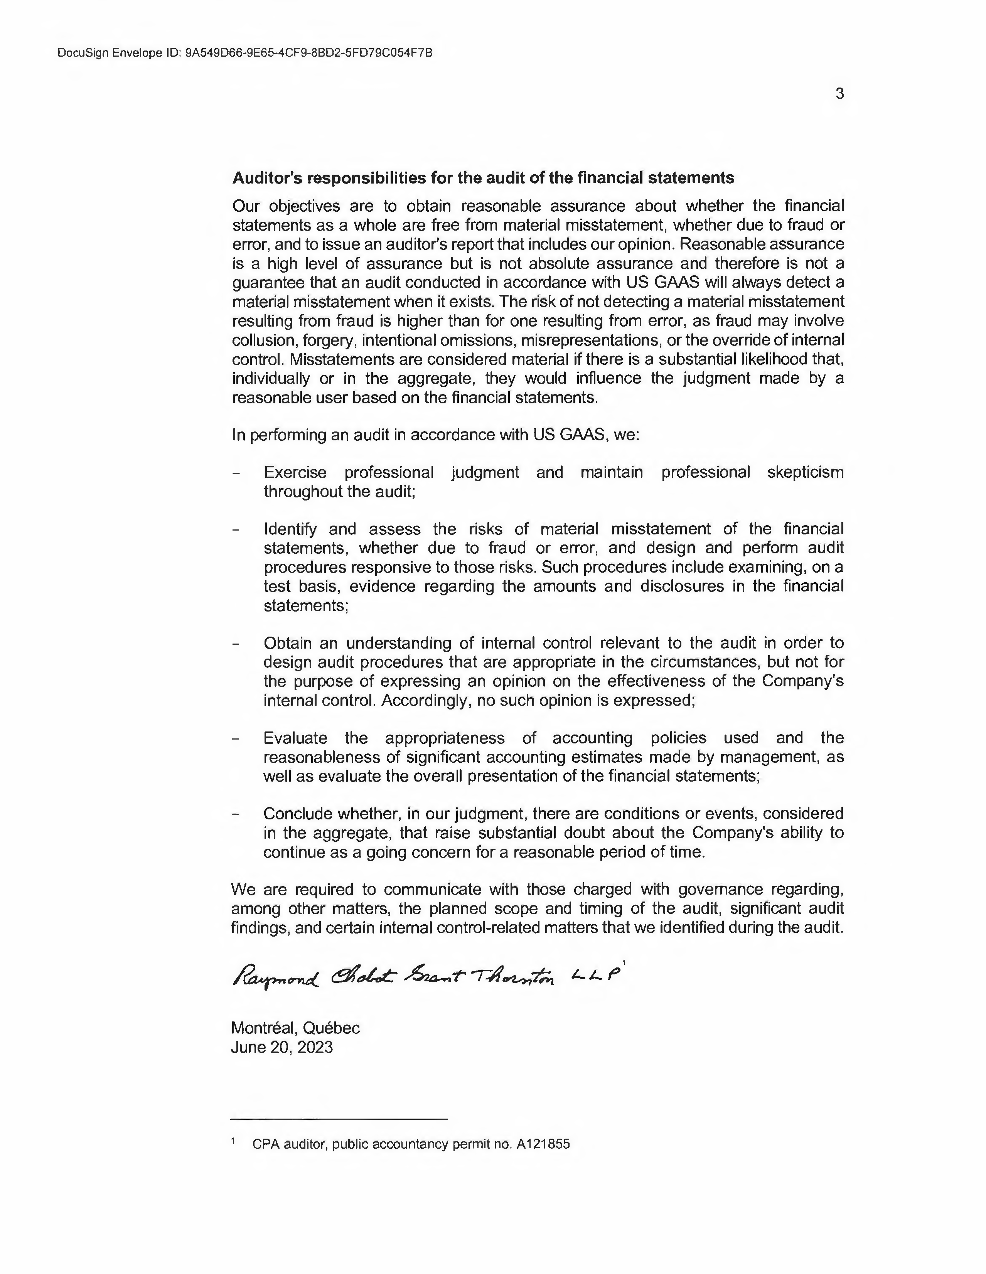

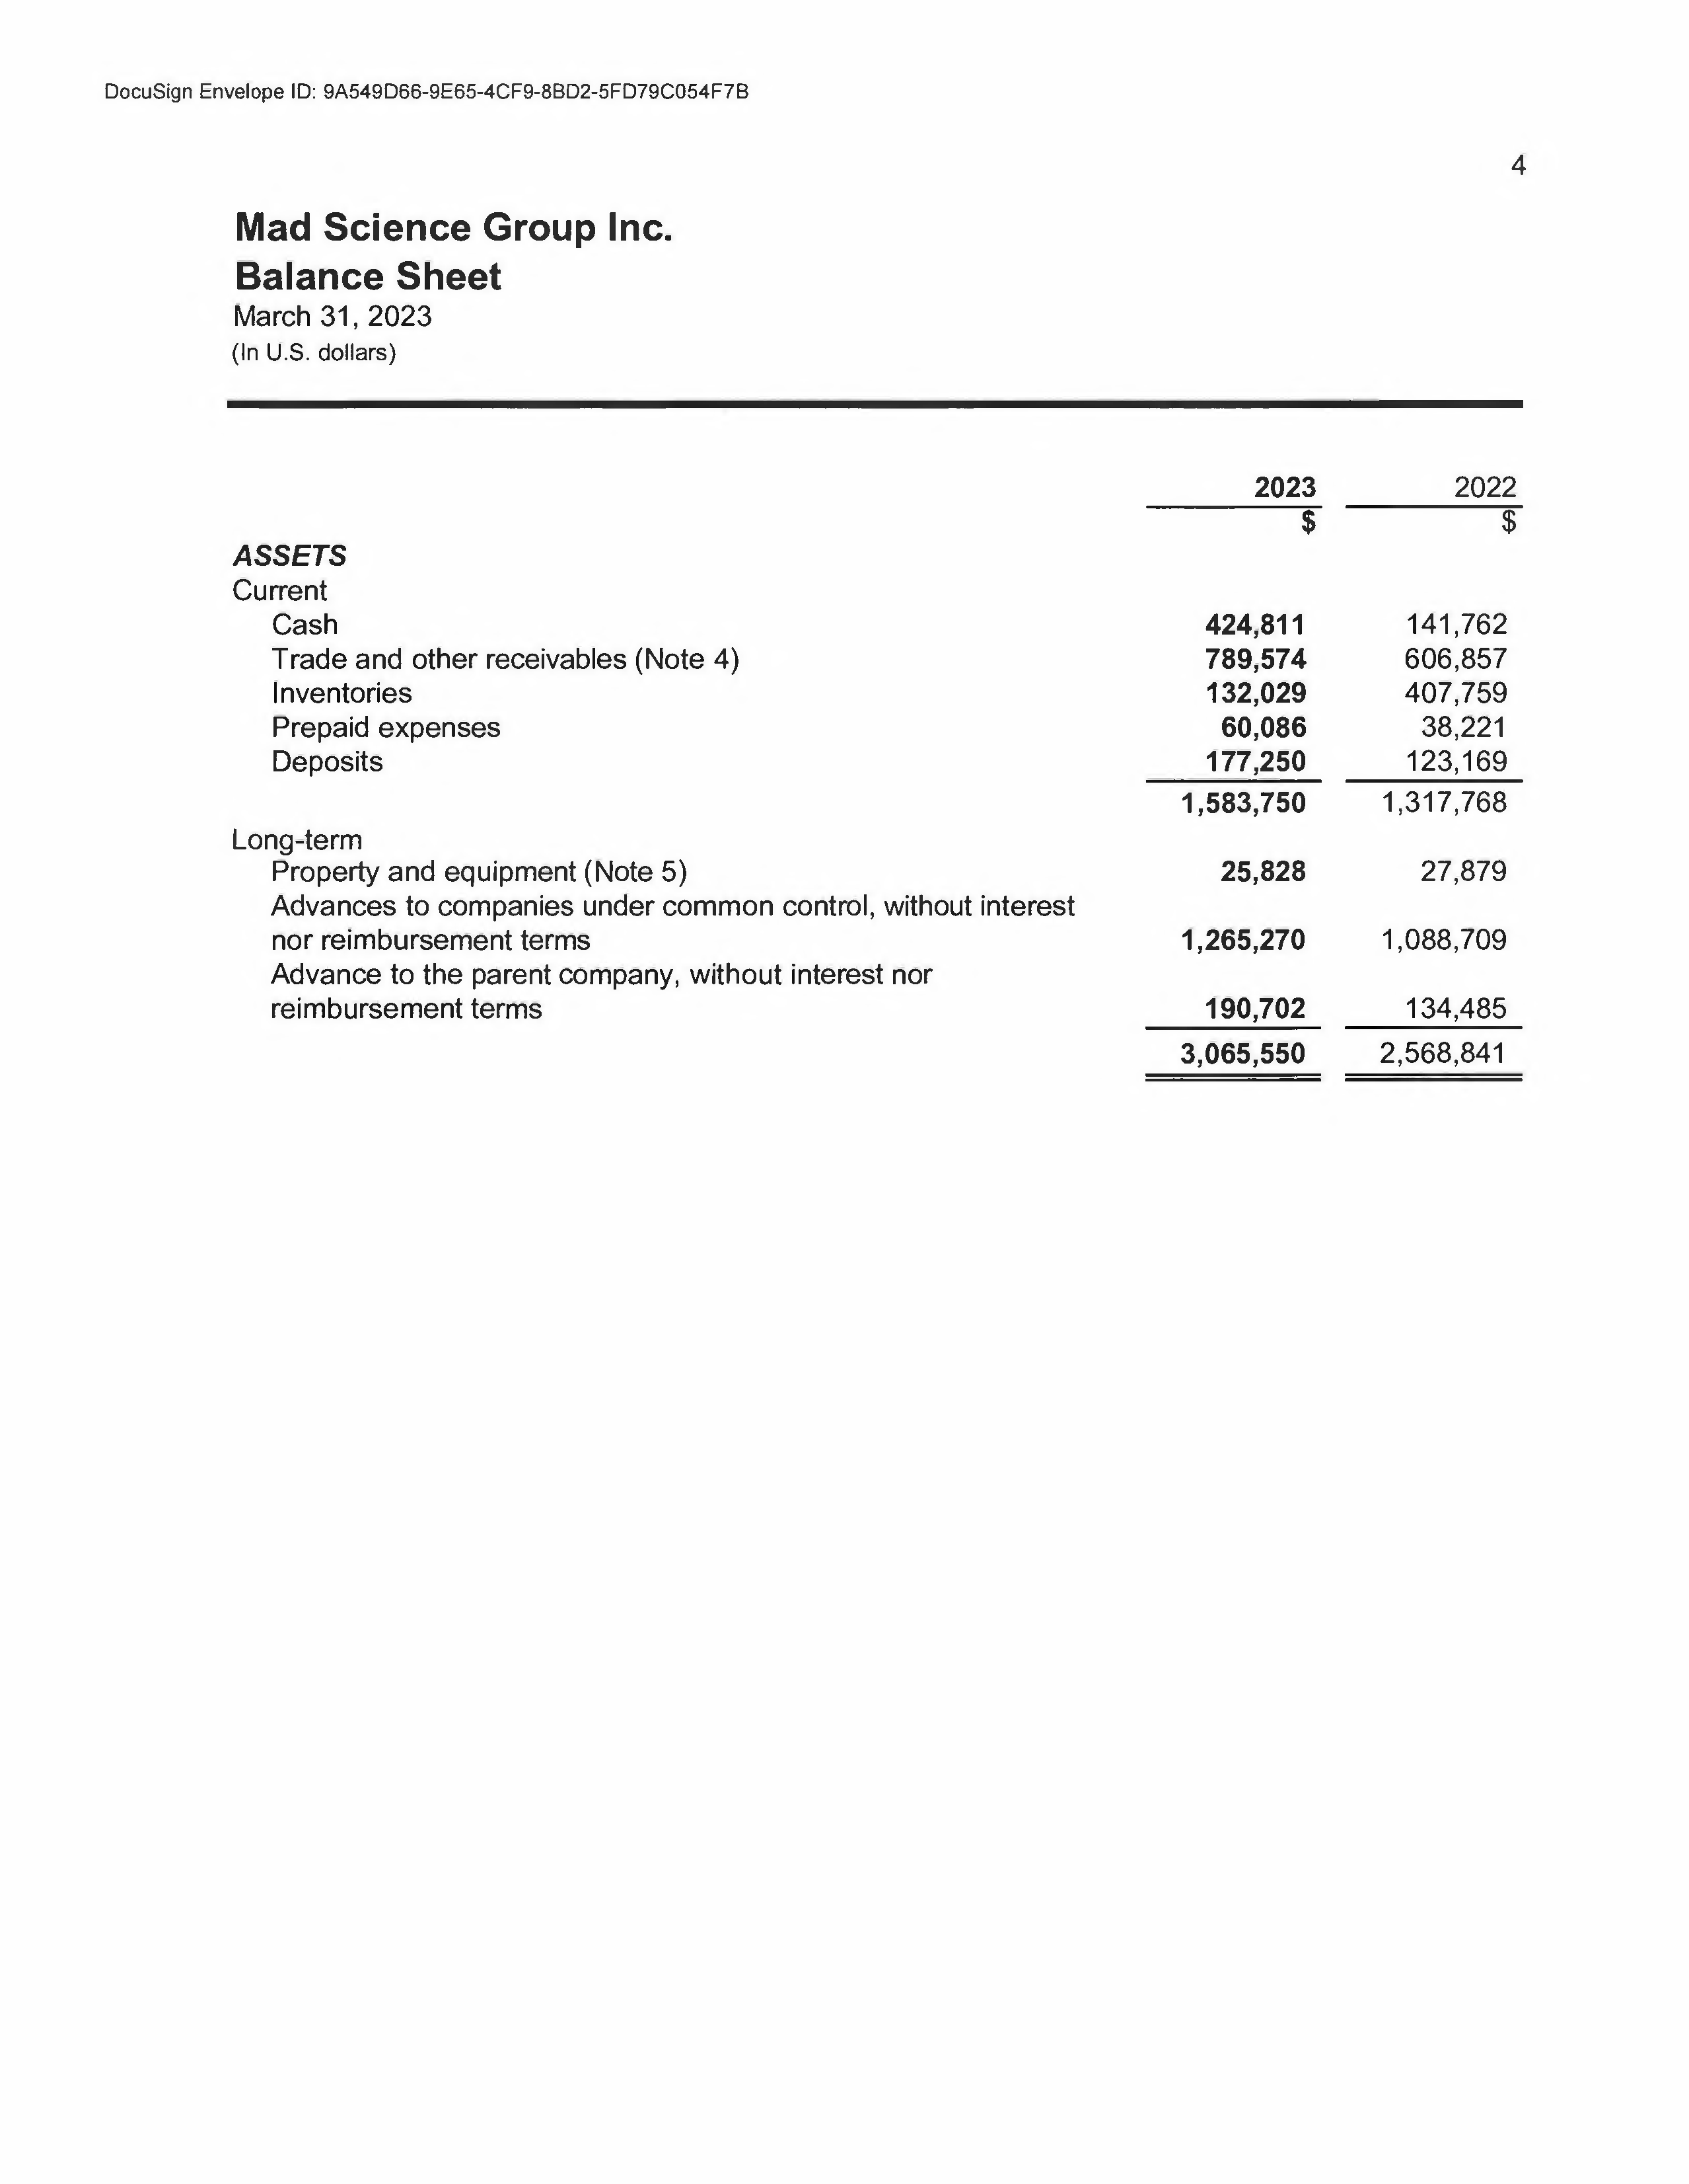

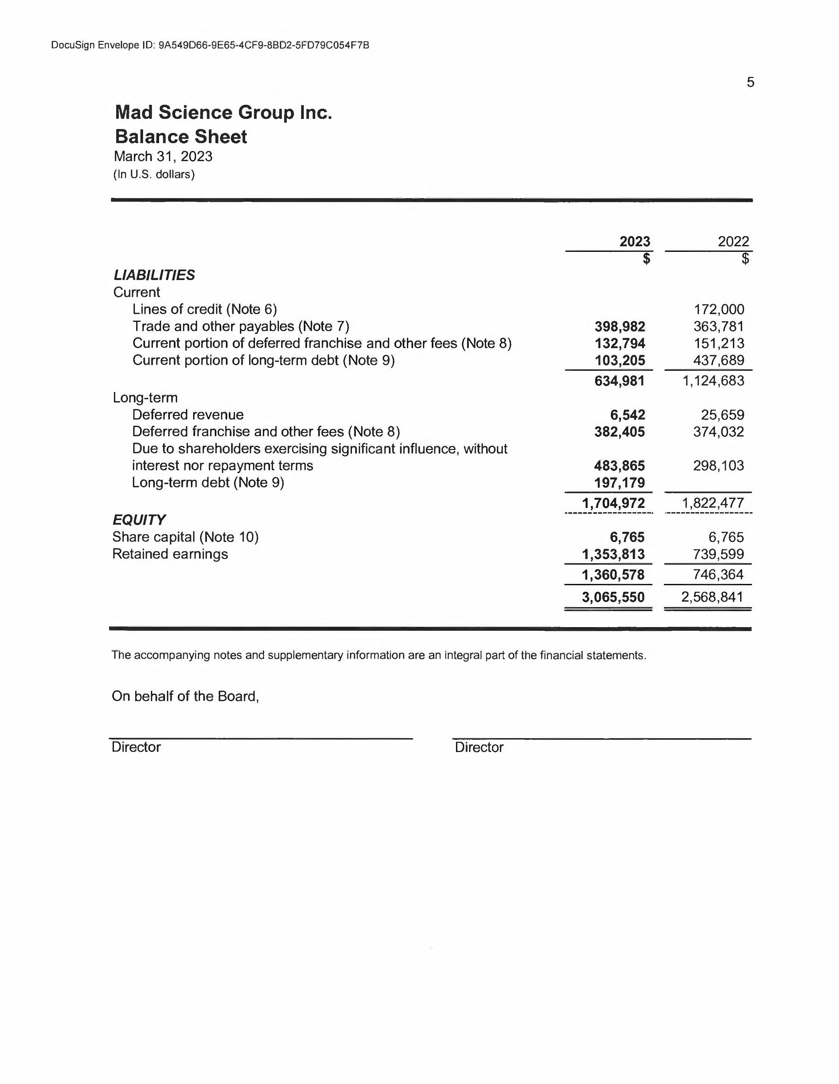

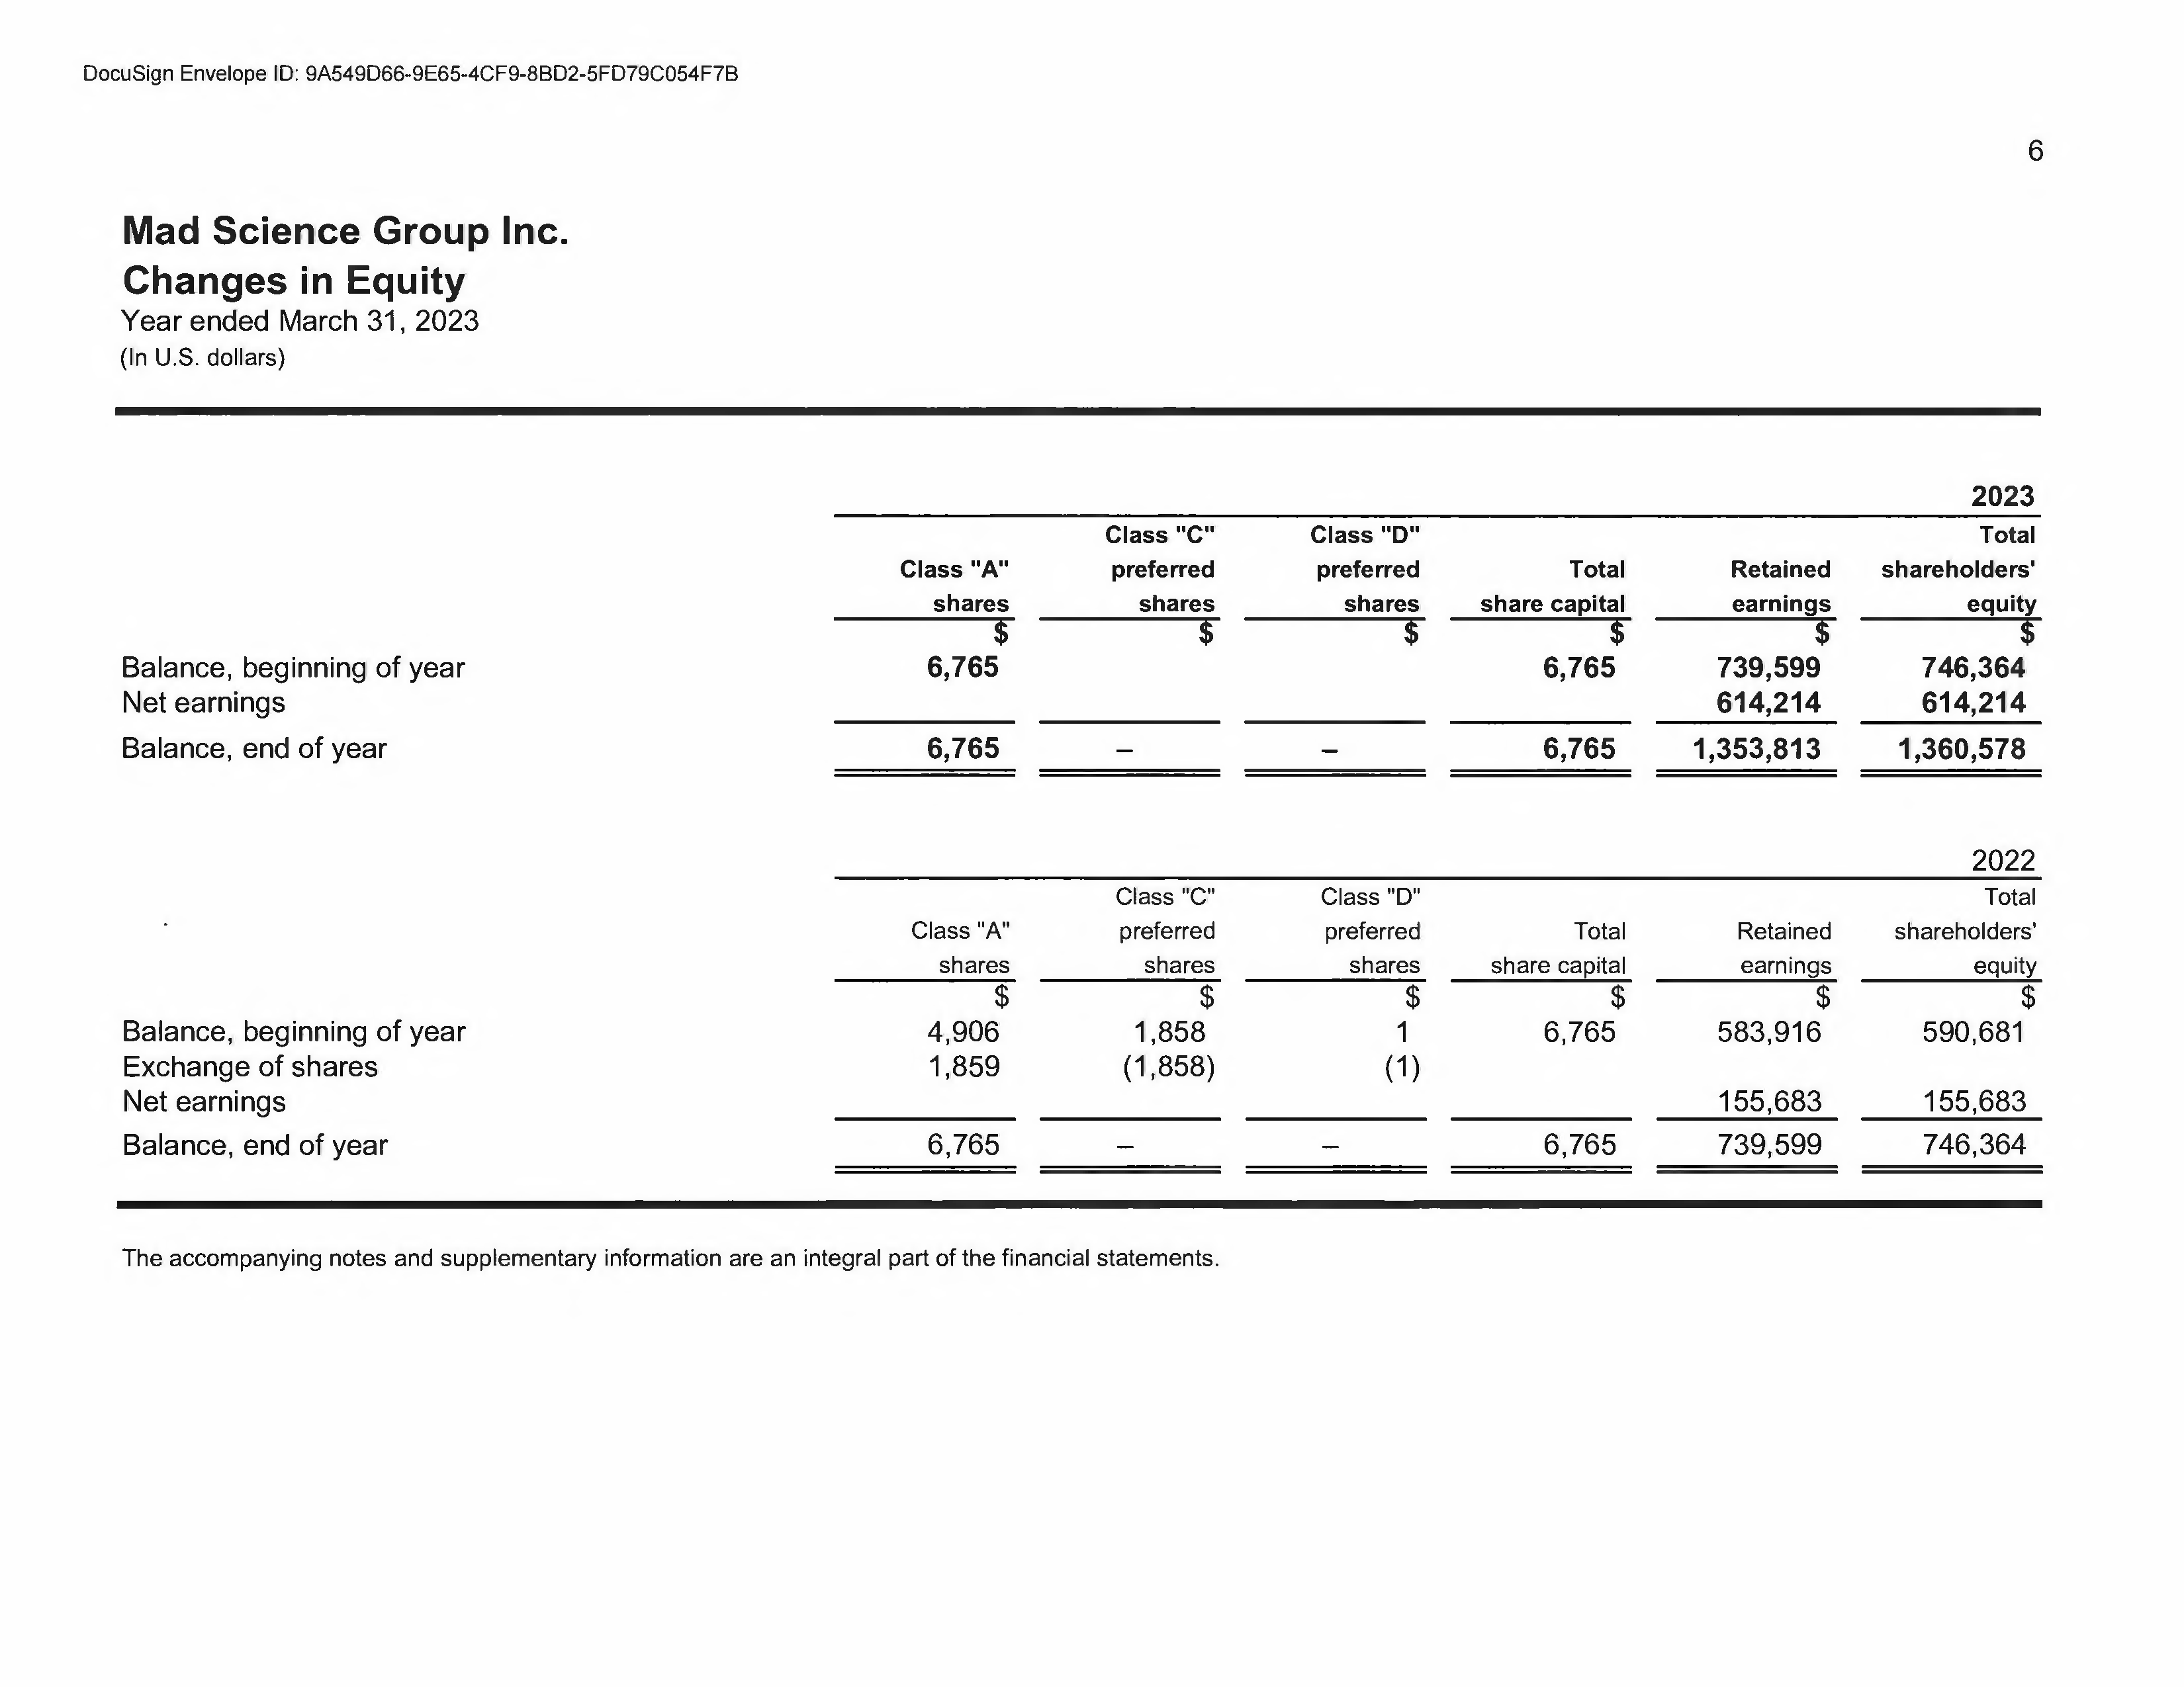

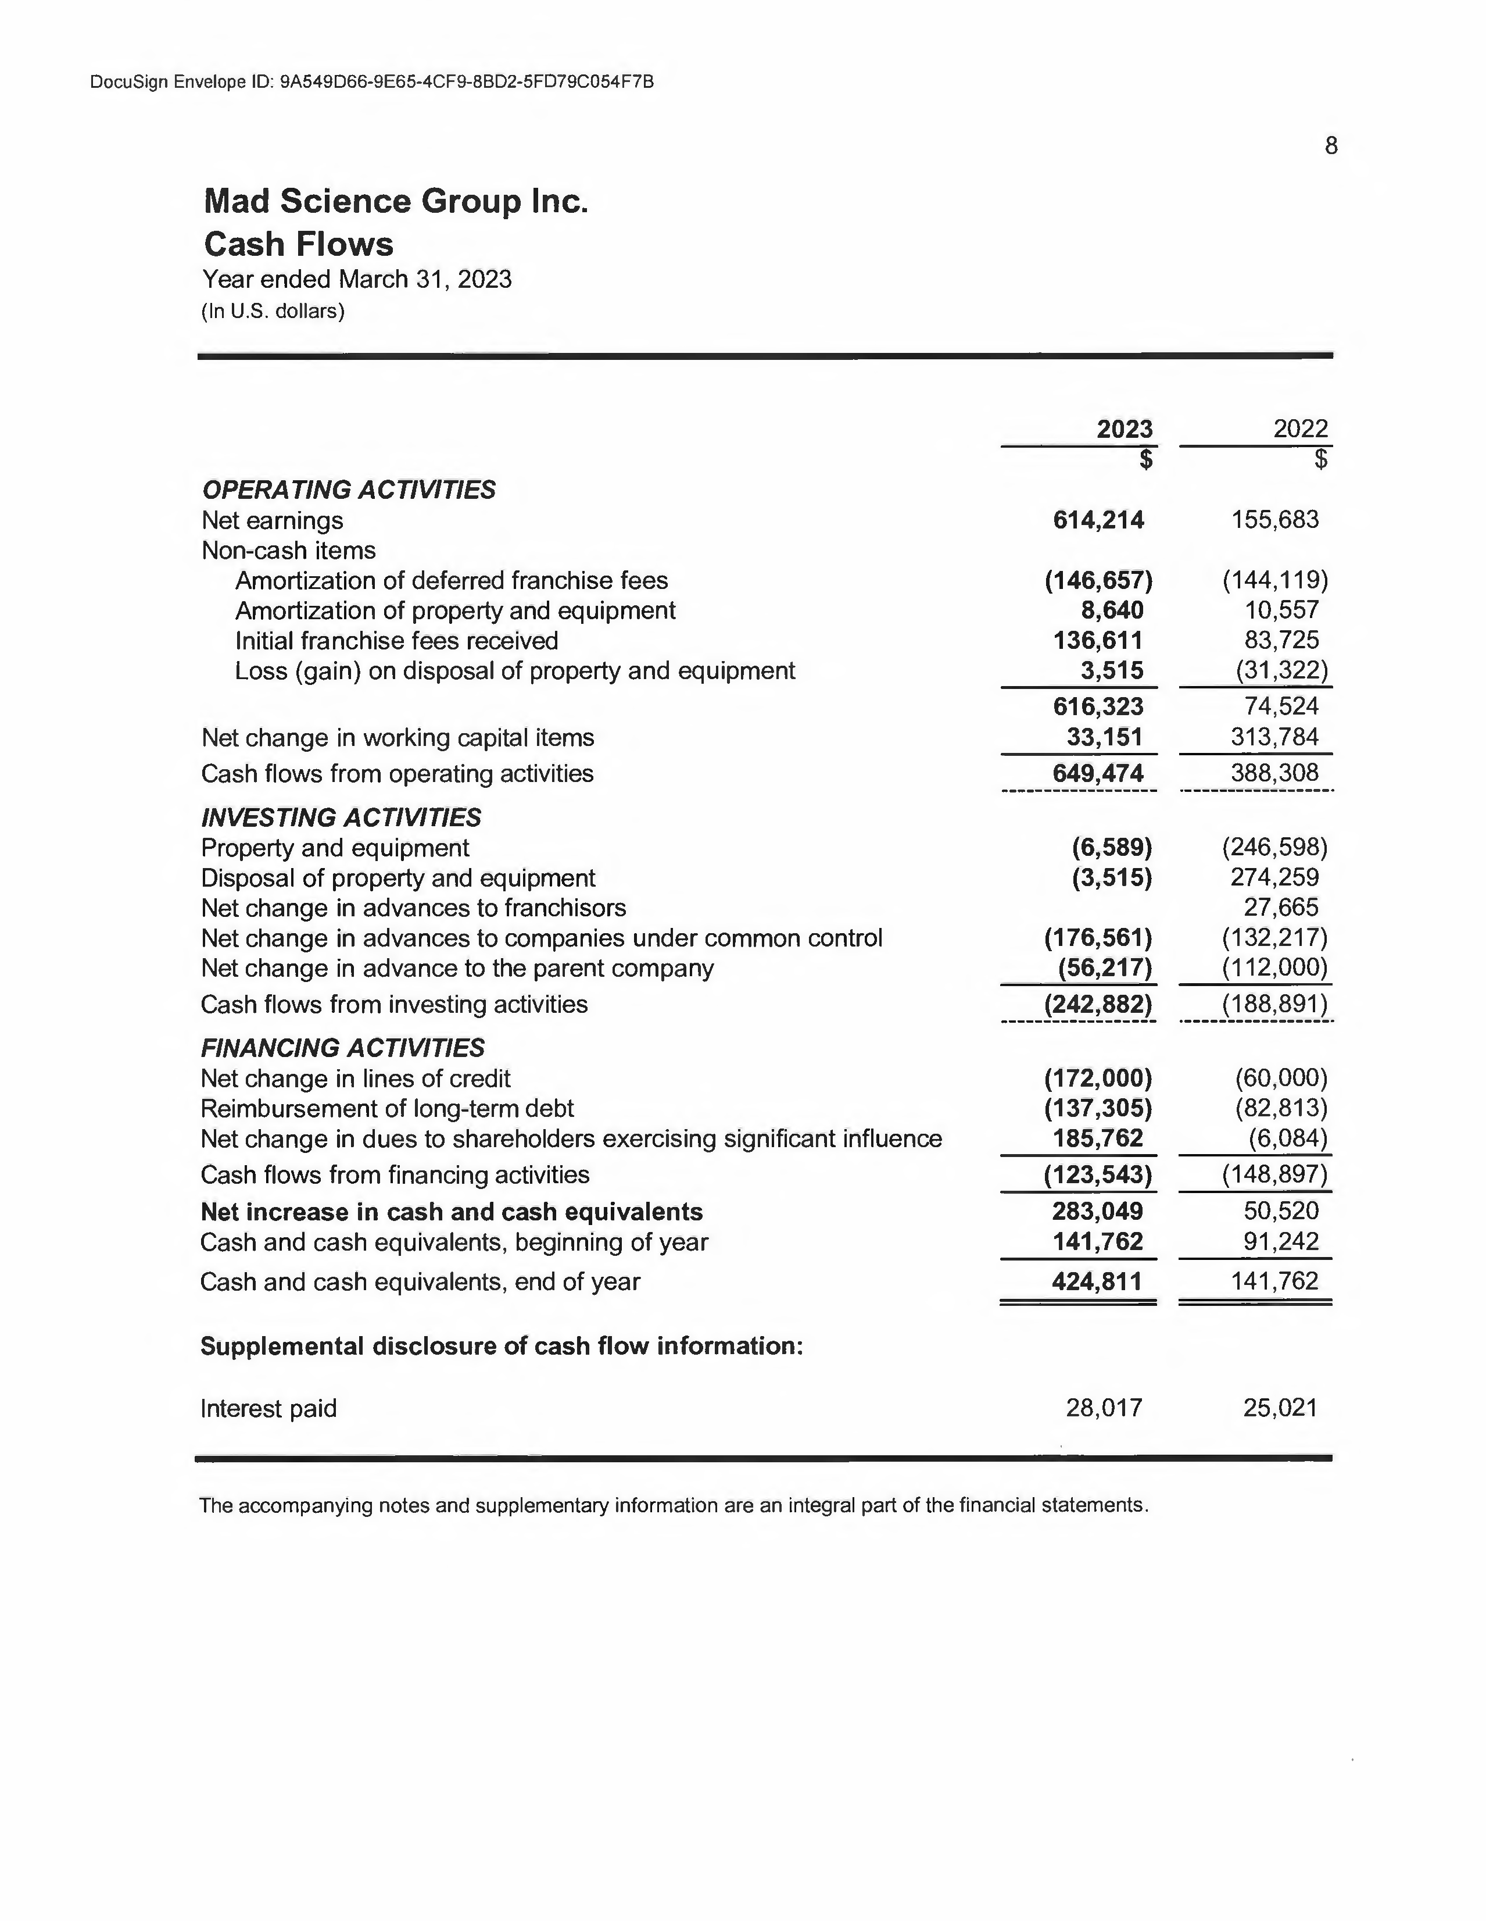

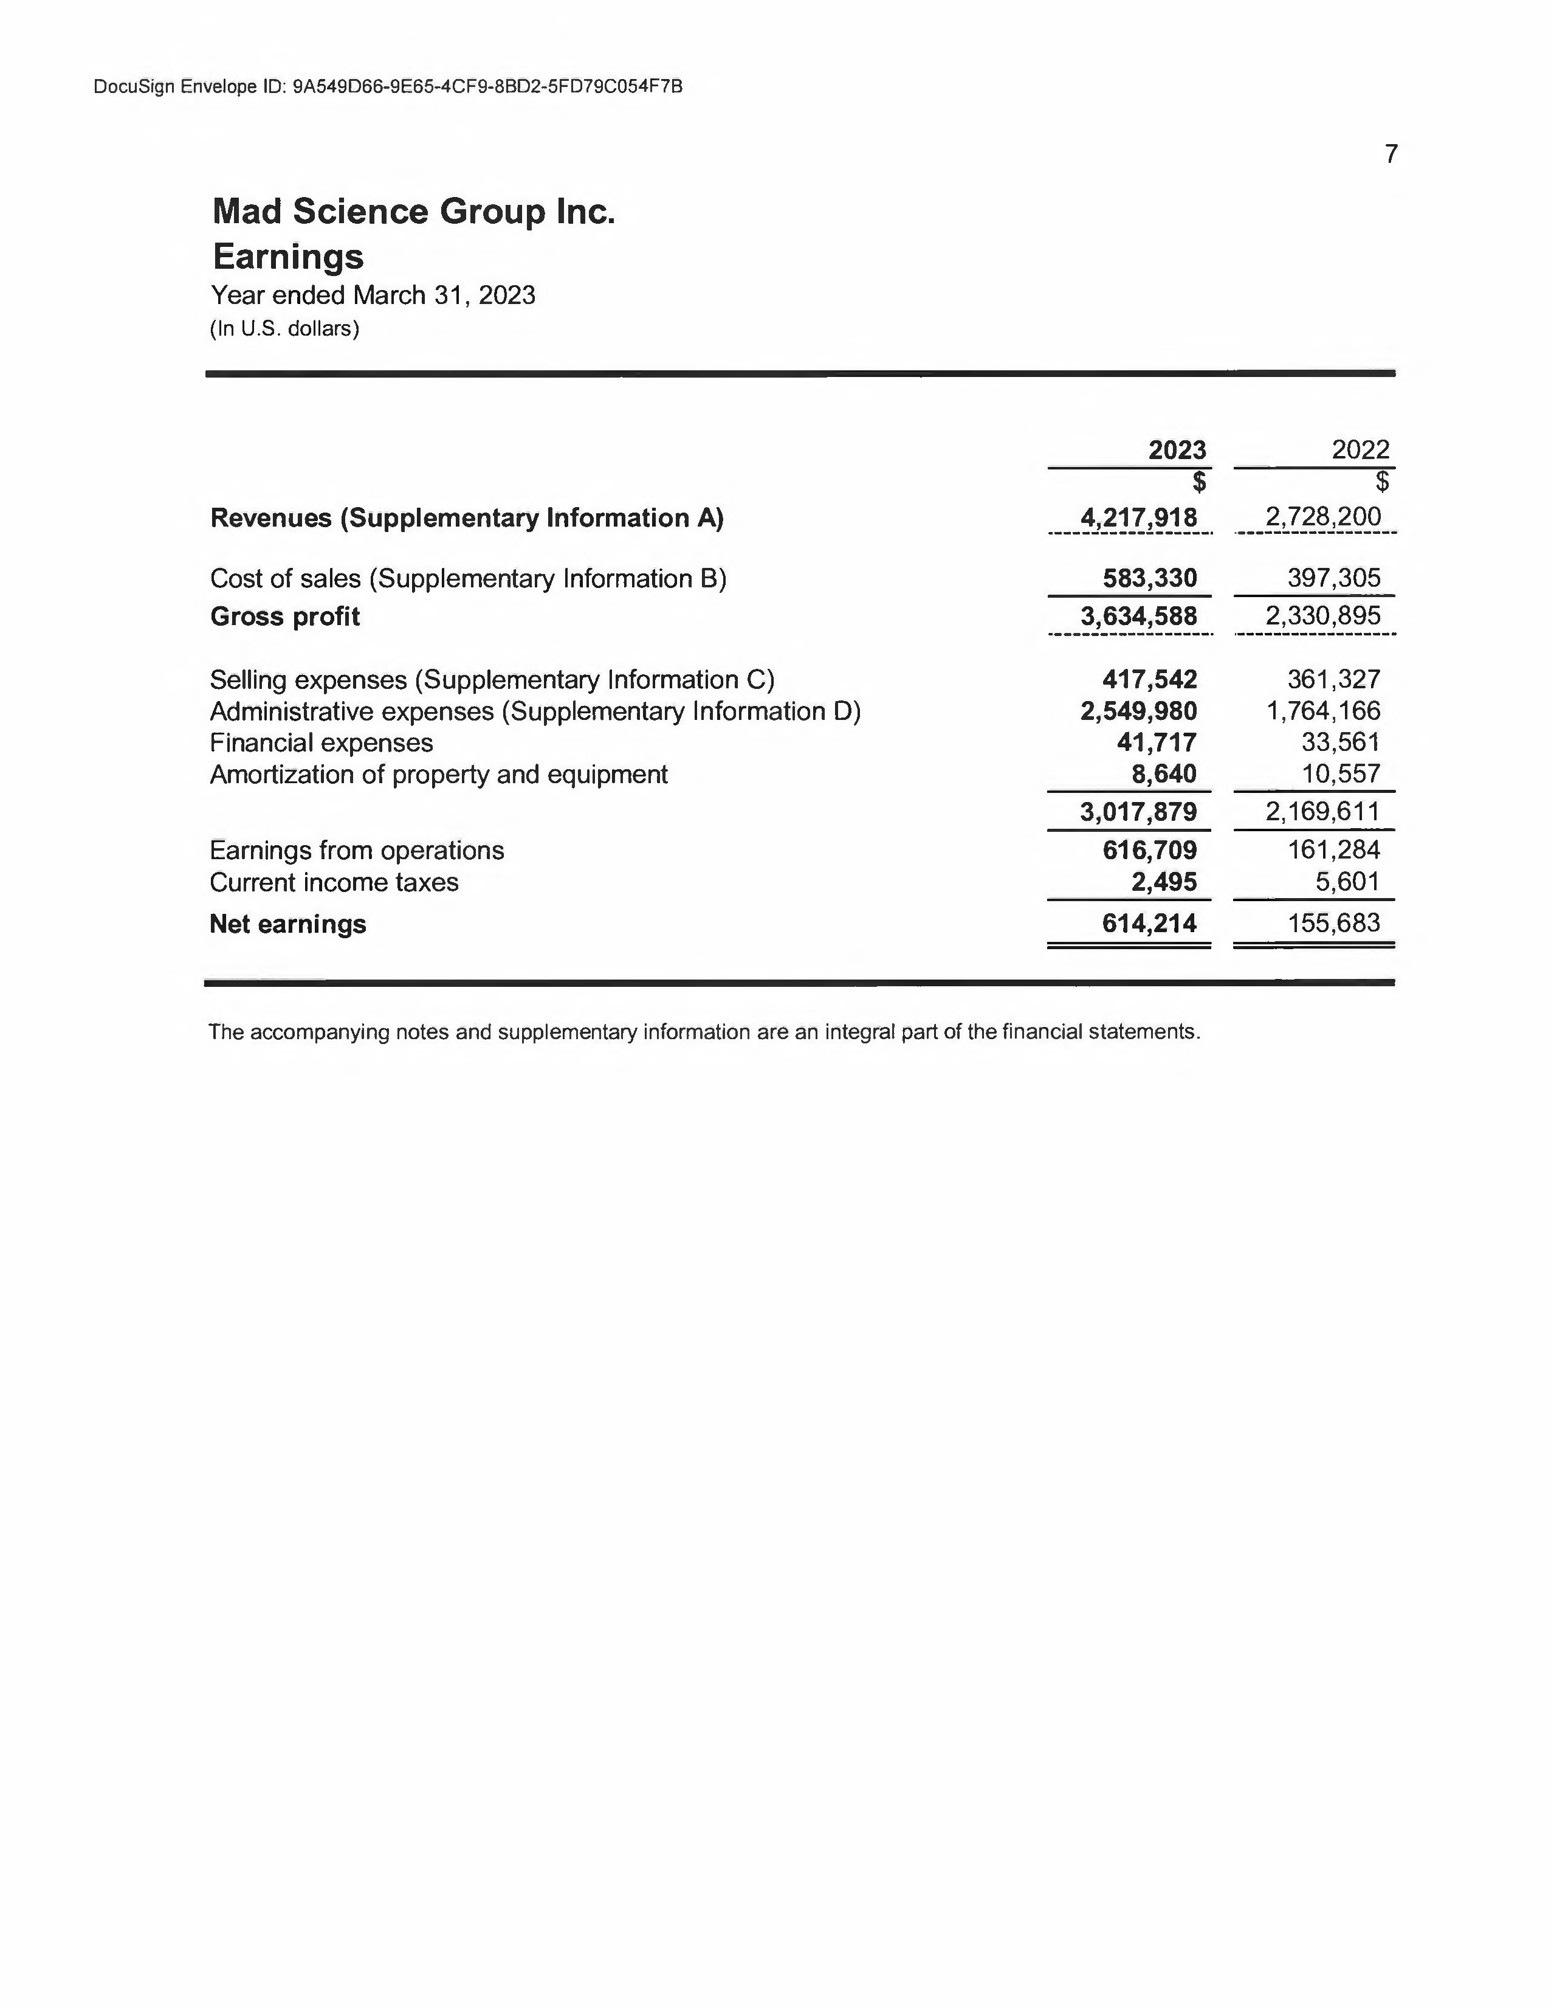

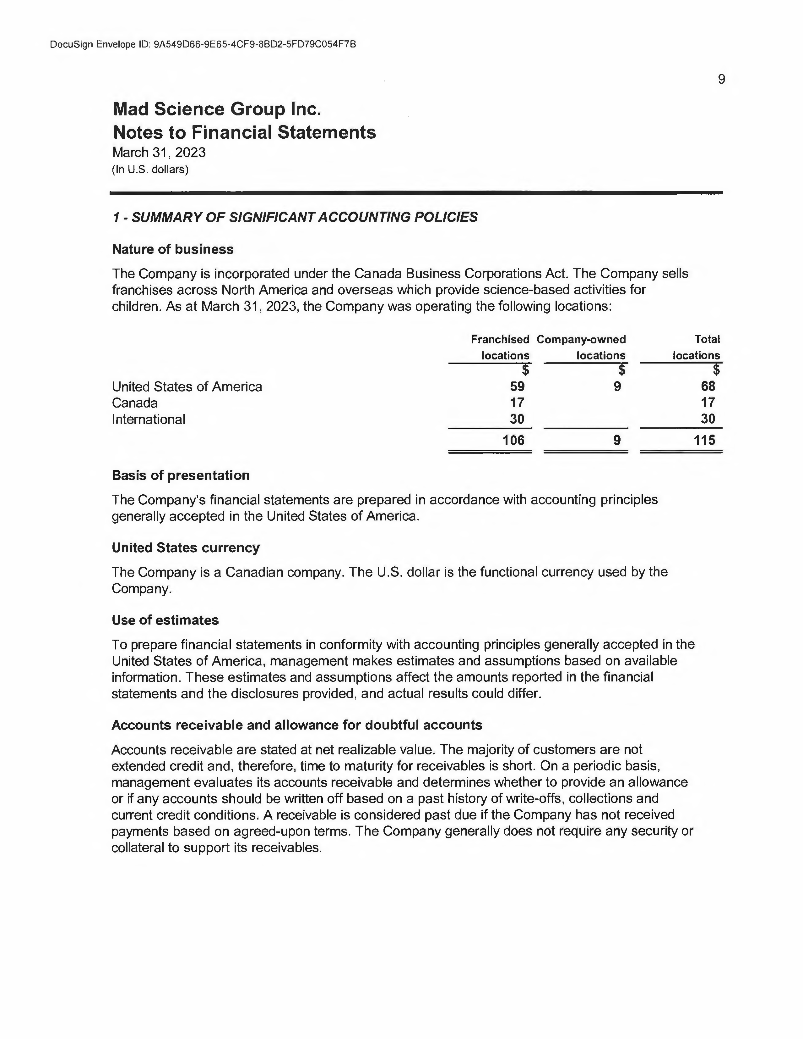

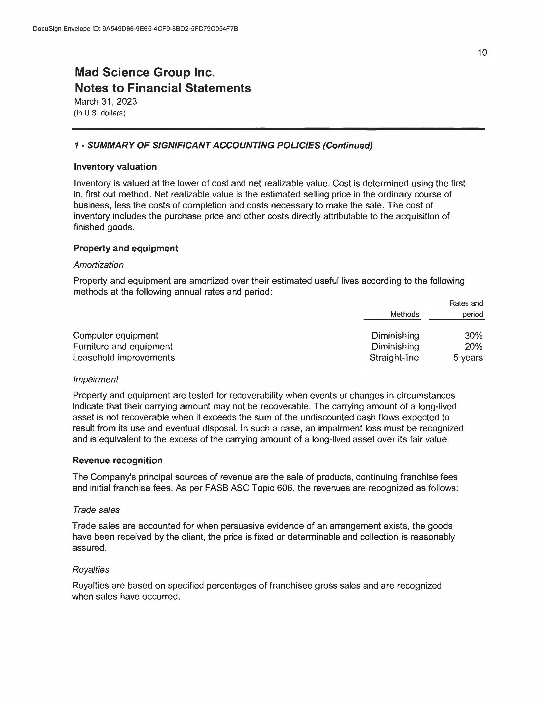

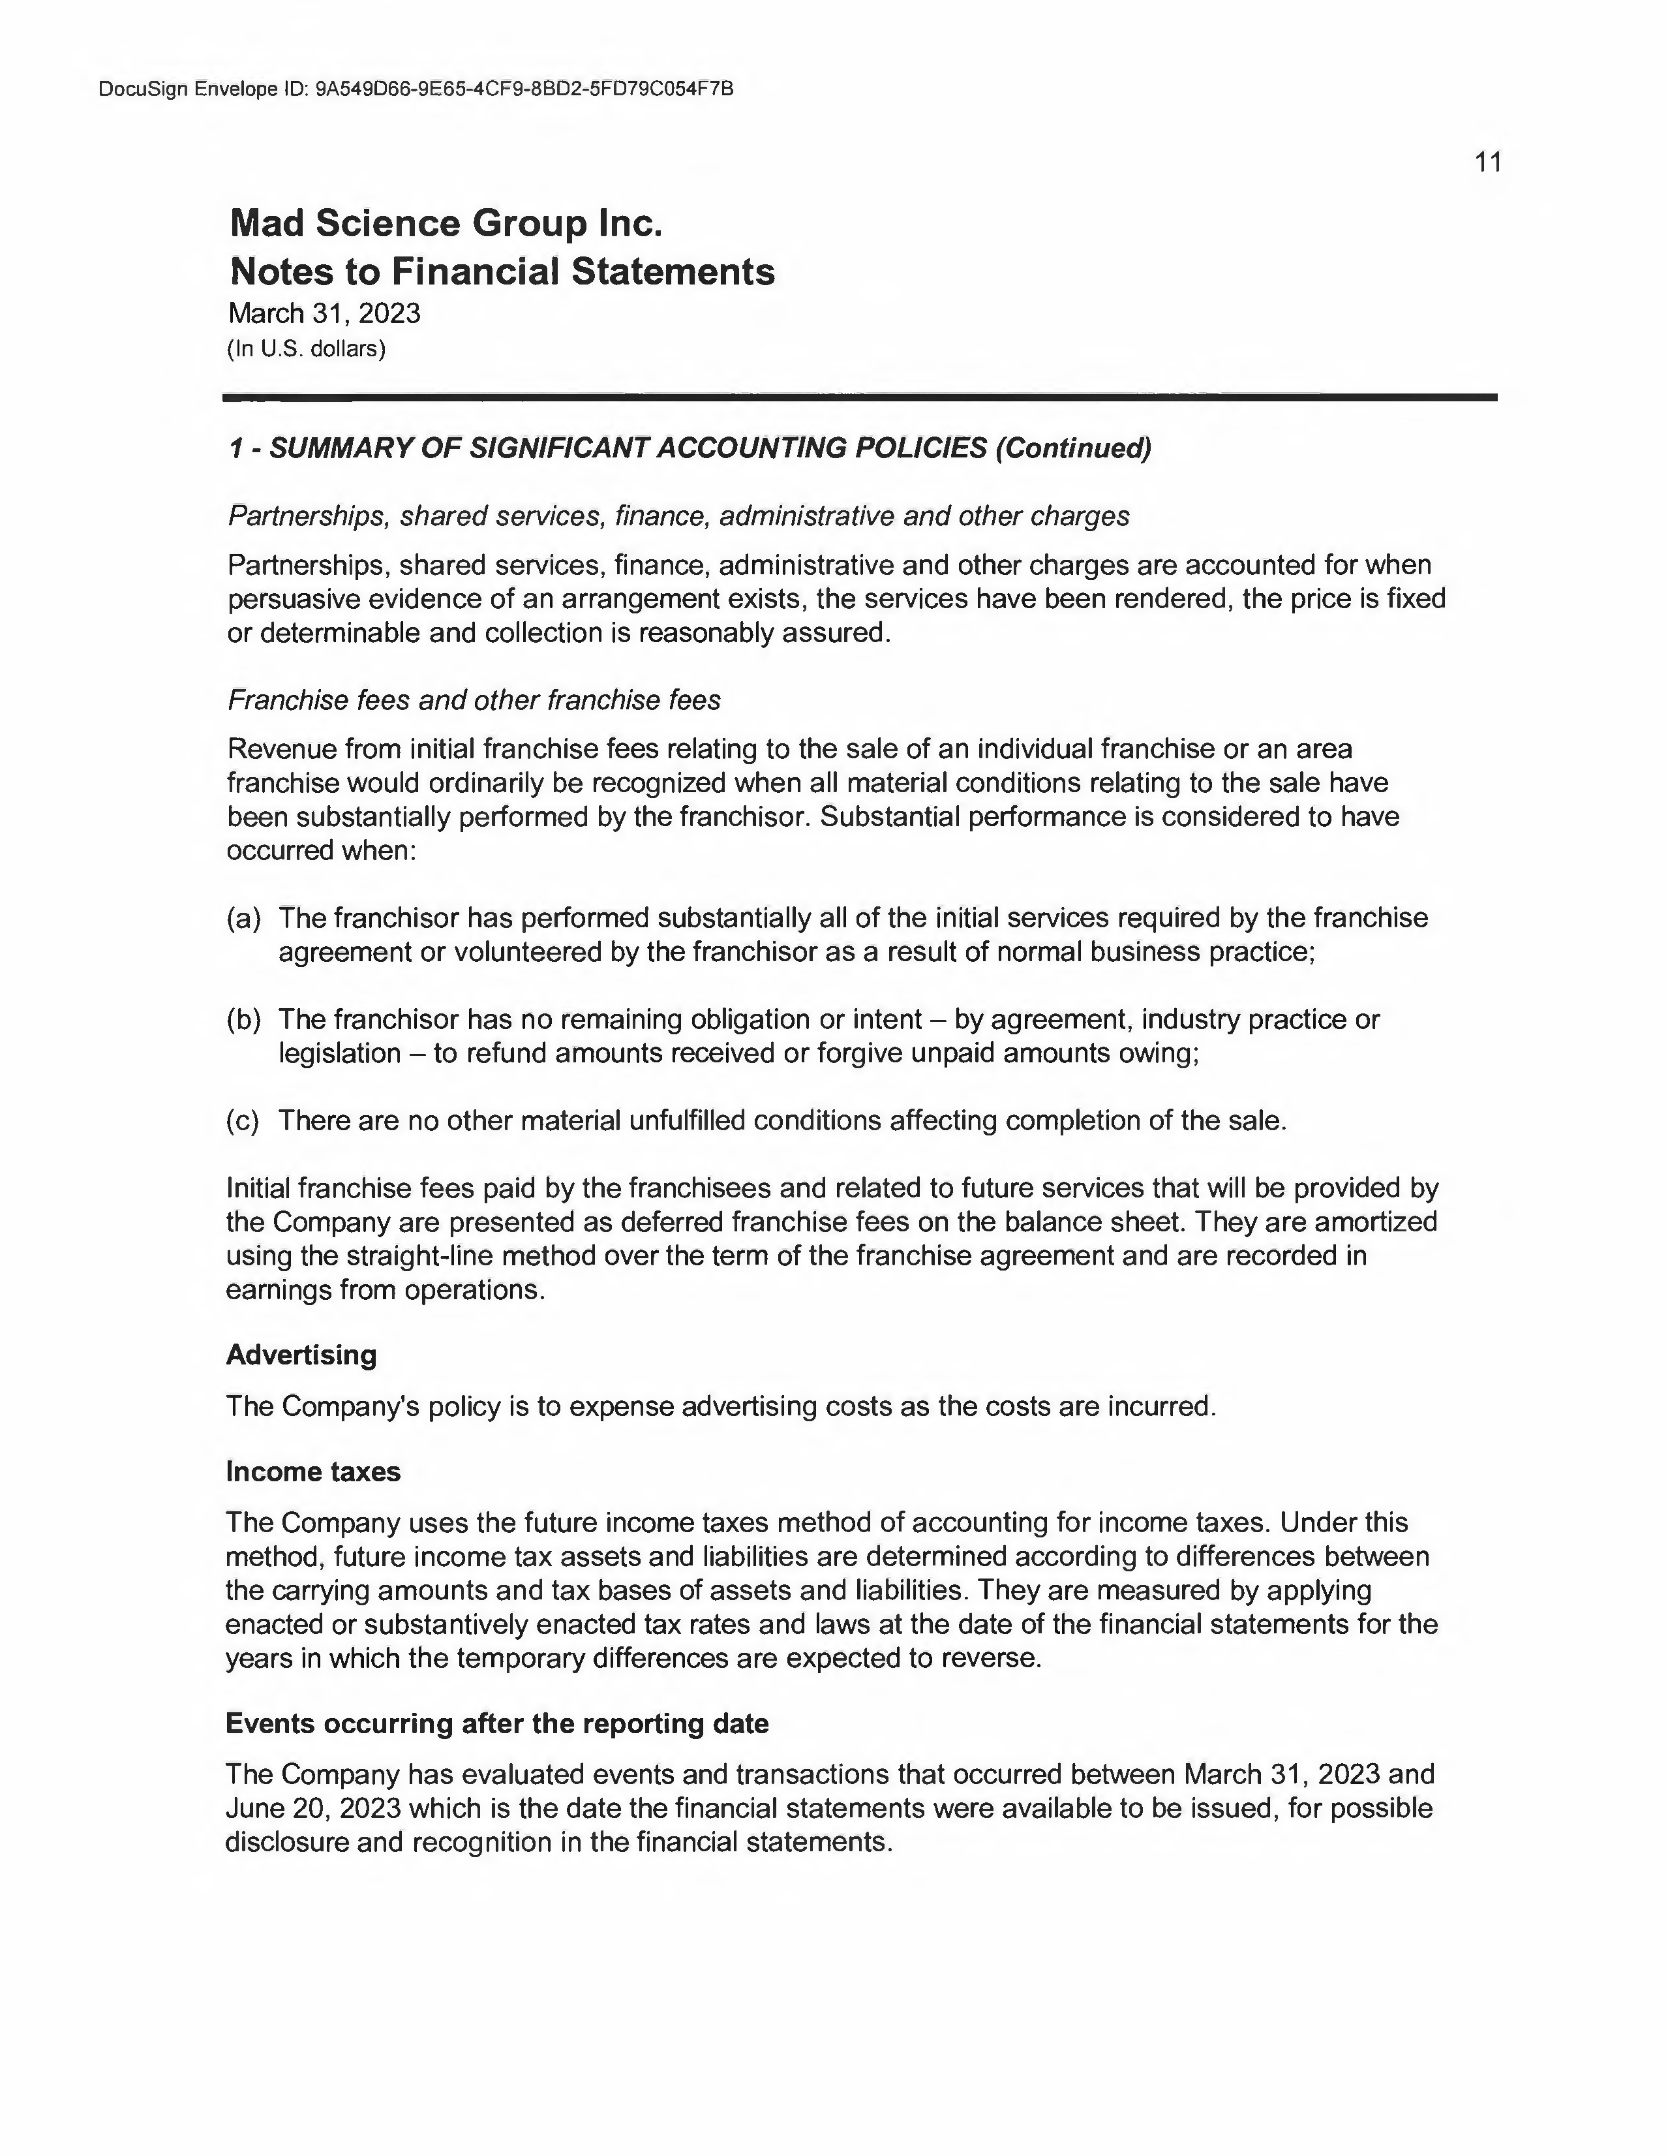

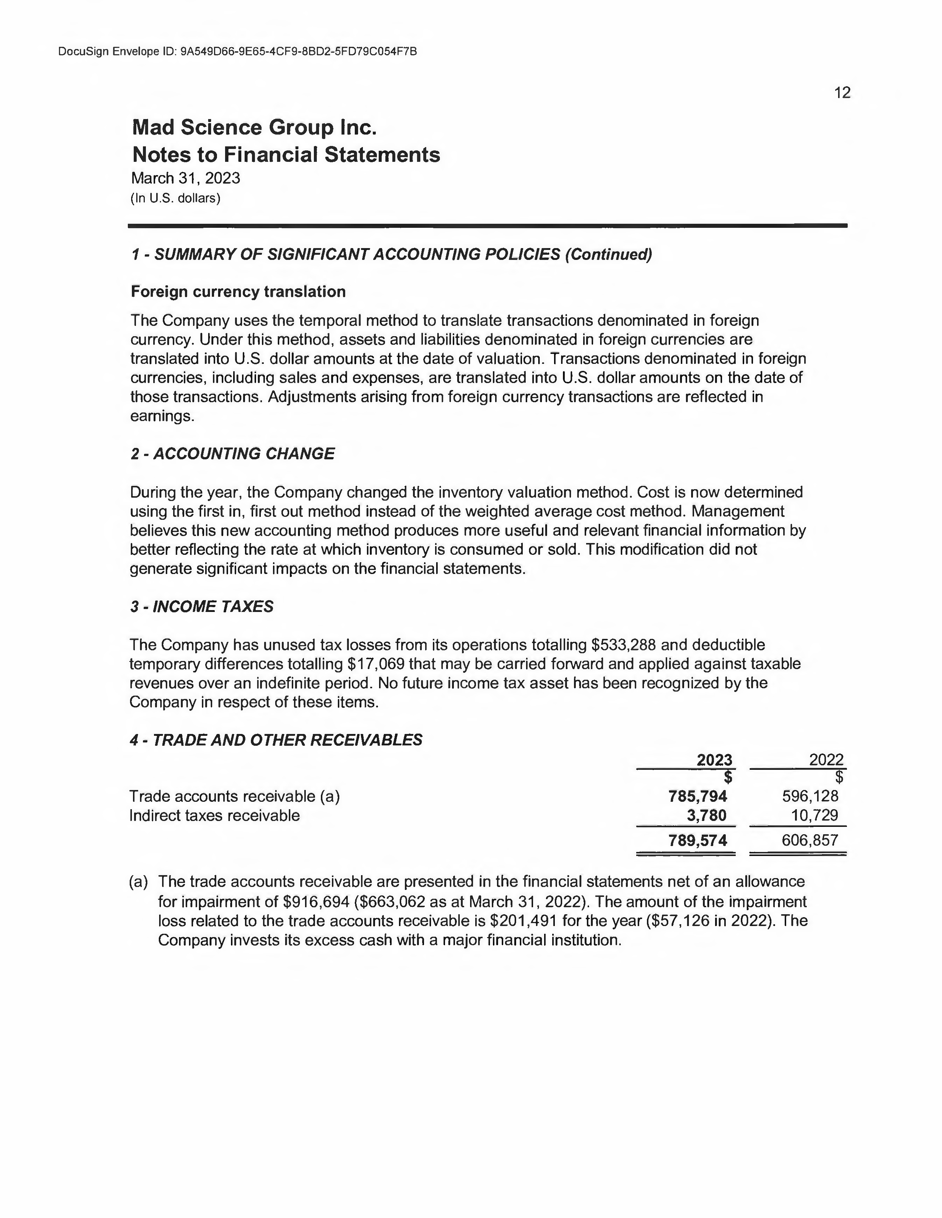

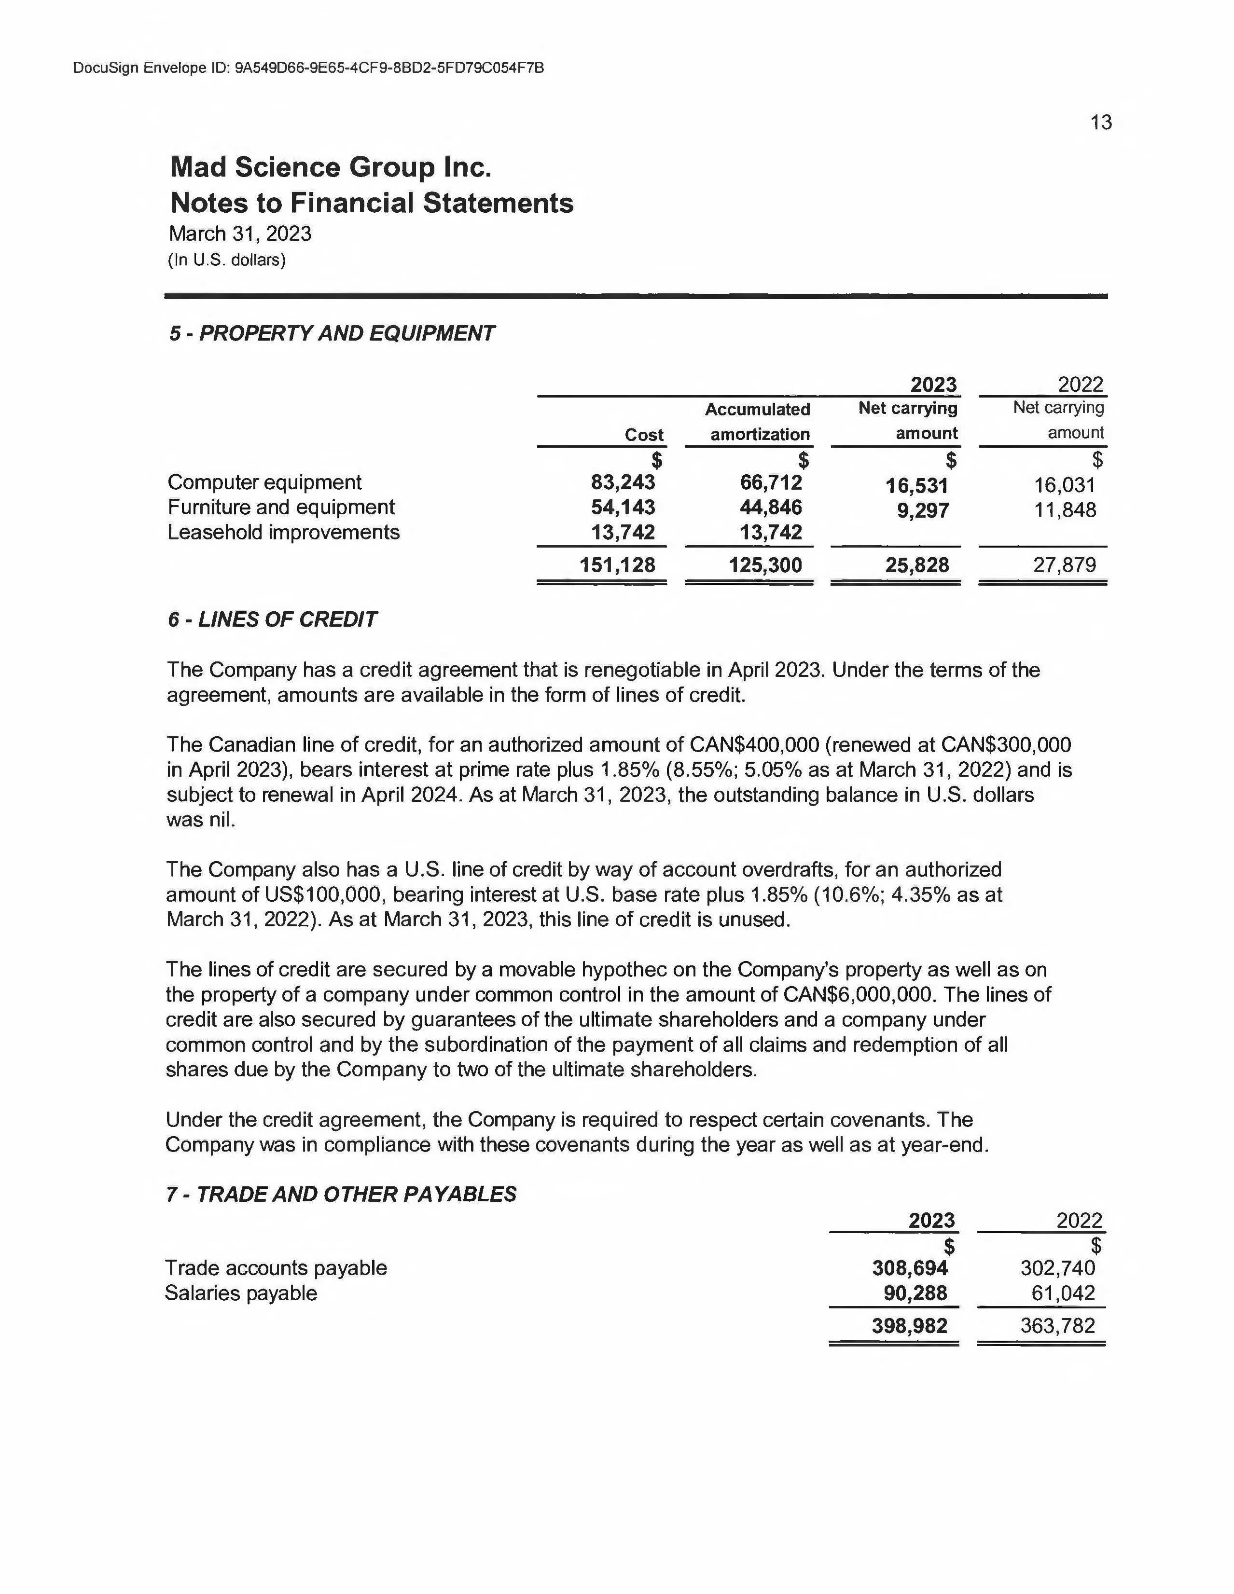

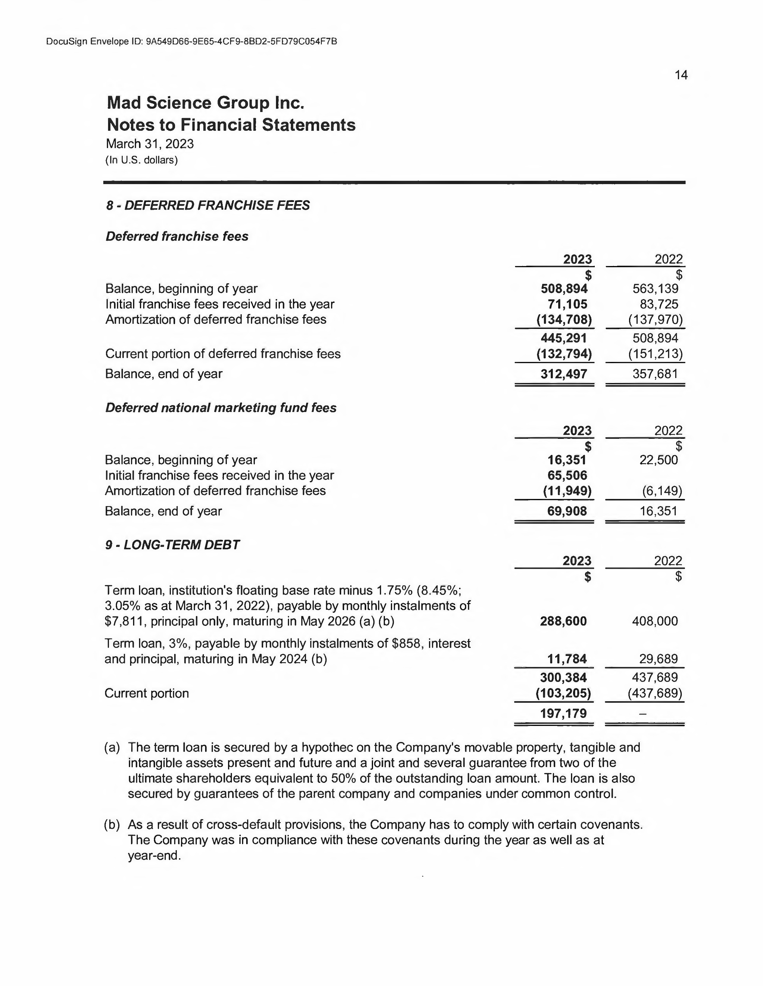

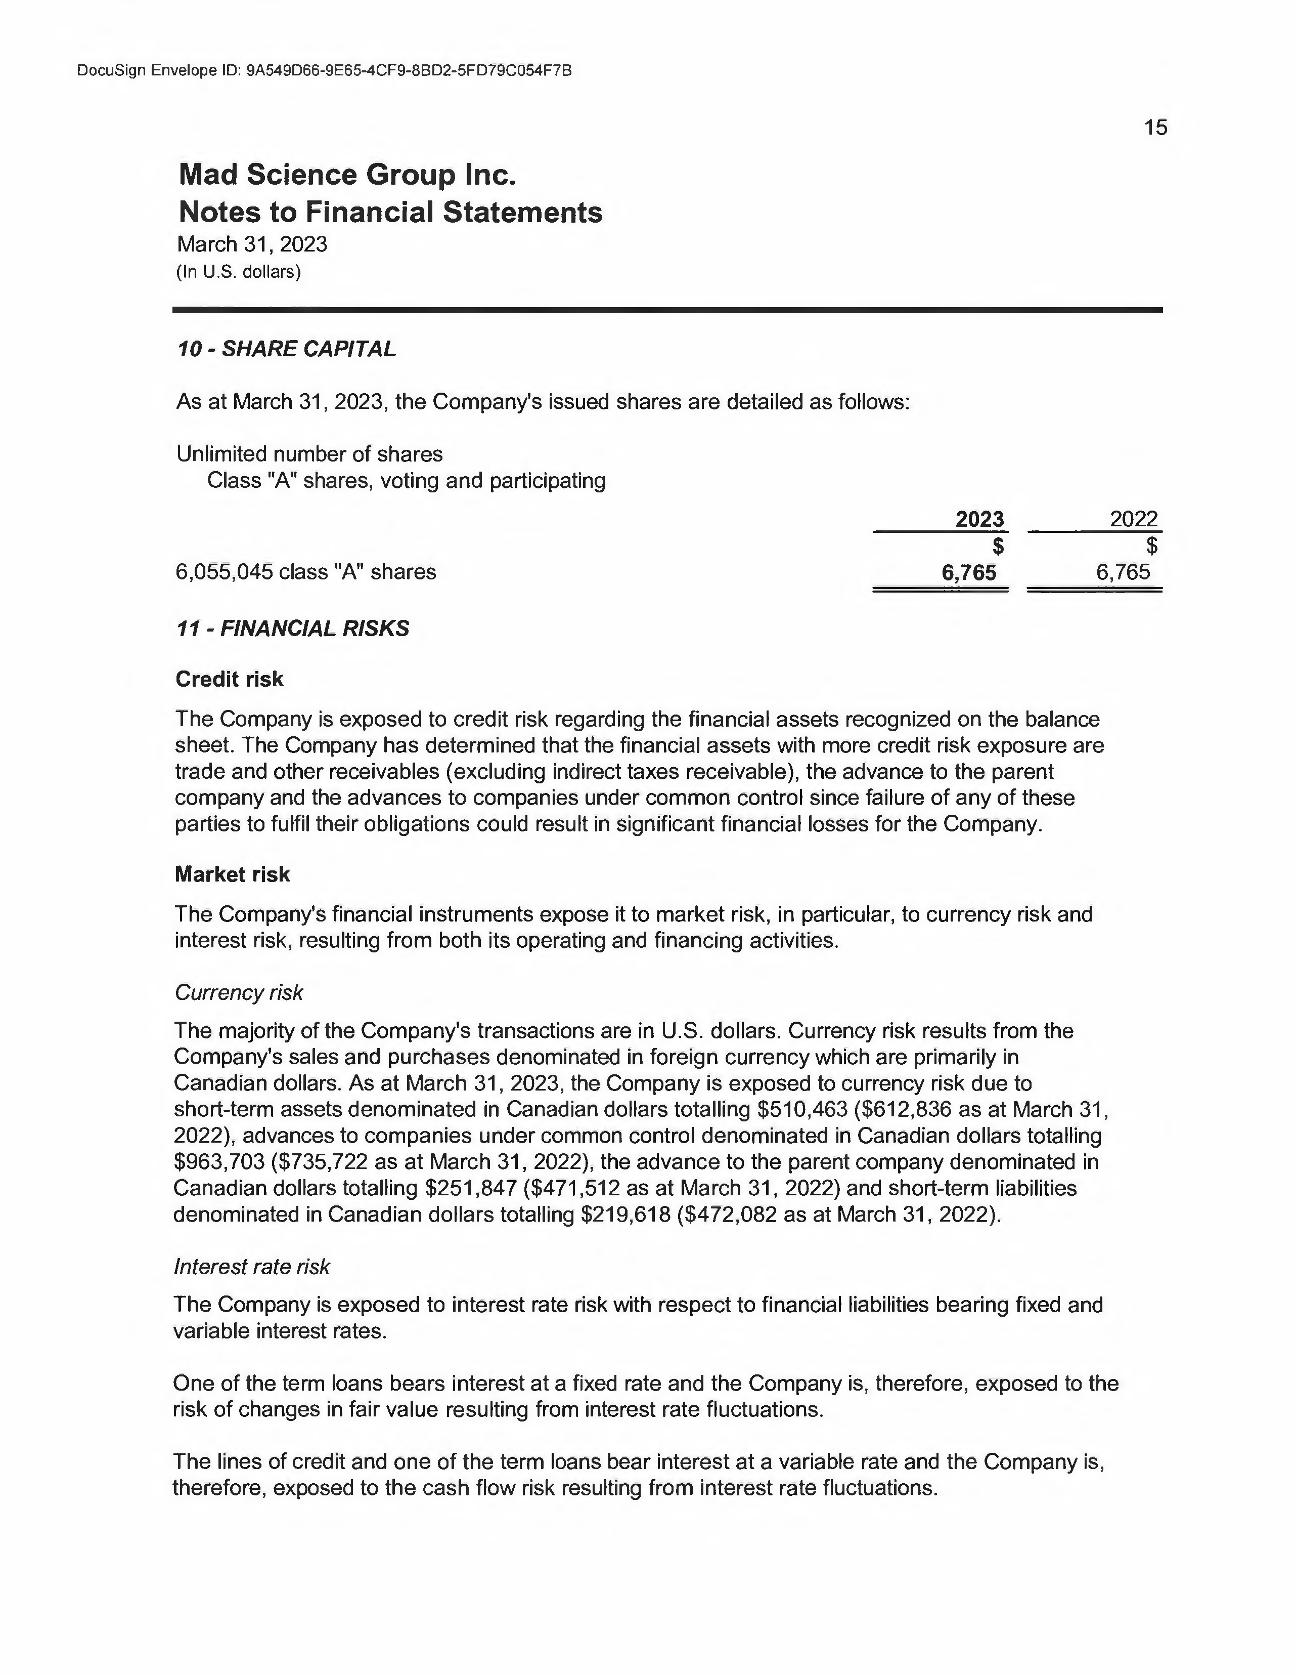

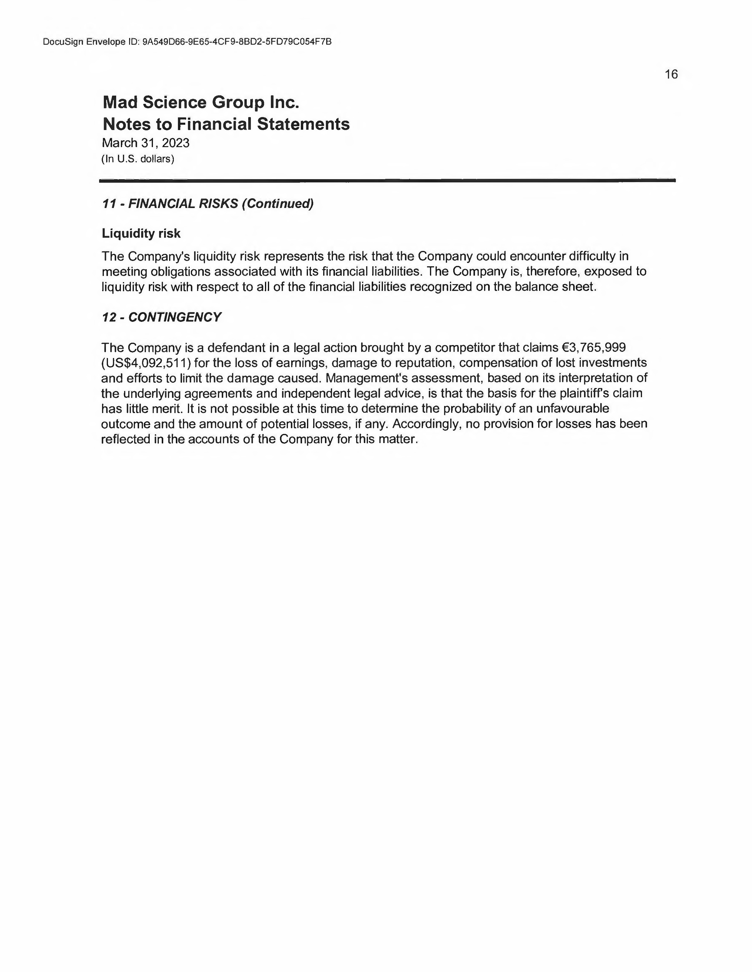

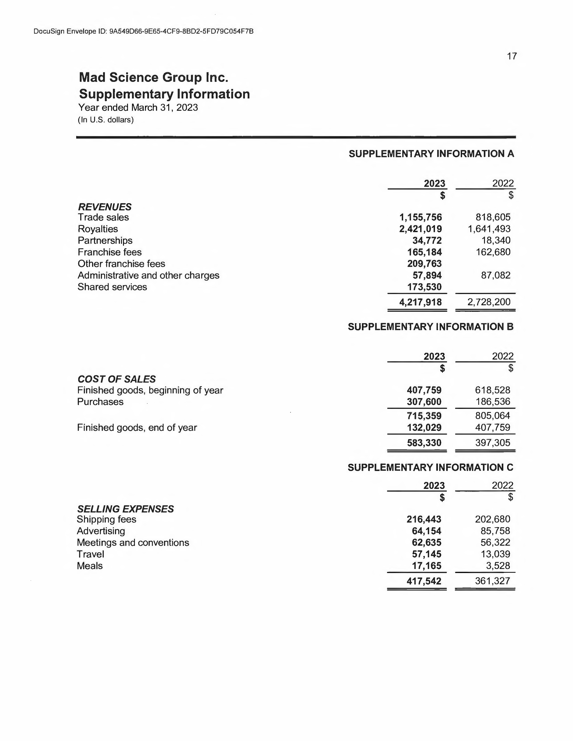

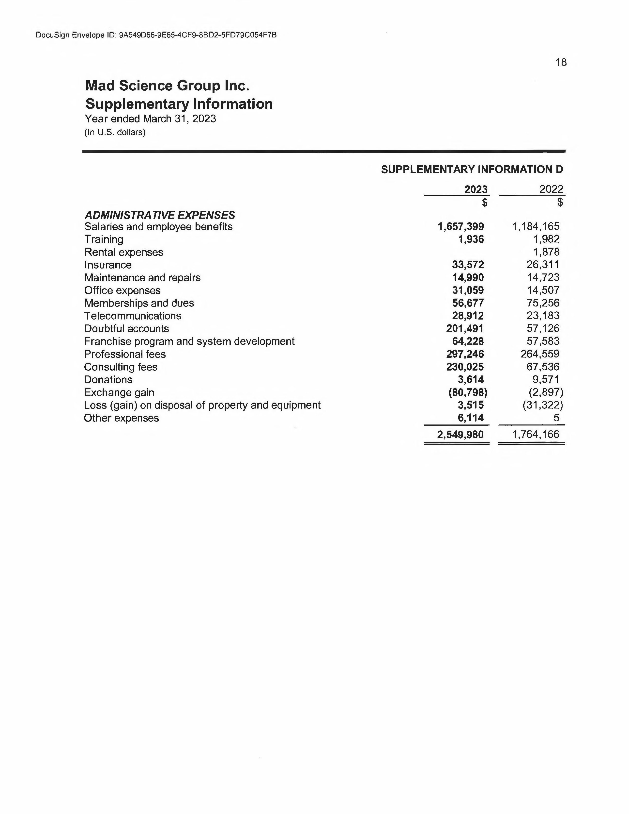

**Exhibit B**

**FRANCHISE AGREEMENT**

**Mad Science Group, Inc.**

MSG FDD 2024

Exhibit B

###### MAD SCIENCE GROUP INC.

###### FRANCHISE AGREEMENT (2024-2025)

###### INITIAL OR RENEWAL OR

###### TRANSFER



[Franchisee]

Franchisee

[Owner]

Owner

[Mad Science of]

Franchise Location Name

[Effective Date]

Effective Date

**TABLE OF CONTENTS**

###### PARTIES 6

###### PREAMBLE 6

###### DEFINITIONS 6

###### FRANCHISE AND FRANCHISE FEE 10

* 1. **GRANT 10**
  2. Territorial Rights 10
  3. Reservation of Rights 10
  4. Distribution Opportunities Reserved for Franchisor 11
  5. Corporate or Institutional Accounts 11
  6. Promotional Activities Limited to Territory 11
  7. Restrictions Associated with Marks and/or System 11
  8. Franchise Fee 12
  9. Varying Standards 12
  10. Franchise Premises 13

###### TERM AND RENEWAL 13

* 1. **TERM 13**
  2. Renewal 13
  3. Conditions to Renewal 13
  4. Non-Renewal by Franchisor 14

###### TRAINING AND ASSISTANCE 15

* 1. Initial Training 15
  2. Additional Training Requested by Franchisee 15
  3. Additional Training Requested by Franchisor 15

###### PROPRIETARY MARKS 16

* 1. Ownership and Goodwill 16
  2. Limitations of Use 16
  3. Trademark Infringement 16
  4. Discontinuance of Use of Marks 17
  5. Right of Entry and Inspection 17

###### MANUAL 17

* 1. Mandatory Nature of the Manuals 17
  2. Sole Property of Franchisor 17
  3. Sole Property of Franchisor 18
  4. Confidential Proprietary Information 18
  5. Incorporation Herein 18

###### CONFIDENTIAL INFORMATION 18

* 1. Types of Confidential Information 18
  2. Disclosure and Limitations on Use 19
  3. Exceptions to Confidentiality 19
  4. Equitable Remedies 19
  5. Copyrighted Works 19
  6. Franchisee Developed Works 19
  7. Federal Protections 20

###### ADDITIONAL PROGRAMS AND MODIFICATION OF THE SYSTEM 20

* 1. Additional Programs 20
  2. Quality Control 20
  3. Consequences to Default 21
  4. Modification of the System 21

###### MARKETING AND ADVERTISING 21

* 1. Marketing Access Fee 21
  2. National Marketing Fund 21
  3. Advertising 23
  4. Compliance 23
  5. Special Promotions 23

###### TECHNOLOGY ACCESS FEE 23

* 1. Fee for Technology Related Tools 23

###### DOMAIN NAME/INTERNET POLICIES 24

* 1. Mandatory Domain Name; onlines Sites 24

###### CONTINUING SERVICES AND ROYALTY FEE 25

* 1. Royalty Fee 25
  2. **DUE DATE 25**
  3. Late Fee and Costs of Collection 25
  4. Interest Rate 25
  5. Electronic Funds Transfer 25
  6. Payment Application 26
  7. Currency 26

###### ACCOUNTING AND RECORDS 26

* 1. **RECORDS 26**
  2. Tax Returns 26
  3. Accounting System 26
  4. New Accounting System 26
  5. Access to Information and Audit 27

###### FRANCHISEE'S OBLIGATIONS 27

* 1. Compliance 27
  2. Commencement of Operations 27
  3. Equipment Package Requirements 27
  4. Areas of Business and Office Location 28
  5. Franchisor as Sole Supplier 28
  6. Equipment Compliance 28
  7. Programming Compliance 28
  8. Product Compliance 29
  9. Licenses, Permits and Certificates 29
  10. Franchisee Supervision 29
  11. Customer Lists 30
  12. Staff Records 30
  13. Instructor Training 30
  14. Background Checks 30
  15. Mandatory Annual Conference Attendance, Possible Fees 30
  16. Notice of Legal Actions 30
  17. E-mail Communications 30
  18. Performance Obligations 31
  19. Payment Card Standard 31
  20. Administration Charge 32

###### FRANCHISOR'S OPERATIONS ASSISTANCE 32

* 1. Prior to Opening 32
  2. During the Term 32
  3. **STEP-IN-RIGHTS 33**

###### INSURANCE 33

* 1. Types of Insurance 33
  2. Certificate of Insurance 34
  3. Non-Compliance 34

###### EXCLUSIVE RELATIONSHIP 34

* 1. Non-Competitive Business During Term 34
  2. Public Companies 35

###### OWNERSHIP AND TRANSFER REQUIREMENTS 35

* 1. Transfer by Franchisor 35
  2. Transfer by Franchisee 35
  3. Conditions for Approval of Any Transfer by Franchisee 35
  4. Audit and Escrow of Funds 37
  5. Revocation of Approval of Transfer 38
  6. Intent to Transfer 38

###### FRANCHISOR'S RIGHT OF FIRST REFUSAL 38

* 1. Right of First Refusal 38
  2. Franchisor Exercises Right 38
  3. Franchisor Declines Right 38
  4. Business Entity Franchisee 38
  5. Death or Incapacity 39

###### TERMINATION OF AGREEMENT 39

* 1. Termination by Franchisee 39
  2. Termination by Franchisor - Failure to Qualify 40
  3. Termination by Franchisor - Non-Curable Default - Immediate Termination 40
  4. Termination by Franchisor - Failure to Cure Curable Default 41
  5. Termination by Franchisor - Performane Obligations Non Met 42
  6. Remedies on Default 43
  7. Franchisor's Loss of License to System 43

###### RIGHTS AND OBLIGATIONS UPON EXPIRATION OR TERMINATION 43

* 1. Payment of Amounts Owed to Franchisor 43
  2. Marks and De-Identification 43
  3. Right to Purchase Equipment 44
  4. Confidential Information 45
  5. Post-Term Competitive Restrictions 45
  6. Continuing Obligation 45

###### RELATIONSHIP OF THE PARTIES/INDEMNIFICATION 46

* 1. Independent Contractor; No Fiduciary Relationship 46
  2. Independent Ownership 46
  3. No Liability; No Warranties 46
  4. Taxes and Regulations 46
  5. Indemnification 47

###### ENFORCEMENT 48

* 1. Severability; Substitution of Valid Provisions 48
  2. Waivers - Cumulative Remedies 48
  3. Limitation of Liability 48
  4. Approval and Consents 48
  5. Waiver of Punitive Damages 48
  6. Governing Laws 48
  7. Waiver of Jury Trial and Right to Bring Class Action 49
  8. Costs and Attorney Fees 49
  9. Binding Effect 49
  10. Entire Agreement 49
  11. Business Organization 49
  12. Construction 50
  13. Timing is of the Essence 50

###### ARBITRATION 50

* 1. Agreement to Arbitrate 50
  2. Place and Language 50
  3. Specific Performance 50
  4. Survival 50

###### NOTICES 50

* 1. **NOTICES 50**

###### ACKNOWLEDGEMENTS 51

###### MAD SCIENCE GROUP INC. FRANCHISE AGREEMENT

###### PARTIES

This Franchise Agreement ("this Agreement") is, made as of [EFFECTIVE DATE] (the “Effective Date” of this Agreement) by and between **MAD SCIENCE GROUP INC.**, a Canadian corporation, having its principal place of business at 8360 Bougainville Street, Suite 201, Montreal, Quebec, Canada, H4P 2G1 ("Franchisor"), and [Franchisee] d/b/a [Mad Science of], having a principal place of business at: [Franchisee Address] ("Franchisee" or “you”), together referred to as the “Parties”.

###### PREAMBLE

**WHEREAS** the Franchisor is licensed by Franchisor’s Affiliate, Mad Science Licensing, Inc. (a “licensor”) to grant franchises involving use of the System and Marks (as herein defined) associated with and in relation to the operation of a Mad Science business; and

**WHEREAS** the Franchisor is in the business of sublicensing the intellectual property associated with the Mad Science brand, in relation to offering services and activities authorized and approved by Franchisor and utilizing the System and Marks throughout the world; and

**WHEREAS** the Franchisee desires to operate a Mad Science franchise using the System and Marks and has applied for a franchise, which application has been approved by Franchisor in reliance upon all of the representations made therein; and

**WHEREAS** the Franchisee understands and acknowledges the importance of Franchisor's high and uniform standards of quality, operations and customer service and the necessity of operating the Mad Science Franchise in conformity with Franchisor's standards and specifications.

###### NOW THEREFORE, IN CONSIDERATION OF THE FOREGOING, THE FEES AND OTHER SUMS PAYABLE BY FRANCHISEE AND OF THE MUTUAL COVENANTS CONTAINED IN THIS AGREEMENT, THE ADEQUACY OF WHICH IS HEREBY ACKNOWLEDGED BY BOTH PARTIES, THE PARTIES AGREE AS FOLLOWS:

###### DEFINITIONS

Franchisor and Franchisee agree that the following definitions shall apply to this Agreement and all other agreements between them, unless expressly provided otherwise:

**"Affiliate"** - Any person, company or other entity, which controls, is controlled by or is under common control with another person, company or other entity.

**"Agreement"** – This Franchise Agreement signed on the Effective Date.

**"Business Entity"** – A business organization such as a corporation, limited liability company or partnership.

**"Competitive Business"** - Any business or other establishment operating or otherwise involved with, or awarding franchises or licenses to others to operate or be involved with, any children’s education and entertainment-related business, including, but not limited to, any (1) business that offers, sells, distributes, provides or is otherwise involved or deals with interactive science activities and scientific demonstrations with hands-on experience such as, but not limited to, party programs, classes, special events, camps and workshops conducted in local schools, hospitals and other institutions, (2) goods and/or services which are then-currently authorized by the Franchisor to be offered by Mad Science Franchises or which Franchisee knows Franchisor intends to authorize, or (3) children’s education and entertainment-related products and/or services, whether at wholesale or retail, whether or not specializing in science.

**"Confidential Information"** – Any and all information, knowledge, know-how, techniques and data which Franchisor has developed and designates as confidential will be deemed confidential for purposes of this Agreement, including but not limited to, (1) business methods, standards, and Trade Secrets that comprise the System, including sales and marketing techniques, pricing, advertising, accounting systems, operation systems, policies, procedures, systems, compilations of information, records, specifications, exclusively designed signage and materials, specially scripted and outlined interactive science activities for children, and specially developed course materials, curriculum and lesson plans; (2) the Manuals, including the Mad Science Confidential Operations Manual, operating procedures, methods and techniques for cost controls, record keeping, reporting, purchasing, sales promotion and advertising, and the Standard Operating Policies Manual; (3) training materials and programs; (4) knowledge of specifications for and suppliers of, and methods of ordering, certain products, materials, equipment and supplies; (5) proprietary software; (6) all password-protected portions of our website, intranets and extranets and the information they contain (including the email addresses of our franchisees); (7) student lists and customer data; (8) knowledge of the operating results and financial performance of other Mad Science franchises; and all other information received by Franchisee from Franchisor to be used in the establishment and operation of a Mad Science Franchise and where the confidentiality of the information is required to protect the Mad Science franchise community, all of which may be changed, improved and further developed by Franchisor or its Affiliates from time to time and with which Franchisee will promptly and fully comply.

**"Effective Date of this Agreement"** - The date listed on the first page of this Agreement.

**"Equipment"** - Equipment to be purchased or otherwise obtained by Franchisee in accordance with Franchisor’s specifications and used by Franchisee in the operation of a Mad Science Franchise.

**"Extranet"** – Internet application established by Franchisor to facilitate communications with, and delivery of information to and from, franchisees and for other business purposes.

**"First Year Standard"** – As defined in Section 16.18.

**"Franchisor-Related Persons/Entities"** –Mad Science Group Inc. (formerly, 2946033 Canada, Inc.) and its past, current and future Affiliates, and each and all of the following, whether past, current and/or future: each and all company(ies)/person(s) acting by, through, under, in concert, affiliated and/or associated in any way, with Franchisor or any Franchisor Affiliate, together with each and all of the partners, shareholders, officers, directors, members, agents, attorneys, accountants, and/or employees of Franchisor, of any such Affiliate and/or any of the foregoing, as well as each and all of the successors and/or assigns of Franchisor and/or any of the foregoing.

**"Gross Revenue"** – The total of all revenues and income from all sales, fees, party charges, merchandise, government grants, sponsorships, trade transactions, and other sums derived from providing educational and entertainment services and related merchandise to customers of Franchisee or any other source, whether or not sold or performed at or from the Mad Science Franchise and whether received in cash, as barter, in services, on credit (whether or not payment is received), or otherwise. Deducted from Gross Revenues for purposes of said computation (but only to the extent they have been included) is the amount of all free passes to non-profit groups, tips, sales tax receipts or similar tax receipts which, by law, are chargeable to customers, if such taxes are separately stated when the customer is charged and if such taxes are paid to the appropriate taxing authority. There will be further deducted from Gross Revenues the amount of any documented refunds, charge backs, credits and allowances given in good faith to customers by Franchisee.

**“Initial Opening”** - The first day of operation of a Mad Science Franchise.

**"Mad Science Franchise"** - The right to operate within the Territory a single children's education and entertainment business identified by the Mark, "MAD SCIENCE,” and specializing in conducting interactive science activities and scientific demonstrations with hands-on experience, including birthday parties, after school programs, workshops, special events, and camps pursuant to the terms and conditions of this Agreement.

**"Marks"** - The trademarks, service marks and other commercial symbols now and/or in the future owned by Franchisor or Franchisor’s licensors and which Franchisor may designate, from time to time, to be used to identify the services and/or products which may be offered by the Mad Science Franchise, including, but not limited to the mark "MAD SCIENCE" and “MAD SCIENTIST”, the Trade Dress and certain associated logos.

**"Manuals"** - One or more handbooks, manuals, broadcasts, bulletins and/or volumes, other written materials, and video, audio and/or software media (including materials distributed electronically or otherwise), regardless of title and including any Confidential Operations Manual and/or Standard Operating Policies Manual, and containing, among other things, mandatory specifications, standards, policies and procedures prescribed from time to time by Franchisor and to be followed by Franchisee in connection with its Mad Science Franchise and Franchisee’s performance under this Agreement, including, but not limited to, all goods and services to be sold and/or provided at or from its Mad Science Franchise and/or in association with the Marks. The Manuals include all changes and supplements issued by Franchisor in the future, with which Franchisee will promptly comply.

**"OEP"** – As defined in Section 16.3 of this Agreement.

**"Owner"** – Any individual holding, directly or indirectly, any legal or beneficial interest in the Franchise or the Franchisee, if the Franchisee is a Business Entity.

**"Parties"** – As defined in Section 1 of this Agreement.

**"Performance Clause"** – As stated in Section 16.18

**"Products" and "Services"** - Products and services designated by Franchisor from time to time for use, sale, lease, rental or to be otherwise used and/or provided at or from the Mad Science Franchise, and/or in association with the Marks.

**"Second Year Standard"** – As defined in Section 16.18.

**"System"** - The system for the operation of businesses which provide entertaining and educational science activities for children from three (3) to twelve (12) years old, developed and used by Franchisor in North America and internationally and as outlined in the various Manuals, Extranet, videos, and other formal communication and training tools made available by Franchisor either now or in the future. The System shall include and be limited to the following specific areas of business:

1. Live, educational, hands-on enrichment activities with a science theme conducted as an after school enrichment activity (“After School Programs”);
2. Live, educational, hands-on enrichment activities with a science theme conducted as an in-school curriculum supplement during the school day (“Workshops”);
3. Live, educational and highly entertaining hands-on enrichment activities with a science theme conducted as entertainment at a child’s birthday party (“Birthday Parties”);
4. Live, educational and highly entertaining hands-on enrichment activities with a science theme, conducted as entertainment at recreation and community centers, summer camps, Girl or Boy Scouts, libraries, corporate family events, and other similar organizations and venues (“Special Events”);
5. Live, educational and highly entertaining hands-on enrichment activities with a science theme, conducted as entertainment for or as a camp (“Camps”); and
6. Any other areas of business and/or programs that Franchisor may select and/or authorize in Franchisor’s sole discretion from time to time.

**"Territory"** - The geographical area described in Schedule B.

**"Theatrical Production"** - Live, interactive and highly scripted theatrical stage shows for groups of 100 or more children incorporating actors, special effects, stage sets and props as well as coordinated sound and lighting, for clients, including, but not limited to, theme parks, amusement parks, fairs, museums, cruise ships and theaters.

**"Third Year Standard"** – As defined in Section 16.18.

**"Trade Dress"** - The Mad Science design and image developed and owned by or licensed to Franchisor for use by the Mad Science Franchise, as it currently exists and as it may be revised and further developed by Franchisor or its licensor(s) from time to time.

**"Trade Secrets"** – Confidential, proprietary information in any form related to or used in the Franchise that is not commonly known by or available to the public and which information: (1) derives economic value, actual or potential, from not being generally known to, and not being readily ascertained by proper means by, other persons who can obtain economic value from its disclosure or use; and (2) is the subject of efforts that are reasonable under the circumstances to maintain its secrecy. Franchisee shall acquire no interest in the Trade Secrets, other than the right to use them in developing and operating the Franchise during the term of this Agreement.

**"Transfer"** - As used in this Agreement the term "transfer" includes (but is not limited to) the voluntary, involuntary, direct or indirect assignment, sale, gift, pledge, mortgage, the granting of any security or similar interest, or other transfer by the Franchisee (or any of its Owners) of any interest, including, but not limited to any interest in: (1) this Agreement; (2) the Mad Science Franchise; or (3) the ownership of the Franchisee, including any ownership restructuring of Franchisee or of any owners of Franchisee. An assignment, sale, or other transfer will include, but is not limited to, the following events: (1) any transfer of ownership of capital stock or any partnership, membership or similar interest; (2) any merger or consolidation or issuance of additional securities representing an ownership interest in the Franchisee; (3) any sale of voting stock of the Franchisee or any security convertible to voting stock of the Franchisee; (4) any transfer of any interest in this Agreement or the Mad Science Franchise, of Franchisee (including any ownership restructuring of Franchisee or of any owners of Franchisee), or of Franchisee in a divorce, insolvency, corporate or partnership dissolution proceeding or otherwise by operation of law; or (5) any transfer of an interest in the revenues, profits, rights or assets of the Mad Science Franchise. Any transfer by the Franchisee, or any of its Owners, to a controlled Business Entity and/or of an interest in the event of Franchisee’s death or the death of an Owner of the Franchisee, by will, declaration of or transfer in trust, under the laws of intestate succession, or otherwise shall be governed by all of the provisions on assignment of this Agreement.

###### FRANCHISE AND FRANCHISE FEE

* 1. Grant:

Until expiration or termination of this Agreement and subject to all the terms and conditions set out herein, Franchisor hereby grants to Franchisee and Franchisee hereby accepts to operate a Mad Science Franchise (the “Franchised Business”), including the right to use in connection therewith the Marks and the System within the boundaries of the Territory.

* 1. Territorial Rights:

Subject to Franchisor’s rights as set forth anywhere in this Agreement and for its term Franchisor shall not enter into a Franchise Agreement licensing a Mad Science Franchise, or open a Franchisor-owned Mad Science Franchise, inside Franchisee’s Territory. This Agreement and the Mad Science Franchise do not grant Franchisee any rights with respect to other and/or related businesses, Products and/or Services, in which Franchisor or any Franchisor-Related Persons/Entities may be involved, now or in the future.

* 1. Reservation of Rights:

Franchisor and any Franchisor-Related Persons/Entities expressly reserve all other rights, and can:

* + 1. own and/or operate itself, and/or authorize others to own and/or operate:
       1. any kind of business in the Territory, except for a Mad Science Franchise, whether or not using the Mad Science Marks and System; and
       2. any kind of business outside of the Territory, including without limitation, Mad Science Franchises, whether or not using the Mad Science Marks and System or any other brand or system;
    2. sell Mad Science branded Products and Services and products and services under other brands, whether or not competitive, to customers located anywhere, including within the Territory using any channel of distribution other than a Mad Science Franchise located in the Territory without payment of any compensation to Franchisee;
    3. develop or be associated with other concepts, whether or not using the Mad Science System or the Marks, which may involve science enrichment programs or other programs for children

aged three (3) to twelve (12), including dual branding and/or other franchise systems, and award franchises under such other concepts for locations anywhere. Notwithstanding the foregoing, Franchisee may purchase approved TV or radio advertising for promotional purposes, as well as conduct interviews in local media which may be filmed for local or national broadcast or publication upon receipt of prior consent by Franchisor;

* + 1. acquire, be acquired by, merge, affiliate with or engage in any transaction with other businesses, whether competitive or not, with units located anywhere. Such transactions may include, but are not limited to, arrangements involving competing outlets and/or brand conversions to or from the Mad Science Marks and System. Such transactions are expressly permitted under this Agreement, and Franchisee agrees to participate at its expense in any such conversion as instructed by Franchisor.
  1. Distribution Opportunities Reserved for Franchisor:

Franchisee understands that the term “Mad Science Franchise” as defined above does not include non- Mad Science franchises, businesses or other distribution opportunities. A non-Mad Science franchise, business concept or distribution opportunity may include, but is not limited to, sales at retail or wholesale of science kits, toys or other products to the general public or otherwise from any retail location, including supermarkets and discount stores, or by direct mail, by internet, by television, and through any other media, Corporate Accounts or otherwise.

* 1. Corporate or Institutional Accounts:

Franchisor, and/or any of the Franchisor-Related Persons/Entities, may service certain corporate or institutional accounts ("Corporate Accounts") that have contracted (or may in the future contract) with Franchisor or any parent, subsidiary or Affiliate of Franchisor for services, irrespective of where the customer is located or the services or products delivered. "Corporate Accounts" shall include entities that have facilities located in more than one territory, cruise ship programs, hotels, resorts, vacation programs, national and/or international Corporations, theatrical productions, and the distribution of trademarked products through retail, wholesale and/or Internet or other electronic-based distribution networks.

* 1. Promotional Activities Limited to Territory:

Franchisee is not permitted to solicit clients or conduct promotional activities outside of its designated Territory.

* 1. Restrictions Associated with Marks and/or System:

Franchisee shall not, without Franchisor’s prior written consent, use, otherwise employ or permit the use or employment of the System or the Marks except in the Territory and in accordance with the provisions of this Agreement nor, subject to the provisions of Section 7 hereof, use, otherwise employ or permit the use or employment of any trade name, trade mark, service mark or commercial symbol other than the Marks in connection with Mad Science Franchise. Any and all rights in the Territory not specifically granted to Franchisee are expressly reserved to Franchisor. For clarification, Franchisee shall not have the right to itself or through any other party, whether or not in association with the Marks:

1. To create or offer for sale, any kind of good or service, except that which is specifically provided by or authorized by the Franchisor;
2. To conduct Theatrical Productions within or outside the Territory;
3. To create or produce any kind of program, activity, or any other form of live or pre- recorded session(s) of content associated with the Marks and Confidential Information on

any linear media channel (television, radio), on the internet and non-linear media channels and/or device supports or media, such as, including but not limited to video platforms, on- demand channel(s), webpages, microsites, social networking sites (i.e. Facebook, Instagram, Twitter, LinkedIn, You Tube, Google Plus, Pinterest, etc.), virtual worlds, blogs, vlogs, applications to be installed on mobile devices (for example, iPad or Android apps), and other applications;

1. To hold any online/virtual class, online programming or virtual session(s);
2. To create or offer for sale any kind of goods or services not prescribed by the Franchisor without Franchisor’s prior written approval, including, but not limited to, the opening of any kind of location-based facility, retail store, party center, pre-school, daycare, or any other type of childcare facility;
3. To create, manufacture, purchase or subcontract the manufacture of Mad Science branded product or merchandise;
4. To conduct services or sell products in connection with the Mad Science Franchise other than those services and products authorized for sale by the Franchisor or supplied by its authorized suppliers;
5. To enter into discussions with potential sponsors or promotional partners, without the prior written consent of Franchisor;
6. To publish or use a website in connection with the Mad Science Franchise, other than a website provided and supported by or through Franchisor or its designee or create a presence in virtual worlds;
7. To create, sell, offer or otherwise distribute any kind of Product or Service to other Mad Science franchisees without the prior written approval by Franchisor;
8. To create, sell, offer or otherwise distribute marketing materials without the prior written approval by Franchisor for any custom templates.
   1. Franchise Fee:

In consideration of the franchise granted herein, Franchisee shall pay to Franchisor upon execution of this Agreement an initial Franchise Fee of Forty Nine Thousand Dollars ($49,000) ("Franchise Fee"). The Franchise Fee is fully earned by Franchisor when Franchisee signs this Agreement. If Franchisee paid an application fee, it will be credited against the amount owed for the Franchise Fee.

* 1. Varying Standards:

Franchisee acknowledges that because complete and detailed uniformity under many varying conditions may not be possible or practical, Franchisor specifically has the unrestricted right to vary standards for any franchisee based upon the peculiarities of the particular site or circumstance, density of population, business potential, population of trade area, existing business practices or any other condition which Franchisor deems to be of importance to the operation of such franchisee's business. Franchisee shall not be entitled to require Franchisor to grant to Franchisee a like or similar variation hereunder, except to the extent required under any applicable law.

* 1. Franchise Premises:

Franchisee must establish prior to the Initial Opening of the Franchise and maintain premises within the Territory for the operation of the Franchised Business throughout the term of this Agreement except as otherwise permitted by Franchisor in writing. Any such location must be approved by Franchisor in advance and meet then current facility size requirements and standards, as provided in the Manuals. Franchise premises are generally anticipated to be located in industrial warehouse or retail locations. Franchisee must submit a written request for site approval to Franchisor and obtain written approval before leasing, purchasing or occupying any premises. Franchisee must provide Franchisor written notice of any proposed change to Franchisee’s premises location and obtain Franchisor’s prior written approval of a new site and facility, as provided herein. If Franchisee and Franchisor are unable to agree on a site within one hundred twenty (120) days of the Effective Date of the Franchise Agreement, and Franchisor has not granted a written time extension in its sole discretion, Franchisor may, in its sole discretion, cancel the Franchise Agreement. In that case, Franchisor will return any initial Franchise Fee actually received by Franchisor, less One Thousand United States Dollars ($1,000) USD for costs and expenses; provided that Franchisee signs a mutual termination agreement and release in a form specified by Franchisor. Franchisee must provide Franchisor written notice of any proposed change to Franchisee’s premises location and obtain Franchisor’s prior written approval of a new site and facility, as provided herein.

1. TERM AND RENEWAL (Refer to Schedule A if renewal or transfer)
   1. Term:

This Agreement shall be effective and binding for an initial term of ten (10) years, commencing on the Effective Date of this Agreement.

* 1. Renewal:

Provided that Franchisee shall have complied with all the terms of this Agreement, and subject to fulfillment of the conditions in section 5.3 below, Franchisee shall have the option to renew this Agreement for two (2) successive periods of five (5) years each.

* 1. Conditions to Renewal:

As conditions to renewal, Franchisee must:

1. Provide Franchisor with written notice of intent to renew this Agreement at least six (6) months prior to the end of the term hereof (but in no event more than nine (9) months);
2. At the time of execution of the new franchise agreement, pay a Renewal Fee of Five Thousand United States Dollars ($5,000.00 USD) per Territory;
3. Execute prior to the expiration of the then existing term of Franchisee’s Mad Science Franchise the then-current franchise agreement used for new Mad Science franchises which may contain financial and other terms materially different from those included in this Agreement, with appropriate modifications to reflect the fact that the then-current franchise agreement relates to the grant of a renewal franchise; the new franchise agreement may require Franchisee to pay different fees than those specified in the previous franchise agreement and may require a restructured or redefined Territory which may be smaller than Franchisee’s existing Territory and/or may require the splitting of the existing Territory into 2 or more separate territories operating under separate franchise agreements; however, the initial franchise fee payable under the new franchise agreement will not be charged;
4. Execute, prior to the expiration of the then existing term of Franchisee’s Mad Science Franchise, all other required documents, including any then current form of consent to renew or renewal addendum;
5. Be in complete compliance with this Agreement at all times, including payment of all fees due, the requirements described in the Manuals and all other agreements and policies in effect between Franchisor and Franchisee;
6. Be current with all financial obligations to third parties prior to the expiration of the then existing term of Franchisee’s Mad Science Franchise;
7. Upgrade, prior to the expiration of the then existing term of Franchisee’s Mad Science Franchise, all hardware, software, equipment and systems used by the Mad Science Franchise to comply with Franchisor’s then-current standards as described in the Manuals;
8. Execute, prior to the expiration of the then existing term of Franchisee’s Mad Science Franchise, a general release in favor of Franchisor, its Affiliates and related individuals and entities, from any claims arising before or during the term hereof;
9. Purchase from Franchisor, its Affiliates or third parties (as applicable) Mad Science Equipment, Products and Services in such quantities as Franchisor determines are necessary as a result of an audit or otherwise to meet the then current System standards; in connection with such purchases, Franchisee shall make an advance payment in an amount to be determined by and payable to Franchisor upon request to be applied towards the purchase of such Mad Science Equipment, Products and/or Services. Franchisee shall pay to Franchisor before the expiration of the then current term of the Mad Science Franchise the amount of any dollar deficiency between the advance payment and the cost of the Equipment, Products and Services required to be obtained from Franchisor or its Affiliates to meet the then current System standards. Franchisor will return to Franchisee the portion of any advance payment not required to offset the costs of such Equipment, Products and Services; and
10. Assist Franchisor or its designee with an on-site audit of the Mad Science Franchise, which shall be conducted by Franchisor or its designee in Franchisor’s discretion, including without limitation, a financial audit and an audit of the Mad Science Equipment, Products and Services to determine their compliance with then current System standards. Any deficiencies identified during the audit must be satisfied prior to the expiration of the then current term of the Mad Science Franchise. If any audit reveals any deficiencies, the costs incurred by Franchisor in connection with any such audit are payable upon demand by Franchisee prior to the expiration of the then existing term, including any audit costs, transportation, lodging, meals, and any other expenses incurred.

If Franchisee fails to complete all of the renewal conditions by the expiration date of this Agreement, Franchisor may choose, in its sole discretion and without any obligation to do so, to permit Franchisee to renew, subject to the payment to Franchisor then-current late renewal administration charge for each month all renewal conditions remain unmet. This charge is in addition to the Renewal Fee described in 5.3 b. above.

* 1. Non-Renewal by Franchisor:

Franchisor shall give Franchisee written notice and an explanation to Franchisee of its election not to renew the franchise at least six (6) months prior to the expiration of the Agreement (the “Notice Period”) or such

other time period as applicable state law may prescribe. Franchisee shall notify Franchisor in writing within ten (10) days of Franchisee’s receipt of such notice from Franchisor if Franchisee intends to transfer its Mad Science Franchise prior to the expiration of Franchisee’s Franchise to a suitable transferee, as provided in Section 20.3 of this Agreement. If Franchisee fails to provide Franchisor such written notice in compliance with this provision or to actively seek a suitable transferee as provided in Section 20.6 of this Agreement, or if Franchisor rejects the proposed transfer, Franchisor reserves the right in its discretion to engage in re-marketing activities for all or a portion of Franchisee’s Territory during such Notice Period without liability to Franchisee and to exercise its option to purchase Mad Science equipment and materials, as provided in Section 23.3 a. of this Agreement upon expiration of the Agreement. Franchisee shall cooperate with Franchisor in connection with any such re-marketing activities. Notwithstanding the foregoing, Franchisor shall not be prohibited from exercising any right or remedy under this Agreement or as permitted by law or equity.

###### TRAINING AND ASSISTANCE

* 1. Initial Training:

Franchisor shall, at its own cost, make available an initial training program to Franchisee or Franchisee's managing Owner and, if Franchisor consents, to Franchisee’s manager. Franchisee or Franchisee's managing Owner (as applicable), and Franchisee's manager (if approved) must attend and successfully complete all phases of the initial training program. All expenses incurred by Franchisee and its employees in attending such program including, without limitation, transportation, lodging, meals, personal expenses, and employees' salaries, shall be the sole responsibility of Franchisee. The training program shall include history; general economics of the business; science demonstration techniques; financial controls; deployment of labor, maintenance of quality standards; an understanding of the Manuals; marketing; advertising; recruiting and training personnel; bookkeeping, record keeping and accounting procedures.

The initial training will take place virtually or, at Franchisor’s sole discretion, at the location of the Mad Science Franchise or such other location as Franchisor shall specify. The training program will be conducted by a representative of the Franchisor. If the Franchisee cancels any scheduled training, or is not available for any significant portion of any training, Franchisee shall reimburse Franchisor for all costs related to the training. During the initial training, the Franchisor’s representative will also assist in establishing and standardizing procedures and techniques essential to the operation of the Mad Science Franchise and in training Franchisee's instructors. The training program is subject to change in Franchisor’s discretion.

If Franchisee owns more than one (1) franchise, the initial training will only be provided for the first franchise that Franchisee purchases.

* 1. Additional Training Requested by Franchisee:

If Franchisee or Franchisee's managing Owner requests additional assistance from Franchisor and if Franchisor, in its sole discretion, deems it necessary, feasible and appropriate to comply with the request, Franchisee shall reimburse Franchisor for the expense of Franchisor providing such additional assistance, including Franchisor's then-current service fee, as set forth in the Manuals, which may be amended from time to time and all related costs of such additional training including, but not limited to, transportation, lodging, means and personal expenses incurred by Franchisor’s personnel or representatives. Franchisor, in its sole discretion, reserves the right to administer all or a portion of the training virtually.

* 1. Additional Training Requested by Franchisor:

Franchisor, in its sole discretion, may schedule additional training and/or assistance in order to assist and guide Franchisee in the operations of the Mad Science Franchise (including training of replacement

managers or personnel), in which case Franchisee shall pay all costs of such additional training including, but not limited to, transportation, lodging, meals and personal expenses incurred by Franchisor’s personnel or representatives in connection with this additional training as well as Franchisor's then-current service fee, as set forth in the Manuals, which may be amended from time to time. Franchisor, in its sole discretion, reserves the right to administer all or a portion of the training virtually. Franchisee’s employees must complete all training required by Franchisor for their positions, to Franchisor’s satisfaction.

###### PROPRIETARY MARKS

* 1. Ownership and Goodwill:

Franchisee acknowledges that Franchisee's right to use the Marks is derived solely from this Agreement, is non-exclusive and is limited to the conduct of business by Franchisee pursuant to and in compliance with this Agreement and all applicable standards, specifications and operating procedures prescribed by Franchisor from time to time during the term of the Agreement or any renewal or continuation thereof. Any unauthorized use of the Marks by Franchisee is a breach of this Agreement and an infringement of the rights of Franchisor/Franchisor’s licensor(s), as applicable, in and to the Marks. Franchisee acknowledges that all usage of the Marks by Franchisee and any goodwill established by Franchisee's use of the Marks shall inure to the exclusive benefit of Franchisor/Franchisor’s licensor(s), as applicable, and that this Agreement does not confer any goodwill or other interests in the Marks upon Franchisee. Franchisee shall not, at any time during the term of this Agreement, or after its expiration or termination, contest the validity or ownership of any of the Marks or assist any other person in contesting the validity or ownership of the Marks. All provisions of this Agreement applicable to the Marks apply to any and all additional trademarks, service marks and commercial symbols authorized for use by and licensed to Franchisee by Franchisor after the Effective Date of this Agreement. Franchisee must submit all proposed uses of the Marks, including, but not limited to, use in connection with printed advertising and promotional materials, informational literature and other publications, and shall obtain Franchisor’s prior written consent to such use, which Franchisor may grant or deny in its sole discretion.

* 1. Limitations of Use:

Franchisee shall not use any Mark, or portion of any Mark, as part of a corporate or other business entity name; with any prefix, suffix or other modifying words, terms, designs or symbols; or in any modified form. Franchisee shall display the Marks in compliance with Franchisor’s standards and specifications, including the use of registration symbols and other designations as specified by Franchisor. Franchisee shall not use any Mark in connection with the sale of any unauthorized products or services or in any other manner not expressly authorized in writing by Franchisor. Franchisee is not authorized to permit its Affiliate(s), and Franchisee’s Affiliate(s) are expressly precluded from, any use of the Marks, or any marks similar thereto, or any derivatives of the Marks in any medium or manner and on or in connection with any product or service. Franchisee shall file and maintain such fictitious business name (“d/b/a”) registrations as may be required under local law for Franchisee’s Mad Science Franchise to trade under the Mad Science name.

* 1. Trademark Infringement:

Franchisee shall promptly notify Franchisor of any claim, demand or cause of action based upon or arising from any attempt by any other person, firm or corporation to use the Marks or any colorable imitation thereof. Franchisee shall also notify Franchisor of any action, claim or demand against Franchisee relating to the Marks within ten (10) days after Franchisee receives notice of said action, claim or demand. Franchisee shall immediately notify Franchisor in writing on learning or receiving notice of any claim, suit or demand with respect to any of the Marks that alleges infringement by Franchisee. Franchisor or its licensor shall take any such action as Franchisor/its licensor deems appropriate. Franchisor/Franchisor’s licensor(s), as applicable, shall have the right to defend and settle any claim or suit using counsel selected by

Franchisor/Franchisor’s licensor(s), as applicable. Franchisee shall cooperate fully with Franchisor/Franchisor’s licensor(s), as applicable, in the defense. Franchisee irrevocably appoints Franchisor/Franchisor’s licensor(s), as applicable, as its attorney in fact to defend or settle all such claims or suits. Franchisee shall not purport to settle or compromise any such claim or suit without Franchisor's prior written consent. Franchisee shall have the right to participate at Franchisee's own expense in the defense or settlement of any claim or suit, provided that Franchisor/Franchisor’s licensor(s), as applicable, shall have the right to control the defense and any settlement. Franchisee also shall notify Franchisor in writing immediately on learning that any third party is or may be using any mark that is the same as or confusingly similar to the Marks, and who Franchisee believes is not authorized to use the Marks. Franchisor/Franchisor’s licensor(s), as applicable, shall have the sole right to determine which, if any, action to take regarding that alleged use. Franchisee shall have no right to make any demand or prosecute any claim against any third party with respect to such use of the Marks or any infringement thereof. Franchisor and Franchisor’s licensor(s) and Affiliates have no obligation to indemnify Franchisee in connection with any infringement matter relating to the Marks.

* 1. Discontinuance of Use of Marks:

If it becomes advisable at any time, in Franchisor's sole discretion, for Franchisor to modify or discontinue use of any Mark and/or to adopt the use of one or more additional or substitute trade names, trademarks, service marks or other commercial symbols, Franchisee shall comply with Franchisor's directions in connection with such change and Franchisor and Franchisor’s licensor(s) and Affiliates shall have no liability or obligation whatsoever with respect to Franchisor's modification or discontinuance of any Mark.

* 1. Right of Entry and Inspection:

In order to preserve the validity and integrity of the Marks and copyrighted materials licensed herein and to ensure that Franchisee is properly employing the same in the operation of the Mad Science Franchise, Franchisor or its agents shall have the right of entry and inspection of the Mad Science Franchise and of the operating procedures. Inspection can be performed at any time during normal business hours and without prior notice to Franchisee. Franchisor shall have the right to observe the manner in which Franchisee is rendering its Mad Science services and conducting its operations; to confer with Franchisee's employees and customers; and to select equipment, products and supplies for test of content and evaluation purposes to make certain that such products, materials and supplies are satisfactory and meet the quality control provisions and performance standards established by Franchisor.

###### MANUALS

* 1. Mandatory Nature of the Manuals:

The Manuals as they may be renamed, amended, expanded and consolidated from time to time by the Franchisor or Franchisor’s licensor, as applicable, contain mandatory operating standards, specifications and procedures as prescribed from time to time by Franchisor for the operations of the Mad Science Franchise. Franchisee shall strictly adhere to the standards, specifications and procedures set forth in the Manuals.

* 1. Modifications to the Manuals:

Franchisor and Franchisor’s licensor, as applicable, shall have the right to add to and otherwise modify the Manuals from time to time to reflect changes in the specifications, standards, operating procedures and rules prescribed for Mad Science Franchises. If Franchisor informs Franchisee that all or part of the Manuals or other specifications, standards and operating procedures are posted on the Extranet or through other communications technology/program, Franchisee agrees that it is Franchisee’s responsibility to monitor the Extranet or other technology for any changes, additions or deletions in the information provided. Franchisee

shall promptly comply, at its sole expense, with each such change. Franchisee shall not have any expectation that the Manuals (and the System) will not be changed over time and the Parties, in fact, anticipate that such changes will take place. Franchisee may not at any time cause or permit others to copy or use any part of the Manuals.

* 1. Sole Property of Franchisor:

The Manuals shall, at all times, remain the sole property of Franchisor/Franchisor’s licensor, as applicable, and shall promptly be returned and any use thereof discontinued upon the expiration or other termination of this Agreement.

* 1. Confidential Proprietary Information:

The Manuals contain proprietary information of Franchisor/Franchisor’s licensor, as applicable, and shall be kept confidential by Franchisee both during the term of this Agreement and subsequent to the expiration or termination of this Agreement. If any court of competent jurisdiction or arbitrator deems the term of the confidentiality requirement of this section to be of excessive duration as to non-Trade Secret information, Franchisee agrees to comply with such obligation during the term of this Agreement and for a period of five

(5) years following the expiration, transfer or termination of this Agreement.

* 1. Incorporation Herein:

The mandatory provisions of the Manuals as modified from time to time and any other mandatory specifications, standards or procedures communicated in writing by Franchisor to Franchisee are incorporated herein and shall constitute provisions of this Agreement as if fully set forth herein. All references to this Agreement shall include all such mandatory specifications, standards and operating procedures.

###### CONFIDENTIAL INFORMATION

* 1. Types of Confidential Information:

Franchisee acknowledges that its entire knowledge of the operation of the Mad Science Franchise is derived from information disclosed to Franchisee by Franchisor and that such information is proprietary, confidential and the Trade Secret of Franchisor/Franchisor’s licensor(s), as applicable. Any and all information, knowledge, know-how, techniques and data which Franchisor has developed will be deemed confidential for purposes of this Agreement, including but not limited to, (1) business methods, standards, and Trade Secrets that comprise the System, including sales and marketing techniques, pricing, advertising, accounting systems, operation systems, policies, procedures, systems, compilations of information, records, specifications, exclusively designed signage and materials, specially scripted and outlined interactive science activities for children, and specially developed course materials, curriculum and lesson plans; (2) the Manuals, including the Mad Science Confidential Operations Manual, operating procedures, methods and techniques for cost controls, record keeping, reporting, purchasing, sales promotion and advertising, and the Standard Operating Policies Manual; (3) training materials and programs; (4) knowledge of specifications for and suppliers of, and methods of ordering, certain products, materials, equipment and supplies; (5) proprietary software; (6) all password-protected portions of our website, intranets and extranets and the information they contain (including the email addresses of our franchisees); (7) student lists and customer data; (8) knowledge of the operating results and financial performance of other Mad Science franchises; and all other information received by Franchisee from Franchisor to be used in the establishment and operation of a Mad Science Franchise and where the confidentiality of the information is required to protect the Mad Science franchise community, all of which may be changed, improved and further developed by Franchisor or its Affiliates from time to time and with which Franchisee will promptly and fully comply.

* 1. Disclosure and Limitations on Use:

All data that Franchisee collects from customers of the Franchised Business or through marketing is deemed to be owned exclusively by Franchisor and/or its Affiliates. Franchisee must install and maintain security measures and devices necessary to protect the customer data from unauthorized access or disclosure, and Franchisee may not sell or disclose to anyone else any personal or aggregated information concerning any customers. Franchisee has the right to use the customer data only in connection with the Franchised Business, while the Franchise Agreement is in effect. Franchisee shall divulge such Confidential Information only to the extent necessary and only to its employees that must have access to it in order to operate the Mad Science Franchise. Franchisor’s right to review and approve any confidentiality agreement is solely to ensure that Franchisee adequately protects the Confidential Information. Under no circumstances will Franchisor control the forms or terms of employment agreements Franchisee uses with its employees or otherwise be responsible for Franchisee’s labor relations or employment practices. Franchisee shall be liable to Franchisor for the acts of Franchisee’s employees with respect to the Confidential Information. Any and all information, knowledge and know-how including, without limitation, drawings, materials, equipment, techniques, and reports posted on the Extranet, and other data which Franchisor designates as confidential shall be deemed confidential for purposes of this Agreement.

* 1. Exceptions to Confidentiality:

The restrictions on disclosure or use of the Confidential Information shall not apply to information which Franchisee can demonstrate lawfully came to Franchisee’s attention prior to disclosure thereof by Franchisor; or which, at the time of disclosure by Franchisor to Franchisee, had lawfully become a part of the public domain through publication or communication by others; or which, after disclosure to Franchisee by Franchisor, lawfully becomes a part of the public domain through publication or communication by others.

* 1. Equitable Remedies:

Due to the special and unique nature of the Confidential Information, Marks and Manuals, Franchisee hereby acknowledges that Franchisor/Franchisor’s licensor(s) shall be entitled to immediate equitable remedies including, but not limited to, restraining orders and injunctive relief, in order to safeguard such proprietary, confidential, unique and special information of Franchisor and that money damages alone would be an insufficient remedy with which to compensate Franchisor for any breach of the terms of Sections 7, 8, and 9 of this Agreement. All Owners, directors, members, shareholders, partners, independent contractors and employees of Franchisee having access to the confidential and proprietary information of Franchisor shall be required to execute non-disclosure agreements in a form acceptable to Franchisor.

* 1. Copyrighted Works:

Franchisee acknowledges and agrees that Franchisor owns or is the licensee of the owner of the copyrighted works and will further create, acquire or obtain licenses for certain copyrights in various works of authorship used in connection with the operation of the Mad Science Franchise including, but not limited to, all categories of works eligible for protection under United States copyright laws, and/or Canadian copyright laws, all of which shall be deemed to be copyrighted works under this Agreement. Such copyrighted works include, but are not limited to, the Manuals, advertisements, promotional materials, posters and signs and may include all or part of the Marks, Trade Dress and other portions of the System. Franchisor intends that all works of authorship related to the System which are created in the future will be owned by it or its parents, subsidiaries or Affiliates.

* 1. Franchisee Developed Works:

If Franchisee develops any new program, project, experiment, demonstration, work of art or other material in the course of operating the Mad Science Franchised Business, Franchisee must submit the new program, project, experiment, demonstration, work of art, or other material to Franchisor for approval, and if approved, this new program, project, experiment, demonstration, work of art or other material shall automatically become the property of and is hereby assigned to Franchisor as though Franchisor had developed the program, project, experiment, demonstration, work of art or other material itself, and will be deemed to be a work for hire made for Franchisor. If Franchisor approves the new program, project, experiment, demonstration, work of art, or other material, Franchisor may incorporate such item or service into the curriculum and distribute it to franchisees, Franchisor Affiliates and others as Franchisor deems appropriate, at Franchisor's expense.

* 1. Federal Protections:

While Franchisee and its employees and contractors do not perform any work for Franchisor as an employer or otherwise, the following notice is provided pursuant to the Defend Trade Secrets Act of 2016 to the extent it is determined or construed to be required for Franchisor or its Affiliates to enforce its/their full rights under such Act or any other law:

“An individual shall not be held criminally or civilly liable under any federal or state trade secret law for the disclosure of a trade secret that is made in confidence to a federal, state or local government official or to an attorney solely for the purpose of reporting or investigating a suspected violation of law. An individual shall not be held criminally or civilly liable under any federal or state trade secret law for the disclosure of a trade secret that is made in a complaint or other document filed in a lawsuit or other proceeding if such filing is made under seal. An individual who files a lawsuit for retaliation by an employer for reporting a suspected violation of law may disclose the trade secret to the attorney of the individual and use the trade secret information in the court proceeding if the individual files any document containing the trade secret under seal and does not disclose the trade secret, except pursuant to court order.”

###### ADDITIONAL PROGRAMS AND MODIFICATION OF THE SYSTEM

* 1. Additional Programs:

Franchisee agrees that it is critical that Franchisor have the flexibility to adapt the System to meet commercial challenges and opportunities. Therefore, Franchisee agrees that Franchisor and Franchisor’s licensor(s) have an unrestricted right to change the Manuals and the System from time to time. Franchisee shall comply with all such changes as required, including without limitation, the implementation of any mandatory supplemental programs in the manner prescribed by Franchisor. By way of illustration, the NASA Program referred to in Schedule “E“ attached hereto is a required supplemental program, for which an addendum is executed concurrently with this Agreement. Franchisor also may choose in its discretion to introduce from time to time supplemental programs which are optional for Franchisee, and which may require participating franchisees to sign an addendum to this Agreement that outlines fees and terms pertinent to such optional program. Franchisee understands that all such System changes and programs may require additional investments by Franchisee.

* 1. Quality Control:

Franchisee acknowledges the critical importance of Franchisor maintaining proper quality control and brand consistency throughout the entire Mad Science network. Franchisee accepts that purchasing branded products or marketing material from any source other than Franchisor or a Franchisor approved supplier or implementing unapproved content variations of any kind whatsoever is a material breach of this Franchise Agreement and may result in the termination of this Agreement, at the sole discretion of Franchisor. Franchisee further agrees to comply with all health, safety and sanitation laws, ordinances and regulations applicable to Franchisee’s Mad Science Franchise and its operation in its local jurisdiction.

* 1. Consequences to Default:

Any default in the performance of any System program in any area of business, as described in Section 3, in the definition of, “System,” shall be deemed to be a default under the Franchise Agreement. The conditions of participation and implementation of any program may include the rights for Franchisor to:

1. immediately upon written notice to Franchisee, terminate Franchisee’s ability to participate in the program;
2. terminate Franchisee’s rights under the Franchise Agreement in accordance with the termination provisions of the Franchise Agreement, if Franchisee defaults in the performance of the program;
3. recuperate all material costs (ex: mystery shopping) and administrative fees; and
4. Other remedies on default listed in section 22.6.
   1. Modification of the System:

In addition to the provisions above, Franchisee acknowledges that from time to time hereafter, Franchisor/Franchisor’s licensor(s) may change or modify the System presently identified by the Marks including, without limitation, the adoption and use of new or modified trade names, trademarks, service marks or copyrighted materials, new experiments or demonstrations, or new techniques, and such modifications will be communicated to Franchisee through the Manuals. Franchisee shall accept, use and display, for the purpose of this Agreement, any such mandatory changes in the System as if they were part of this Agreement at the time of execution hereof. Franchisee shall make such expenditures as are reasonably required in connection with all such changes or modifications in the System. Franchisee shall not change, modify or alter the System in any way.

###### MARKETING AND ADVERTISING

* 1. Marketing Access Fee:

The Parties acknowledge the value of standardized marketing for the growth of the goodwill and public image associated with the Marks and the System. Franchisor is the sole supplier of all marketing materials as of the date of this Agreement, but reserves the right to designate approved suppliers for any or all such materials. Franchisor has the unrestricted right to charge a fee (the “Marketing Access Fee”), in its sole discretion, for any purposes and activities which Franchisor believes will enhance the image of the System. Franchisor may choose to charge its then-current Marketing Access Fee as published in the Manuals or other written instruction from Franchisor. This fee is payable in the same manner as and at the same time as the Royalty payment, unless otherwise instructed by Franchisor. Any Marketing Access Fee is payable in addition to any National Marketing Fund contribution payable under this Agreement.

* 1. National Marketing Fund:

Franchisor reserves the right to establish a fund (the "National Marketing Fund" or “Fund”) for the purpose of promoting and enhancing the System and the Marks. Franchisee shall participate in all National Marketing Fund programs and pay to Franchisor a Marketing Fund contribution on or before the tenth (10th) day of each calendar month throughout the term of this Agreement at the same time and in the same manner as Royalty Fees, as provided in this Agreement. As of the Effective Date of this Agreement, the annual Marketing Fund Fee is the greater of: (i) $2,000 or (ii) up to 3% (currently 2%) of the Franchised Businesses’ Gross Revenues from the preceding fiscal year. The Marketing Fund Fee is payable in equal installments. The amount of the Marketing Fund Fee and pay frequency are subject to change by

Franchisor as published in the Manuals or other written instruction. Any Mad Science business owned by Franchisor or its Affiliate may, but is not obligated to, make contributions to any Marketing Fund.

The National Marketing Fund will have the characteristics and be operated according to the terms contained in this Section 11.2. Franchisor has sole discretion over all matters relating to its operations and is solely responsible for its financial management. Franchisor may hold National Marketing Fund monies in a separate account or in its general account, but the funds will be accounted for separately and contributions may be used to pay for taxes related to the Fund and all administrative, accounting, audit, legal and other costs related to Fund activities and purposes and/or as authorized by the relevant Franchise Agreements. Franchisor will prepare and, upon written request, give to you each calendar year a financial report of revenues and expenditures for the National Marketing Fund, which report may or may not be audited at our discretion. The National Marketing Fund may be used as Franchisor considers appropriate, including for, but not limited to, the costs of preparing and conducting radio, television, electronic and print advertising campaigns in any local, regional or national medium; utilizing networking media social sites, such as Facebook, Twitter, LinkedIn, Instagram, YouTube and on-line blogs and forums; developing, maintaining, and updating a World Wide Web or Internet site for the System; creating of maintaining a presence in virtual worlds; direct mail advertising; deploying social networking promotional initiatives through online media channels; marketing surveys; employing advertising and/or public relations agencies to provide assistance; purchasing promotional items; conducting and administering promotions and “mystery shopper” program(s); implementation and use of Customer Relationship Management software and solutions; and providing promotional and other marketing materials and services to the Mad Science franchises operating under the System. Franchisor is not required to spend any amount of the Fund in Franchisee’s Territory. Franchisor may use a portion of the National Marketing Fund for the costs and overhead, if any, it incurs in activities reasonably related to the implementation of advertising and marketing programs for franchisees. Franchisor reserves the right to use up to 10% of the National Marketing Fund to solicit new franchise sales.

In implementing the National Marketing Fund, Franchisor has the right to spend in any fiscal year an amount greater or less than the aggregate contributions to the Fund in that year, and the National Marketing Fund may borrow from Franchisor or other lenders to cover Fund deficits. Franchisor can accumulate funds over time until such time as Franchisor determines in its sole discretion that sufficient funds are available to adequately conduct Fund activity(ies) as contemplated herein. Franchisor can cause the Fund to invest any surplus. Franchisor may, in its sole discretion, defer, waive and/or compromise claims for contributions to, and/or claims against or with respect to, the Fund and take legal or other action against any franchisee in default of its obligations and/or deny it access to programs, materials and/or other benefits funded by the National Marketing Fund. Franchisee acknowledges and agrees that Franchisor has no obligation to ensure that expenditures by the National Marketing Fund are or will be proportionate or equivalent to contributions to the Fund by franchisees operating in any geographic area, or that any franchisee will benefit directly, indirectly or in proportion to its contribution to the Fund. Any interest earned on Fund contributions will be remitted to the National Marketing Fund. Franchisor and its Affiliates will not be liable for any act or omission in connection with the National Marketing Fund that is consistent with this Agreement. Franchisee acknowledges that any National Marketing Fund is not a “trust,” and does not create and is not in the nature of a “fiduciary” or similar special arrangement.

Franchisor has the right to terminate the National Marketing Fund in its sole discretion. The Fund shall not be terminated, however, until all Fund contributions have been expended for purposes consistent with this Section 11.2 or returned to then current franchisees in good standing on a pro rata basis based on total Fund contributions made by each such franchisee in the 12 months immediately preceding the termination of the Fund.

* 1. Advertising:

Each calendar month Franchisee shall spend funds on advertising and promotion for a total annual expenditure at least equal to: (a) in the first two years of operation, $3,000 per year; (b) in the third and subsequent years of operation, the greater of (i) $3,000 or (ii) three percent (3%) of Gross Revenues earned by Franchisee in the immediately preceding fiscal year. Franchisor, in its discretion, may change the local advertising expenditure amount. Franchisee shall, upon written request, provide to Franchisor confirmation of such expenditure, including receipts so that Franchisor may audit Franchisee’s compliance hereunder. Franchisor has the unrestricted right to require Franchisee to spend such funds on promotions, campaigns, and other activities as Franchisor directs, including direct payment to Franchisor for Franchisor to spend in its sole discretion as provided in Section 11.2.

* 1. Compliance:

Franchisee shall comply with marketing and advertising standards established from time to time by Franchisor. Franchisee shall use, sell or distribute only those marketing or advertising materials which are authorized by Franchisor in writing prior to use. Franchisee shall comply with marketing and advertising standards established from time to time by Franchisor. Franchisor reserves the right to approve all marketing and advertising material which is not provided by Franchisor. Franchisor-produced common promotional material, if any, can be downloaded by Franchisee via Franchisor’s system and deemed automatically approved to be used in Franchisee’s marketing materials. If any audit reveals that Franchisee has either not paid the requisite amount to the Marketing Fund or has not spent the requisite amount on advertising, Franchisee must pay to the Marketing Fund the difference between what was owed and what was paid/spent. If any audit reveals that Franchisee has either not paid the requisite amount to the Marketing Fund or has not spent the requisite amount on advertising by two percent (2%) or more, or if Franchisee has failed to submit complete Reports and/or remittances to Franchisor, or Franchisee does not make these materials available, Franchisee shall pay (i) the reasonable cost of the audit and/or inspection, including the cost of auditors and attorneys, incurred by Franchisor, (ii) an underpayment fee equal to 10% of the total amount that was owed but was not paid/spent, (iii) interest; and (iv) the difference between what was owed and what was paid/spent, no later than thirty (30) days after the completion of such audit.

###### SPECIAL PROMOTIONS

Franchisor may, in its sole discretion, establish special promotional campaigns applicable to franchisees as a whole or to specific advertising market areas and Franchisee will be required to participate. Franchisee shall be required to pay for the development, purchase, lease, installation and/or erection of all materials necessary to such promotional campaigns, including but not limited to posters, banners, signs, photography or give-away items. Franchisee may not offer any special promotional programs without Franchisor’s prior written consent. Additionally, Franchisee shall be required to offer any and all discounts mandated by Franchisor to clients designated by Franchisor to receive same.

###### TECHNOLOGY ACCESS FEE

* 1. Fee for Technology Related Tools:

Franchisor may assess and Franchisee shall pay its then-current technology access fee, as specified in the Manual or other written notification. Fee amounts can be changed by Franchisor from time to time. In Franchisor’s sole discretion, this fee shall be used for adopting and implementing computer network record- keeping systems and/or other technology-related tools to allow Franchisee to more effectively manage the Mad Science Franchise, to allow Franchisor to have instant on-line access to Franchisee records, and/or

for other business purposes. Franchisee shall purchase and maintain such equipment and software as may be required by Franchisor from time to time; input all required information related to all required systems, equipment or tools; participate as required in any new System program; and pay the Technology Access Fees charged by Franchisor or its designee, in the same manner as and at the same time as the Royalty payment is made, unless otherwise instructed by Franchisor. For purposes of this provision, the applicable operating year shall be determined based upon the initial opening of the Mad Science Franchise in the Territory.

###### DOMAIN NAME / INTERNET POLICIES

* 1. Mandatory Domain Name; Online Sites:

Franchisee shall be required to use and advertise exclusively a domain name specified by Franchisor, as set out in the Manuals, and as may be modified by Franchisor/Franchisor’s licensor(s). Furthermore, all web pages must be designated through Franchisor’s website and must meet Franchisor’s specifications. Franchisor can require Franchisee to pay a webpage service fee, which may be collected on an annual or other basis, and shall be subject to change as stated in the Manuals. Franchisee must not use, or authorize the use of, any means of referring to the Franchised Business on the Internet, such as by meta tags, frames, links, or similar reference devices, without Franchisor’s prior written consent. Franchisee must follow all of Franchisor’s Internet/intranet procedures and guidelines including any involving Internet key word purchases, videos, pages, or other communications that can be accessed through electronic means, including, but not limited to, the Internet, World Wide Web, webpages, microsites, social networking sites (for example, Facebook, Twitter, LinkedIn, You Tube, Google Plus, Pinterest, etc.), virtual worlds, blogs, vlogs, applications to be installed on mobile devices (for example, iPad or Android apps), and other applications, etc. (collectively “Online Sites”). All Online Sites must meet Franchisor’s specifications. Online Sites are considered as “advertising” and are subject (among other things) to Franchisor’s review and prior written approval before they may be used (as described above). Franchisee may neither establish nor permit any other party to establish an Online Site relating to the Franchised Business, Proprietary Marks, Franchisor, or the System. Additionally, Franchisee may not offer, promote, or sell any products or services, or make any use of the Proprietary Marks, through an Online Site without Franchisor’s prior written approval. If Franchisor decides to grant consent, it has the right to require that Franchisee adhere to certain rules and standards concerning any Online Site. These may include: (1) before establishing any Online Site, Franchisee must submit to Franchisor, for Franchisor’s prior written approval, a sample of the proposed Online Site, including its domain name, format, visible content (including, without limitation, proposed screen shots), and non-visible content (including meta tags), in the form and manner Franchisor may require; (2) Franchisee must not use or modify an Online Site without Franchisor’s prior written approval;

(3) Franchisee must comply with the standards and specifications for Online Sites that Franchisor may periodically prescribe in the Manuals or otherwise in writing; (4) if Franchisor requires, Franchisee must establish hyperlinks to Franchisor’s Online Site and other Online Sites; and (5) Franchisor may require Franchisee to make Franchisor the sole administrator of any social networking pages that Franchisee maintains or that are maintained on Franchisee’s behalf. Upon termination or expiration of this Agreement, Franchisee must stop all use of the Marks in all media, including, but not limited to, Online Sites. Franchisee will instruct in writing all online directories, search engines, and other advertising publishers as necessary to take down and remove any directory listings and advertisements for Franchisee containing the Marks and will deliver copies of such instructions to Franchisor within three (3) days of the termination or expiration of this Agreement. Franchisee will give Franchisor on request at any time during and after the term of this Agreement such an instruction letter signed by Franchisee and hereby authorizes Franchisor to deliver the instructions to directory publishers and others when this Agreement is terminated or expires. These requirements survive the termination or expiration of this Agreement. Franchisee agrees that electronic commerce is a rapidly developing field and that Franchisor can establish additional/modified policies and

requirements concerning use of the Internet and electronic media and Franchisee will follow them. Franchisor reserves the right to charge its then-current website service fee, which Franchisee must pay.

###### CONTINUING SERVICES AND ROYALTY FEE

* 1. Royalty Fee:

Franchisee shall pay Franchisor, without offset, credit or deduction of any nature, for the term of this Agreement, a Royalty Fee equal to eight percent (8%) of the Gross Revenues derived from the Mad Science Franchise. Said Royalty Fee shall be paid monthly, in the manner specified below, or as otherwise prescribed in the Manuals. Franchisor reserves the right, in its discretion, to require that the Royalty Fee be paid weekly. Franchisee will use its best efforts to maximize Gross Revenues.

* 1. Due Date:

On or before the tenth (10th) day of each month, Franchisee shall submit to Franchisor, on a form approved by Franchisor, a correct statement, signed electronically or manually by Franchisee, of Franchisee's Gross Revenues for the preceding month just ended. Each monthly statement of Gross Revenues shall be accompanied by the Royalty Fee payment based on the Gross Revenues reported in the statement so submitted and any monthly reports outlined in the Manuals. Franchisee will make available to Franchisor all original books and records that Franchisor may deem necessary to ascertain Franchisee's Gross Revenues for reasonable inspection at reasonable times.

* 1. Late Fee and Costs of Collection:

Franchisee shall pay Franchisor’s then-current late fee for any Royalty Fees reported more than two (2) business days after the applicable due date. Late fees will continue to accrue monthly. Franchisee acknowledges that this section shall not constitute an agreement by Franchisor to accept such payments after same are due or a commitment by Franchisor to extend credit to or otherwise finance Franchisee's operation of the Mad Science Franchise. Further, Franchisee acknowledges that its failure to pay all amounts when due may constitute cause for termination of this Agreement, as provided in Section 22.4 hereof, notwithstanding the provisions of this section. Franchisee agrees to pay Franchisor on demand all costs of collection that Franchisor may incur.

* 1. Interest Rate:

All amounts owed by Franchisee to Franchisor, including but not limited to, franchise fees, amounts for equipment purchases, advertising, marketing and technology fees and contributions that are not paid when due, shall bear interest of one percent (1%) per month, or at the maximum rate permitted by law.

* 1. Electronic Funds Transfer:

All Royalty Fees, advertising, marketing and technology fees, amounts due for purchases by Franchisee from Franchisor or Franchisor Affiliates and other amounts which Franchisee owes to Franchisor must be paid through an Electronic Funds Transfer ("EFT") via Franchisor’s recommended payment platform, as set forth in the Manuals or otherwise. In the event Franchisee cannot make an EFT payment via Franchisor’s recommended payment platform, Franchisee shall pay Franchisor via other electronic means as instructed by Franchisor (which may include ACH, wire transfer or other payment method). If required, Franchisee must execute Franchisor’s then-current form of authorization necessary to permit Franchisor to make withdrawals from Franchisee’s account by electronic means. For the avoidance of doubt, Franchisee shall pay Franchisor its actual cost incurred for bank charges, plus a reasonable administrative fee in Franchisor’s sole discretion if any electronic payment attempt is unsuccessful in whole or in part, or rejected, or if Franchisee closes the operating account, or any check or other means of payment used is returned not paid. If payment by electronic means is not possible, then Franchisor may mandate another method of

payment. Franchisor reserves the right to modify the payment method or payment period at any time and as per Franchisor's instructions.

* 1. Payment Application:

Franchisor will apply Franchisee’s payments to specific invoices as directed by Franchisee, or, if no such direction is provided, to the oldest unpaid invoice.

* 1. Currency:

Unless expressly provided otherwise or Franchisor consents in writing to the contrary, all amounts due shall be paid in the designated amount in United States Dollars and all references to any amounts shall be deemed to be references to United States Dollars.

###### ACCOUNTING AND RECORDS

* 1. Records:

Franchisee shall maintain during the term of this Agreement and preserve full, complete, and accurate books, records and accounts in accordance with the standard accounting system prescribed by Franchisor in the Manuals or otherwise in writing. For a period of six (6) years thereafter, Franchisee shall retain all books and records related to the Mad Science Franchise including, without limitation, sales checks, purchase orders, invoices, payroll records, customer lists, check stubs, sales tax records and returns, cash receipts and disbursement journals, bank statements and general ledgers. Franchisee shall submit to Franchisor such other periodic reports, forms and records as specified, in the manner and at the time specified in the Manuals or as Franchisor shall otherwise require in writing from time to time.

* 1. Tax Returns:

Within sixty (60) days of Franchisee’s fiscal year end, Franchisee shall supply to Franchisor, in the form approved by Franchisor, a profit and loss statement and a balance sheet for the preceding twelve (12) months just ended. Additionally, Franchisee shall, at its expense, submit to Franchisor within six (6) months after the end of each fiscal year during the term of this Agreement, copies of all tax returns for the Mad Science Franchise. If Franchisee makes a request to the government for a filing extension proof of such request must be provided to Franchisor, and Franchisee shall deliver to Franchisor a copy of the filed tax return within ten (10) days after filing.

* 1. Accounting System:

Franchisee shall be required to record all sales by business category (such as, but not limited to, After- School Programs, Workshops, Birthday Parties, Camps and Special Events) and related activities on computer hardware and software fully compatible with any accounting package or system which Franchisor, in its discretion, may now or in the future employ or prescribe. Franchisee must procure a computer system and/or accounting package/system meeting the specifications and standards prescribed by Franchisor from time to time in the Manuals. All Gross Revenues and sales related information in addition to all expenses shall be recorded on such equipment and/or using such a system. Franchisor shall have full access to all of Franchisee's data, system and related information by means of direct access, whether in person, by telephone/modem, or by other electronic or web-based system. Franchisor expressly reserves the right to access Franchisee’s account funds to direct refunds to Franchisee’s customers and for other business purposes in the event Franchisee abandons its business or in other circumstances in which Franchisor deems such action is required.

* 1. New Accounting System:

If Franchisor introduces a new accounting program or system, Franchisee shall have twelve (12) months to fully integrate the new program/system into Franchisee’s operations. Franchisor reserves the right to require Franchisee to pay a fee for any accounting program/system provided by Franchisor and/or its designee, which Franchisor can collect in advance on an annual basis or on other terms prescribed by Franchisor.

* 1. Access to Information and Audit:

Franchisee shall maintain accurate business records, reports, correspondence, accounts, books and data relating to Franchisee's operation of the Franchised Business. At any time during normal business hours, Franchisor or its designee may enter the Franchised Business or any other premises where these materials are maintained and inspect and/or audit Franchisee's business records and make copies to determine if Franchisee is accurately maintaining same. Alternatively, Franchisee shall deliver these materials to Franchisor or its designee if Franchisor requests. If any audit reveals that any royalties due to Franchisor have been understated in any report then Franchisee must pay Franchisor, on demand, the understated amount, plus interest on the amount of the deficiency from the date this amount was due until paid. If any audit reveals that Franchisee has understated Gross Revenues by two percent (2%) or more, or if Franchisee has failed to submit complete Reports and/or remittances to Franchisor for any two (2) reporting periods, or Franchisee does not make these materials available, Franchisee shall pay (i) the reasonable cost of the audit and/or inspection, including the cost of auditors and attorneys, incurred by Franchisor, (ii) an underpayment fee equal to 10% of the total amount of the understated Gross Revenue, (iii) the unpaid amounts due for royalty and other fees as a result of such understated Gross Revenues, and (iv) interest from the date when the Gross Revenues should have been reported, no later than fourteen (14) days after the completion of such audit.

###### FRANCHISEE'S OBLIGATIONS

* 1. Compliance:

Franchisee shall comply with all requirements set forth in this Agreement, the Manuals and other written policies supplied to Franchisee by Franchisor. Mandatory specifications, safety precautions, standards, operating procedures (including days and hours of operation) and rules prescribed from time to time by Franchisor in the Manuals or otherwise communicated to Franchisee in writing or by e-mail, shall constitute provisions of this Agreement as if fully set forth herein. Franchisee shall comply with the entire System including, but not limited to, the requirements of this section. Franchisee shall not conduct any other business from the Franchised Business premises and may not rent out the space to any other individual or entity.

* 1. Commencement of Operations:

Franchisee shall commence operation of the Mad Science Franchise within one hundred twenty (120) days from the Effective Date. Prior to such opening, Franchisee shall have procured all necessary licenses, permits, approvals and insurance including, but not limited to, construction permits; hired and trained personnel; made all leasehold improvements (if any); and unless waived in writing by Franchisor, purchased the Original Equipment Package defined below. If Franchisee for any reason fails to commence operation as herein required such failure shall be considered a default and Franchisor may terminate this Agreement as herein provided.

* 1. Equipment Package Requirements:

Franchisor shall prepare and sell to Franchisee an Original Equipment Package ("OEP"). The cost of the OEP is TWENTY EIGHT THOUSAND United States Dollars ($28,000 USD) plus applicable freight and is payable upon execution of this Agreement.

* 1. Areas of Business and Office Location:

Franchisee shall offer for sale (and sell services for) all areas of business authorized by Franchisor (including Birthday Parties, Special Events, Camps, After School Programs and Workshops) and offered in the System. Franchisee shall establish a business location in the Territory, for which standards and requirements are outlined in the Manuals or through other written communication to Mad Science Franchisees.

* 1. Franchisor as Sole Supplier:

In order to maximize the high quality experience of customers engaged in Mad Science programs, to provide for uniform product quality and to benefit all franchisees with economies of scale, Franchisor may from time to time designate itself, and/or a Franchisor-Related Person/Entity and/or a designee as a supplier, exclusive or otherwise, for some or all branded items, equipment, marketing materials or take home projects. Franchisee hereby agrees to purchase such branded items, equipment, marketing materials, or take home projects as required for use within the Territory from such supplier as may be designated by Franchisor. Franchisor and each Franchisor-Related Person/Entity has the right to receive rebates, incentive amounts, discounts and other economic benefits from designated and other suppliers and to profit on any sales of equipment, materials, goods and services Franchisor and/or a Franchisor- Related Person/Entity may make to Franchisee. Franchisee agrees to comply with any product/service shipping and/or distribution requirements established by Franchisor, including but not limited to an e-order system or other electronic means of product order distribution.

* 1. Equipment Compliance:

Franchisee shall purchase, use and offer each of, and only, such types, brands, quantity and/or quality of equipment, products, services, technology tools, and other items, whether bearing the Marks or not, as Franchisor designates and, where Franchisor so requires, use only suppliers as designated by Franchisor. Unless or until Franchisor has designated a supplier, Franchisee can use any supplier Franchisee deems appropriate. Franchisee shall notify Franchisor in writing, and submit to Franchisor such information, specifications, and samples as Franchisor requests, if Franchisee proposes to purchase, use or offer any type, brand and/or quality of items that has not been previously approved by Franchisor, or if Franchisee proposes to use any supplier as an alternative to a designated supplier, or if Franchisee proposes to use any supplier that has not been previously approved by Franchisor. Franchisee shall arrange for pre- payment of reasonable charges connected with Franchisor’s review and evaluation of such proposal. Franchisor shall notify Franchisee within a reasonable time whether or not Franchisee is authorized to purchase or use the proposed type, brand and/or model of such items or to deal with the proposed supplier. Franchisor may, from time to time, withhold and/or revoke its approval of particular items or suppliers in its sole and absolute discretion. On receipt of written notice of revocation, Franchisee must immediately cease to sell or use any disapproved items and cease to deal with or use items from any such suppliers.

* 1. Programming Compliance:

Franchisee shall use in the operation of the Mad Science Franchise only such programs and activities as are included in the Mad Science System, and only in the manner prescribed by Franchisor. Franchisee is prohibited from teaching or using in the operation of the Mad Science Franchise any programs, demonstrations, products or other related activities not prescribed and approved by Franchisor, including programming removed for safety reasons. Franchisee must offer all programs and activities as Franchisor

shall require from time to time. Failure to adhere to this requirement may subject Franchisee to Franchisor’s then-current fines for breach in addition to all other remedies under this Agreement.

* 1. Product Compliance:

Each program has an associated branded product which must be used. When certain product(s) are integrated with specific programs, Franchisee must use the designated product in association with the specified program and may not replace, modify or substitute such product, without the prior written approval from Franchisor. Failure to adhere to this requirement may subject Franchisee to Franchisor’s then-current fines for breach in addition to all other remedies under this Agreement.

* 1. Licenses, Permits and Certificates:

Franchisee shall secure and maintain in force, all required licenses, permits, certificates, and insurance relating to the operation of the Mad Science Franchise and shall operate the Mad Science Franchise in full compliance with all applicable laws, ordinances and regulations including, without limitation all government regulations relating to occupational hazards and health, consumer protection, trade regulation, workers' compensation, unemployment insurance, and withholding and payment of state, provincial and federal income taxes, social security taxes, and sales, use and property taxes. Franchisee shall abide by all applicable laws pertaining to privacy of information collected or maintained regarding clients or other individuals (“Privacy”), and shall comply with Franchisor’s standards and policies pertaining to Privacy. If there is a conflict between Franchisor’s standards and policies pertaining to Privacy and applicable law, Franchisee shall: (a) comply with the requirements of applicable law; (b) immediately give Franchisor written notice of said conflict; and (c) promptly and fully cooperate with Franchisor and its counsel as it may request to assist in a determination regarding the most effective way, if any, to meet the standards and policies pertaining to Privacy within the bounds of applicable law.

* 1. Franchisee Supervision:

The Mad Science Franchise shall at all times be under the direct, on-premises supervision of Franchisee or (if Franchisee is a Business Entity) Franchisee’s managing Owner. If Franchisee desires to employ a trained and competent full-time manager in replacement of Franchisee or Franchisee’s managing Owner, such request shall be submitted to Franchisor in writing, and shall be approved or disapproved by Franchisor in writing. Notwithstanding the foregoing, Franchisee acknowledges that it will remain obligated to supervise the operations of the Mad Science Franchise as agreed upon by Franchisee and Franchisor and Franchisee remains ultimately responsible for compliance with this Agreement, including all System standards. Franchisee will not engage in any business that conflicts with Franchisee’s obligations to the Franchised Business. Franchisee or at least one active managing Owner (if Franchisee is a Business Entity), must be primarily devoted to the management and operation of the Franchised Business. If the Mad Science Franchise is a Business Entity, at least one (1) Owner must personally supervise and work in the Franchise, unless Franchisor has given prior written approval to do otherwise. In the event Franchisee operates more than one (1) franchise, at least one (1) trained and competent employee shall act as a full- time manager, subject to the notification and approval process described herein. Franchisee must hire all employees of the Franchised Business and is solely responsible for the terms of their work, training, compensation, management, promotions, terminations, and oversight. Franchisor’s System standards may regulate or provide guidance to Franchisee as to the Mad Science franchise’s staffing levels, identifying management personnel, employee qualifications, their dress and appearance. However, Franchisee’s employees are under Franchisee’s day-to-day control. Franchisee must communicate clearly with its employees in Franchisee’s employment agreements, employee manuals, human resources materials, written and electronic correspondence, pay checks and other materials that Franchisee (and only Franchisee) is their employer, and Franchisor, is not their employer and does not engage in any employer- type activities (including those described above) for which only Franchisee is responsible.

* 1. Customer Lists:

Franchisor shall require Franchisee to maintain a current listing of the names, addresses, ages and activity statistics of customers of the Mad Science Franchise, subject to your compliance with local data privacy laws and the Mad Science Standard Operations and Procedures Manual. To maintain such list, Franchisor may require that Franchisee use and keep updated approved contact management software. Franchisee may be asked to supply such list electronically on a monthly basis. Franchisee acknowledges that the lists shall at all times remain the sole and exclusive property of Franchisor. Franchisee is required to maintain the confidentiality of said list and may not disclose, provide or sell such list to any person or entity other than Franchisor. Franchisor may use this information as it deems fit.

* 1. Staff Records:

Franchisee agrees to maintain accurate staff records, including name, addresses, job function, qualifications, date of employment, termination date and social security number. Franchisee further agrees to have all employees sign a “Confidentiality Agreement”, a copy of which will be sent by Franchisee to Franchisor. Franchisor’s right to review and approve any confidentiality agreement is solely to ensure that Franchisee adequately protects the Confidential Information. Under no circumstances will Franchisor control the forms or terms of employment agreements Franchisee uses with its employees or otherwise be responsible for Franchisee’s labor relations or employment practices. Franchisee shall reimburse all expenses, including, but not limited to, operations costs, legal fees and all damages incurred by Franchisor if Franchisee fails to fully comply with this requirement.

* 1. Instructor Training:

Franchisee shall train all instructors of the Mad Science Franchised Business in accordance with standards prescribed by Franchisor.

* 1. Background Checks:

Due to the extensive amount of contact of employees of the Mad Science Franchise with children, Franchisee shall conduct criminal record checks and/or fingerprinting on all instructors employed by the Mad Science Franchise as prescribed by applicable law.

* 1. Mandatory Annual Conference Attendance, Possible Fees:

Unless otherwise excused by Franchisor in writing, Franchisee is required to attend all franchisee conferences, which will be held annually or at such intervals as Franchisor may determine is appropriate. A minimum of one management level individual shall attend on behalf of Franchisee. Franchisor may permit additional staff to be sent if Franchisee desires. Franchisee shall bear all costs of attending each conference or meeting, including transportation, lodging, meals and personal expenses. In addition, Franchisor may elect to charge its then-current Conference Fee per Mad Science Franchise, as per the Manuals. Non- attendance of the conference shall be considered a material breach of this Agreement and the Franchisor may elect to charge its then-current Non Attendance Fee per Mad Science Franchise.

* 1. Notice of Legal Actions:

Franchisee shall notify Franchisor in writing within five (5) days of the commencement of any action, suit or proceeding and of the issuance of any order, writ, injunction, award or decree of any court, agency or other governmental instrumentality, which may adversely affect the operation or financial condition of the Mad Science Franchise.

* 1. E-mail Communications:

The e-mail communication system shall be used to share valuable information for the operation of the Mad Science Franchise and to stimulate the growth of the Mad Science System. Franchisor owns all Mad Science e-mail addresses and may access any such accounts as it deems fit. All e-mail communications involving the Franchised Business must be sent and received using the supplied Mad Science e-mail accounts.

* 1. Performance Obligations:
     1. First Year Standard:

As of the first anniversary date of the Initial Opening of the Mad Science Franchise, the cumulative Gross Revenues for the immediately preceding twelve (12) month period (the “First Operating Year”) must be a minimum of Seventy-Five Thousand United States Dollars ($75,000 USD). Franchisee will be deemed to be on probation if Franchisee fails to meet the First Year Standard. A subsequent failure to meet the Second Year Standard, as defined below, is good cause for immediate termination of this Agreement. Franchisor may, but is not required to, implement in its sole discretion the correction process set out in section 22.5 if Franchisee fails to meet a yearly standard. Franchisor may choose immediate termination in lieu of probation/correction.

* + 1. Second Year Standard:

As of the second anniversary date of the Initial Opening of the Mad Science Franchise, the cumulative Gross Revenues for the immediately preceding twelve (12) month period (the “Second Operating Year”) must be a minimum of One Hundred Thousand United States Dollars ($100,000 USD). Franchisee will be deemed to be on probation if Franchisee fails to meet the Second Year Standard. A subsequent failure to meet the Third Year Standard, as defined below, is good cause for immediate termination of this Agreement. Franchisor may, but is not required to, implement in its sole discretion the correction process set out in section 22.5 if Franchisee fails to meet a yearly standard. Franchisor may choose immediate termination in lieu of probation/correction.

* + 1. Third Year Standard:

As of the third anniversary date of the Initial Opening of the Mad Science Franchise, the cumulative Gross Revenues for the immediately preceding twelve (12) month period (the “Third Operating Year”) must be a minimum of One Hundred and Fifty Thousand United States Dollars ($150,000 USD). Failure to meet the Third Year Standard is good cause for immediate termination of this Agreement. Franchisor may, but is not required to, implement in its sole discretion the correction process set out in section 22.5 if Franchisee fails to meet a yearly standard. Franchisor may choose immediate termination in lieu of probation/correction.

* + 1. Ongoing Performance Standards Clause:

Beginning with the fourth year of operation and in each year thereafter, Franchisee must maintain a minimum Average Growth rate of five percent (5%). The “Average Growth” shall be the average of the annual Gross Revenues growth rates for your Mad Science Franchise for the four (4) immediately preceding years. Failure to do so is good cause for immediate termination of this Agreement. Franchisor may, but is not required to, implement in its sole discretion the correction process set out in section 22.5 if Franchisee fails to meet a yearly standard. For purposes of Sections 16.18 and 22.5, each “year” shall be a twelve (12) consecutive month period. Franchisor may choose immediate termination in lieu of probation/correction.

* 1. Payment Card Standard:

Franchisee shall comply with the then-current Payment Card Industry Data Security Standard and any revision to it adapted by the PCI Security Standards Council, LLC (the “PCI Council”) or any successor organization or standards Franchisor may specify. Franchisee shall implement enhancements and security requirements and other requirements established by the PCI Council for merchants accepting payment by credit or debit cards.

* 1. Administration Charge

Franchisee will pay Franchisor’s then-current fee if Franchisee requests document modifications subsequent to a change of shareholders, or change in corporate entity or any other change which requires the redrafting of documentation already in place or the drafting of new documentation.

###### FRANCHISOR'S OPERATIONS ASSISTANCE

* 1. Prior to Opening:

Prior to Franchisee's commencement of operation of the Mad Science Franchise, Franchisor shall:

* + 1. Train Franchisee and its manager(s) as described in section 6 of this Agreement;
    2. Make accessible all of the specifications, Approved Suppliers Lists, Approved Supplies Lists, Extranet access and Manuals to Franchisee pursuant to this Agreement upon execution of this Agreement for so long as Franchisee holds a Mad Science Franchise, subject to the terms of this Agreement and as Franchisor deems necessary. Franchisor may, but is not obligated to, assist Franchisee in establishing prices, such as setting minimum and/or maximum prices at which Franchisee must sell products and services.
  1. During the Term:

During the operation of the Mad Science Franchise, Franchisor shall:

* + 1. Assist Franchisee with the commencement of operation of the Mad Science Franchise as described in Section 6 of this Agreement;
    2. Make accessible electronically all Manuals or provide on-line access to the Manuals for programming purchased by Franchisee for so long as Franchisee holds a Mad Science Franchise, subject to the terms of this Agreement;
    3. Coordinate, approve or disapprove advertising materials, advertising strategies and promotional programs;
    4. Supply Franchisee with or inform Franchisee of any written updates to the Manuals and Franchisor's other written policies;
    5. Update the Approved Supplies List and Approved Suppliers List as Franchisor deems necessary;
    6. Provide on-going training and support in the manner and to the extent Franchisor considers appropriate;
    7. Regulate quality standards and products throughout the network of the Mad Science Franchise;
    8. Provide negotiation of group rates for purchases of products and materials as Franchisor, in its sole discretion, deems necessary and appropriate;
    9. In Franchisor’s sole discretion, assist with on-going research and development of new instructional programs, procedures and techniques, and other enhancements to the System in the manner and to the extent Franchisor considers appropriate;
    10. Provide franchisee meetings and/or conferences as described in Section 16.15 of this Agreement if and to the extent Franchisor considers appropriate.
  1. Step-In Rights

If in Franchisor’s sole judgment it determines that the operation of the Franchised Business is in jeopardy, or if a default occurs, then in order to prevent an interruption in operation of the Franchised Business, Franchisor may operate the Franchised Business for as long as it deems necessary and practical. In Franchisor’s sole judgment, it may deem Franchisee incapable of operating the Franchised Business if, without limitation, Franchisee is absent or incapacitated by reason of illness or death; Franchisee has failed to pay when due or has failed to remove any and all liens or encumbrances of every kind placed upon or against the Franchised Business; or Franchisor determines that operational problems require that it operate the Franchised Business for a period of time that Franchisor determines, in its sole discretion, to be necessary to maintain the operation of the business as a going concern. Franchisor shall keep in a separate account all monies generated by the operation of the Franchised Business, less Franchisor’s then-current management fee, and its operating expenses, including reasonable compensation and expenses for its representatives. The Franchised Business will still have to pay all costs under the Franchise Agreement, including royalties and Fund payments. Franchisee must hold Franchisor and its representatives harmless for all actions occurring during the course of such temporary operation. Franchisee must pay all of Franchisor’s reasonable attorneys’ fees and costs incurred.

###### INSURANCE

* 1. Types of Insurance:

During the term of this Agreement and any renewal thereof, Franchisee shall maintain, at Franchisee’s sole expense, the types of insurance described in the Manuals or otherwise described in writing by Franchisor. Such insurance must be in such amounts as may be required by Franchisor from time to time, issued by a company acceptable to Franchisor and must designate Franchisor and Mad Science Licensing, Inc. as additional named insured. We may require you to purchase other insurance and may change the required minimums to reflect inflation or experience with claims or otherwise. If you do not obtain and maintain the required insurance coverage, we may obtain the insurance coverage and charge our costs to you, plus a reasonable fee for our expenses in procuring the insurance coverage. You must pay these costs to us immediately upon notice. Our current minimum insurance requirements are:

General Aggregate (must include abuse and molestation coverage) $1,000,000 Products/Completed Operations Aggregate $1,000,000

Personal and Advertising Injury $1,000,000

Each Occurrence $1,000,000

Automobile Liability $500,000

Fire Damage (any one fire) $300,000

Medical Expense (any one person) $5,000

Accident Policy $5,000

Cyber Insurance $500,000

* 1. Certificate of Insurance:

Franchisee shall submit to Franchisor prior to commencing operations and at least annually or on demand thereafter a certificate of such insurance, describing and confirming the required coverage set forth above, each of which shall contain a statement by the insurer that the policy will not be cancelled or materially altered without at least thirty (30) days prior written notice to Franchisor.

* 1. Non-Compliance:

If Franchisee fails to comply with the insurance requirements herein, Franchisor will send a notice of non- compliance and may levy a fine as established in the Manual or otherwise for Franchisee’s failure to procure the required insurance. Franchisor may, but is not obligated to, obtain such insurance and keep the same in force and effect, and Franchisee shall pay Franchisor, on demand, the cost thereof. Franchisee’s obligation to maintain the insurance does not relieve Franchisee of any liability under the indemnity provisions of Section 24.5.

###### EXCLUSIVE RELATIONSHIP

* 1. Non-Competitive Business During Term:

Franchisee agrees that Franchisor would be unable to protect the Confidential Information against unauthorized use or disclosure and would be unable to encourage a free exchange of ideas and information amongst Mad Science Franchise Owners if Owners of Mad Science Franchises were permitted to hold interest in any Competitive Business. Franchisee also acknowledges that Franchisor has entered into this Agreement in part in consideration of and in reliance on Franchisee’s agreement to deal exclusively with Franchisor. Therefore, Franchisee agrees that during the Term of this Agreement and the renewals thereof, neither Franchisee, Franchisee Owners, or any spouse (and if a corporation or partnership is the franchise Owner, neither its shareholders, members, officers, directors, partners, nor any spouse) shall:

* + 1. engage in a Competitive Business or provide any financial support or perform services for a Competitive Business, directly or indirectly, as a director, owner, proprietor, officer, manager, employee, consultant, representative, agent, independent contractor or otherwise, except under a franchise agreement with Franchisor or its Affiliates;
    2. have any direct or indirect legal or beneficial ownership interest in a Competitive Business, except under a franchise agreement with Franchisor or its Affiliates;
    3. have a direct or indirect legal or beneficial ownership interest in any entity which is granted or is granting franchises or licenses to others to operate a Competitive Business, except under franchise agreement with Franchisor or its Affiliates;
    4. knowingly engage in any activity to solicit, encourage or induce any customer doing business with any Mad Science franchise owner, wherever located, to commence doing business with Franchisee instead;
    5. directly or indirectly, on behalf of itself or any other person, or as an employee, proprietor, owner, consultant, agent, contractor, employer, Affiliate, partner, officer, director, member, associate, or stockholder of any other person or entity, or in any other capacity, solicit, divert,

take away, or interfere with any of the business, customers, clients, contractors, referral sources, trade or patrons of Franchisor, its Affiliates or their franchise owners as such may exist throughout the terms of this Agreement;

* + 1. divulge to any person, partnership, corporation, limited liability company or any other entity any information, Trade Secrets or processes used in the System or any information stated in the Manuals.
  1. Public Companies:

Notwithstanding the foregoing, any aggregate ownership of five percent (5%) or less of the issued and outstanding shares of any class of stock of a publicly traded company is not prohibited by the provisions of this section.

###### OWNERSHIP AND TRANSFER REQUIREMENTS

* 1. Transfer by Franchisor:

This Agreement and all rights hereunder are fully transferable by Franchisor and will inure to the benefit of any person or entity to whom it is transferred, or to any other legal successor to Franchisor’s interest in this Agreement. If Franchisor transfers this Agreement, Franchisor shall have no further obligation to Franchisee.

* 1. Transfer by Franchisee:

Franchisee understands and acknowledges that the rights and duties created by this Agreement are personal to Franchisee and that Franchisor has entered into this Agreement in specific reliance upon the individual or collective character, skill, aptitude, attitude, business ability and financial capacity of Franchisee (and if Franchisee is a Business Entity, on these qualities of the Owners). Therefore, except as provided with respect to assignment to a controlled Business Entity approved by Franchisor, neither this Agreement or any interest in it, nor the Mad Science Franchise or any interest therein, nor any part or all of the ownership of the Franchisee or the Mad Science Franchise (including any ownership restructuring of Franchisee or of any owners of Franchisee) or any interest therein or assets thereof may be transferred without Franchisor’s prior written approval. Any such Transfer or attempted Transfer without Franchisor’s prior written approval constitutes a breach of this Agreement, and will convey no rights to, or interests in, this Agreement, the Franchise, the Franchisee or the Mad Science Business and will be void.

* 1. Conditions for Approval of ANY Transfer by Franchisee:

If Franchisee is in full compliance with this Agreement, Franchisor will not unreasonably withhold approval of a transfer that meets all the applicable requirements of this section and requirements for transfer as specified in the Manuals from time to time. The proposed transferee or its owner(s) must be of good moral character and otherwise meet the then applicable standards for agreements. Franchisee must provide Franchisor with a minimum of sixty (60) days prior written notice of any proposed transfer with all information pertaining to the proposed transfer. All of the following additional conditions must be met prior to, or concurrently with, the effective date of any Transfer, unless otherwise permitted by Franchisor in writing.

* + 1. The transferee must have sufficient business experience, aptitude and financial resources to operate the Mad Science Franchise and must meet all standards then-applied by Franchisor in evaluating prospects to whom a Mad Science Franchise might be granted;
    2. Franchisee must pay all royalties, advertising, marketing and technology fees, and other amounts owed by Franchisee (including any entity affiliated with and/or related to Franchisee) to Franchisor (including any entity affiliated with and/or related to Franchisor) which are then unpaid (including acceleration of the balances of all promissory notes and other unpaid amounts owed to Franchisor or any Affiliates of Franchisor); all obligations to third parties arising out of the operation of the Mad Science Franchise must be satisfied by Franchisee or assumed by the transferee; and the Mad Science Franchise and its operations must have been brought into full compliance with the specifications and standards then applicable for new and/or renewing Mad Science Franchises, including compliance with all then-current standards for facility design, furniture, equipment, software, signage, provision of goods and services, methods of operation and other Mad Science System standards, plus such renovation and modernization of the Mad Science Franchise and business operations as Franchisor may reasonably require to reflect the then-current standards and image of the System;
    3. Franchisee must submit all required reports, financial statements and other documents due to Franchisor up to the effective date of the Transfer;
    4. Franchisee must have complied with all of the terms and provisions of this Agreement, any amendment hereof or successor hereto, and all other agreements between the Parties, Franchisor’s subsidiaries, Affiliates or divisions, and, at the time of Transfer, shall not be in default thereof;
    5. the transferee and its personnel, as applicable, must, at Franchisor’s option, complete or agree to complete the training program to Franchisor’s satisfaction;
    6. the transferee shall attain within the time limits set by Franchisor, and maintain thereafter, all permits and licenses required for the operation of the Mad Science Franchise;
    7. Franchisee shall remain liable for all obligations to Franchisor, its subsidiaries, affiliates, and divisions, incurred in connection with the Mad Science Franchise prior to the effective date of the Transfer and shall execute any and all instruments reasonably required by Franchisor to evidence such liability;
    8. the transferee must assume all of Franchisee’s duties and obligations and, at Franchisor’s option, (a) agree to be bound by all terms and conditions of this Agreement for the remainder of its term or (b) execute Franchisor’s then-current form of franchise agreement and ancillary documents (including guarantees) as are then customarily used by Franchisor in granting Mad Science franchises (which may, among other things, provide for higher royalties, advertising, marketing and technology fees, and materially different rights and obligations than are provided for in this Agreement) provided, however, that no initial franchise fee will be required and provided further that effective on the approval by the Franchisor of the proposed Transfer (including execution by the Franchisee of the release specified herein), the Franchisee shall be released from, and have no further obligations with respect to any obligations to pay royalties or advertising, marketing or technology fees (by present value or otherwise) for periods after the effective date of the approved transfer;
    9. Franchisee or the transferee must pay Franchisor a non-refundable transfer fee of Ten Thousand United States Dollars ($10,000 USD) per Territory;
    10. Franchisee and its Owners (or, in the event of death or disability, the estate or guardian) must execute a general release, in a form satisfactory to Franchisor, of any and all claims, liabilities and/or obligations, of any nature whatsoever, however arising, known or unknown, against Franchisor and/or any Franchisor-Related Persons/Entities;
    11. notwithstanding any transfer, Franchisee’s non-competition, indemnity and confidentiality/non-use obligations, and the provisions relating to dispute resolution shall survive any Transfer; and
    12. Franchisor must approve the material terms and conditions of such Transfer, which approval shall not be given if the price and terms of payment are so burdensome as to adversely affect, in the discretion of the Franchisor, the future operations of the Mad Science Franchise by the transferee. In any event, Franchisor may withhold or condition its consent to any transfer as deemed reasonably appropriate based on the circumstances of the Transfer or otherwise, to the extent permitted under law.
  1. Audit and Escrow of Funds:
     1. Before or concurrently with the effective date of any Transfer, Franchisee shall direct the transferee to hold in escrow $10,000 of the sale proceeds (the “Escrow Fund”). Within a reasonably prompt time after the effective date, Franchisor shall conduct an on-site audit of the condition of the Mad Science Equipment, Products and Services in use at the Franchised Business to determine their compliance with then-current System standards. Franchisor may also conduct a financial audit of the Franchised Business. The costs incurred by Franchisor in connection with any such audit(s) are payable from the Escrow Fund, including any audit costs, transportation, lodging, meals, and any other expenses incurred.
     2. To the extent that the Equipment, Products and Services do not reflect Franchisor’s then-current standards and image of the System, the transferee shall be required to take necessary steps, including the repair or purchase of certain Equipment, Products and Services, to bring them into compliance.
     3. The Escrow Fund shall be distributed as follows:
        1. The audit costs shall be distributed to Franchisor after the audit is completed;
        2. Transferee shall make the expenditure of funds for the purposes set forth in Section 20.4 b.
        3. Any remaining monies, if any, shall be released to the transferor.
     4. If the sale proceeds are less than $10,000, the transferee shall hold all sale proceeds in escrow with Franchisor and the amount in escrow shall be treated in the same manner as stipulated in subsection 20.4 c except amounts under 20.4 c(ii) will be released by Franchisor after the transferee has demonstrated, to Franchisor’s satisfaction, the expenditure of funds for the purposes set forth in Section 20.4 b, up to the remaining balance of the Escrow Fund (less the cost of the audit).
     5. Nothing in this Section 20.4 shall relieve Franchisee of its obligation under Section 20.3 to bring the Mad Science Franchise and its operations into full compliance with the specifications and standards then applicable for new and/or renewing Mad Science Franchises prior to or concurrently with the effective date of the Transfer.
  2. Revocation of Approval of Transfer:

Franchisor may, in its business judgment before the effective date of the Transfer, revoke its approval of the Transfer if (a) the Transfer has not been completed within 60 days after the date of the Authorization to Transfer; (b) Franchisee fails to comply with its obligations under the Franchise Agreement pending the Transfer; or (c) other serious unforeseen factors relating to the Transfer or the transferee become known to Franchisor.

* 1. Intent to Transfer:

Franchisee shall actively seek a suitable transferee as provided in Section 20.3, above, in connection with any proposed transfer of Franchisee’s Mad Science Franchise. If Franchisor determines in its discretion that Franchisee’s marketing efforts are deficient after being informed by Franchisee of Franchisee’s intent to transfer, Franchisor may, but is not obligated to, assist Franchisee in a manner Franchisor deems appropriate to identify such a proposed transferee. Franchisee shall cooperate with Franchisor in connection with any such assistance. Notwithstanding the foregoing, Franchisor shall not be prohibited from exercising any right or remedy under this Agreement or as permitted by law or equity.

###### FRANCHISOR’S RIGHT OF FIRST REFUSAL

* 1. Right of First Refusal:

If Franchisee desires to make a Transfer of any interest of the Mad Science Franchise for value, Franchisee shall, at least sixty (60) days prior to such proposed sale or Transfer, notify Franchisor in writing. Said notice must set forth the name of the proposed purchaser, a description of the offered property, all terms and conditions of the proposed sale and the proposed form of purchase and sale agreement, and other related documents as may be reasonably required by Franchisor. The purchase and sale agreement must explicitly state that its effectiveness is contingent upon Franchisor’s waiver of its right of first refusal as described herein upon Franchisor’s consent to the transaction. The sixty (60) day notice period shall commence upon receipt by Franchisor of all required documents.

* 1. Franchisor Exercises Right:

Within the sixty (60) day notice period, Franchisor may elect to purchase the offered property on the same terms and conditions set forth in the purchase and sale agreement. In the event that Franchisor exercises its right of first refusal and elects to purchase the offered property, the closing shall take place on the earliest of the date stated in the notice of proposed Transfer or ninety (90) days following Franchisor’s receipt of all required documents.

* 1. Franchisor Declines Right:

If Franchisor does not exercise its right of first refusal, Franchisor shall notify Franchisee whether the proposed Transfer has been approved. Such approval shall not be unreasonably withheld upon compliance with Section 20 above.

* 1. Business Entity Franchisee:

If Franchisee desires to assign their rights under this Agreement and the assets of the Mad Science Franchise to a Business Entity, such as a corporation or LLC, which is owned or controlled 100% by Franchisee, such assignment may only be made with Franchisor’s written consent. Franchisee understands

and agrees that conditions of Franchisor’s consent to any such assignment and/or to the grant of a Franchise to a Business Entity Franchisee include the following:

* + 1. the Business Entity must execute such documents as Franchisor may require, including, but not limited to, an assumption by the new Business Entity of all Franchisee’s obligations upon an assignment of this Agreement;
    2. the Owners and their spouses must personally guarantee and covenant to ensure compliance by new Business Entity with the terms and obligations of this Agreement;
    3. the Owners must execute a general release as a condition to an assignment, in a form satisfactory to Franchisor, of any and all claims, liabilities and/or obligations, of any nature whatsoever, however arising, known or unknown, against Franchisor and/or any Franchisor-Related Persons/Entities, to the extent permitted by law;
    4. the Owners are obligated to personally supervise and work in the Mad Science Franchise, unless otherwise authorized by Franchisor in writing;
    5. Franchisee must deliver to Franchisor certified copies of the Articles of Incorporation or other comparable formation/governing documents of any proposed Business Entity assignee. Operation of the Franchised Business must be the Business Entity’s sole undertaking;

Franchisee is prohibited from using “Mad Science” or any other Mark (in whole or in part) or any variation or derivative thereof alone or in combination with any other words in the name of the Business Entity Franchisee.

* 1. Death or Incapacity:

In the event of death or incapacity of the Franchisee or its controlling Owner, the heirs or representatives shall have six (6) months from the date of death or incapacity to:

* + 1. agree to the terms of the then current franchise agreement, except that the term shall be the balance of the term; or
    2. transfer Franchisee’s rights under this Agreement to a third party approved by Franchisor in accordance with the terms and conditions of this Section 21.

###### TERMINATION OF AGREEMENT

* 1. Termination by Franchisee:

Franchisee understands that Franchisee is not permitted to terminate this Agreement for any default of Franchisor, except as permitted by applicable law. If Franchisee claims that such a default exists or that Franchisee has some other basis for terminating this Agreement or for making any other claim against Franchisor, Franchisee shall give Franchisor written notice within sixty (60) days of such alleged act or omission. The notice shall state specifically the nature of the alleged act or omission and allow ninety (90) days to cure such alleged act or omission after receipt of the notice. Franchisee’s failure to give timely written notice of any breach shall be deemed to be a waiver of Franchisee’s right to complain about the alleged act or omission. Should Franchisor not cure within ninety (90) days of receipt of notice, the dispute resolution provisions of the Agreement shall apply, except if the alleged act or omission is not susceptible

to cure within ninety (90) days, but Franchisor takes action within ninety (90) days to begin to cure and acts diligently to complete the cure within a reasonable time, Franchisor shall be deemed to have timely cured the breach.

* 1. Termination by Franchisor – Failure to Qualify:

Franchisor may, but is under no obligation to, terminate this Agreement effective upon the return to Franchisee of the Franchise Fee less Franchisor’s reasonable expenses actually incurred if:

* + 1. Franchisee fails to start the Mad Science Franchise within sixty (60) days after the end of initial training; or
    2. if Franchisor, in its sole opinion, believes that Franchisee will be unable to successfully complete the mandatory training program and an individual training program is not capable of remedying the deficiency.
  1. Termination by Franchisor – Non-Curable Default – Immediate Termination:

Franchisor may terminate this Agreement for a non-curable default constituting good cause without giving Franchisee any prior notice or opportunity to cure and without returning any of the Franchise Fee. Termination shall be effective on delivery to Franchisee of a written declaration of termination. Alternatively, Franchisor has the unrestricted right to take any of the actions identified in Section 22.6. Non-curable defaults constituting good cause for termination without an opportunity to cure occur when Franchisee or any Franchisee Owner, as the case may be:

* + 1. is adjudicated as bankrupt, becomes insolvent, commits any affirmative act of insolvency, or files any action or petition of insolvency; if a receiver (permanent or temporary) of its property or any part thereof is appointed by a court of competent authority; if it makes a general assignment for the benefit of its creditors; if a final judgment remains unsatisfied of record for thirty (30) days or longer (unless supersedes bond is filed); if execution is levied against Franchisee's business or property; or if suit to foreclose any lien or mortgage against its location or Equipment is instituted against Franchisee and not dismissed within thirty (30) days, or is not in the process of being dismissed; provided, however, that Franchisor reserves the right to be named as trustee or receiver in any voluntary petition for bankruptcy or insolvency filed by Franchisee;
    2. abandons, the Mad Science Franchise for a period of more than ten (10) consecutive days or fails to operate the Business for a period of more than seven (7) consecutive days without Franchisor’s prior written approval;
    3. has made any material misrepresentation or omission in its application for the Mad Science Franchise;
    4. makes any unauthorized use, disclosure or duplication of any portion of the Manuals or duplicates, discloses or makes any unauthorized use of any Trade Secret or Confidential Information provided to Franchisee by Franchisor;
    5. materially misuses or makes an unauthorized use of any of the Marks or commits any other act which can reasonably be expected to materially impair the goodwill associated with any of the Marks;
    6. fails, for a period of ten (10) days after notification of noncompliance, to comply with any law or regulation applicable to the operation of the Business;
    7. surrenders or transfers control of the operation of the Mad Science Franchise, makes an unauthorized direct or indirect assignment of the Mad Science Franchise, its assets, or an ownership interest in Franchisee, or fails or refuses to assign the Mad Science Franchise or the interest in Franchisee of a deceased or disabled controlling Owner thereof as herein required;
    8. fails to retain, or otherwise fails to produce on request, any records required to be maintained by Franchisor’s record retention policy or otherwise are required for Franchisor to confirm Franchisee’s compliance with the provisions of this, or any other agreement;
    9. is convicted of or pleads no contest to a felony or other crime or offense, including an offense that is likely to adversely affect the reputation of Franchisee or the Mad Science Franchise;
    10. uses bad faith in carrying out the terms of any requirements or standards under the Agreement, the Manuals or any other written requirements published by Franchisor, or is materially dishonest;
    11. is the subject of three or more different customer complaints with respect to a Mad Science franchise in any twelve (12) month period, whether or not resolved. For the purposes of this provision a “Customer Complaint” shall mean a complaint in reference to one event or occurrence that (i) is reported to the Franchisor in writing, (ii) is substantially true, (iii) describes conduct or programming by Franchisee not permitted under the Franchise Agreement, Standard Operating Policies Manual, Operations Manual and (iv) may adversely affect the reputation of the Franchisee and the Franchisor. For clarification, three complaints from different people about the same event or occurrence shall be deemed to be one Customer Complaint;
    12. after curing a default, engages in the same default within a twelve (12) month period whether or not this default is corrected after notice; or, within any twenty-four (24) month period, engages in four (4) separate defaults, whether or not these defaults are cured after notice;
    13. failure to meet a Performance Obligation as provided in Section 22.5
    14. breaches the in-term covenants not to compete; or
    15. fails to obtain Franchisor’s approval of a site in the Territory for the Franchise premises within one hundred twenty (120) days of the Effective Date of the Franchise Agreement or fails to open the business within the time periods required in this Agreement.
  1. Termination by Franchisor – Failure to Cure Curable Default:

Franchisor may give Franchisee a notice of default for a curable default, which must provide a cure period of at least ten (10) days for monetary defaults and thirty (30) days for non-monetary defaults. If Franchisee cures the default before the cure period expires, the notice of default shall no longer be effective. If Franchisee fails to cure the default before the cure period expires, Franchisor has the unrestricted right to

give Franchisee a notice of termination providing that this Agreement is terminated as of a specified date, on which date this Agreement automatically terminates, or to take any action identified in Section 22.6 or as is otherwise available to Franchisor at law or in equity. Events that constitute curable defaults occur when Franchisee or any Franchisee Owner, as the case may be:

* + 1. fails, refuses, or neglects to pay any fee or money due to Franchisor, it affiliates, or any designated suppliers on the due date, such as, but not limited to, Royalties, conference fees, equipment purchases, audit fees, advertising, marketing and technology fees;
    2. fails, within the time prescribed, to file any report or survey required under this Agreement or the Manuals;
    3. fails to pay all taxes when due and before delinquent;
    4. allows unlawful activities to occur or allows any unauthorized or illegal material to be utilized, exchanged or sold at Franchisee’s location;
    5. violates any health, safety or sanitation law, ordinance or regulation or operates the Mad Science Franchise in a manner that presents a health or safety hazard to its customers or the public, and fails to cure that violation within seventy-two (72) hours of the earliest receipt of notice from Franchisor, a parent, school board or other inspection or advisory board;
    6. fails or refuses to permit Franchisor to inspect, review, or audit the Business;
    7. fails to pay any fee charged in lieu of termination; or
    8. fails to comply with any other provision of this Agreement, any other agreement with Franchisor and/or any Affiliate, or any specification, standard or operating procedure or rule prescribed by Franchisor in the Manuals or by other writing which does not provide for a shorter notice period.
  1. Termination by Franchisor – Performance Obligations Not Met:

Failure by the Franchisee to meet the First, Second or Third Year Standard or the Ongoing Performance Standards Clause shall be deemed a default of the Franchisee’s obligations under this Agreement subject to immediately termination. In the event of such a default, Franchisor has the unrestricted right, but no obligation, to take the following actions:

i). Correction Process: Franchisor may notify Franchisee of the failure to meet the performance obligation and Franchisee will have twelve (12) months after receipt of such notice to meet the applicable performance obligation based on Franchisee’s operations for the twelve (12) month period commencing on the date Franchisee receives the aforementioned notice (“Correction Period”). Franchisor’s assistance in achieving this performance requirement may include, but is not limited to, on-site consultations, meetings at Franchisor’s headquarters, and/or retraining activities or programs at designated locations and any other assistance stipulated in the Manuals, all at Franchisee’s costs.

ii) Termination: If Franchisee’s cumulative Gross Revenues for the applicable Correction Period are again less than the performance obligation, then Franchisee shall be deemed to have committed a material, non-curable default of this Agreement for which Franchisor shall have the right to terminate this Agreement immediately upon delivery of written notice to Franchisee. For

avoidance of doubt, a franchisee’s failure to achieve the performance standards required as per Section 16.18 shall be a material breach of this Agreement subject to immediate termination and the offer of a Correction Period is optional for Franchisor. The fact that any correction process is ongoing will not prevent Franchisor from exercising any other rights and/or remedies, including any right to terminate this Agreement for another default under this or any other agreement.

* 1. Remedies on Default:

In addition to Franchisor’s remedies under law and in this Agreement, in the event of a non-curable or uncured breach of this Agreement, Franchisor has the right to take any or all of the following actions without liability to Franchisee to the fullest extent permitted by law:

* + 1. suspend any service to Franchisee;
    2. suspend any computer or online service to Franchisee;
    3. audit the Mad Science Franchise for compliance at Franchisee’s sole expense;
    4. suspend, reduce or eliminate territorial rights;
    5. discontinue selling and/or providing any goods and/or services to Franchisee;
    6. require Franchisee to pay C.O.D. (cash on delivery) or pre-pay by certified check;
    7. impose a reasonable fine for each infraction as stated in the Manuals, per occurrence.
  1. Franchisor’s Loss of License to System:

If during the term of this Agreement Franchisor is no longer licensed by Mad Science Licensing, Inc. (or any successor or assign) to grant and support Mad Science franchises and this Agreement is not assumed by another person/Business Entity as authorized by Mad Science Licensing, Inc., then Mad Science Licensing, Inc. (or its designee, as applicable) shall assume this Agreement for the remainder of the then- current franchise term. In the event of such an assignment and assumption of this Franchise Agreement, Franchisee’s obligations hereunder shall be continuing and due to Mad Science Licensing, Inc. (or its designee) in accordance with the terms of this Franchise Agreement. Mad Science Licensing, Inc. and its designee shall have no responsibility of any kind for any liabilities incurred by or claims arising against Franchisor.

###### RIGHTS AND OBLIGATIONS UPON EXPIRATION OR TERMINATION

* 1. Payment of Amounts Owed to Franchisor:

Franchisee agrees to pay Franchisor within seven (7) days after the effective date of expiration or termination of this Agreement, or any later date that the amounts due to Franchisor are determined, any amounts owed to Franchisor or its Affiliates, which are then unpaid.

* 1. Marks and De-Identification:

No later than seven (7) days after the expiration or termination of this Agreement, Franchisee must:

* + 1. not directly or indirectly at any time identify itself or any business with which Franchisee is associated as a current Mad Science Franchise, franchisee, or franchise Owner (this requirement goes into effect immediately upon termination or expiration);
    2. remove from all premises associated with the Mad Science Franchised Business any interior and exterior displays and signage and any physical and/or structural features associated with the Marks and otherwise de-identify the premises so that it does not create any public confusion. If immediate removal of exterior signage is not possible because of the necessity of lessor involvement or similar requirements involving leased premises, Franchisee must arrange for coverage of the exterior signage such that it is no longer visible to the public and for the prompt removal of the exterior signage;
    3. not use any Mark or colorable imitation of any Mark in any manner or for any purpose, or use for any purpose any trademark or other commercial symbol that suggests or indicates an association with Franchisor (this requirement goes into effect immediately upon termination or expiration);
    4. return to Franchisor, remove the Marks from or destroy all forms and materials containing the Mark or otherwise relating to a Mad Science Franchise, as Franchisor specifies;
    5. instruct all online directories, search engines, and other advertising publishers as necessary to take down and remove any directory listings and advertisements for Franchisee containing the Marks, as required in Section 13.1 of this Agreement;
    6. take any action that may be required to cancel all fictitious or assumed name or equivalent registrations relating to the use of any Mark;
    7. stop any use or sale of the Mad Science Equipment, and Products and Services (this requirement goes into effect immediately upon termination or expiration); and
    8. assign to Franchisor all rights, title and interest in and to the telephone numbers used for the Mad Science Franchise (See Schedule F of this Agreement).
  1. Right to Purchase Equipment:
     1. Franchisor shall have the right, but not the duty, to be exercised by notice of intent to do so, to purchase the initial equipment package and all items bearing the Marks, in accordance with the following schedule:

|  |  |
| --- | --- |
| **YEARS OF OPERATIONS** | **PERCENTAGE OF FRANCHISEE’S COST** |
| 1st year of operations of the Mad Science Franchise | 50% |
| 2nd year of operations of the Mad Science Franchise | 35% |
| 3rd year of operations of the Mad Science Franchise | 25% |
| 4th year of operations of the Mad Science Franchise | 15% |
| 5th year of operations of the Mad Science Franchise and each year thereafter | 10% |

If Franchisor elects to exercise any option to purchase as herein provided, it shall have the right to set off all amounts due from Franchisee under this Agreement, if any, against any payment thereof.

* + 1. Franchisee must furnish Franchisor with satisfactory evidence of its compliance with all post- termination obligations within thirty (30) days after the effective date of expiration or termination of this Agreement.
  1. Confidential Information:

Franchisee agrees that upon expiration or termination of this Agreement, Franchisee will immediately cease to use any of the Confidential Information, and will not use it in any business or for any other purpose or disclose it in any manner. Franchisee further agrees to immediately return to Franchisor all copies of Manuals, and any other materials containing Confidential Information that Franchisor has loaned or otherwise provided to Franchisee.

* 1. Post-Term Competitive Restrictions:

In the event of transfer, expiration or termination of this Agreement in accordance with its terms, Franchisee, and each Owner of a Business Entity Franchisee agree that for a period of two (2) years after the effective date of transfer, expiration or termination, neither Franchisee, nor any Owner of a Business Entity Franchise, nor any member of the immediate family of any of the foregoing shall:

* + 1. engage in a Competitive Business or company, directly or indirectly, on behalf of itself or any other person or as an employee, proprietor, owner, partner, agent, contractor, employer, consultant, affiliate, lender or as a director, officer or member or as a stockholder of any person or entity (i) within the Territory, (ii) within 50 miles of the Territory, (iii) within the territory of any other Mad Science franchises or (iv) within 50 miles of any other Mad Science franchise territory (as specified in their respective Franchise Agreements);
    2. have any direct or indirect interest in any entity which is granted or is granting franchises or licenses to others to operate a Competitive Business; or
    3. directly or indirectly, on behalf of itself or any other person, or as an employee, proprietor, consultant, agent, contractor, employer, affiliate, partner, owner, officer, director, or member, or stockholder of any other person or entity; or in any capacity, solicit, divert, take away or interfere with any business, customer, referral source, client, contractors, trade or patronage of Franchisor, its Affiliates or any of their respective franchise owners as such may exist during the term of this Agreement or afterwards.
  1. Continuing Obligation:

All obligations under this Agreement, whether Franchisee’s or Franchisor’s, which expressly or by their nature survive the expiration or termination of this Agreement, will continue in full force and effect after and not withstanding its expiration or termination until they are satisfied in full or by their nature expire.

###### RELATIONSHIP OF THE PARTIES / INDEMNIFICATION

* 1. Independent Contractor; No Fiduciary Relationship:

This Agreement does not create a fiduciary relationship between Franchisee and Franchisor nor will a fiduciary relationship exist between Franchisor and Franchisee. This Agreement does not constitute Franchisee as an agent, legal representative, joint venturer, joint employer, partner, employee or servant of Franchisor for any purpose whatsoever. Franchisee may not represent to third parties that it is an agent of Franchisor and it is understood between the parties hereto that Franchisee shall be an independent contractor and is in no way authorized to make any contract, agreement, warranty or representation on behalf of Franchisor or to create any obligation, express or implied, on behalf of Franchisor.

* 1. Independent Ownership:

Franchisee shall prominently display, by posting a sign within public view, on or in Franchisee’s location (if the location is located in a commercial setting), and on letterhead, business cards, publicity inserts, contracts and all other printed documents used by Franchisee, a statement that clearly indicates that the Mad Science Franchise is independently owned and operated by Franchisee as a Mad Science franchise of Franchisor and not as an agent thereof.

* 1. No Liability; No Warranties;

Neither Franchisor nor Franchisee will make any express or implied agreements, warranties, guarantees or representations, or incur any debt, in the name of or on behalf of the other or represent that the relationship between the Parties is other than that of Franchisor and Franchisee. Franchisor will not be liable for any agreements, representations, or warranties that Franchisee will make that are not expressly authorized under this Agreement. Franchisor shall not be obligated for any damages to any person or property directly or indirectly arising out of the operations of the business Franchisee conducts pursuant to this Agreement, whether or not caused by Franchisee’s negligence or willful action or failure to act, or Franchisee’s use of the Marks in a manner not in accordance with this Agreement. Franchisee must not employ the use of the Marks in signing any contract or applying for any license or permit in any manner that may result in Franchisor’s liability for Franchisee’s debts or obligations.

* 1. Taxes and Regulations:

Franchisor and its Affiliates shall not be liable for any sales, service, use, excise, income, gross receipts, property, payroll or other taxes levied against Franchisee or its assets or against Franchisor or any Franchisor Affiliate in connection with the business Franchisee conducts or any payments Franchisee makes pursuant to this Agreement or any other agreement (except for Franchisor’s own income taxes and any taxes Franchisor is required by law to collect from Franchisee on purchases from Franchisor). If any amount to be paid or reimbursed under this Agreement to Franchisor, or any of its Affiliates, is subject to any gross receipts taxes, value added taxes, sales taxes, excise taxes, use taxes, personal property taxes and similar taxes imposed on or required to be collected or paid by Franchisor, then Franchisee must pay or reimburse an additional amount to Franchisor or to such Franchisor Affiliate, as the case may be, so that the amount actually received by Franchisor or its Affiliate after such deduction, payment or withholding will equal the full amount due from Franchisee under this Agreement. If the laws applicable to the Territory require Franchisee to withhold tax on any payment which Franchisee is obliged to make to the Franchisor, the Franchisee shall timely remit to the appropriate taxing authorities all withholding and/or other taxes and provide Franchisor with proof of payment thereof within five (5) days of such payment. Franchisee also

shall do all such other things and take such other steps as may be reasonably required to enable the Franchisor to obtain any tax credit which may be available to it. Franchisor shall not be liable or responsible for Franchisee’s compliance or failure to comply with any and all laws, rules, and regulations imposed by any governmental agency. It is the Franchisee’s obligation to ensure compliance with such laws and regulations.

* 1. Indemnification:

Franchisee shall defend, at its own cost, and indemnify and hold harmless Franchisor and Franchisor Affiliates, and their respective shareholders, directors, officers, members, partners, employees and agents (“Indemnitees”) from and against any and all losses, compensatory, exemplary or punitive damages, fines, charges, costs, expenses, lost profits, attorneys’ fees, experts’ fees, court costs, settlement amounts, judgments, compensation for damages to Franchisor’s reputation and goodwill, costs of or resulting from delays, financing, costs of advertising material and media time/space, and costs of changing, substituting, or replacing same, and any and all expenses of recall, refunds, compensation, public notices, and other such amounts incurred in connection with the matters described, however caused, resulting directly or indirectly from or pertaining to (i) Franchisee’s breach of this Agreement; (ii) any negligent or willful act or omission of Franchisee, its Affiliates, employees, agents, servants, contractors or others for whom Franchisee is, in law, responsible; and/or (iii) the use, condition, construction, equipping, decorating, marketing, maintenance or operation of the Mad Science Franchise. Such losses, claims, costs, expenses, damages and liabilities shall include, without limitation, those arising from latent or other defects in the Mad Science Franchise, whether or not discoverable by Franchisor, and those arising from the death or injury to any person or arising from damage to the property of Franchisee, Franchisor, their agents, or employees, or any third person, firm or corporation. Franchisee agrees to give Franchisor notice of any such action, suit, proceeding, claim, demand, inquiry, or investigation. The foregoing indemnification shall not apply to losses or expenses to the extent arising from Franchisor’s gross negligence or willful acts. In the settlement of any matter hereunder, in no event shall Franchisee be permitted to admit fault on behalf of an Indemnitee nor to agree to any provision that places any obligations or restrictions on an Indemnitee (including the payment of any money) without Franchisor’s express written consent. At Franchisee’s expense and risk, Franchisor may elect to assume (but under no circumstance is obligated to undertake) the defense and/or settlement of any such action, suit, proceeding, claim, demand, inquiry or investigation, provided that Franchisor will seek Franchisee’s advice and counsel and shall keep Franchisee informed with regard to any such proposed or contemplated settlement(s). Such an undertaking by Franchisor shall in no manner or form diminish Franchisee’s obligations hereunder. Franchisee’s indemnification obligation shall continue in full force after, and survive any expiration or termination of this Agreement.

###### ENFORCEMENT

* 1. Severability; Substitution of Valid Provisions:

Except as otherwise stated in this Agreement, each term of this Agreement and any portion thereof is severable. The remainder of this Agreement shall remain in full force and effect. To the extent that any provision restricting Franchisee’s competitive activities or otherwise is deemed unenforceable, Franchisor and Franchisee and each Franchisee Owner agree that such provision shall be enforced to the fullest extent permissible under governing laws.

* 1. Waivers – Cumulative Remedies:

Franchisor shall not be deemed to have waived any right to demand exact compliance with any of the terms of this Agreement. Similarly, Franchisor’s waiver of any particular breach or series of breaches under this Agreement or of any similar terms in any other agreement between the Parties or between the Parties and any other Franchisee, shall not affect Franchisor’s rights with respect to any later breach by Franchisee or any other Franchisee. The rights and remedies provided in this Agreement are cumulative and neither Franchisor nor Franchisee will be prohibited from exercising any other right or remedy under this Agreement or permitted by law or equity.

* 1. Force Majeure:

Neither Franchisor, its parent, predecessor or affiliate nor Franchisee shall be liable for loss or damage or deemed to be in breach of this Agreement or any related agreement if its failure to perform its obligations is not the fault nor within the reasonable control of the person due to perform but results from, without limitation, fire, flood, natural disasters, acts of God, governmental acts or orders, or civil disorders. Any delay resulting from any such cause shall extend the time of performance for the period of such delay or for such other reasonable period of time as the parties agree in writing or shall excuse performance, in whole or in part, as Franchisor deems reasonable, provided however, in the event that any such delay (i) extends any deadline to open or (ii) prevents the operation of the Franchised Business, in excess of ninety

(90) days, Franchisor may, at its option, terminate this Agreement. Nothing herein shall extend the timing for the payment of fees owed by Franchisee to Franchisor nor excuse payment.

* 1. Approval and Consents:

Whenever this Agreement requires Franchisor’s advance approval, agreement or consent, Franchisee agrees to make a timely written request for it. Franchisor’s approval or consent shall not be valid unless it is in writing. Except where expressly stated otherwise in this Agreement, Franchisor has the absolute right to refuse any request made by Franchisee or to withhold approval, consent or suggestion.

* 1. Limitation on Liability:

###### EXCEPT FOR FRANCHISEE’S OBLIGATION TO INDEMNIFY FRANCHISOR AND FOR CLAIMS FOR UNAUTHORIZED USE OF THE MARKS, COPYRIGHTS, OR CONFIDENTIAL INFORMATION, BOTH PARTIES WAIVE TO THE FULLEST EXTENT PERMITTED BY LAW ANY RIGHTS TO, OR CLAIMS FOR, ANY PUNITIVE OR EXEMPLARY DAMAGES AGAINST THE OTHER. TO THE EXTENT PERMITTED BY LAW, IN NO EVENT SHALL FRANCHISOR BE LIABLE FOR ANY INDIRECT, SPECIAL, CONSEQUENTIAL OR ANY OTHER DAMAGES THAT ARE NOT DIRECT DAMAGES, REGARDLESS OF THE NATURE OF THE CLAIM FOR DAMAGES

* 1. Governing Laws:

###### THIS AGREEMENT AND ALL OTHER MATTERS, INCLUDING BUT NOT LIMITED TO, RESPECTIVE RIGHTS AND OBLIGATIONS CONCERNING THE PARTIES SHALL BE GOVERNED BY AND

###### CONSTRUED AND ENFORCED IN ACCORDANCE WITH THE LAWS OF THE PROVINCE OF QUEBEC, CANADA.

* 1. Waiver of Jury Trial and Right to Bring Class Action:

###### THE PARTIES EACH IRREVOCABLY WAIVE TRIAL BY JURY IN ANY ACTION, PROCEEDING OR COUNTERCLAIM, WHETHER AT LAW OR IN EQUITY, BROUGHT BY EITHER PARTY, IF AND TO THE FULLEST EXTENT PERMITTED UNDER APPLICABLE LAW. EACH PARTY FURTHER AGREES THAT ANY ACTION WILL BE CONDUCTED ON AN INDIVIDUAL, NOT A CLASS-WIDE OR MULTIPLE PLAINTIFF, BASIS UNLESS PROHIBITED BY LAW

* 1. Costs and Attorney Fees:

The party prevailing in any proceeding between the Parties shall be entitled to reimbursement of its costs and expenses, including reasonable accounting and attorneys’ fees. Attorneys’ fees shall include, without limitation, reasonable legal fees charged by attorneys, paralegal fees, and costs and disbursements, whether incurred prior to or in preparation for, or in contemplation of, the filing of written demand or claim, action, hearing, or proceeding to enforce the obligation of the Parties under this Agreement.

* 1. Binding Effect:

This Agreement is binding on and will inure to the benefit of Franchisor’s successors and assigns. Except as otherwise provided in this Agreement, this Agreement shall also be binding on Franchisee’s successors and assigns, heirs, executors, and administrators.

* 1. Entire Agreement:

This Agreement, including the introduction, addenda and exhibits to it, constitute the entire Agreement between the Parties and supersedes all prior understandings or agreements, whether oral, or written, pertaining to any rights or obligations in this Agreement. There are no other oral or written understandings or agreements between the Parties concerning the subject matter of this Agreement provided that nothing herein is intended to disclaim or require Franchisee to waive reliance on any representation made in the Disclosure Document you received. This Agreement may be modified only by written agreement signed by both Parties, provided that nothing herein shall be deemed to limit Franchisor’s or Franchisor’s licensor(s), as applicable, sole right to modify the Manuals in accordance with the terms of this Agreement.

* 1. Business Organization:

If Franchisee is a business organization (“Business Entity”) like a corporation, limited liability company or partnership, Franchisee agrees and represents that:

* + 1. it has the authority to execute, deliver and perform its obligations under this Agreement and is duly organized or formed and validly existing in good standing under the laws of the state or province of its incorporation or formation, and
    2. each of its Owners during the term of this Agreement, and each of their respective spouses or domestic partners, if so required by Franchisor, shall sign and deliver to Franchisor the standard form of Personal Guaranty and Owners Statement. The Owners Statement shall

completely and accurately describe all of Franchisee’s Owners and their interests in the Mad Science Franchise and shall be updated when necessary.

* 1. Construction:

The headings of the sections are for convenience only. If two or more persons are at the same time franchisees hereunder, whether or not as partners or joint venturers, their obligations and liabilities to Franchisor shall be joint and severable. This Agreement may be signed in multiple copies, each of which shall be an original. “**A or B**” means “**A**” or “**B**” or both. The singular use of any pronoun also includes the plural and the masculine and neuter usages include the other and the feminine.

* 1. Timing is of the Essence:

It will be a material breach of this Agreement to fail to perform any obligation within the time required or permitted by this Agreement.

* 1. Execution.

This Agreement may be signed in counterparts, all of which when taken together shall form one valid and effective agreement which may be electronically signed, and any digital or electronic signatures (including pdf, facsimile or electronically imaged signatures provided by a digital signature provider) will be treated the same as handwritten signatures for the purposes of validity, enforceability and admissibility, and delivery of any such electronic signature, or a signed copy of this Agreement, may be made by facsimile, email or other electronic transmission.

###### ARBITRATION

* 1. Agreement to Arbitrate:

Except for i) claims related to or based on the marks and ii) an action for collection of monies owed in which the right to payment is not in dispute, which at Franchisor’s sole option may be submitted either to any court of competent jurisdiction or to arbitration, all disputes arising out of or in connection with this Agreement, or in respect of any legal relationship associated with or derived from this Agreement, shall be finally resolved by arbitration pursuant to the National Arbitration Rules of the Arbitration and Dispute Resolution Institute of Canada Inc. (ADR Institute of Canada).

* 1. Place and Language:

The place of arbitration shall be in Montreal, Quebec, Canada, and the language of the arbitration shall be in English.

* 1. Specific Performance:

Nothing in this Agreement shall prevent either Party from obtaining temporary restraining orders and temporary or preliminary injunctive relief in a court of competent jurisdiction.

* 1. Survival:

This provision shall continue in full force and effect subsequent to and notwithstanding the expiration or termination of this Agreement for any reason.

###### NOTICES

* 1. Notices:

Any and all notices required or permitted under this Agreement shall be in writing and shall be either personally delivered; sent by nationally recognized overnight courier (Ex: FedEx); sent by certified or

registered mail, return receipt requested; or sent by email (provided that the sender also sends a copy by certified or registered mail or recognized overnight courier contemporaneously) to the respective parties at the following addresses unless and until a different address has been designated by written notice to the other party. Notwithstanding the foregoing, Franchisee’s knowledge of a change in Franchisor’s principal place of business shall be deemed adequate designation of a change and notice shall be sent to Franchisor’s new address. Any notice shall be deemed to have been given at the time of personal delivery or, in the case of email, upon confirmation of receipt (or confirmation of delivery via contemporaneous methods required above, whichever occurs first) or, in the case of overnight courier, on the next business day after mailing, or in the case of registered or certified mail, three (3) business days after the date and time of mailing.

Notices to Franchisor: MAD SCIENCE GROUP INC.

8360 Bougainville Street, Suite 201 Montreal, Quebec

Canada, H4P 2G1

Email: [legal@madscience.org](mailto:legal@madscience.org)

Copy to: Stark & Stark

PO Box 5315

Princeton, NJ 08543

Email: [asiegelheim@stark-stark.com](mailto:asiegelheim@stark-stark.com)

(Such notice shall be deemed to be for informational purposes only and will not constitute notice to the Franchisor or otherwise.)

Notices to Franchisee: [Abstract]

[Owner

[Company Address]

[Email]

###### ACKNOWLEDGEMENTS

1. Franchisee and Franchisor agree that Franchisee’s and Franchisor’s relationship is not a fiduciary or similar special relationship, but rather is an ordinary commercial relationship between independent business people with arms length dealings.
2. Franchisee understands and agrees that franchisees are separate and distinct from Franchisor and are independently owned and operated and that while Franchisor may encourage Franchisee to speak with franchisees in connection with Franchisee’s evaluation of this franchise opportunity, they do not act as Franchisor’s agents or representatives in providing any information to Franchisee, Franchisor has no obligations or liabilities with respect to any information, opinions or otherwise other franchisees may provide to Franchisee, and Franchisee should not rely on the same.
3. Franchisee acknowledges that Franchisee (and each of Franchisee’s Owners) has received a copy of Franchisor’s Franchise Disclosure Document with all exhibits at least fourteen (14) calendar days prior to signing any binding documents or paying any sums (whichever occurred first).
4. Franchisee understands, acknowledges and agrees that 1) Franchisor may have offered franchises in the past, may currently be offering franchises and/or may offer franchises in the future, on

economic and/or other terms, conditions and provisions which may significantly differ from those set forth in this Agreement and any related documents and 2) there may be instances where Franchisor has varied, or will vary, the terms on which it offers franchises, the charges it (and/or its Affiliates) makes or may otherwise deal with its franchisees to suit the circumstances of a particular transaction, the particular circumstances of that franchisee or otherwise, in each case in its sole discretion.

1. Franchisee acknowledges that Franchisee has had an opportunity to review and has considered the prices of and pricing structure for the products and services sold by Franchisor and/or Franchisor Affiliates as of the date of this Agreement, including, but not limited to, branded Equipment and other items, and further acknowledges that Franchisor and/or Franchisor Affiliates have the right to be the exclusive supplier of any such items/services, to profit from the same, and that prices and pricing practices are subject to change.
2. Franchisee acknowledges and accepts that Franchisor has no permanent or other establishment outside Montreal, Canada as of the date of this Agreement to provide Franchisee with local support, marketing or operational assistance. Franchisee agrees that Franchisor’s training/support services are provided from Canada and only as provided in this Agreement.
3. The parties agree that this agreement, other agreements between the parties and electronic notices may be electronically signed. The parties agree that all such electronic signatures, including any appearing on this agreement, are the same as handwritten signatures for purposes of validity, enforceability and admissibility.

Intending to be bound, the Parties hereto have signed and delivered in two (2) copies effective as of the Effective Date.

###### FRANCHISOR: FRANCHISEE:

**MAD SCIENCE GROUP INC.** [Franchisee]

**d/b/a** [Mad Science of]

Signature: Signature:

Name: Shafik Mina Name: [Owner

Title: President Title: Title

Dated: Dated:

###### SCHEDULE A TO THE FRANCHISE AGREEMENT RENEWAL ADDENDUM TO FRANCHISE AGREEMENT

(Current Form of Addendum; Subject to Change by Franchisor)

This Addendum to the Franchise Agreement (the “Addendum”) is made as of [Effective Date] between **MAD SCIENCE GROUP INC.** (the “Franchisor”) having its principal place of business at 8360 Bougainville, Suite 201, Montreal, Quebec, H4P 2G1 and [Franchisee] **d/b/a** [Mad Science of] represented by [Owner having a place of business at [Franchisee Address] (the “Franchisee”) and modifies and supplements the Franchise Agreement of the same date (the “Franchise Agreement”) between the Franchisor and the Franchisee.

For Washington Only. This general release does not apply with respect to claims arising under the Washington Franchise Investment Protection Act, RCW 19.100, and the rules adopted thereunder.

###### ADDENDUM

1. This Addendum modifies, and controls over any conflicting provisions of the Franchise Agreement. Terms not defined in this Addendum have the same meaning as in the Franchise Agreement. All references to sections refer to sections in the Franchise Agreement, unless otherwise stated. Except as expressly modified herein, the terms and conditions of the Franchise Agreement remain in full force and effect.

###### CHANGES

###### 4. FRANCHISE AND FRANCHISE FEE; RENEWAL FEE

Section 4.8 shall be modified as follows:

**4.8 Franchise Fee:** Franchisee shall not be required to pay Franchisor an Initial Franchise Fee. Franchisee shall pay to Franchisor upon execution of this Agreement a renewal fee in the amount of

$ as required under the franchise agreement governing the term immediately preceding the term of this Agreement.

###### 5. TERM AND RENEWAL

Section 5.1 shall be modified as follows:

* 1. **Term:** This Agreement shall be effective and binding from the date of its execution for a (“first” or “second”) renewal term of five (5) years, commencing on the Effective Date of this Agreement.

Section 5.2 shall be modified as follows:

* 1. **Renewal:** Provided that Franchisee shall have complied with all the terms of this Agreement, and subject to fulfillment of the conditions in section 5.3 below, Franchisee shall have the option to renew this Agreement for ( ) successive term(s) of five (5) years, as provided in the initial franchise agreement for such Mad Science Franchise **(or, as applicable, “shall not have any further right to renew, as provided in the initial franchise agreement for such Mad Science Franchise.”)**.

###### 6. TRAINING AND ASSISTANCE

Section 6.1 shall be modified as follows:

**6.1 Initial Training:** Franchisee and Franchisor have already met their respective obligations under this Section and it is deleted.

###### FRANCHISEE’S OBLIGATIONS

Section 16.2 shall be modified as follows:

* 1. **Commencement of Operations:** Franchisee has already met Franchisee’s obligations under this Section and it is deleted.

Section 16.3 shall be modified as follows:

* 1. **Equipment Package Requirements:** Franchisee has already met Franchisee’s obligations under this Section and it is deleted.

Section 16.18 shall be modified by adding the following subsection:

**16.18 c. Renewal Term:** Franchisee is entering into this Agreement as a renewal term and, as such, Franchisee’s performance in prior operating years shall be used for purposes of calculating Ongoing Performance Standards under this Agreement and measuring any other applicable performance obligations.

###### FRANCHISOR'S OPERATIONS ASSISTANCE

Section 17.1 shall be modified as follows:

* 1. **Prior to Opening:** Franchisor has already met Franchisor’s obligations under this Section and it is deleted.

Section 17.2 a) shall be modified as follows:

* 1. **a** Franchisor has already met Franchisor’s obligations under this Section and it is deleted.

###### FRANCHISOR’S RIGHT OF FIRST REFUSAL

Section 21.5.a shall be modified as follows:

a. agree to the terms of the then current franchise agreement, except that the term shall be the balance of the five year term; or

###### TERMINATION OF AGREEMENT

Section 22.2 shall be modified as follows:

**22.2 Termination by Franchisor – Failure to Qualify:** Franchisee has already met Franchisee’s obligations under this Section and it is deleted.

###### CONFIDENTIALITY OBLIGATION

Franchisee agrees that all changes hereby made to the Franchise Agreement shall remain confidential. This confidentiality obligation extends to all third parties including, but not limited to, all other franchisees system wide. Consequences to the breach of this confidentiality obligation may result in the immediate termination of the Franchise Agreement.

###### GENERAL RELEASE OF CLAIMS

In compliance with the renewal conditions required under the franchise agreement for Franchisee’s immediately preceding term, Franchisee will sign a general release of claims in form satisfactory to Franchisor at or before the execution of this Agreement and any applicable Addendum, unless such a release is precluded by law and without force and effect. (See General Release attached)

This Addendum is not effective until signed by an authorized officer of Franchisor.

OR

###### TRANSFER ADDENDUM TO FRANCHISE AGREEMENT

This Addendum to the Franchise Agreement (the “Addendum”) is made as of , 20 between **MAD SCIENCE GROUP INC.** (the “Franchisor”) having its principal place of business at 8360 Bougainville, Suite 201, Montreal, Quebec, H4P 2G1 and **d/b/a MAD SCIENCE OF**

, represented by , having a place of business at (the “Franchisee”) and modifies and supplements the Franchise Agreement of the same date (the “Franchise Agreement”) between the Franchisor and the Franchisee.

###### ADDENDUM

This Addendum modifies, and controls over any conflicting provisions of the Franchise Agreement. The “Transferor” as referenced below represents owned by

. Terms not defined in this Addendum have the same meaning as in the Franchise Agreement. All references to sections refer to sections in the Franchise Agreement, unless otherwise stated. Except as expressly modified herein, the terms and conditions of the Franchise Agreement remain in full force and effect.

###### CHANGES

###### FRANCHISE AND FRANCHISE FEE

Section 4.8 shall be modified as follows:

**4.8 Franchise Fee:** Franchisee shall not be required to pay Franchisor an Initial Franchise Fee.

###### TERM AND RENEWAL

Section 5.1 shall be modified as follows:

* 1. **Term:** This Agreement shall be effective and binding from the date of its execution for a term of

, commencing on the Effective Date of this Agreement representing the balance of the term of the Transferor.

Section 5.2 shall be modified as follows:

* 1. **Renewal:** Provided that Franchisee shall have complied with all the terms of this Agreement, and subject to fulfillment of the conditions in section 5.3 below, Franchisee shall have the option to renew this Agreement for successive period(s) of five (5) years each.

###### TRAINING AND ASSISTANCE

Section 6.1 shall be modified as follows:

* 1. **Initial Training:** Franchisor has already met its obligations under this Section and it is deleted.

Section 6 shall be modified by adding the following text:

**6.4 On-Site Training:** Franchisor will provide Franchisee, or Franchisee’s managing owner, at Franchisor's expense, with on-site training lasting approximately five (5) days, to be conducted by a representative of Franchisor. If the Franchisee cancels any scheduled visit, or is not available for any significant portion of any visit, Franchisee shall reimburse Franchisor for all costs related to the visit. During the on-site training, the Franchisor’s representative will also assist Franchisee or Franchisee's managing owner in establishing and standardizing procedures and techniques essential to the operation of the Mad Science Franchise and in training Franchisee's instructors. If Franchisee owns more than one (1) franchise, this assistance will only be provided for the first franchise that Franchisee purchases. The training program shall include history; general economics of the business; science demonstration techniques; financial controls; deployment of labor, maintenance of quality standards; an understanding of the Manuals; marketing and advertising; recruiting and training personnel; bookkeeping, record keeping and accounting procedures.

###### FRANCHISEE’S OBLIGATIONS

Section 16.2 shall be modified as follows:

* 1. **Commencement of Operations:** Franchisee has already met Franchisee’s obligations under this Section and it is deleted.

Section 16.3 shall be modified as follows:

* 1. **Equipment Package Requirements:** Franchisee has already met Franchisee’s obligations under this Section and it is deleted.

Section 16.18 a. through c. shall be replaced with the following:

16.18 Performance Obligations:

a. First, Second, Third Year Standard:

Franchisee is entering into this Agreement as a transfer and, as such, Transferor’s performance in prior operating years shall be used for purposes of calculating the First/Second/Third Year Standard. Based on the Transferor’s years of operation, the First/Second/Third Year Standard has already been met.

Section 16.18 d shall be replaced with the following:

1. Ongoing Performance Standards Clause:

For every anniversary after the Effective Date, Franchisee must maintain a minimum Average Growth rate of five percent (5%). The “Average Growth rate” shall be the average of the annual Gross Revenues growth rates for your Mad Science Franchise for the four (4) years immediately prior to the year in question, which may include the prior operating years of the Transferor. Failure to meet this performance standard is good

cause for immediate termination of this Agreement. Franchisor may, but is not required, to implement in its sole discretion the correction process set out in section 22.5 if Franchisee fails to meet a yearly standard.

Section 16.18 shall be further modified by adding the following subsection;

1. Transfer Term:

Franchisee is entering into this Agreement as a transfer and, as such, Transferor’s performance in prior operating years shall be used for purposes of calculating Ongoing Performance Standards under this Agreement and measuring any other applicable performance obligations.

###### FRANCHISOR'S OPERATIONS ASSISTANCE

Section 17.1 shall be modified as follows:

* 1. **Prior to Opening:** Franchisor has already met Franchisor’s obligations under this Section and it is deleted.

Section 17.2 a) shall be modified as follows:

* 1. **a)** Franchisor has already met Franchisor’s obligations under this Section and it is deleted.

###### 22. TERMINATION OF AGREEMENT

Section 22.2 shall be modified as follows:

**22.2 Termination by Franchisor – Failure to Qualify:** Franchisee has already met Franchisee’s obligations under this Section and it is deleted.

###### CONFIDENTIALITY OBLIGATION

Franchisee agrees that all changes hereby made to the Franchise Agreement shall remain confidential. This confidentiality obligation extends to all third parties including, but not limited to, all other franchisees system wide. Consequences to the breach of this confidentiality obligation may result in the immediate termination of the Franchise Agreement.

###### FRANCHISOR: FRANCHISEE:

**MAD SCIENCE GROUP INC.** [Franchisee]

**d/b/a** [Category]

Signature: Signature: Name: Shafik Mina Name: [Owner

Title: President Title: Title

###### GENERAL RELEASE OF CLAIMS BY FRANCHISEE (RENEWAL ADDENDUM)

In consideration of the Franchise Agreement (the “Franchise Agreement”) granted to Franchisee by Franchisor for a renewal term (commencing for a period of years {the “Effective Date of Renewal”}) in connection with Franchisee’s Mad Science Franchise and as provided in the franchise agreement governing the preceding Franchise term dated , Franchisee makes the following general release of claims (the “Release”) in favor of Franchisor and the related parties identified below as of this day of 20 (the “Release Date”):

###### AGREEMENTS

* 1. General Release of Claims. Franchisee hereby releases and forever discharges Franchisor, all persons and/or entities controlling, controlled by, under common control or affiliated or associated with any of the foregoing in any way, each of any affiliate of the foregoing, subsidiaries, corporate parents and predecessors, each of any of the foregoing owners, partners, stockholders, directors, officers, employees, agents, representatives, attorneys, accountants, guarantors, related persons and/or entities and all persons acting by, through, under or in concert or affiliated in any way with any of the foregoing (collectively and individually referred to in this document as the **"Franchisor-Related Entities"**) of and from any and all causes of action, in law or in equity, suits, debts, liens, defaults under contracts, leases, agreements or promises, liabilities, claims, demands, damages, losses, costs or expenses, including but not limited to any liabilities and/or obligations of the Franchisor-Related Entities (or any of them) arising out of, related in any way to, or in connection with the Franchise Agreement, the Franchise, its sale or operation, or otherwise, of any nature whatsoever, howsoever arising, known or unknown, fixed or contingent, past or present, which you now have or may hereafter have against all or any of the Franchisor-Related Entities from the beginning of time to the date hereof (the "Claims").

Franchisee intends that this release be as broad as permitted by law and that all of its rights, and all obligations of Franchisor and any Franchisor-Related Entities, are hereby forever canceled and forgiven (except as expressly stated otherwise in this Agreement).

Franchisee expressly assumes the risk of any mistake of fact, or fact of which it is unaware, or that the true facts may be other than any facts now known or believed to exist by Franchisee. Franchisee agrees to forever settle, adjust and compromise any and all present or future disputes with respect to all matters from the beginning of time to the date of this Agreement finally and forever and without regard to who may or may not have been correct in their understanding of the facts, law or otherwise. All releases are intended to constitute a full, complete, unconditional and immediate substitution for any and all rights, claims, demands and causes of action whatsoever which exist, or might have existed, on the date of this Agreement. Franchisee has not relied on any statement, promise, representation or otherwise, whether of fact, law or otherwise, or lack of disclosure of any fact, law or otherwise, by Franchisor, its attorney or anyone else, in entering into this Agreement and the related releases. Franchisee has read and understands this Agreement and Franchisor has strongly recommended that Franchisee have it reviewed by its own attorney before signing it.

* 1. Attorney's Fees. If Franchisee or any person or entity connected with Franchisee in any way commences, joins in, or in any manner seeks relief through any suit or otherwise arising out of, based upon, or relating to any of the Claims or in any manner asserts against all or any of Franchisor or Franchisor- Related Entities any of the Claims, Franchisee agrees to pay directly to Franchisor or Franchisor-Related Entities incurring such costs, all attorneys’ fees incurred in defending or otherwise responding to such suit or assertion.
  2. Date of Releases. The releases granted hereunder will be deemed effective as of the Release Date specified above.

###### GENERAL PROVISIONS

* 1. Entire Understanding. The parties jointly intend and agree that (1) this Agreement contains the final, complete and exclusive expression of the terms of the parties’ agreement and entirely supersedes and replaces any and all prior and/or concurrent understandings, agreements, inducements, prior course(s) of dealing, representations (financial or otherwise), promises, options, rights-of-first refusal, guarantees, warranties (express or implied) or otherwise (whether oral or written) between the parties, (2) there are no prior and/or concurrent understandings, agreements, inducements, prior course(s) of dealing, representations (financial or otherwise), promises, options, rights-of-first refusal, guarantees, warranties (express or implied) or otherwise (whether oral or written) which are not fully expressed in this Agreement, and (3) no prior and/or concurrent understandings, agreements, inducements, prior course(s) of dealing, representations (financial or otherwise), promises, options, rights-of-first refusal, guarantees, warranties (express or implied) or otherwise (whether oral or written) of any kind or nature whatsoever have been made by Franchisor or anyone else, nor have been relied upon by Franchisee nor shall have any force or effect; in each case except the obligations of Franchisees under the Franchise Agreement or otherwise which are expressly created or preserved by this Agreement.

Franchisee understands that Franchisor is relying on Franchisee to bring forward in writing at this time any matters inconsistent with any of the foregoing and agrees that, if any of the foregoing is not true, correct and complete, Franchisee will make a written statement regarding such so that Franchisor may address and resolve any such issue(s) at this time.

* 1. Captions. Captions are not a part hereof, are for convenience only and shall not be considered or referred to in resolving questions of interpretation.
  2. Counterparts. This Agreement may be executed in one or more counterparts, each of which will constitute an original instrument.
  3. Severability. The invalidity or unenforceability of any provision hereof as determined by a court of competent jurisdiction shall in no way affect the validity or enforceability of any other provision. If any part of this Agreement is deemed unlawful in any way, the parties agree that such provision will be deemed interpreted and/or modified to the minimum extent necessary to make such provision lawful or, if such construction is not permitted or available, the remainder of this Agreement will continue in full force and effect.
  4. Joint and Several Liability. The releases granted hereunder will be deemed effective as of the date hereof. The liabilities and obligations of each of the Franchisees (and any other person/entity providing releases hereunder) will be joint and several.
  5. Waiver. The failure of any party to seek redress for violation of this Agreement or to insist upon the strict performance of any covenant or condition of this Agreement shall not prevent a subsequent act, which would have originally constituted a violation, from having the effect of an original violation. The rights and remedies provided by this Agreement are cumulative and the use of any one right or remedy by any party shall not preclude or waive the right to use any or all other remedies. These rights and remedies are given in addition to any other rights the parties may have by law, statute, ordinance or otherwise.
  6. Heirs and Assigns. Each of the terms, covenants and conditions of this Agreement shall be binding on and inure to the benefit of, the parties, each of their respective heirs, representatives, executors, administrators, assigns, and successors in interest or otherwise. Whenever in this Agreement reference is made to any party, the reference shall be deemed to include, whenever applicable, the heirs, representatives, executors, administrators, assigns and successors in interest of that party the same as if in every case expressed. Franchisee may not assign this Agreement or any of the rights or obligations hereunder, without the express written consent of Franchisor.
  7. Attorney's Fees. Unless expressly provided otherwise in this Agreement, in the event of any legal action or proceeding brought by either party against the other, or on behalf of any party, whether arising out of this Agreement, related thereto, related to any transaction referenced herein, or otherwise, each party will bear their own legal costs.
  8. Coverage, Inconsistencies, etc. Franchisor and each Franchisor-Related Entities will receive each of the benefits of this Agreement and of the sections of the Franchise Agreement referenced herein, as if they were expressly named therein. In the event of any inconsistency between this Agreement and any other agreement, document or otherwise, the provisions of this Agreement will control.
  9. Choice of Law. This Agreement shall be interpreted, and the rights and liabilities of the parties hereto shall, for all purposes, be governed by and construed and enforced, without giving effect to the principles of conflicts of laws, in accordance with the laws of the Province of Quebec. Whenever possible, each provision of this Agreement shall be interpreted in such manner as to be effective and valid under applicable law, but if any provision of this Agreement shall be prohibited by or invalid under such law, such provision shall be ineffective to the extent of such prohibition or invalidity, without invalidating the remainder of such provision or the remaining provisions of this Agreement.
  10. Choice of Venue. Any litigation based hereon, or arising out of, under, or in connection with this Agreement, shall be brought and maintained exclusively in the courts of the City of Montreal in the Province of Quebec. Each party hereto hereby expressly and irrevocably submits to the jurisdiction of the courts of the City of Montreal in the Province of Quebec for the purpose of any such litigation as set forth above. Each party hereto further irrevocably consents to the service of process by registered mail, postage prepaid, or by personal service. Franchisee hereby expressly and irrevocably waives, to the fullest extent permitted by law, any objection which it may now or hereafter have to the laying of venue of any such litigation brought in any such court referred to above and any claim that such litigation has been brought in an inconvenient forum.
  11. Dispute Resolution.
      1. Agreement to Arbitrate: All disputes arising out of or in connection with this Agreement, or in respect of any legal relationship associated with or derived from this Agreement, shall be finally resolved by arbitration pursuant to the National Arbitration Rules of the Arbitration and Dispute Resolution Institute of Canada Inc. (ADR Institute of Canada).
      2. Place and Language: The place of arbitration shall be in Montreal, Quebec, Canada, and the language of the arbitration shall be in English.
      3. Specific Performance: Nothing in this Agreement shall prevent either party from obtaining temporary restraining orders and temporary or preliminary injunctive relief in a court of competent jurisdiction.
      4. Language: The parties hereto acknowledge that they have requested and are satisfied that this agreement and related documents be drawn up in the English language. French translation of the preceding sentence: Les parties aux présentes reconnaissent qu'elles

ont exigé que la présente convention et tout document qui s'y rattache soient rédigées en anglais et s'en déclarent satisfaites.

* 1. Mistake of Fact. Franchisees understand that if the facts relied upon in making this Release are discovered hereafter to be other than or different from the facts now believed to be true, or if additional facts are discovered, Franchisees expressly accept the risk of such possible different or additional facts and agree that this release and waiver shall remain effective notwithstanding any such discoveries. Franchisees are not deciding to make this release based on any factual representations of Franchisor except for material representations expressly contained in this Release and in the Franchise Agreement and Renewal Addendum thereto.
  2. Representations. Franchisees represent, warrant, agree and acknowledge that,

1. Franchisees have had ample opportunity to consult with legal counsel in making the above release and that Franchisee has read and fully understands the terms of this release and voluntarily and freely signs this release, and
2. that the validity of this release is a condition to and essential consideration for the renewal of Franchisee’s Mad Science Franchise.

(*FOR CALIFORNIA FRANCHISEES ONLY)*

Franchisees acknowledge that they are familiar with the provisions of California Civil Code Section 1542 (or the provisions of any similar law of any other state having jurisdiction over this Agreement and the transactions contemplated hereby), and intend the General Release to cover, encompass, release, and extinguish *inter alia,* all claims and matters which might otherwise be reserved by California Civil Code section 1542, which provides as follows:

*"A General Release does not extend to claims which creditor does not know or suspect to exist in his favor at the time of executing the release, which if known by him must have materially affected his settlement with the debtor."*

**California** Franchisees, being aware of this Code section, hereby expressly waive all of their rights thereunder as well as under any other statutes or common law principles of similar effect of any applicable jurisdiction. No release of claims by Franchisee will act to release Claims for which a release is expressly precluded under the California Franchise Relations Act and/or the California Franchise Investment Law.

**CAUTION: THIS AGREEMENT CONTAINS A RELEASE OF CLAIMS. PLEASE READ CAREFULLY BEFORE SIGNING.**

*(Sign here if Franchisee is a natural person)*

FRANCHISEE (Individual(s))

Signature: Owner[Owner

Printed Name: Owner[Owner

*(Sign here if Franchisee is a type of business entity)*

FRANCHISEE (Corp., LLC or Partnership)

[Franchisee Corporation]

Legal Name of Entity

A Jurisdiction of Formation

Corporation, LLC or Partnership

By: Signature: Owner[Owner

Title

FRANCHISEE OWNER(S) PERCENTAGE OF OWNERSHIP

OF BUSINESS ENTITY FRANCHISEE

Owner [Owner] %

###### SCHEDULE B TO THE FRANCHISE AGREEMENT TERRITORY MAP AND DESCRIPTION

[Mad Science of]

Franchisee acknowledges and agrees that if the Territory exceeds 400,000 in population, Franchisor reserves the right to split the geographical area depicted in the Territory into 2 or more Territories according to then current statistics as published by United States Department of Education National Center for Education Statistics. In that event, the split territories shall be subject to the terms of this Franchise Agreement, provided: i) no initial franchise fee shall be due for the split territories when the split occurs; ii) a single transfer fee shall be payable in the event of a transfer during the initial term of this agreement, even if the transfer involves both of the split territories; and iii) a single renewal fee shall be payable as provided in Section 5.3 of this Agreement for each renewal term provided under this Agreement. The execution of a separate Franchise Agreement for each of the split territories shall be required upon the occurrence of a transfer or a renewal.

As of the effective date of this Agreement, a Standard Territory contains a population of between 200,000 to 300,000 people.

###### FRANCHISOR: FRANCHISEE:

**MAD SCIENCE GROUP INC.** [Franchisee]

**d/b/a** [Mad Science of]

**Signature: Signature: Name:** Shafik Mina **Name:** [Owner

Title: President Title: Title

###### SCHEDULE C TO THE FRANCHISE AGREEMENT PRINCIPAL OWNER’S GUARANTY

This guaranty must be signed by each owner of the Business Entity Franchisee under the Franchise Agreement between each owner of the Business Entity Franchisee and Mad Science Group Inc. (the “Agreement”), and by their respective spouse(s) or domestic partner(s) (each referenced as “you” or “Guarantor”), if so required by Mad Science Group Inc. (referred to as “us”, “our”, or “we”), and is dated as of the Effective Date, as defined in the Agreement. Terms not otherwise defined in this Guaranty have the meaning as defined in the Agreement. This Guaranty is governed by the laws of Quebec. Each of you irrevocably submits to the jurisdiction of Quebec courts.

1. **Scope of Guaranty:** In consideration of and as an inducement to our signing and delivering the Agreement or consenting to an assignment thereof, each of you signing this Guaranty personally and unconditionally: (a) guarantee to us and our successor and assigns that the Business Entity will punctually pay and perform each and every undertaking, agreement and covenant set forth in the Agreement; and (b) agree to be personally bound by, and personally liable for the breach of, each and every provision in the Agreement.
2. **Waivers:** Each of you waive: (a) acceptance and notice of acceptance by us of your obligations under this Guaranty; (b) notice of demand for payment of any indebtedness or nonperformance of any obligation guaranteed by you; (c) protest and notice of default to any party with respect to indebtedness or nonperformance of any obligations guaranteed by you; any right you may have to require that an action be brought against the Business Entity or any other person as a condition to your liability; (e) all rights to payments and claims for reimbursement or subrogation which you may have against the Business Entity arising as a result of your execution of and performance under this Guaranty; and (f) all other notices and legal or equitable defenses to which you may be entitled in your capacity as guarantors.
3. **Consent and Agreements:** Each of you consent and agree that: (a) your direct and immediate liability under this Guaranty is joint and several; (b) you must render any payment or performance required under the Agreement upon demand if the Business Entity fails or refuses to do so; (c) your liability will not be contingent or conditioned upon our pursuit of any remedies against the Business Entity or any other person; (d) your liability shall not be diminished, relieved, or otherwise affected by any extension of time, credit or other indulgence which we may from time to time grant to the Business Entity or to any other person, including, without limitation, the acceptance of any partial payment or performance or the compromise or release of any claim and no such indulgence shall in any way modify or amend this Guaranty; (e) this Guaranty shall continue and is irrevocable during the term of the Agreement and, if required by the Agreement, after the expiration or termination of this Agreement.
4. **Enforcement Costs:** If we are required to enforce this Guaranty in any judicial or arbitration proceeding or appeals, you must reimburse us for our enforcement costs. Enforcement costs include reasonable accountants’, attorneys’, attorney’s assistants’, arbitrators’ and expert witness fees, cost of investigation and proof of facts, court costs, arbitration filing fees, other litigation expenses and travel and living expenses, whether incurred prior to, in preparation for, or in contemplation of the filing of any written demand, claim, action, hearing or proceeding to enforce this Guaranty.
5. **Dispute Resolution:** You acknowledge having read and understood the Franchise Agreement and the undersigned agree that this Guaranty and all other matters concerning you and us and/or your and our respective rights and obligations will be governed by, and construed and enforced in accordance with

the dispute resolution provisions of Sections 25 and 26 of the Franchise Agreement, as though you were “Franchisee” for purposes of such Sections. Sections 25 and 26 are attached to this Guarantee and incorporated by reference.

Each of you now sign and deliver this Guaranty as of the Effective Date of the Agreement, regardless of the actual date of signature.

Effective Date: [Effective Date]

###### GUARANTORS: PERCENTAGE OF OWNERSHIP INTEREST IN BUSINESS ENTITY:

[Owner **(OWNER)**

Signature: [Owner]

Signature of Spouse or Domestic Partner:

(Name) ( )

Sections 25 and 26 of the Franchise Agreement (Attachment to Guaranty)

###### ENFORCEMENT

* 1. Severability; Substitution of Valid Provisions;

Except as otherwise stated in this Agreement, each term of this Agreement and any portion thereof is severable. The remainder of this Agreement shall remain in full force and effect. To the extent that any provision restricting Franchisee’s competitive activities or otherwise is deemed unenforceable, Franchisor and Franchisee and each Franchisee Owner agree that such provision shall be enforced to the fullest extent permissible under governing laws.

* 1. Waivers – Cumulative Remedies:

Franchisor shall not be deemed to have waived any right to demand exact compliance with any of the terms of this Agreement. Similarly, Franchisor’s waiver of any particular breach or series of breaches under this Agreement or of any similar terms in any other agreement between the Parties or between the Parties and any other Franchisee, shall not affect Franchisor’s rights with respect to any later breach by Franchisee or any other Franchisee. The rights and remedies provided in this Agreement are cumulative and neither Franchisor nor Franchisee will be prohibited from exercising any other right or remedy under this Agreement or permitted by law or equity.

* 1. Force Majeure:

Neither Franchisor, its parent, predecessor or affiliate nor Franchisee shall be liable for loss or damage or deemed to be in breach of this Agreement or any related agreement if its failure to perform its obligations is not the fault nor within the reasonable control of the person due to perform but results from, without limitation, fire, flood, natural disasters, acts of God, governmental acts or orders, or civil disorders. Any delay resulting from any such cause shall extend the time of performance for the period of such delay or for such other reasonable period of time as the parties agree in writing or shall excuse performance, in whole or in part, as Franchisor deems reasonable, provided however, in the event that any such delay (i) extends any deadline to open or (ii) prevents the operation of the Franchised Business, in excess of ninety

(90) days, Franchisor may, at its option, terminate this Agreement. Nothing herein shall extend the timing for the payment of fees owed by Franchisee to Franchisor nor excuse payment.

* 1. Approval and Consents:

Whenever this Agreement requires Franchisor’s advance approval, agreement or consent, Franchisee agrees to make a timely written request for it. Franchisor’s approval or consent shall not be valid unless it is in writing. Except where expressly stated otherwise in this Agreement, Franchisor has the absolute right to refuse any request made by Franchisee or to withhold approval, consent or suggestion, or if Franchisor neglects or delays the response, or denies any request for any of those, Franchisor shall not be deemed to have made any warranties or guarantees which Franchisee may then rely on, and Franchisor shall not assume any liability or obligation to Franchisee.

* 1. Limitation on Liability:

###### EXCEPT FOR FRANCHISEE’S OBLIGATION TO INDEMNIFY FRANCHISOR AND FOR CLAIMS FOR UNAUTHORIZED USE OF THE MARKS, COPYRIGHTS, OR CONFIDENTIAL INFORMATION, BOTH PARTIES WAIVE TO THE FULLEST EXTENT PERMITTED BY LAW ANY RIGHTS TO, OR CLAIMS FOR, ANY PUNITIVE OR EXEMPLARY DAMAGES AGAINST THE OTHER. TO THE EXTENT PERMITTED BY LAW, IN NO EVENT SHALL FRANCHISOR BE LIABLE FOR ANY INDIRECT,

###### SPECIAL, CONSEQUENTIAL OR ANY OTHER DAMAGES THAT ARE NOT DIRECT DAMAGES, REGARDLESS OF THE NATURE OF THE CLAIM FOR DAMAGES.

* 1. Governing Laws:

###### THIS AGREEMENT AND ALL OTHER MATTERS, INCLUDING BUT NOT LIMITED TO, RESPECTIVE RIGHTS AND OBLIGATIONS CONCERNING THE PARTIES SHALL BE GOVERNED BY AND CONSTRUED AND ENFORCED IN ACCORDANCE WITH THE LAWS OF THE PROVINCE OF QUEBEC, CANADA.

* 1. Waiver of Jury Trial and Right to Bring Class Action:

###### THE PARTIES EACH IRREVOCABLY WAIVE TRIAL BY JURY IN ANY ACTION, PROCEEDING OR COUNTERCLAIM, WHETHER AT LAW OR IN EQUITY, BROUGHT BY EITHER PARTY, IF AND TO THE FULLEST EXTENT PERMITTED UNDER APPLICABLE LAW. EACH PARTY FURTHER AGREES THAT ANY ACTION WILL BE CONDUCTED ON AN INDIVIDUAL, NOT A CLASS-WIDE OR MULTIPLE PLAINTIFF, BASIS UNLESS PROHIBITED BY LAW.

* 1. Costs and Attorney Fees:

The party prevailing in any proceeding between the Parties shall be entitled to reimbursement of its costs and expenses, including reasonable accounting and attorneys’ fees. Attorneys’ fees shall include, without limitation, reasonable legal fees charged by attorneys, paralegal fees, and costs and disbursements, whether incurred prior to or in preparation for, or in contemplation of, the filing of written demand or claim, action, hearing, or proceeding to enforce the obligation of the Parties under this Agreement.

* 1. Binding Effect:

This Agreement is binding on and will inure to the benefit of Franchisor’s successors and assigns. Except as otherwise provided in this Agreement, this Agreement shall also be binding on Franchisee’s successors and assigns, heirs, executors, and administrators.

* 1. **Entire Agreement:** This Agreement, including the introduction, addenda and exhibits to it, constitute the entire Agreement between the Parties and supersedes all prior understandings or agreements, whether oral, or written, pertaining to any rights or obligations in this Agreement. There are no other oral or written understandings or agreements between the Parties concerning the subject matter of this Agreement provided that nothing herein is intended to disclaim or require Franchisee to waive reliance on any representation made in the Disclosure Document you received. This Agreement may be modified only by written agreement signed by both Parties, provided that nothing herein shall be deemed to limit Franchisor’s or Franchisor’s licensor(s), as applicable, sole right to modify the Manuals in accordance with the terms of this Agreement.
  2. Business Organization:

If Franchisee is a business organization (“Business Entity”) like a corporation, limited liability company or partnership, Franchisee agrees and represents that:

* + 1. it has the authority to execute, deliver and perform its obligations under this Agreement and is duly organized or formed and validly existing in good standing under the laws of the state or province of its incorporation or formation, and
    2. each of its Owners during the term of this Agreement, and each of their respective spouses or domestic partners (spouses of owners signing in their individual capacity are also required to sign a guaranty), if so required by Franchisor, shall sign and deliver to Franchisor the standard form

of Personal Guaranty and Owners Statement. The Owners Statement shall completely and accurately describe all of Franchisee’s Owners and their interests in the Mad Science Franchise and shall be updated when necessary.

* 1. Construction:

The headings of the sections are for convenience only. If two or more persons are at the same time franchisees hereunder, whether or not as partners or joint venturers, their obligations and liabilities to Franchisor shall be joint and severable. This Agreement may be signed in multiple copies, each of which shall be an original. “**A or B**” means “**A**” or “**B**” or both. The singular use of any pronoun also includes the plural and the masculine and neuter usages include the other and the feminine.

* 1. Timing is of the Essence:

It will be a material breach of this Agreement to fail to perform any obligation within the time required or permitted by this Agreement.

###### ARBITRATION

* 1. Agreement to Arbitrate:

Except for i) claims related to or based on the marks and ii) an action for collection of moneys owed in which the right to payment is not in dispute, which at our sole option may be submitted either to any court of competent jurisdiction or to arbitration, all disputes arising out of or in connection with this Agreement, or in respect of any legal relationship associated with or derived from this Agreement, shall be finally resolved by arbitration pursuant to the National Arbitration Rules of the Arbitration and Dispute Resolution Institute of Canada Inc. (ADR Institute of Canada).

* 1. Place and Language:

The place of arbitration shall be in Montreal, Quebec, Canada, and the language of the arbitration shall be in English.

* 1. Specific Performance:

Nothing in this Agreement shall prevent either Party from obtaining temporary restraining orders and temporary or preliminary injunctive relief in a court of competent jurisdiction.

* 1. Survival:

This provision shall continue in full force and effect subsequent to and notwithstanding the expiration or termination of this Agreement for any reason.

###### SCHEDULE D TO THE FRANCHISE AGREEMENT PRINCIPAL OWNER’S STATEMENT

This statement must be completed by the Franchisee (“**I**”, “**me**”, or “**my**”) if I have multiple owners or if I, or my Franchised Business is owned by a Business Entity. Franchisor is relying on the truth and accuracy of this form in awarding the Franchise to me.

1. **Form of Owner:** I am a (check one):
   1. General Partnership □
   2. Corporation □
   3. Limited Partnership □
   4. Limited Liability Company □
   5. Other □

Specify:

I was formed under the laws of (State, Province, or Country).

1. **Business Entity:** I was incorporated or formed on , 20 . I have not conducted business under any other name other than my corporate, limited liability company or partnership name and . The following is a list of all persons who have management rights and powers (e.g., officers, managers, directors, partners, etc.) and their positions are listed below:

Name of Person Position(s) Held

1. **Owners:** The following list includes the full name and mailing address of each person who is one of my owners and fully describes the nature of each owner’s interest. Attach additional sheets if necessary.

Description of Interest and

Owner’s Name and Address Percentage Ownership

1. **Governing Documents:** Attached are copies of the documents and contracts governing the ownership, management and other significant aspects of the Business Entity.

This Statement of Owner is current and complete as of , 20 .

###### OWNER INDIVIDUALS:

Signature: [Owner [Owner

Print Name

###### CORPORATION, LIMITED LIABILITY COMPANY OR PARTNERSHIP:

[Franchisee Corporation]

Signature: [Owner [Owner

Print Name

###### SCHEDULE E TO THE FRANCHISE AGREEMENT NASA ADDENDUM TO FRANCHISE AGREEMENT

**THIS AGREEMENT** made as of the day of [Effective Date],

###### BY AND BETWEEN: MAD SCIENCE GROUP INC.

8360 Bougainville Street, Suite 201 Montreal, Quebec, Canada, H4P 2G1. Hereinafter referred to as “Franchisor”

**AND**: Name of Franchisee: [Franchisee]

Name of Franchise Location: [Mad Science of]

Address: [Franchisee Address]

Hereinafter referred to as “Franchisee”

**WHEREAS** Franchisor and NASA have entered into a collaboration to develop a series of hands-on enrichment activities, products and programs for children that are all deemed to be part of Franchisor’s proprietary System to be used exclusively in connection with both Franchisor and NASA’s Trademarks (the “NASA Program”); AND

**WHEREAS** Franchisor wishes to make such NASA Program available to Franchisee subject to complete and absolute compliance of the terms and conditions set forth herein; AND

**WHEREAS** the Franchisor and Franchisee have entered into a franchise agreement dated [Effective Date] (hereinafter referred to as the “Franchise Agreement”) under which the Franchisee has been granted the limited right to offer within its Territory children’s science enrichment services exclusively in connection with the Mad Science Franchise using the Mad Science System, products and trademarks, and capitalized

terms used herein which are not otherwise defined herein shall have the meanings they are given in the Franchise Agreement.

###### GIVEN THE FOREGOING, THE PARTIES HERETO AGREE AS FOLLOWS:

This Addendum to Franchise Agreement (the ”Addendum”) is supplemental to the Franchise Agreement and all terms contained herein shall have the same meaning ascribed to them in the Franchise Agreement unless such terms have been defined specifically in this Addendum.

###### FRANCHISOR’S RELATIONSHIP WITH NASA

Franchisee acknowledges and agrees that the NASA Program is a valuable asset to the System and is the result of Franchisor’s special relationship with NASA.

Franchisee’s participation in the NASA Program is conditioned upon Franchisee’s existing and continuing compliance with the terms and conditions of the Franchise Agreement and this Addendum.

Any action taken by Franchisee to communicate directly with NASA shall be deemed to be an incurable breach of the Franchise Agreement, this Addendum and shall be deemed to be an intentional interference with Franchisor’s business relationship with NASA and the goodwill of the System.

###### TERMS OF PARTICIPATION IN THE NASA PROGRAM

* 1. Franchisee agrees to use the NASA Program exactly as specified by Franchisor from time to time. Franchisee may not modify, adapt or change the NASA Program in any way whatsoever.
  2. Franchisee acknowledges and agrees that from time to time hereafter, Franchisor may change or modify the NASA Program or the System presently used by Franchisee in connection with the Marks including, without limitation, the adoption and use of new or modified experiments, demonstrations, activities or techniques, and that such modifications will be communicated to Franchisee. Franchisee shall implement such changes or modifications immediately following such notice by Franchisor.
  3. Franchisee shall only use the products and materials designated by Franchisor (the NASA Products”) in the sale and delivery of the NASA Program. The NASA Products (i) shall be acquired by Franchisee only from Franchisor (ii) must be used exclusively in connection with Franchisee’s delivery of the NASA Program. NASA Products may not be used for any purpose or in connection with any other program whatsoever.
  4. Franchisee may only promote the NASA Program with the NASA Marketing materials supplied by Franchisor. Franchisee may not modify, adapt or adjust the NASA Marketing materials in any way whatsoever.
  5. Franchisee accepts and acknowledges it has no rights to use the NASA Logo in any way whatsoever except as specifically designated by Franchisor for the marketing, sale, distribution and use of the NASA Products, NASA Marketing Materials and NASA Program.
  6. Franchisee must purchase from Franchisor all its requirements of NASA Products and NASA Marketing Materials. Franchisee may not modify, duplicate or cause others to modify or duplicate the NASA Product or NASA Marketing Materials.
  7. Franchisor and Franchisee both acknowledge that varying regional cultures and needs may require from time to time, slight variations in Mad Science’s programs, activities, System and marketing materials. Should Franchisee feel such a variation is required in its territory, either relating to the NASA Program or any other Mad Science program, Franchisee must complete and submit to Franchisor an official “Content Modification Form.” All content modification is subject to Franchisor’s sole and absolute discretion. Only written content modification approvals from Franchisor are binding.
  8. Franchisee acknowledges the critical importance of Franchisor maintaining proper quality control and brand consistency throughout the entire Mad Science System. Franchisee accepts that purchasing branded products or marketing material from any source other than Franchisor or implementing unapproved content variations of any kind whatsoever is a material breach to its Franchise Agreement and may result in the termination of the Franchise, at the sole discretion of Franchisor.

###### MISCELLANEOUS

* 1. All terms, obligations and conditions outlined in the Franchise Agreement shall remain in full effect and shall be construed to apply equally and separately to the NASA Program.
  2. All terms relating to Franchisor’s confidential information including but not limited to “Franchised Business”, “System” and “Trade Secrets” as defined in the Franchise Agreement are hereby modified to include the NASA Program and all modifications thereto.
  3. All Gross Revenues from the NASA Program must be declared with the same reporting and payment requirements set in the Franchise Agreement.
  4. Franchisee may only market, sell and distribute the NASA Program to customers inside their Territory. The Franchisee is not permitted to offer any NASA Programs to customers located outside of their Territory.

###### DEFAULT & TERMINATION

* 1. Any default in the performance of this Addendum or the performance of the NASA Program as defined from time to time, shall be deemed to be a default under the Franchise Agreement. If Franchisee defaults in the performance of any of its obligations under this Addendum, Franchisor at its sole discretion may:

1. immediately upon written notice to Franchisee, terminate Franchisee’s ability to participate in the NASA Program; and/or
2. terminate Franchisee’s rights under the Franchise Agreement in accordance with the termination provisions of the Franchise Agreement.
   1. If Franchisee’s ability to participate in the NASA Program is terminated in accordance with section

4.1 above, Franchisee shall immediately cease to use all NASA Products and all NASA Marketing Materials. All NASA Products and NASA Marketing Materials shall be returned to Franchisor at Franchisee’s expense. Franchisee shall receive a credit for NASA Products and NASA Marketing Materials received in re-sellable condition. Franchisee may not promote or conduct any aspect of the NASA Program with any substitute product or marketing materials.

* 1. In the event of a default resulting in Franchisor’s termination of the Franchise Agreement, in addition to the requirements of Section 4.2 above, Franchisee must comply with all termination and post termination provisions set forth in the Franchise Agreement.
  2. Franchisee hereby agrees to indemnify defend and hold harmless Franchisor and its Affiliates and each of their respective shareholders, directors, officers, employees and agents and the Mad Science System from and against any and all losses, costs, expenses (including attorneys' fees), damages and liabilities, however caused, resulting directly or indirectly from and breach of this Addendum or any use or misuse of the NASA Program, NASA Products and NASA Marketing Materials. Such losses, claims, costs, expenses, damages and liabilities shall include, without limitation, those arising from injury to any person or business their agents, employees, any third person, firm or corporation.
  3. Franchisee acknowledges and agrees that NASA is a government entity and that in accordance with the terms of the NASA Program Franchisor may at any time be required for any reason at NASA’s

discretion to terminate Franchisee’s ability to use or promote the NASA Program as well as all NASA Products and NASA Marketing Materials possibly at short notice. In such circumstances Franchisor will use its best efforts to provide such notice to Franchisee as soon as commercially possible.

###### MODIFICATIONS & APPROVALS

* 1. No waiver, alteration, or modification of the provisions of this Addendum will be binding unless mutually agreed upon in writing by the parties.
  2. All written authorizations required in this Addendum or in the Franchise Agreement must be signed by the President or CEO of Franchisor to be considered valid and binding, except Content Modification Forms which may be authorized in writing by the Director of R&D. Verbal discussions, approvals or encouragement by employees of Franchisor, (including the President and CEO of Franchisor), unaccompanied by a formal written approval, do not constitute a valid or binding authorization for the purposes of this Addendum or the Franchise Agreement.

Initials:

###### SEVERABILITY

* 1. In the event that any clause, sentence, paragraph or part of this Addendum is determined to be invalid or unenforceable by law or contrary to public policy, it shall not affect, impair, invalidate, or void the remaining provisions of this agreement unless the purpose and intent of the agreement is no longer in effect.

###### FRANCHISE AGREEMENT IN EFFECT

Except as expressly modified herein the Franchise Agreement shall remain in full force and effect.

**IN WITNESS WHEREOF** the parties have duly executed this Addendum as of the date and year first written above.

###### AGREED AND ACCEPTED:

###### FRANCHISOR: FRANCHISEE:

**MAD SCIENCE GROUP INC.** [Franchisee]

**d/b/a** [Mad Science of]

Signature: Signature: Name: Shafik Mina Name: [Owner

Title: President Title: Title

###### SCHEDULE F TO THE FRANCHISE AGREEMENT TELEPHONE, INTERNET WEB SITES AND LISTINGS AGREEMENT

**THIS TELEPHONE, INTERNET WEB SITES AND LISTINGS AGREEMENT** (the “Agreement”) is

made and entered into as of the day of , 20 (the “Effective Date”), by and between Mad Science Group, Inc. a Canadian company (the “Franchisor”), and

, a (the “Franchisee”).

###### W I T N E S S E T H:

**WHEREAS**, Franchisee desires to enter into a Franchise Agreement with Franchisor for the right to own and operate a Mad Science Group franchised business (the “Franchise Agreement”); and

**WHEREAS**, Franchisor would not enter into the Franchise Agreement without Franchisee’s agreement to enter into, comply with, and be bound by all the terms and provisions of this Agreement;

**NOW, THEREFORE**, for and in consideration of the foregoing and the mutual promises and covenants contained herein, and in further consideration of the Franchise Agreement and the mutual promises and covenants contained therein, and for other good and valuable consideration, the receipt and sufficiency of which are hereby acknowledged, the parties hereto agree as follows:

###### DEFINITIONS

All terms used but not otherwise defined in this Agreement shall have the meanings set forth in the Franchise Agreement. “Termination” of the Franchise Agreement shall include, but shall not be limited to, the voluntary termination, involuntary termination, or natural expiration thereof.

###### TRANSFER; APPOINTMENT

* 1. Interest in Telephone Numbers, Internet Web Sites and Listings. Franchisee may acquire (whether in accordance with or in violation of the Franchise Agreement) during the term of the Franchise Agreement, certain right, title, and interest in and to certain telephone numbers and other telephone directory listings (collectively, the “Telephone Numbers and Listings”); social media accounts, domain names, hypertext markup language, uniform resource locator addresses, and access to corresponding Internet web sites, blogs, vlogs, email addresses and the right to hyperlink to certain web sites and listings on various Internet search engines (collectively, the “Internet Web Sites and Listings”) related to the Franchised Business or the Marks (all of which right, title, and interest is referred to herein as “Franchisee’s Interest”).
  2. Transfer. On Termination of the Franchise Agreement, or on periodic request of Franchisor, Franchisee will immediately direct all Telephone companies or listing companies, Internet Service Providers, social media platforms; domain name registries, Internet search engines, and other listing agencies (collectively, the “Companies”) with which Franchisee has Telephone Numbers and Listings or Internet Web Sites and Listings: (i) to transfer all of Franchisee’s Interest in such Telephone Numbers and Listings or Internet Web Sites and Listings to Franchisor; and (ii) to execute such documents and take such actions as may be necessary to effectuate such transfer. In the event Franchisor does not desire to accept any or all such Telephone Numbers and Listings or Internet Web Sites and Listings, Franchisee will immediately terminate Telephone Numbers and Listings or Internet Web Sites and Listings, or if such termination requires the involvement of the Companies, immediately direct the Companies to terminate such Telephone Numbers and Listings or Internet Web Sites and Listings and Franchisee will take such other actions as Franchisor directs.
  3. Appointment; Power of Attorney. Franchisee hereby constitutes and appoints Franchisor and any officer or agent of Franchisor, for Franchisor’s benefit under the Franchise Agreement and this Agreement or otherwise, with full power of substitution, as Franchisee’s true and lawful attorney-in-fact with full power and authority in Franchisee’s place and stead, and in Franchisee’s name or the name of any

affiliated person or affiliated company of Franchisee, to take any and all appropriate action and to execute and deliver any and all documents that may be necessary or desirable to accomplish the purposes of this Agreement. Franchisee further agrees that this appointment constitutes a power coupled with an interest and is irrevocable until Franchisee has satisfied all of its obligations under the Franchise Agreement and any and all other agreements to which Franchisee and any of its affiliates on the one hand, and Franchisor and any of its affiliates on the other, are parties, including without limitation this Agreement. Without limiting the generality of the foregoing, Franchisee hereby grants to Franchisor the power and right to do the following:

* + 1. Direct the Companies to transfer all Franchisee’s Interest to Franchisor;
    2. Direct the Companies to terminate any or all of the Telephone Numbers and Listings or Internet Web Sites and Listings; and
    3. Execute Companies’ standard assignment forms or other documents in order to affect such transfer or termination of Franchisee’s Interest.
  1. Certification of Termination. Franchisee hereby directs the Companies to accept, as conclusive proof of Termination of the Franchise Agreement, Franchisor’s written statement, signed by an officer or agent of Franchisor, that the Franchise Agreement has terminated.
  2. Cessation of Obligations. After the Companies have duly transferred all Franchisee’s Interest to Franchisor, as between Franchisee and Franchisor, Franchisee will have no further interest in, or continuing obligations under, such Telephone Numbers and Listings or Internet Web Sites and Listings. Notwithstanding the foregoing, Franchisee will remain liable to each and all of the Companies for the sums Franchisee is obligated to pay such Companies for obligations Franchisee incurred before the date Franchisor duly accepted the transfer of such Interest, and shall remain liable for any actions occurring prior to the date of transfer.

###### MISCELLANEOUS

* 1. Release. Franchisee hereby releases, remises, acquits, and forever discharges each and all of the Companies and each and all of their parent corporations, subsidiaries, affiliates, directors, officers, stockholders, employees, and agents, and the successors and assigns of any of them, from any and all rights, demands, claims, damage, losses, costs, expenses, actions, and causes of action whatsoever, whether in tort or in contract, at law or in equity, known or unknown, contingent or fixed, suspected or unsuspected, arising out of, asserted in, assertable in, or in any way related to this Agreement.
  2. Indemnification. Franchisee is solely responsible for all costs and expenses related to its performance, its nonperformance, and Franchisor’s enforcement of this Agreement, which costs and expenses Franchisee will pay Franchisor in full, without defense or setoff, on demand. Franchisee agrees that it will indemnify, defend, and hold harmless Franchisor and its affiliates, and its and their directors, officers, shareholders, partners, members, employees, agents, and attorneys, and the successors and assigns of any and all of them, from and against, and will reimburse Franchisor and any and all of them for, any and all loss, losses, damage, damages, claims, debts, claims, demands, or obligations that are related to or are based on this Agreement.
  3. No Duty. The powers conferred on Franchisor hereunder are solely to protect Franchisor’s interests and shall not impose any duty on Franchisor to exercise any such powers. Franchisee expressly agrees that in no event shall Franchisor be obligated to accept the transfer of any or all of Franchisee’s Interest in any or all such Telephone Numbers and Listings or Internet Web Sites and Listings.
  4. Further Assurances. Franchisee agrees that at any time after the date of this Agreement, Franchisee will perform such acts and execute and deliver such documents as may be necessary to assist in or accomplish the purposes of this Agreement.
  5. Successors, Assigns, and Affiliates. All Franchisor’s rights and powers, shall inure to Franchisor and its successors and assigns and all Franchisee’s obligations, under this Agreement shall be binding on Franchisee’s heirs, representatives, successors, assigns, and affiliated persons or entities as if they had duly executed this Agreement.
  6. Effect on Other Agreements. This is agreement and the documents referenced herein constitute the entire agreement between the parties related to the subject matter herein.
  7. Survival. This Agreement shall survive the Termination of the Franchise Agreement.
  8. Joint and Several Obligations. All Franchisee’s obligations under this Agreement shall be joint and several.
  9. Governing Law. This Agreement shall be governed by and construed under the laws of the State where the Franchisee is located, without regard to the application of conflict of law rules.

IN WITNESS WHEREOF, the undersigned have executed or caused their duly authorized representatives to execute this Agreement as of the Effective Date.

###### FRANCHISOR: FRANCHISEE:

**MAD SCIENCE GROUP INC.** [Franchisee]

**d/b/a** [Mad Science of]

Signature: Signature: Name: Shafik Mina Name: [Owner

Title: President Title: Title

###### SCHEDULE G TO THE FRANCHISE AGREEMENT CONFIDENTIALITY, NON-SOLICITATION, NON-USE AND NON-COMPETITION AGREEMENT

[FOR USE OUTSIDE OF CALIFORNIA]

In consideration of, and as an inducement to, the execution of the Franchise Agreement for the operation of a Mad Science franchise (“Franchise”), and any revisions, modifications and amendments thereto, (hereinafter collectively the "Franchise Agreement") dated [Effective Date] by and between **MAD SCIENCE GROUP, INC.** (hereinafter "Franchisor"), [Franchisee] **d/b/a** [Mad Science of] (hereinafter "Franchisee"), and the undersigned ("Owner") agrees as follows:

1. Non-Solicitation and In Term Non-Competition Covenants.

Owner acknowledges that as a result of Owner's equity position in Franchisee, Owner may receive valuable Confidential Information, as that term is defined below, and other proprietary information of Franchisor’s or Franchisor’s Affiliates (as defined below). Owner covenants that, during the term of the Franchise Agreement and subject to the post-termination provisions contained therein and any applicable addendum to the Franchise Agreement, and except as otherwise approved in writing by Franchisor, Owner will not, either directly or indirectly, for himself/herself or through, on behalf of or in conjunction with any Family Members (as defined below) or other person, persons, partners or entity:

* 1. engage in a Competitive Business or any company, as defined below, or provide any financial support or perform services for a Competitive Business, directly or indirectly, as a director, owner, proprietor, officer, manager, employee, consultant, representative, agent, independent contractor or otherwise, except under a franchise agreement with Franchisor or its Affiliates;
  2. have any direct or indirect legal or beneficial ownership interest in a Competitive Business, except under a franchise agreement with Franchisor or its Affiliates;
  3. have a direct or indirect legal or beneficial ownership interest in any entity which is granted or is granting franchises or licenses to others to operate a Competitive Business, except under franchise agreement with Franchisor or its Affiliates;
  4. knowingly engage in any activity to solicit, encourage or induce any customer doing business with any Mad Science franchise owner, wherever located, to commence doing business with Franchisee instead;
  5. directly or indirectly, on behalf of itself or any other person, or as an employee, proprietor, owner, consultant, agent, contractor, employer, Affiliate, partner, officer, director, member, associate, or stockholder of any other person or entity, or in any other capacity, solicit, divert, take away, or interfere with any of the business, customers, clients, contractors, referral sources, trade or patrons of Franchisor, its Affiliates or their franchise owners as such may exist throughout the terms of this Agreement;
  6. divulge to any person, partnership, corporation, limited liability company or any other entity any information, Trade Secrets, as defined below, or processes used in the System or any information stated in the Manuals.

For purposes of this Agreement:

* + 1. an “Affiliate” is deemed to be any person, company or other entity, which controls, is controlled by or is under common control with another person, company or other entity.
    2. a “Competitive Business” is any business or other establishment operating or otherwise involved with, or awarding franchises or licenses to others to operate or be involved with, any children’s education and entertainment-related business, including, but not limited to, any (1) business that offers, sells, distributes, provides or is otherwise involved or deals with interactive science activities and scientific demonstrations with hands-on experience such as, but not limited to, party programs, classes, special events, camps and workshops conducted in local schools, hospitals and other institutions, (2) goods and/or services which are then-currently authorized by the Franchisor to be offered by Mad Science Franchises or which Franchisee knows Franchisor intends to authorize, or (3) children’s education and entertainment-related products and/or services, whether at wholesale or retail, whether or not specializing in science;
    3. “Family Members” are deemed to include an individual and his/her spouse and/or domestic partner, and their respective mother, father, brother, sister, son, and daughter; and
    4. “System” is the system for the operation of businesses which provide entertaining and educational science activities for children from three (3) to twelve (12) years old, developed and used by Franchisor in North America and internationally and as outlined in the various Manuals, Extranet, videos, and other formal communication and training tools made available by Franchisor either now or in the future. The System shall include and be limited to the following specific areas of business:
       1. Live, educational, hands-on enrichment activities with a science theme conducted as an after school enrichment activity (“After School Programs”);
       2. Live, educational, hands-on enrichment activities with a science theme conducted as an in-school curriculum supplement during the school day (“Workshops”);
       3. Live, educational and highly entertaining hands-on enrichment activities with a science theme conducted as entertainment at a child’s birthday party (“Birthday Parties”);
       4. Live, educational and highly entertaining hands-on enrichment activities with a science theme, conducted as entertainment at recreation and community centers, summer camps, Girl or Boy Scouts, libraries, corporate family events, and other similar organizations and venues (“Special Events”);
       5. Live, educational and highly entertaining hands-on enrichment activities with a science theme, conducted as entertainment for or as a summer camp (“Camps”); and
       6. Any other areas of business and/or programs that Franchisor may select and/or authorize in Franchisor’s sole discretion from time to time.
    5. “Trade Secrets” are confidential, proprietary information in any form related to or used in the Franchise that is not commonly known by or available to the public and which information: (a) derives economic value, actual or potential, from not being generally known to, and not being readily ascertained by proper means by, other persons who can obtain economic value from its disclosure or use; and (b) is the subject of efforts that are reasonable under the circumstances to maintain its secrecy. Franchisee shall acquire no interest in the Trade Secrets, other than the right to use them in developing and operating the Franchise during the term of this Agreement.

1. Post Term Covenants.

Owner covenants that, except as otherwise approved in writing by Franchisor, for a continuous uninterrupted period commencing upon the expiration or termination of the Franchise Agreement, regardless of the cause for termination, and continuing for two (2) years thereafter will neither directly nor indirectly, for itself or through, on behalf of or in conjunction with any person, persons, partnership or corporation, or other Business Entity:

1. engage in a Competitive Business or company, directly or indirectly, on behalf of itself or any other person or as an employee, proprietor, owner, partner, agent, contractor, employer, consultant, affiliate, lender or as a director, officer or member or as a stockholder of any person or entity (i) within the Territory (as specified in the Franchisee’s Franchise Agreement), (ii) within the territory of any other Mad Science Franchise, or (iii) within 50 miles of the Territory or the territory of any other Mad Science Franchise (as specified in their respective Franchise Agreements);
2. have any direct or indirect interest in any entity which is granted or is granting franchises or licenses to others to operate a Competitive Business; or
3. directly or indirectly, on behalf of itself or any other person, or as an employee, proprietor, consultant, agent, contractor, employer, affiliate, partner, owner, officer, director, or member, or stockholder of any other person or entity; or in any capacity, solicit, divert, take away or interfere with any business, customer, referral source, client, contractors, trade or patronage of Franchisor, its Affiliates or any of their respective franchise owners as such may exist during the term of this Agreement or afterwards.
4. Non-Use and Non-Disclosure Covenants.

Owner agrees to protect as confidential, and not to disclose to any person or entity any Confidential Information, either directly or indirectly, except as may be required for the fulfillment of Owner’s and/or Franchisee’s obligations under the Franchise Agreement. For purposes of this Agreement, Confidential Information is defined as:

Certain confidential and proprietary information that Franchisor or its Affiliates has/have developed, including but not limited to, business methods and Trade Secrets that comprise the System, including sales techniques, pricing, advertising, accounting systems, operation systems, policies, procedures, systems, compilations of information, records, specifications, exclusively designed signage and materials, specially scripted and outlined interactive science activities for children, specially developed course materials, the Manuals including the Mad Science Confidential Operations Manual, operating procedures, methods and techniques for cost controls, record keeping, reporting, personnel management, purchasing, sales promotion and advertising, the Standard Operating Policies Manual and all other information received by Franchisee from Franchisor to be used in the establishment and operation of a Mad Science Franchise and where the confidentiality of the information is required to protect the Mad Science franchise community, all of which may be changed, improved and further developed by Franchisor or its Affiliates from time to time and with which Franchisee will promptly and fully comply.

Owner further agrees:

* 1. Not to utilize any Confidential Information other than for the benefit of the Franchisee and during the term of, and in accordance with the provisions of, the Franchise Agreement;
  2. To take all precautions necessary to ensure that the Confidential Information shall not be disclosed to third parties; and
  3. Acknowledges that all Confidential Information is and shall remain the property of Franchisor or Franchisor’s licensor, even if the Owner or Franchisee participated in the creation of the Confidential Information, as applicable, and nothing herein or any course of conduct between Franchisor, Franchisee and Owner shall be deemed to grant Owner any rights in or to all or any portion of the Confidential Information and acknowledges that it does not have any proprietary or other rights or claims of any kind in or to any elements of the Confidential Information.

1. No Undue Hardship. Owner acknowledges and agrees that the covenants set forth above are fair and reasonable and will not impose any undue hardship on Owner since Owner has other considerable skills, experience and education which afford him/her the opportunity to derive income from other endeavors.
2. Inapplicability of Restrictions. The restrictions described in paragraphs 1 and 2 do not apply to the Owner owning shares of a class of securities listed on a stock exchange or traded on the over-the- counter market that represent less than five percent (5%) of the outstanding number of shares of that class issued by a Competitive Business.
3. Independence of Covenants. Each of the above covenants shall be deemed independent of any other covenant or provision of this Agreement. If any of the restrictions in this Agreement are determined to be unenforceable to an extent because of excessive duration, geographic area, scope of business or otherwise, they will be reduced to the level that provides the greatest protection to Franchisor and the System, but which is still enforceable. If a court of competent jurisdiction deems any provision of this Agreement unreasonable, the court may declare a reasonable modification, and this Agreement shall be valid and enforceable as so modified.
4. Modification of Covenants. Owner understands and acknowledges that Franchisor shall have the right, in its sole discretion, to reduce the scope of any of the above covenants without Owner's consent, effective immediately upon receipt by Owner of written notice thereof, and Owner shall comply with any covenant as so modified.
5. Enforcement of Covenants. Owner expressly agrees that the existence of any claims Owner may have against Franchisor shall not act as a defense to the enforcement by Franchisor of the covenants contained in this Agreement. Owner agrees to pay all costs and expenses (including reasonable attorneys' fees) incurred by Franchisor in connection with the enforcement of the covenants set forth in this Agreement.
6. Specific Performance. Owner acknowledges that any breach of Owner’s obligations herein may cause Franchisor great and irreparable injury that cannot be adequately compensated by the payment of damages in an action at law. Accordingly and notwithstanding any contrary or inconsistent term of the Franchise Agreement, Franchisor and any Franchisor licensor, as applicable, shall be entitled to the remedies of injunction, specific performance and other equitable relief to redress any breach, or to prevent any threatened breach (and Franchisor and any licensor shall not be required to post any bond or prove

special damages) and Owner shall pay any and all costs and expenses (including reasonable attorneys’ fees and expenses) incurred by Franchisor or any such licensor in enforcing its rights hereunder. Nothing contained in this Agreement shall, however, be construed as a waiver by Franchisor of any other right, including, without limitation, Franchisor's right to damages.

1. Binding. This Agreement shall be binding on and inure to the benefit of the parties and their successors and permitted assigns. Franchisor may assign its rights and obligations under this Agreement to anyone without the consent of Owner. Owner shall not assign any of Owner’s rights or obligations under this Agreement.
2. Laws. The choice of law and the methods of dispute resolution that govern this Agreement shall be the same as those outlined in the Franchise Agreement.
3. Survival. Owner’s obligations shall survive termination of the Franchise Agreement. Any failure on the part of Franchisor to insist upon the performance of this Agreement in whole or in part shall not constitute a waiver of any right under this Agreement. No waiver of any provision of this Agreement shall be effective unless in writing and executed by the party waiving the right. The parties agree that the covenants included in this Agreement, taken as a whole, are reasonable in duration and scope and necessary to protect Franchisor and the System, and it is the desire and intent of the parties that the provisions of this Agreement shall be enforced to the fullest extent permissible under the laws and public policies applied in each jurisdiction in which enforcement is sought. If in any judicial proceeding a court shall refuse to enforce any of the separate covenants included in this Agreement, then such unenforceable covenant shall be deemed modified so as to be enforceable (or if not subject to modification, then eliminated) to the extent necessary to permit the remaining covenants to be enforced.
4. Defined Terms. Capitalized terms used in this Agreement, unless otherwise defined herein, shall have the meanings ascribed to such terms in the Franchise Agreement.
5. Independent Legal Advice. Owner acknowledges having received, reviewed and understood the terms of the Franchise Agreement and having had ample opportunity to consult with independent counsel of Owner’s choosing prior to the execution of this Agreement.
6. Representations and Warranties. The undersigned represents that the undersigned’s academic background, vocational training and career orientation are not specifically related to the Franchise, and that upon the termination of the undersigned’s relationship, employment, involvement with or engagement by the Mad Science Group Inc., Schoolhouse Chess and/or such entities, the capacity of the undersigned to seek gainful employment based upon such academic background, vocational training and career orientation, will in no way be hindered by the terms of this Agreement and that everything the undersigned knows about the Franchise has been solely derived from the undersigned’s involvement with Mad Science Group Inc., Schoolhouse Chess and/or such entities.

IN WITNESS WHEREOF, the undersigned have set their hands as of this day of

, 20 .

###### FRANCHISOR: FRANCHISEE:

**MAD SCIENCE GROUP INC.** [Franchisee]

**d/b/a** [Category]

Signature: Signature: Name: Shafik Mina Name: [Owner]

Title: President Title: Title

###### OWNER:

Signature

Printed Name

Signature of Spouse or Domestic Partner:

(Name) ( )

###### SCHEDULE 1 TO THE CONFIDENTIALITY, NON-SOLICITATION, NON-USE AND NON-COMPETITION AGREEMENT

###### FRANCHISE AGREEMENT TERRITORY DESCRIPTION

[Mad Science of]

###### SCHEDULE H TO THE FRANCHISE AGREEMENT STATEMENT OF PROSPECTIVE FRANCHISEE

This Statement of Prospective Franchisee should not be completed by residents of, or anyone seeking to locate a franchise in, the following states: California, Hawaii, Illinois, Indiana, Maryland, Michigan, Minnesota, New York, North Dakota, Rhode Island, South Dakota, Virginia, Washington, or Wisconsin.

As you know, you and Mad Science Group, Inc. (“Franchisor”) are entering into a Franchise Agreement (the “Franchise Agreement”) for the operation of a Mad Science business (the “Franchised Business”). The purpose of this Questionnaire is to determine whether any statements or promises were made to you by employees or authorized representatives of the Franchisor, or by employees or authorized representatives of a broker acting on behalf of the Franchisor that have not been authorized, or that were not disclosed in the Disclosure Document or that may be untrue, inaccurate or misleading. The Franchisor, through the use of this document, desires to ascertain (a) that the undersigned, individually, and as a representative of any legal entity established to acquire the franchise rights, fully understands and comprehends that the purchase of a franchise is a business decision, complete with its associated risks, and (b) that you are not relying upon any oral statement, representations, promises or assurances during the negotiations for the purchase of the franchise which have not been authorized by Franchisor.

In the event that you are intending to purchase an existing Franchised Business from an existing Franchisee, you may have received information from the transferring Franchisee, who is not an employee or representative of the Franchisor. The questions below do not apply to any communications that you had with the transferring Franchisee. Please review each of the following questions and statements carefully and provide honest and complete responses to each.

Acknowledgments and Representations

1. Did you receive a copy of Franchisor’s Franchise Disclosure Document (and all exhibits and attachments at least 14 calendar days prior to signing the Franchise Agreement or paying any consideration to the Franchisor (10 business days for Michigan; the earlier of 10 business days or the first personal meeting for New York; and the earlier of 14 calendar days or the first personal meeting for Iowa)? Check one: Yes No. If no, please comment:
2. Have you studied and reviewed carefully Franchisor’s Franchise Disclosure Document and Franchise Agreement? Check one: Yes No. If no, please comment:
3. Did you receive a copy of the Franchise Agreement with any unilateral material changes made by Franchisor at least seven calendar days prior to the date on which the Franchise Agreement was executed? Check one: Yes. No If no, please comment:
4. Do you understand all the information contained in both the Franchise Disclosure Document and Franchise Agreement? Check one Yes No. If no, please comment:
5. Was any oral, written or visual claim or representation made to you which contradicted the

disclosures in the Franchise Disclosure Document, including statements, promises or agreements concerning advertising, marketing, training, support services or assistance to be furnished to you? Check one: No Yes. If yes, please state in detail the oral, written or visual claim or representation:

1. Did any employee, broker, or other person speaking on behalf of Franchisor make any oral, written or visual claim, statement, promise or representation to you that stated, suggested, predicted, or projected sales, revenues, expenses, earnings, income or profit levels at any Franchised Business, or the likelihood of success at your Franchised Business? Check one: No Yes. If yes, please state in detail the oral, written or visual claim or representation:
2. Do you understand that the Franchise granted is for the right to develop one Franchised Business and that Franchisor has the right, subject only to the limited rights granted to you under the Franchise Agreement, to issue Franchises or licenses or operate competing businesses for or at locations, as Franchisor determines, near your Franchised Business?

Check one: Yes No. If no, please comment:

1. Do you understand that the Franchise Agreement contains the entire agreement between you and Franchisor concerning your Franchised Business, meaning that any prior oral or written statements not set out in the Franchise Agreement or Franchise Disclosure Document will not be binding? Check one: Yes No. If no, please comment:
2. Do you understand that the success or failure of your Franchised Business will depend in large part upon your skills and experience, your business acumen, your location, the local market for Franchised Business products and services, interest rates, the economy, inflation, the number of employees you hire and their compensation, competition and other economic and business factors? Further, do you understand that the economic and business factors that exist at the time you open your Franchised Business may change? Check one Yes No. If no, please comment:
3. You further acknowledge that Executive Order 13224 (the “Executive Order”) prohibits transactions with terrorists and terrorist organizations and that the United States government has adopted, and in the future may adopt, other anti-terrorism measures (the “Anti-Terrorism Measures”). The Franchisor therefore requires certain certifications that the parties with whom it deals are not directly involved in terrorism. For that reason, you hereby certify that neither you nor any of your employees, agents or representatives, nor any other person or entity associated with you, is:
   1. a person or entity listed in the Annex to the Executive Order;
   2. a person or entity otherwise determined by the Executive Order to have committed acts of terrorism or to pose a significant risk of committing acts of terrorism;
   3. a person or entity who assists, sponsors, or supports terrorists or acts of terrorism; or
   4. owned or controlled by terrorists or sponsors of terrorism.

You further covenant that neither you nor any of your employees, agents or representatives, nor any other person or entity associated with you, will during the term of the Franchise Agreement become a person or entity described above or otherwise become a target of any Anti-Terrorism Measure.

1. Please list all states in which the undersigned are residents: .

###### YOU UNDERSTAND THAT YOUR ANSWERS ARE IMPORTANT TO FRANCHISOR AND THAT FRANCHISOR WILL RELY ON THEM. BY SIGNING THIS DOCUMENT, YOU ARE REPRESENTING THAT YOU HAVE CONSIDERED EACH QUESTION CAREFULLY AND RESPONDED TRUTHFULLY. IF MORE SPACE IS NEEDED FOR ANY ANSWER, CONTINUE ON A SEPARATE SHEET AND ATTACH.

###### NOTE: IF THE FRANCHISEE IS A CORPORATION, PARTNERSHIP, LIMITED LIABILITY COMPANY OR OTHER ENTITY, EACH OF ITS OWNERS MUST EXECUTE THIS ACKNOWLEDGMENT.

Signed: Date:

Signed: Date:

###### SCHEDULE I TO THE FRANCHISE AGREEMENT

###### OPTIONAL SCHOOLHOUSE CHESS PROGRAM ADDENDUM TO FRANCHISE AGREEMENT

**THIS ADDENDUM** is made as of the [Effective Date] ,hereinafter referred to as the “Effective Date of this Addendum”.

###### BY AND BETWEEN: MAD SCIENCE GROUP INC.

8360 Bougainville Street, Suite 201 Montreal, Quebec, Canada, H4P 2G1, Hereinafter referred to as “Franchisor”

**AND**: Name of Franchisee: [Franchisee]

Name of Franchise Location: [Mad Science of]

Address: [Franchisee Address]

Hereinafter referred to as “Franchisee”

**IN CONNECTION** with Franchisee’s participation in the Schoolhouse Chess program and the offer/sale of products and services related to such program (collectively, the “Program”); and

**WHEREAS,** Franchisor and Franchisee have entered into a Mad Science franchise agreement dated [Effective Date] (the “Franchise Agreement”) under which the Franchisee has been granted the limited right to offer within its Territory children’s science enrichment services exclusively in connection with the Mad Science Franchise and using Franchisor’s proprietary System, products and trademarks; and

**WHEREAS** Franchisor may, but is not obligated to, implement from time to time programs under which some or all Mad Science Franchisees are permitted to offer children’s enrichment services/products which are not necessarily science-based services, but which Franchisor determines to be ancillary or complementary to the standard Mad Science services/product offerings and wishes to permit participating franchisees an opportunity to offer under their Franchise; and

**WHEREAS** Franchisor has chosen to offer some or all Mad Science Franchisees an opportunity to participate on a voluntary basis in the Program identified above in compliance with the terms and conditions contained in this Addendum; and

**WHEREAS** Franchisee understands that participation in the Program will require additional investment by Franchisee for the purchase of related equipment, products and/or other items/services, as more fully detailed in Appendix 1 to this Addendum (individually and collectively, “Program Products”); and

**WHEREAS** Franchisee has informed Franchisor that Franchisee voluntarily chooses to participate in the Program and agrees to comply with all of the terms and conditions of this Addendum in connection with such participation.

###### THEREFORE, THE PARTIES AGREE AS FOLLOWS:

This Addendum to Franchise Agreement (the “Addendum”) is supplemental to the Franchise Agreement, and terms contained herein shall have the same meanings that they do in the Franchise Agreement, unless separately defined in this Addendum.

###### PROGRAM CUSTOMER LIMITATIONS

Franchisee shall only use, market, sell and distribute the Program to customers inside Franchisee’s Territory and shall not offer or sell any component of the Program, including Program Products, to customers located outside of Franchisee’s Territory.

###### TERMS OF PARTICIPATION IN THE PROGRAM

* 1. Franchisee agrees to offer and use the Program only as specified by Franchisor from time to time. Franchisee may not modify, adapt or change any component of or offering related to the Program in any way.
  2. Franchisor has the unrestricted right to change or modify the Program and the System from time to time, including, without limitation, the adoption and use of new or modified Program products, services, components, demonstrations, activities or techniques. Franchisee shall implement such changes or modifications at Franchisee’s expense immediately following Franchisee’s receipt of notice of such changes or modifications by Franchisor. Franchisee agrees to comply with the Manuals generally, as well as with any policies, specifications, guidelines or standards Franchisor may establish from time to time pertinent to franchisees operating under a Program Addendum, including any guidelines regarding advertising, franchise identification, and other matters.
  3. Franchisee shall use the products, services and materials designated by Franchisor (the “Program Products”) in the use, sale and delivery of the Program. The Program Products shall be acquired by Franchisee only from Franchisor or its designated supplier and used exclusively in connection with Franchisee’s delivery of the Program and for no other purpose. Franchisee must offer and sell such Program Products and services as Franchisor shall require from time to time. Franchisee shall not use, offer, sell or distribute any products or services in connection with the Program that are not Program Products or authorized by Franchisor in writing. Franchisor may require that Franchisee complete additional training pertinent to the Program and/or the Program Products as a condition to their offer, sale or use.
  4. Amounts paid or payable to or otherwise derived by Franchisee from or in connection with the Program shall be included in Gross Revenues, as defined under the Franchise Agreement, for purposes of royalty calculation and otherwise, and shall be reported in the manner specified by Franchisor. Franchisee may be required to account for and report separately Gross Revenues in connection with the Program. Franchisor has an unrestricted right to receive money and other consideration or benefits from suppliers and other third parties in connection with Franchisee’s participation in the Program.
  5. Franchisee is permitted to use the trademarks, logos, service marks and/or other commercial identifiers specified on Appendix 1 to this Addendum (the “Program Marks”) solely as provided under this Addendum and the Franchise Agreement. Franchisee shall not use or permit the use of the Program Marks in any medium or manner, including, but not limited to, the Internet, social media, marketing, advertising, or otherwise, except with and as expressly provided under an advance written authorization from Franchisor. Franchisee shall not adopt an assumed name or d/b/a including any of the Program Marks.

Franchisee has no right of any kind to, in or in connection with the Program Marks other than the limited right to use permitted under an express written authorization from Franchisor. Franchisee agrees that all of Franchisee’s obligations under the Franchise Agreement in connection with the other Mad Science Marks also shall be owed in connection with the Program Marks, now or in the future owned by Franchisor, with all of the rights and remedies afforded to Franchisor under the Franchise Agreement, at law and in equity.

* 1. Franchisor may, but is not obligated to, make marketing and other materials (collectively, “Marketing Materials”) available to Franchisee. Franchisor reserves the right to require Franchisee to purchase or otherwise acquire such Marketing Materials from Franchisor or Franchisor’s designated supplier(s).
  2. The Franchisee must meet the following performance obligations:
     1. On the first year anniversary of the Effective Date of this Addendum, Gross Revenue exclusively from Schoolhouse Chess programming, shall not be less than

$10,000;

* + 1. On the second year anniversary of the Effective Date of this Addendum, Gross Revenue exclusively from Schoolhouse Chess programming, shall not be less than

$20,000;

* + 1. On the third year anniversary of the Effective Date of this Addendum, Gross Revenue exclusively from Schoolhouse Chess programming, shall not be less than

$30,000;

* + 1. On the fourth year anniversary of the Effective Date of this Addendum, and on every anniversary thereafter Gross Revenue exclusively from Schoolhouse Chess programming shall increase by not less than 5% year over year.
  1. Franchisor and Franchisee both acknowledge that varying regional cultures and needs may require from time to time variations in Mad Science’s programs, activities, System, the Program and Marketing Materials. Should Franchisee feel such a variation is required in its territory, either relating to the Program or any other Mad Science program, Franchisee must complete and submit to Franchisor a request on the form and in the manner specified by Franchisor (the “Content Modification Form”). Franchisor has an unrestricted right to grant or deny any such proposed modification. No modification shall be effective without Franchisor’s advance written consent.
  2. Franchisee shall pay to Franchisor upon execution of this Addendum a Program Fee ("Program Fee") of Ten Thousand United States Dollars ($10,000 USD). The Program Fee is fully earned by Franchisor and nonrefundable when Franchisee signs this Addendum.

###### MISCELLANEOUS

* 1. All terms, obligations and conditions contained in the Franchise Agreement shall remain in full effect and be construed to apply equally to the Program as though originally expressed therein.
  2. All defined terms relating to Franchisor’s confidential and/or proprietary information, including, but not limited to, “Confidential Information”, “Mad Science Franchise”, “System” and “Trade Secrets” are hereby modified to include the Program and all modifications thereto.
  3. This Addendum contains the final, complete and exclusive expression of the terms of agreement between Franchisee and Franchisor regarding Franchisee’s participation in the Program and supersedes

all other agreements and/or representations of any kind or nature; provided that this Addendum shall be a supplement to, and not in replacement of, terms of the Franchise Agreement or any related agreements between Franchisee and Franchisor. Nothing in this Addendum is intended to disclaim any representation made by Franchisor in any franchise disclosure document that Franchisee received.

###### TERM; DEFAULT & TERMINATION

* 1. The term of this Addendum begins on the Effective Date of this Addendum and shall expire concurrently with the Franchise Agreement, if not sooner terminated as provided in this Section 4. Franchisor is not obligated to offer to Franchisee, and Franchisee is not obligated to accept, any Program Addendum or equivalent document, for a successive term or otherwise. Franchisee and Franchisor have no right to renew or to an extension of the Term of this Addendum. Each party enters into this Addendum with this express understanding and in reliance upon the other party’s unqualified acceptance of and agreement with this Section 4. No party has any expectation of a renewal or extension of this Addendum, of a successor term or of a continuation of the Program.
  2. Any default in the performance of this Addendum or in Franchisee’s performance of the Program, as it may be modified from time to time, also shall be deemed to be a default under the Franchise Agreement. If Franchisee defaults in the performance of any of Franchisee’s obligations under this Addendum, Franchisor at its sole discretion may:
     1. terminate Franchisee’s ability to participate in the Program, effective immediately upon receipt by Franchisee of such notice of termination from Franchisor or as of any other termination date expressed in such notice; and/or
     2. terminate Franchisee’s rights under the Franchise Agreement in accordance with the termination provisions of the Franchise Agreement.
  3. Should the license or any other legal authorization be required by the Franchisor to offer the Program either expire, terminate or be rescinded, the Franchisor and Franchisee acknowledge and agree that this Addendum shall be terminated immediately. Franchisee and Franchisor agree that any such termination shall be deemed to be a mutual termination for good cause and shall not be construed to be a breach of this Addendum or the Franchise Agreement. Franchisor will use commercially reasonable efforts to provide Franchisee with advance notice of any such termination or expiration.
  4. If Franchisee’s ability to participate in the Program is terminated or expires, Franchisee shall immediately cease use of the Program Marks in any manner or medium and shall cease to offer, sell, or use, or permit others to offer, sell or use, the Program Products. All Program Products shall be returned to Franchisor at Franchisee’s expense. If Franchisee’s Franchise Agreement survives the termination or expiration of this Addendum, Franchisee shall receive a reasonable credit for Program Products received by Franchisor in re-sellable condition, which credit shall in no event exceed the actual cost of such Program Products to Franchisee. In all events Franchisor shall have the option, but not the obligation, to purchase Franchisee’s inventory of Program Products at a price to be negotiated between the parties, but not to exceed Franchisee’s actual purchase price.
  5. Franchisee hereby agrees to indemnify, defend and hold harmless Franchisor and Franchisor’s affiliates, and each of their respective shareholders, members, partners, directors, officers, employees and agents from and against any and all losses, costs, expenses (including attorneys' fees), damages and liabilities, however caused, arising out of or in connection with Franchisee’s participation in the Program or the offer, sale, distribution, or use of the Program Products or services. Such losses, claims, costs,

expenses, damages and liabilities shall include, without limitation, those arising from injury to any person or business or to their respective agents and employees, or to any third person, firm or corporation. This provision survives the termination or expiration of this Addendum and the Franchise Agreement.

###### MODIFICATIONS & APPROVALS

* 1. No waiver, alteration, or modification of the provisions of this Addendum will be binding unless mutually agreed upon in writing and signed by an executive officer for each of the parties.
  2. This Addendum is personal to Franchisee or its Owners, as applicable, and is not assignable. Any attempted assignment by Franchisee shall be void and without effect. Franchisor has the right to assign this Addendum with Franchisee’s Franchise Agreement and without Franchisee’s consent.

###### SEVERABILITY

If any clause, sentence, paragraph or part of this Addendum is determined to be invalid or unenforceable by law or to be contrary to public policy, it shall be severed, but shall not affect, impair, invalidate, or void the remaining provisions of this Addendum.

###### FRANCHISE AGREEMENT IN EFFECT

The Franchise Agreement shall remain in full force and effect and modified to the extent provided herein.

###### FRANCHISEE ACKNOWLEDGMENT

Franchisee acknowledges and understands that Franchisee’s participation in the Program is entirely voluntary and will involve an investment in Program Products, and Franchisor does not represent or guarantee that Franchisee will realize any income or profit specific to this Program or otherwise.

**IN WITNESS WHEREOF** the parties have duly executed this Addendum as of the date first written above.

###### AGREED AND ACCEPTED:

###### FRANCHISOR: FRANCHISEE:

**MAD SCIENCE GROUP INC.** [Franchisee]

**d/b/a** [Mad Science of]

Signature: Signature: Name: Shafik Mina Name: [Owner

Title: President Title: Title

APPENDIX 1 TO

PROGRAM ADDENDUM

Addendum Term:

The term of this Addendum begins on the Effective Date of this Addendum and shall expire concurrently with the Franchise Agreement, if not sooner terminated as provided in this Section 4.

Program Marks:

Franchisee must have Franchisor’s prior written approval for each use of these Marks, as explained in Section 2.5 of the Addendum.

###### “SCHOOLHOUSE CHESSTM”

®



Program Training:

Before offering, using or selling the Program and Program Products, Franchisee must obtain and complete to Franchisor’s satisfaction the following training (if any) at the location(s) identified below.

Subject: No. of Hours: Location:

OTHER THAN THE AFOREMENTIONED, NO ADDITIONAL TRAINING IS PROVIDED BY FRANCHISOR OR MUST BE COMPLETED BY FRANCHISEE.

Franchisee’s Purchases:

Franchisee must purchase equipment, products and/or other items/services (individually and collectively, “Program Products”) to begin participating in the Program.

PRODUCT PRICING INFORMATION IS SUBJECT TO CHANGE. WE RECOMMEND YOU CONTACT THE SUPPLIERS IDENTIFIED BELOW FOR COST INFORMATION BEFORE SIGNING THIS ADDENDUM. FRANCHISEE ACKNOWLEDGES IT IS FRANCHISEE’S SOLE RESPONSIBILITY TO DETERMINE THE CURRENT COST OF PROGRAM PRODUCTS.

|  |
| --- |
| **Supplier Information** |
| Mad Science Group: Talitha Cere, 514-344-4181, ext. 126, [TalithaC@madscience.org](mailto:SteveG@madscience.org) Wholesale Chess Equipment: Lyndia, 1-888-582-4377, [www.wholesalechess.com,](http://www.wholesalechess.com/) |
| Ventura Signs & Screen Printing: Robin DeRueda, 1-805-658-0430, [www.venturasigns.com,](http://www.venturasigns.com/) [robin@venturasigns.com](mailto:robin@venturasigns.com) |

Franchisee will also incur additional ongoing costs of participation, such as continuing inventory requirements, marketing expenses, staffing costs and other related business expenses.

###### SCHEDULE J TO THE FRANCHISE AGREEMENT

###### OPTIONAL BRIXOLOGY PROGRAM ADDENDUM TO FRANCHISE AGREEMENT

**THIS ADDENDUM** is made as of the [Effective Date], hereinafter referred to as the “Effective Date of this Addendum”.

###### BY AND BETWEEN: MAD SCIENCE GROUP INC.

8360 Bougainville Street, Suite 201 Montreal, Quebec, Canada, H4P 2G1, Hereinafter referred to as “Franchisor”

1. **AND**: Name of Franchisee: [Franchisee]
2. Name of Franchise Location: [Mad Science of]
3. Address: [Franchisee Address]
4. Hereinafter referred to as “Franchisee”

In connection with Franchisee’s offer/sales of the following complementary service/program/product(s): **BRIXOLOGY**

(individually and collectively hereinafter referred to as the “Complementary Program.”)

**WHEREAS** Franchisor and Franchisee have entered into a Mad Science franchise agreement dated (the “Franchise Agreement”) under which the Franchisee has been granted the limited right to offer within its Territory children’s science enrichment services exclusively in connection with the Mad Science Franchise and using Franchisor’s proprietary System, products and trademarks; and

**WHEREAS** Franchisor may, but is not obligated to, implement from time to time a pilot program under which some or all Mad Science Franchisees are permitted to offer children’s enrichment services/products which are not necessarily science-based services, but which Franchisor determines to be ancillary or complementary to the standard Mad Science services/product offerings and wishes to offer on an exploratory basis; and

**WHEREAS** Franchisor has chosen to offer some or all Mad Science Franchisees an opportunity to participate on a voluntary basis in the Complementary Program identified above in compliance with the terms and conditions contained in this Addendum; and

**WHEREAS** Franchisee understands that participation in the Complementary Program will require additional investment by Franchisee for the purchase of related equipment, products and/or other items/services, as more fully detailed in Appendix 1 to this Addendum (individually and collectively, “Complementary Program Products”); and

**WHEREAS** Franchisee further understands that the duration of the Complementary Program is uncertain since it is available only on an experimental basis; and

**WHEREAS** Franchisee acknowledges that the term of this Addendum, which is stated on the attached Appendix 1, maybe shorter than the term of the Franchise Agreement and subject to earlier termination, as provided in Section 5 of this Addendum; and

**WHEREAS** Franchisee has informed Franchisor that Franchisee voluntarily chooses to participate in the Complementary Program and agrees to comply with all of the terms and conditions of this Addendum in connection with such participation.

###### THEREFORE, THE PARTIES AGREE AS FOLLOWS:

This Addendum to Franchise Agreement (the “Addendum”) is supplemental to the Franchise Agreement, and terms contained herein shall have the same meanings that they do in the Franchise Agreement, unless separately defined in this Addendum.

###### COMPLEMENTARY PROGRAM INTELLECTUAL PROPERTY

Franchisee understands that Franchisor may be authorized by a strategic business associate (the “Co-Developer”) for this Complementary Program to permit Franchisee to participate in the Complementary Program at Franchisee’s sole expense and subject to the terms of this Addendum. Franchisee acknowledges that Franchisee and Franchisor are the only parties to this Addendum and that the Co-Developer has no obligations to Franchisee under this Addendum or otherwise.

###### TERMS OF PARTICIPATION IN THE COMPLEMENTARY PROGRAM

* 1. Franchisee agrees to offer and use the Complementary Program only as specified by Franchisor from time to time. Franchisee may not modify, adapt or change any component of or offering related to the Complementary Program in any way.
  2. Franchisor has the unrestricted right to change or modify the Complementary Program and the System from time to time, including, without limitation, the adoption and use of new or modified Complementary Program products, services, components, demonstrations, activities or techniques. Franchisee shall implement such changes or modifications at Franchisee’s expense immediately following Franchisee’s receipt of notice of such changes or modifications by Franchisor. Franchisee acknowledges that the Complementary Program offering from Franchisor is a new program and anticipated to evolve. Franchisee agrees to comply with the Manuals generally, as well as with any policies, specifications, guidelines or standards Franchisor may establish from time to time pertinent to franchisees operating under this Complementary Program Addendum, including any guidelines regarding advertising, franchise identification, and any other matters.
  3. Franchisee shall use the products, services and materials designated by Franchisor (the “Complementary Program Products”) in the use, sale and delivery of the Complementary Program. The Complementary Program Products shall be acquired by Franchisee only from Franchisor or its designated supplier, and used exclusively in connection with Franchisee’s delivery of the Complementary Program and for no other purpose. Franchisee must offer and sell such Complementary Program Products and services as Franchisor shall require from time to time. Franchisee shall not use, offer, sell or distribute

any products or services in connection with the Complementary Program that are not Complementary Program Products or authorized by Franchisor in writing. Franchisor may require that Franchisee complete additional training pertinent to the Complementary Program and/or the Complementary Program Products as a condition to their offer, sale or use.

* 1. Amounts paid or payable to or otherwise derived by Franchisee from or in connection with the Complementary Program shall be included in Gross Revenues, as defined under the Franchise Agreement, for purposes of royalty calculation and otherwise, and shall be reported in the manner specified by Franchisor. Franchisee may be required to account for and report separately Gross Revenues in connection with the Complementary Program. Franchisor may pay Co-Developer a portion of royalty fees or other amounts payable by Franchisee in connection with the Complementary Program and reserves the right to receive money and other consideration or benefits from Co-Developer and other third parties in connection with Franchisee’s participation in the Complementary Program.
  2. Franchisee is permitted to use the trademarks, logos, service marks and/or other commercial identifiers specified on Appendix 1 to this Addendum (the “Complementary Program Marks”) solely as provided under this Addendum and the Franchise Agreement. Franchisee shall not use or permit the use of the Complementary Program Marks in any medium or manner, including, but not limited to, the Internet, social media, marketing, advertising, or otherwise, except with and as expressly provided under an advance written authorization from Franchisor. Franchisee shall not adopt an assumed name or d/b/a including any of the Complementary Program Marks. Franchisee understands that a Co- Developer may be the owner of rights in and to some or all of the Complementary Program Marks. Franchisee has no right of any kind to, in or in connection with the Complementary Program Marks other than the limited right to use permitted under an express written authorization from Franchisor. Franchisee agrees that all of Franchisee’s obligations under the Franchise Agreement in connection with the Marks also shall be owed to Co- Developer to the extent that any Complementary Program Mark is owned by Co- Developer. Such Co-Developer shall be afforded no less than the same rights and remedies as to any such Complementary Program Mark as are afforded Franchisor under the Franchise Agreement, at law and in equity.
  3. Franchisor may, but is not obligated to, make marketing and other materials (collectively, “Marketing Materials”) available to Franchisee. Franchisor reserves the right to require Franchisee to purchase or otherwise acquire such Marketing Materials from Franchisor or Franchisor’s designated supplier(s).
  4. Franchisee shall only use, market, sell and distribute the Complementary Program to customers inside Franchisee’s Territory and shall not offer or sell any component of the Complementary Program, including Complementary Program Products, to customers located outside of Franchisee’s Territory.
  5. Franchisor and Franchisee both acknowledge that varying regional cultures and needs may require from time to time variations in Mad Science’s programs, activities, System, the Complementary Program and Marketing Materials. Should Franchisee feel such a variation is required in its territory, either relating to the Complementary Program or any other Mad Science program, Franchisee must complete and submit to Franchisor a

request on the form and in the manner specified by Franchisor (the “Content Modification Form”). Franchisor has an unrestricted right to grant or deny any such proposed modification. No modification shall be effective without Franchisor’s advance written consent.

###### USE OF THE LEGO® LOGOS AND/OR TRADEMARKS

* 1. Usage of any and all LEGO Logos and/or trademarks must follow these guidelines from the LEGO Group:
     1. The word LEGO® or any other major brand owned by the LEGO Group such as DUPLO®, LEGO® Technic, and LEGO® MINDSTORMS® NXT (the “**LEGO Trademarks**”), must be written in all CAPITAL letters.
     2. The LEGO Trademarks must be used as adjectives, not as nouns. For example, refer to the LEGO® products as “LEGO® toys,” “LEGO® DUPLO® sets” or “LEGO® MINDSTORMS® NXT robots.” LEGO products should not be referred to in a generic way, such as “LEGOS” or “legos,” or as plural or possessive words like, “LEGO’s.”
     3. The first time one of the LEGO Trademarks appears in copy (especially in a headline or title), it should be accompanied by the appropriate registration symbol (either ®, if the trademark is registered in all of the countries in which it is being used, or TM, if registration is limited or pending). Registration symbols are NOT needed when referring the LEGO Group company names (i.e., LEGO System A/S, The LEGO Group).
     4. Do not set any of the LEGO Trademarks in a special typeface or lettering so that the word takes on the appearance of a new logo or design (e.g., LEGO® toys, NOT *LEGO*® toys (Italics)).
     5. LEGO Trademarks that contain two or more words should never be split/separated on different lines of printed materials.
     6. Any online use of the LEGO Trademarks must always be accompanied by the following legal line:

1. LEGO, the LEGO logo, the Minifigure, MINDSTORMS and LEGOLAND are trademarks of the LEGO Group of companies which does not sponsor, authorize or endorse this site.
   * 1. Any offline use of the LEGO Trademarks must always be accompanied by the following legal line:
2. LEGO, the LEGO logo, the Minifigure, MINDSTORMS and LEGOLAND are trademarks of the LEGO Group of companies which does not sponsor, authorize or endorse this offering.

###### MISCELLANEOUS

* 1. All terms, obligations and conditions contained in the Franchise Agreement shall remain in full effect and be construed to apply equally to the Complementary Program as though originally expressed therein.
  2. All defined terms relating to Franchisor’s confidential and/or proprietary information, including, but not limited to, “Confidential Information”, “Mad Science Franchise”, “System” and “Trade Secret”, are hereby modified to include the Complementary Program and all modifications thereto.
  3. This Addendum contains the final, complete and exclusive expression of the terms of agreement between Franchisee and Franchisor regarding Franchisee’s participation in the Complementary Program and supersedes all other agreements and/or representations of any kind or nature; provided that this Addendum shall be a supplement to, and not in replacement of, terms of the Franchise Agreement or any related agreements between Franchisee and Franchisor. Nothing in this Addendum is intended to disclaim any representation made by Franchisor in any franchise disclosure document that Franchisee received.

###### TERM; DEFAULT & TERMINATION; TERMINATION WITHOUT CAUSE

* 1. The term of this Addendum begins on the Effective Date of this Addendum and shall expire on the expiration date stated on Appendix 1 of this Addendum, if not sooner terminated as provided in this Section 5. Franchisor is not obligated to offer to Franchisee, and Franchisee is not obligated to accept, any Complementary Program Addendum or equivalent document, for a successive term or otherwise. Each party enters into this Addendum with this express understanding and in reliance upon the other party’s unqualified acceptance of and agreement with this Section 5. No party has any expectation of a renewal of this Addendum, of a successor term or of a continuation of the Complementary Program.
  2. Any default in the performance of this Addendum or in Franchisee’s performance of the Complementary Program, as it may be modified from time to time also shall be deemed to be a default under the Franchise Agreement. If Franchisee defaults in the performance of any of Franchisee’s obligations under this Addendum, Franchisor at its sole discretion may:
     1. terminate Franchisee’s ability to participate in the Complementary Program, effective immediately upon receipt by Franchisee of such notice of termination from Franchisor or as of any termination date expressed therein; and/or
     2. terminate Franchisee’s rights under the Franchise Agreement in accordance with the termination provisions of the Franchise Agreement.
  3. Franchisor and Franchisee acknowledge and agree that the Complementary Program is a pilot program as of the execution of this Addendum and, as such, each party requires flexibility to evaluate and continue or discontinue the arrangement contemplated by this Addendum. Therefore, both parties have a right to cancel this Addendum, with or without cause. Written notice of such a termination must be delivered to the non-terminating party and shall not be effective until thirty (30) calendar days after the non-terminating party’s

receipt of such notice. No such notice of termination shall be considered or deemed to be a breach of the Franchise Agreement or this Addendum, and any such termination is a mutual termination and shall be considered as such by both parties.

* 1. Franchisor and Franchisee further acknowledge and agree that this Addendum shall be terminated immediately upon the termination or expiration at any time of any license or other legal authorization required by Franchisor to offer the Complementary Program. Franchisee and Franchisor agree that any such termination shall be deemed to be a mutual termination for good cause and shall not be construed to be a breach of this Addendum or the Franchise Agreement. Franchisor will use commercially reasonable efforts to provide Franchisee with advance notice of any such termination or expiration.
  2. If Franchisee’s ability to participate in the Complementary Program is terminated, is not renewed or expires, Franchisee shall immediately cease use of the Complementary Program Marks in any manner or medium and shall cease to offer, sell, or use, or permit others to offer, sell or use, the Complementary Program Products. All Complementary Program Products shall be returned to Franchisor at Franchisee’s expense. If Franchisee’s Franchise Agreement survives the termination or expiration of this Addendum, Franchisee shall receive a reasonable credit for Complementary Program Products received by Franchisor in re-sellable condition, which credit shall in no event exceed the actual cost of such Complementary Program Products to Franchisee. In all events Franchisor shall have the option, but not the obligation, to purchase Franchisee’s inventory of Complementary Program Products at a price to be negotiated between the parties, but not to exceed Franchisee’s actual purchase price.
  3. Franchisee hereby agrees to indemnify, defend and hold harmless Franchisor, each Complementary Program Co-Developer, and each of their respective shareholders, members, partners, directors, officers, employees and agents from and against any and all losses, costs, expenses (including attorneys' fees), damages and liabilities, however caused, arising out of or in connection with Franchisee’s participation in the Complementary Program or the offer, sale, distribution, or use of the Complementary Program Products or services. Such losses, claims, costs, expenses, damages and liabilities shall include, without limitation, those arising from injury to any person or business or to their respective agents and employees, or to any third person, firm or corporation. This provision survives the termination or expiration of this Addendum and the Franchise Agreement.

###### MODIFICATIONS & APPROVALS

* 1. No waiver, alteration, or modification of the provisions of this Addendum will be binding unless mutually agreed upon in writing and signed by an executive officer for each of the parties.
  2. This Addendum is personal to Franchisee or its Owners, as applicable, and is not assignable. Any attempted assignment by Franchisee shall be void and without effect. Franchisor has the right to assign this Addendum with Franchisee’s Franchise Agreement and without Franchisee’s consent.

###### SEVERABILITY

If any clause, sentence, paragraph or part of this Addendum is determined to be invalid or unenforceable by law or to be contrary to public policy, it shall be severed, but shall not affect, impair, invalidate, or void the remaining provisions of this Addendum

###### FRANCHISE AGREEMENT IN EFFECT

The Franchise Agreement shall remain in full force and effect and modified to the extent provided herein.

###### FRANCHISEE ACKNOWLEDGMENT

Franchisee acknowledges and understands the following facts:

1. Unless otherwise stipulated, in Appendix 1, BRIXOLOGY shall not be marketed under any other name.

Initials

1. The BRIXOLOGY eight (8) week after school program (ASP) may not be combined with any other Mad Science program.

Initials

1. The BRIXOLOGY half-day camp may not be combined with any other Mad Science program, except as follows. The BRIXOLOGY half-day camp may be run in conjunction with another Mad Science camp program. If combining these programs on a flyer, the integrity of the BRIXOLOGY branding must be respected and marketed separately from the science program, for example:

“We are happy to offer a full day summer camp that will feature a BRIXOLOGY full week half day camp run in the morning AND our RED HOT ROBOTS — full week of half day camp run in the afternoon;

Initials

1. BRIXOLOGY branded products may not be used as substitutions in any Mad Science program except birthday parties and booths.

Initials

1. Branded products from any other Mad Science program may not be used as substitutions in the BRIXOLOGY program.

Initials

1. BRIXOLOGY after-school program classes may be used as in-school workshops.

## Initials

(h) Sales of BRIXOLOGY programs must be tracked separately from other ASPs or Camp programs.

## Initials

**IN WITNESS WHEREOF** the parties have duly executed this Addendum as of the date and year first written above.

###### AGREED AND ACCEPTED:

###### FRANCHISOR: FRANCHISEE:

**MAD SCIENCE GROUP INC.** [Franchisee]

**d/b/a** [Mad Science of]

Signature: Signature:

Name: Shafik Mina Name: [Owner

Title: President Title: Title

APPENDIX 1 TO

BRIXOLOGY PROGRAM ADDENDUM

Addendum Term:

This Addendum shall expire on the earliest of the 5th anniversary of the Effective Date of this Addendum or date of termination or expiration of the Franchise Agreement (the “expiration date”), unless it is terminated earlier as provided in Section 5 of the Addendum.

Complementary Program Marks:

Franchisee must have Franchisor’s prior written approval for each use of these Marks, as explained in Section 2.5 of the Addendum.

* All countries (excluding the Netherlands and Quebec):
  1. Wordmark: **BRIXOLOGY**
  2. Wordmark & Design:



* The Netherlands only:
  1. Wordmark: **STEENGOED**
  2. Wordmark & Design:



* Province of Quebec only:
  1. Wordmark: **BRIXOLOGIE**
  2. Wordmark & Design:



Complementary Program Training:

Before offering, using or selling the Complementary Program and Complementary Program Products, Franchisee must obtain and complete to Franchisor’s satisfaction the following training (if any) at the location(s) identified below.

|  |  |  |  |  |
| --- | --- | --- | --- | --- |
| **Subject:** |  | **No. of Hours:** |  | **Location**: |
| Brixology ASP |  | 8 |  | online |
| Brixology Summer Camp |  | 5 or 8 half days as per Standard or Deluxe curriculum as described below) |  | online |

Franchisee’s Purchases:

Franchisee must purchase the following equipment, products and/or other items/services (individually and collectively, “Complementary Program Products”) to begin participating in the Complementary Program.

Equipment 8 Kits

|  |
| --- |
| Aerospace Builders |
| Boat Builders |
| Bridge Builders |
| Carnival Builders |
| Creature Builders |
| Machine Builders |
| Tower Builders |
| Vehicle Builders |

Total = $5,159.00 (Includes a few minor branded items)

Franchisee also will incur additional ongoing costs of participation, such as continuing inventory requirements, marketing expenses, staffing costs and other related business expenses.

###### SCHEDULE K TO THE FRANCHISE AGREEMENT SBA LOAN ADDENDUM

###### SCHEDULE K TO THE FRANCHISE AGREEMENT SBA LOAN ADDENDUM

**THIS ADDENDUM** (“Addendum”) is made and entered into on [Effective Date], by and between **Mad Science Group, Inc.,** a Canadian corporation having its principal place of business at 8360 Bougainville Street, Suite 201, Montreal, Quebec, Canada, H4P 2G1(“Franchisor”), and [Franchisee] (“Franchisee”).

**Recitals.** Franchisor and Franchisee entered into a Franchise Agreement on [Effective Date], (“Franchise Agreement”). The Franchisee Location agreed, among other things, to operate and maintain a franchise located at [Franchisee Address]. Franchisee has obtained from a lender a loan (“Loan”) in which funding is provided with the assistance of the United States Small Business Administration (“SBA”). SBA requires the execution of this Addendum as a condition for obtaining the SBA assisted financing.

**NOW, THEREFORE**, in consideration of the mutual promises below, and for good and valuable considerations in hand paid by each of the parties to the others, the receipt and sufficiency of which the parties acknowledge the parties agree as follows:

* + 1. The Franchise Agreement is in full force and effect, and Franchisor has sent no official notice of default to Franchisee under the Franchise Agreement that remains uncured on the date hereof.
    2. **Section 21.1. Franchisor’s Right of First Refusal** - This Section is modified as follows:
       1. Notwithstanding any provision in this Agreement to the contrary, Franchisor’s option to purchase shall not apply in the event of a proposed partial transfer of the business. Franchisor will only have a Right of First Refusal on a 100% change of ownership.
    3. This Addendum automatically terminates on the earliest to occur of the following: (i) a Termination occurs under the Franchise Agreement; (ii) the Loan is paid; or (iii) SBA no longer has any interest in the Loan.
    4. Except as amended by this Addendum, the Franchise Agreement remains in full force and effect according to its terms.

IN WITNESS WHEREOF, the parties hereto have duly signed and executed this Addendum as of the day and year first above written.

###### FRANCHISOR: FRANCHISEE:

**MAD SCIENCE GROUP INC.** [Franchisee]

**d/b/a** [Mad Science of]

Signature: Signature: Name: Shafik Mina Name: [Owner

Title: President Title: Title

###### SCHEDULE L TO THE FRANCHISE AGREEMENT DIRECT DEBIT FORM ADDENDUM

AUTHORIZATION AGREEMENT FOR PREARRANGED PAYMENTS

The undersigned depositor (“Depositor” or “Franchisee”) hereby authorizes Mad Science Group Inc. (“Franchisor”) to initiate debit entries and/or credit correction entries to the undersigned’s checking and/or savings account(s) indicated below and the depository designated below (“Depository”) (“Bank”) to debit or credit such account(s) pursuant to Franchisor’s instructions.

Depository Branch

City State Zip Code

Bank Transit/ABA Number Account Number

This authority is to remain in full force and effect until Depository has received written notification from Mad Science Group, Inc. and Depositor of its termination.

Depositor: Signed by: Name: Title: Date:

Please attach a voided blank check, for purposes of setting up Bank and Transit Numbers.

**Exhibit C**

**AGENTS FOR SERVICE OF PROCESS**

**Mad Science Group, Inc.**

MSG FDD 2024

Exhibit C

###### STATE FRANCHISE LAW ADMINISTRATORS

|  |  |
| --- | --- |
| California:  Department of Financial Protection and Innovation One Sansome Street, Suite 600  San Francisco, CA 94104  320 West 4th Street, Suite 750 Los Angeles, CA 90013-2344  2101 Arena Blvd.  Sacramento, CA 95834  1455 Frazee Road, Suite 315 San Diego, CA 92108  1-866-ASK-CORP  Hawaii:  Department of Commerce and Consumer Affairs  Business Registration Division 335 Merchant Street, Room 203  Honolulu, HI 96813  Illinois:  Office of the Attorney General 500 South Second Street Springfield, IL 62706  Indiana:  Indiana Securities Division Secretary of State  302 West Washington Street, Room E-111 Indianapolis, IN 46204  Maryland:  Office of the Attorney General Division of Securities  200 Saint Paul Place Baltimore, MD 21202-2020  Michigan:  Michigan Attorney General’s Office Consumer Protection Division Franchise Unit  525 W. Ottawa St.  G. Mennen Williams Building, 1st FL Lansing, MI 48913  Minnesota:  Minnesota Department of Commerce 85 7th Place East, Suite 280  St. Paul, MN 55101 (651) 539-1500 | New York:  Office of the New York State Attorney General Investor Protection Bureau  Franchise Section  28 Liberty Street, 21st Floor New York, NY 10005  (212) 416-8222 (phone)  (212) 416-6042 (fax)  North Dakota:  North Dakota Securities Department 600 East Boulevard,  State Capitol, 5th Floor Bismarck, ND 58505-0510  701-328-4712  Oregon Director  Department of Consumer & Business Services Division of Finance & Corporate Securities  P.O. Box 14480  Salem, Oregon 97309-0405  (503) 378-4140  Rhode Island:  Division of Securities 1511 Pontiac Avenue  John O. Pastore Complex 69-1 Cranston, RI 02920-4407  South Dakota:  Division of Insurance Securities Regulation 124 S. Euclid, Suite 104  Pierre, SD 57501  (605) 773-3563  Virginia:  State Corporation Commission Division of Securities and Retail Franchising  1300 East Main Street, 9th Floor Richmond, VA 23219  Washington:  Department of Financial Institutions Securities Division  P. O. Box 41200  Olympia, Washington 98504-1200  360-902-8760  Wisconsin:  State of Wisconsin  Office of the Commissioner of Securities 4822 Madison Yards Way, North Tower  Madison, WI 53705 |

###### AGENTS FOR SERVICE OF PROCESS

The Franchisor has not appointed the agent identified below unless it has registered in that state, as noted on the page following the State Cover page.

|  |  |
| --- | --- |
| California:  California Commissioner of Financial Protection and Innovation  Department of Financial Protection and Innovation One Sansome Street, Suite 600  San Francisco, California 94104  Hawaii:  Commissioner of Securities Department of Commerce and Consumer Affairs  Business Registration Division 335 Merchant Street, Room 203  Honolulu, Hawaii 96813  Illinois:  Illinois Attorney General 500 South Second Street Springfield, Illinois 62706  Indiana:  Secretary of State 201 State House  200 West Washington Street Indianapolis, Indiana 46204  Maryland:  Securities Commissioner 200 Saint Paul Place  Baltimore, Maryland 21202-2020  Michigan:  Department of Attorney General's Office Consumer Protection Division  670 Law Building  Lansing, Michigan 48913  Minnesota:  Commissioner of Commerce 85 7th Place E., Ste 280  St. Paul, MN 55101 (651) 539-1500 | New York:  New York Department of State One Commerce Plaza  99 Washington Avenue, 6th Floor Albany, New York 12231-0001  (518) 473-2492  North Dakota:  Commissioner  North Dakota Securities Department 600 East Boulevard,  State Capitol, 5th Floor Bismarck, ND 58505-0510  701-328-4712  Rhode Island:  Director of Business Regulation Division of Securities  John O. Pastore Complex 69-1 1511 Pontiac Avenue  Cranston, RI 02920  South Dakota:  Director  Division of Insurance Securities Regulation 124 S. Euclid, Suite 104  Pierre, South Dakota 57501  (605) 773-3563  Virginia:  Clerk of the State Corporation Commission 1300 East Main Street, 1st Floor Richmond, Virginia 23219  Washington:  Director  Department of Financial Institutions Securities Division  150 Israel Road SW Tumwater, WA 98501  Wisconsin:  Administrator  Department of Financial Institutions Division of Securities  4822 Madison Yards Way, North Tower Madison, Wisconsin 53705 |

**Exhibit D**

**OPERATIONS MANUAL TABLE OF CONTENTS**

**Mad Science Group, Inc.**

MSG FDD 2024

Exhibit D

**MAD SCIENCE SOPM**

**TABLE OF CONTENTS**

###### [SECTION 1 - DAILY OPERATIONS 4](https://docs.google.com/document/d/1JSyOXafITM4iYC5Pdtr8LiZyFIbXQ_Xf/edit#heading%3Dh.gjdgxs)

###### [SECTION 2 - APPROVED ACTIVITIES 6](https://docs.google.com/document/d/1JSyOXafITM4iYC5Pdtr8LiZyFIbXQ_Xf/edit#heading%3Dh.tyjcwt)

###### [SECTION 3 - IMAGINE ARTS ACADEMY PROGRAM COMPLIANCE 6](https://docs.google.com/document/d/1JSyOXafITM4iYC5Pdtr8LiZyFIbXQ_Xf/edit#heading%3Dh.3dy6vkm)

###### [SECTION 4 - SPHERE OF INFLUENCE 8](https://docs.google.com/document/d/1JSyOXafITM4iYC5Pdtr8LiZyFIbXQ_Xf/edit#heading%3Dh.17dp8vu)

###### [SECTION 5 - NEIGHBORING TERRITORIES 9](https://docs.google.com/document/d/1JSyOXafITM4iYC5Pdtr8LiZyFIbXQ_Xf/edit#heading%3Dh.3rdcrjn)

###### [SECTION 6 - STANDARDS OF QUALITY AND CUSTOMER SERVICE 10](https://docs.google.com/document/d/1JSyOXafITM4iYC5Pdtr8LiZyFIbXQ_Xf/edit#heading%3Dh.lnxbz9)

###### [SECTION 7 - COPYRIGHT / TRADEMARK INFRINGEMENT POLICY 11](https://docs.google.com/document/d/1JSyOXafITM4iYC5Pdtr8LiZyFIbXQ_Xf/edit#heading%3Dh.1ksv4uv)

###### [SECTION 8 - CHILD PROTECTION POLICY13](https://docs.google.com/document/d/1JSyOXafITM4iYC5Pdtr8LiZyFIbXQ_Xf/edit#heading%3Dh.z337ya) [SECTION 9 - ADVERTISING / MARKETING 16](https://docs.google.com/document/d/1JSyOXafITM4iYC5Pdtr8LiZyFIbXQ_Xf/edit#heading%3Dh.4i7ojhp)

###### [SECTION 10 - REPORTING REQUIREMENTS / ACCOUNTING 17](https://docs.google.com/document/d/1JSyOXafITM4iYC5Pdtr8LiZyFIbXQ_Xf/edit#heading%3Dh.qsh70q)

###### [SECTION 11 - CONFERENCE & REGIONAL MEETINGS 18](https://docs.google.com/document/d/1JSyOXafITM4iYC5Pdtr8LiZyFIbXQ_Xf/edit#heading%3Dh.1pxezwc)

###### [SECTION 12 - EQUIPMENT, SUPPLIES & PRODUCT, PROCUREMENT & USE 19](https://docs.google.com/document/d/1JSyOXafITM4iYC5Pdtr8LiZyFIbXQ_Xf/edit#heading%3Dh.49x2ik5)

###### [SECTION 13 - COMMUNICATIONS & EXTRANET OBLIGATIONS 21](https://docs.google.com/document/d/1JSyOXafITM4iYC5Pdtr8LiZyFIbXQ_Xf/edit#heading%3Dh.3o7alnk)

###### [SECTION 14 - TECHNOLOGY REQUIREMENTS 22](https://docs.google.com/document/d/1JSyOXafITM4iYC5Pdtr8LiZyFIbXQ_Xf/edit#heading%3Dh.23ckvvd)

###### [SECTION 15 - COMPLIANCE STANDARDS / FINANCIAL PENALTY POLICY 23](https://docs.google.com/document/d/1JSyOXafITM4iYC5Pdtr8LiZyFIbXQ_Xf/edit#heading%3Dh.32hioqz)

###### [SECTION 16 - INSURANCE 24](https://docs.google.com/document/d/1JSyOXafITM4iYC5Pdtr8LiZyFIbXQ_Xf/edit#heading%3Dh.1hmsyys)

###### [APPENDIX 1.5 - LIST OF APPROVED IMAGINE ARTS ACADEMY PROGRAMS 25](https://docs.google.com/document/d/1JSyOXafITM4iYC5Pdtr8LiZyFIbXQ_Xf/edit#heading%3Dh.41mghml)

###### [APPENDIX 1.7 - CONSENT FOR CRIMINAL BACKGROUND CHECK FORM 26](https://docs.google.com/document/d/1JSyOXafITM4iYC5Pdtr8LiZyFIbXQ_Xf/edit#heading%3Dh.2grqrue)

###### [APPENDIX 1.8 - INSTRUCTOR POLICY GUIDE 27](https://docs.google.com/document/d/1JSyOXafITM4iYC5Pdtr8LiZyFIbXQ_Xf/edit#heading%3Dh.vx1227)

###### [APPENDIX 1.10 - CONFIDENTIALITY AND NON-COMPETITION AGREEMENT 28](https://docs.google.com/document/d/1JSyOXafITM4iYC5Pdtr8LiZyFIbXQ_Xf/edit#heading%3Dh.3fwokq0)

###### [APPENDIX 3.3 - IMAGINE ARTS ACADEMY SAFETY MANUAL 29](https://docs.google.com/document/d/1JSyOXafITM4iYC5Pdtr8LiZyFIbXQ_Xf/edit#heading%3Dh.1v1yuxt)

###### [APPENDIX 3.4 - INCIDENT REPORT 30](https://docs.google.com/document/d/1JSyOXafITM4iYC5Pdtr8LiZyFIbXQ_Xf/edit#heading%3Dh.4f1mdlm)

###### [APPENDIX 3.7 - CONTENT MODIFICATION FORM 31](https://docs.google.com/document/d/1JSyOXafITM4iYC5Pdtr8LiZyFIbXQ_Xf/edit#heading%3Dh.2u6wntf) [APPENDIX 5.1 - OPEN TERRITORY REQUEST FORM 32](https://docs.google.com/document/d/1JSyOXafITM4iYC5Pdtr8LiZyFIbXQ_Xf/edit#heading%3Dh.19c6y18)

###### [APPENDIX 6.8 - IMAGINE ARTS ACADEMY DRESS CODE/EQUIPMENT GUIDELINES 33](https://docs.google.com/document/d/1JSyOXafITM4iYC5Pdtr8LiZyFIbXQ_Xf/edit#heading%3Dh.3tbugp1)

###### [APPENDIX 7.6 - TRADEMARK INFRINGEMENT FORM 34](https://docs.google.com/document/d/1JSyOXafITM4iYC5Pdtr8LiZyFIbXQ_Xf/edit#heading%3Dh.28h4qwu)

###### [APPENDIX 8.1 - SAMPLE CHILD PROTECTION POLICY 35](https://docs.google.com/document/d/1JSyOXafITM4iYC5Pdtr8LiZyFIbXQ_Xf/edit#heading%3Dh.nmf14n)

###### [APPENDIX 8.2 - CHILD PROTECTION PROGRAM AUDIT CHECKLIST 36](https://docs.google.com/document/d/1JSyOXafITM4iYC5Pdtr8LiZyFIbXQ_Xf/edit#heading%3Dh.37m2jsg)

###### [APPENDIX 9.3 - IMAGINE ARTS ACADEMY BRAND & STYLE GUIDE 37](https://docs.google.com/document/d/1JSyOXafITM4iYC5Pdtr8LiZyFIbXQ_Xf/edit#heading%3Dh.1mrcu09)

###### [APPENDIX 9.4 - IMAGINE ARTS ACADEMY SOCIAL MEDIA GUIDELINES38](https://docs.google.com/document/d/1JSyOXafITM4iYC5Pdtr8LiZyFIbXQ_Xf/edit#heading%3Dh.46r0co2)

###### [APPENDIX 9.5 - MARKETING MATERIALS REQUEST FORM 39](https://docs.google.com/document/d/1JSyOXafITM4iYC5Pdtr8LiZyFIbXQ_Xf/edit#heading%3Dh.2lwamvv)

###### [APPENDIX 9.7 - VIDEO & PHOTO RELEASE 40](https://docs.google.com/document/d/1JSyOXafITM4iYC5Pdtr8LiZyFIbXQ_Xf/edit#heading%3Dh.111kx3o)

###### [APPENDIX 10.11 - IMAGINE ARTS ACADEMY STANDARD CHART OF ACCOUNTS 41](https://docs.google.com/document/d/1JSyOXafITM4iYC5Pdtr8LiZyFIbXQ_Xf/edit#heading%3Dh.3l18frh)

###### [APPENDIX 12.2 - EQUIPMENT SALES FORM 42](https://docs.google.com/document/d/1JSyOXafITM4iYC5Pdtr8LiZyFIbXQ_Xf/edit#heading%3Dh.206ipza)

###### [APPENDIX 12.3 - IMAGINE ARTS ACADEMY PRODUCT WARRANTY & RMA PROCEDURES](https://docs.google.com/document/d/1JSyOXafITM4iYC5Pdtr8LiZyFIbXQ_Xf/edit#heading%3Dh.4k668n3)

[................................................................................................................................. 43](https://docs.google.com/document/d/1JSyOXafITM4iYC5Pdtr8LiZyFIbXQ_Xf/edit#heading%3Dh.4k668n3)

###### [APPENDIX 14.1 - IMAGINE ARTS ACADEMY WEBSITE USER GUIDE 44](https://docs.google.com/document/d/1JSyOXafITM4iYC5Pdtr8LiZyFIbXQ_Xf/edit#heading%3Dh.2zbgiuw)

**Exhibit E**

**STATE ADDENDA**

**Mad Science Group, Inc.**

MSG FDD 2024

Exhibit E

**CALIFORNIA ADDENDUM TO THE FRANCHISE DISCLOSURE DOCUMENT AND FRANCHISE AGREEMENT**

### Neither the franchisor, nor any person or franchise broker identified in Item 2 of this disclosure document is subject to any currently effective order of any national securities association or national securities exchange, as defined in the Securities Exchange Act of 1934, 15 U.S.C.A. § 78a et seq., suspending or expelling the person from membership in the association or exchange.

### California Business and Professions Code § 20000 through 20043 provide rights to the franchisee concerning transfer, termination or non-renewal of a franchise. If the Franchise Agreement contain a provision that is inconsistent with the law, the law will control.

### The Franchise Agreement provides for termination upon bankruptcy. This provision may not be enforceable under federal bankruptcy law (11 U.S.C.A. § 101 et seq.).

### The Franchise Agreement contains a covenant not to compete, which extends beyond the termination of the franchise. This provision may not be enforceable under California law.

### The Franchise Agreement requires application of the laws of Quebec, Canada. This provision may not be enforceable under California law.

### Prospective franchisees are encouraged to consult private legal counsel to determine the applicability of California and federal laws (such as Business and Professions Code § 20040.5, Code of Civil Procedure § 1281, and the Federal Arbitration Act) to any provisions of a Franchise Agreement restricting venue to a forum outside the State of California.

### § 31125 of the California Corporations Code requires the franchisor to give the franchisee a special disclosure document before soliciting a proposed material modification of an existing franchise.

### The Franchise Agreement requires the franchisee to sign a general release of claims as a condition of relocation, resale, or renewal of the franchise. § 31512 of the California Corporations Code provides that any condition, stipulation or provision purporting to bind any person acquiring any franchise to waive compliance with any provision of the Franchise Investment Law or any rule or order under it is void. Therefore, any general release of claims that you are required to sign under the Franchise Agreement will be considered amended to delete any waiver of Franchisor’s compliance with the Franchise Investment Law. This will not prevent Franchisor from requiring you to sign a general release of claims, including claims arising under the Franchise Investment Law, as part of the negotiated settlement of a dispute.

### The Antitrust Law Section of the Office of the California Attorney General views maximum price agreements as per se violations of the Cartwright Act. Any restrictions on pricing may not be enforceable under California law.

### Under California Civil Code Section 1671, certain liquidated damages clauses are unenforceable.

### The highest interest rate allowed by law in California is 10% annually.

## The registration of this franchise offering by the California Department of Financial Protection and Innovation does not constitute approval, recommendation, or endorsement by the Commissioner.

### THE CALIFORNIA FRANCHISE INVESTMENT LAW REQUIRES THAT A COPY OF ALL PROPOSED AGREEMENTS RELATING TO THE SALE OF THE FRANCHISE BE DELIVERED TOGETHER WITH THE DISCLOSURE DOCUMENT.

### THE FRANCHISOR’S WEBSITE HAS NOT BEEN REVIEWED OR APPROVED BY THE CALIFORNIA DEPARTMENT OF FINANCIAL PROTECTION AND INNOVATION. ANY COMPLAINTS CONCERNING THE CONTENT OF THIS WEBSITE MAY BE DIRECTED TO THE CALIFORNIA DEPARTMENT OF FINANCIAL PROTECTION AND INNOVATION at

### [www.dfpi.ca.gov](http://www.dfpi.ca.gov/).

### No statement, questionnaire, or acknowledgment signed or agreed to by a franchisee in connection with the commencement of the franchise relationship shall have the effect of (i) waiving any claims under any applicable state franchise law, including fraud in the inducement, or (ii) disclaiming reliance on any statement made by any franchisor, franchise seller, or other person acting on behalf of the franchisor. This provision supersedes any other term of any document executed in connection with the franchise. See NASAA STATEMENT OF POLICY REGARDING THE USE OF FRANCHISE QUESTIONNAIRES AND ACKNOWLEDGMENTS.

### <https://www.nasaa.org/wp-content/uploads/2022/11/sop-franchise-questionnaires.pdf>.

### IN WITNESS WHEREOF, the parties hereto have duly executed, sealed and delivered this Addendum dated

###### AGREED AND ACCEPTED:

###### FRANCHISOR: FRANCHISEE:

###### FRANCHISOR: FRANCHISEE:

**MAD SCIENCE GROUP INC.** [Franchisee]

**d/b/a** [Mad Science of]

Signature: Signature:

Name: Name: Owner

Title: President Title: [Title]

###### ADDENDUM TO THE DISCLOSURE DOCUMENT IN ACCORDANCE WITH THE HAWAII FRANCHISE INVESTMENT LAW

###### THESE FRANCHISES HAVE BEEN FILED UNDER THE FRANCHISE INVESTMENT LAW OF THE STATE OF HAWAII. FILING DOES NOT CONSTITUTE APPROVAL, RECOMMENDATION OR ENDORSEMENT BY THE DIRECTOR OF THE DEPARTMENT OF COMMERCE AND CONSUMER AFFAIRS OR A FINDING BY THE DIRECTOR OF THE DEPARTMENT OF COMMERCE AND CONSUMER AFFAIRS THAT THE INFORMATION PROVIDED HEREIN IS TRUE, COMPLETE AND NOT MISLEADING.

###### THE FRANCHISE INVESTMENT LAW MAKES IT UNLAWFUL TO OFFER OR SELL ANY FRANCHISE IN THIS STATE WITHOUT FIRST PROVIDING TO THE PROSPECTIVE FRANCHISEE OR SUBFRANCHISOR, AT LEAST SEVEN (7) DAYS PRIOR TO THE EXECUTION BY THE PROSPECTIVE FRANCHISEE, OF ANY BINDING FRANCHISE OR OTHER AGREEMENT, OR AT LEAST SEVEN (7) DAYS PRIOR TO THE PAYMENT OF ANY CONSIDERATION BY THE FRANCHISEE OR SUBFRANCHISOR, WHICHEVER OCCURS FIRST, A COPY OF THE DISCLOSURE DOCUMENT, TOGETHER WITH A COPY OF ALL PROPOSED AGREEMENTS RELATING TO THE SALE OF THE FRANCHISE.

###### THIS DISCLOSURE DOCUMENT CONTAINS A SUMMARY ONLY OF CERTAIN MATERIAL PROVISIONS OF THE FRANCHISE AGREEMENT. THE CONTRACT OR AGREEMENT SHOULD BE REFERRED TO FOR A STATEMENT OF ALL RIGHTS, CONDITIONS, RESTRICTIONS AND OBLIGATIONS OF BOTH THE FRANCHISOR AND FRANCHISEE.

1. (1) This registration (or one substantially similar) is presently on file or will shortly be on file in the States of California, Hawaii, Illinois, Indiana, Maryland, Michigan, Minnesota, New York, Virginia, South Dakota, Rhode Island, Washington and Wisconsin.
   1. The registration is exempt from the registration requirements of the States of Florida, Kentucky, Nebraska, and Texas.
   2. No states have refused, by order or otherwise, to register these franchises.
   3. No states have revoked or suspended the right to offer these franchises.
   4. The proposed registration of these franchises has been withdrawn in no states.
2. No release language set forth in the franchise agreement shall relieve us or any other person, directly or indirectly, from liability imposed by laws concerning franchising in the State of Hawaii.

###### ILLINOIS ADDENDUM

###### TO MAD SCIENCE GROUP INC.

###### FRANCHISE DISCLOSURE DOCUMENT AND FRANCHISE AGREEMENT

1. Illinois law governs the Franchise Agreement, to the extent Applicable.
2. In conformance with Section 4 of the Illinois Franchise Disclosure Act, any provision in a franchise agreement that designates jurisdiction and venue in a forum outside of the State of Illinois is void, to the extent applicable. However, a franchise agreement may provide for arbitration to take place outside of Illinois.
3. Franchisees' rights upon Termination and Non-Renewal are set forth in sections 19 and 20 of the Illinois Franchise Disclosure Act, to the extent applicable.
4. In conformance with section 41 of the Illinois Franchise Disclosure Act, to the extent applicable, any condition, stipulation or provision purporting to bind any person acquiring any franchise to waive compliance with the Illinois Franchise Disclosure Act or any other law of Illinois is void.
5. There is no formal schedule for the initial training program required for this franchise opportunity.
6. No statement, questionnaire, or acknowledgment signed or agreed to by a franchisee in connection with the commencement of the franchise relationship shall have the effect of (i) waiving any claims under any applicable state franchise law, including fraud in the inducement, or (ii) disclaiming reliance on any statement made by any franchisor, franchise seller, or other person acting on behalf of the franchisor. This provision supersedes any other term of any document executed in connection with the franchise.

###### AGREED AND ACCEPTED:

###### FRANCHISOR: FRANCHISEE:

###### MAD SCIENCE GROUP INC.

d/b/a MAD SCIENCE OF

Signature: Signature:

Name: Name:

Title: President Title:

###### MARYLAND ADDENDUM TO MAD SCIENCE GROUP INC.

###### FRANCHISE DISCLOSURE DOCUMENT, FRANCHISE AGREEMENT, STATEMENT OF PROSPECTIVE FRANCHISEE, SCHOOLHOUSE CHESS AGREEMENT, OPTIONAL BRIXOLOGY PROGRAM AGREEMENT AND OPTIONAL COMPLEMENTARY PROGRAM

Item 17 of the Disclosure Document and Sections 5.3, 20.3 and 21.4 of the Franchise Agreement shall be amended to include the following:

A general release required as a condition of renewal, sale, and/or assignment/transfer shall not apply to any liability under the Maryland Franchise Registration and Disclosure Law.

Item 17 of the Disclosure Document and Section 26.2 of the Franchise Agreement are amended to include the following:

A Franchisee may bring any court litigation for claims arising under the Maryland Franchise Registration and Disclosure Law in Maryland.

Item 17 of the Disclosure Document and Article 26 of the Franchise Agreement is amended to include the following:

Any claims arising under the Maryland Franchise Registration and Disclosure Law must be brought within 3 years after the grant of the franchise.

The Franchise Agreement, Statement of Prospective Franchisee, Schoolhouse Chess Agreement, Optional Brixology Program Agreement and Optional Complementary Program Agreement are amended to include the following:

All representations requiring prospective franchisees to assent to a release, estoppel or waiver of liability are not intended to nor shall they act as a release, estoppel or waiver of any liability incurred under the Maryland Franchise Disclosure Law.

No statement, questionnaire, or acknowledgment signed or agreed to by a franchisee in connection with the commencement of the franchise relationship shall have the effect of (i) waiving any claims under any applicable state franchise law, including fraud in the inducement, or (ii) disclaiming reliance on any statement made by any franchisor, franchise seller, or other person acting on behalf of the franchisor. This provision supersedes any other term of any document executed in connection with the franchise.

###### AGREED AND ACCEPTED:

###### FRANCHISOR: FRANCHISEE:

###### MAD SCIENCE GROUP INC.

d/b/a MAD SCIENCE OF

Signature: Signature: Name: Name:

Title: President Title:

###### MINNESOTA ADDENDUM TO MAD SCIENCE GROUP INC.

###### FRANCHISE DISCLOSURE DOCUMENT AND FRANCHISE AGREEMENT

1. Minnesota Statutes §80C.21 and Minnesota Rule 2860.4400J prohibit us from requiring litigation to be conducted outside Minnesota, to the extent applicable. In addition, nothing in the Disclosure Document or Agreement can abrogate or reduce any of your rights as provided for in Minnesota Statutes, Chapter 80C, or your rights to any procedure, forum, or remedies provided for by the laws of jurisdiction, to the extent applicable.
2. With respect to franchises governed by Minnesota law, the franchisor will comply with Minnesota Statues Section 80C.14, Subdivisions 3, 4 and 5 which require, except in certain specified cases, that a franchisee be given 90 days notice of termination (with 60 days to cure) and 180 days notice for non- renewal of the Franchise Agreement.
3. Item 13 of the Franchise Disclosure Document and Article 7 of the Franchise Agreement are modified with respect to Minnesota Franchisees as follows, to the extent applicable: The Minnesota Department of Commerce requires that the Franchisor indemnify Minnesota Franchisees against liability to third parties resulting from claims by third parties that the Franchisee’s use of the Franchisor’s trademarks or service marks infringes trademark rights of some third party. The Franchisor does not indemnify against the consequences of the Franchisee’s use of the Franchisor’s trademark except in accordance with the requirements of the franchise (and to the extent validly required as a condition to registration), and, as a condition to indemnification, the Franchisee must provide notice to the Franchisor of any such claim within 10 business days and tender the defense of claim to the Franchisor. If the Franchisor accepts the tender of defense, the Franchisor has the right to manage the defense of the claim including the right to compromise, settle or otherwise resolve the claim, and to determine whether to appeal a final determination of the claim.
4. Minn. Rule 2860.4400J prohibits a franchisee from waiving its rights to a jury trial or waiving its rights to any procedure, forum or remedies provided for by the laws of the jurisdiction, or consenting to liquidated damages, termination penalties or judgment notes. To the extent the Franchise Agreement is inconsistent with this Rule, to the extent applicable, the Rule will control.
5. Section 9.4 of the Franchise Agreement is amended to read as follows:

9.4 Equitable Remedies:

Due to the special and unique nature of the Confidential Information, Marks and Manuals of Franchisor, Franchisee hereby acknowledges that Franchisor and Licensor shall be entitled to seek immediate equitable remedies, including, but not limited to, restraining orders and injunctive relief, in order to safeguard such proprietary, confidential, unique and special information of Franchisor, and that money damages alone would be an insufficient remedy with which to compensate Franchisor or Licensor for any breach of the terms of Sections 7, 8, and 9 of this Agreement. In connection with any such court action, the court shall determine if a bond is required. All Owners, directors, members, shareholders, partners, independent contractors and employees of Franchisee having access to the confidential and proprietary information of Franchisor shall be required to execute non-disclosure agreements in a form acceptable to Franchisor.

1. Any releases required as a condition of renewal and/or assignment/transfer will not apply to claims that may arise under the Minnesota Franchises Law.
2. No statement, questionnaire, or acknowledgment signed or agreed to by a franchisee in connection with the commencement of the franchise relationship shall have the effect of (i) waiving any claims under any applicable state franchise law, including fraud in the inducement, or (ii) disclaiming reliance on any statement made by any franchisor, franchise seller, or other person acting on behalf of the franchisor. This provision supersedes any other term of any document executed in connection with the franchise.

###### AGREED AND ACCEPTED:

###### FRANCHISOR: FRANCHISEE:

###### MAD SCIENCE GROUP INC.

d/b/a MAD SCIENCE OF

Signature: Signature:

Name: Name:

Title: President Title:

###### NEW YORK ADDENDUM TO MAD SCIENCE GROUP INC.

###### FRANCHISE DISCLOSURE DOCUMENT

1. The cover page of the Franchise Disclosure Document is amended to included to the following:

INFORMATION COMPARING FRANCHISORS IS AVAILABLE. CALL THE STATE ADMINISTRATOR LISTED IN EXHIBIT “C” OR YOUR PUBLIC LIBRARY FOR SOURCES OF INFORMATION. REGISTRATION OF THIS FRANCHISE BY NEW YORK STATE DOES NOT MEAN THAT NEW YORK STATE RECOMMENDS IT OR HAS VERIFIED THE INFORMATION IN THIS DISCLOSURE DOCUMENT. IF YOU LEARN THAT ANYTHING IN THE DISCLOSURE DOCUMENT IS UNTRUE, CONTACT THE FEDERAL TRADE COMMISSION AND NEW YORK STATE DEPARTMENT OF LAW BUREAU OF INVESTOR PROTECTION AND SECURITIES, 28 LIBERTY ST., 21ST FLOOR, NEW YORK, N.Y., 10005.

THE FRANCHISOR MAY, IF IT CHOOSES, NEGOTIATE WITH YOU ABOUT ITEMS COVERED IN THE PROSPECTUS. HOWEVER, THE FRANCHISOR CANNOT USE THE NEGOTIATING PROCESS TO PREVAIL UPON A PROSPECTIVE FRANCHISEE TO ACCEPT TERMS WHICH ARE LESS FAVORABLE THAN THOSE SET FORTH IN THIS PROSPECTUS.

The name and address of the Franchisor’s agent for service of process in New York is: Secretary of State of the State of New York, 99 Washington Avenue, Albany, New York 12231.

1. Item 3 of the Franchise Disclosure Document is amended to include the following to the end of the section:

Except as provided above, neither the franchisor, its predecessors, nor any person identified in Item 2 has pending any administrative, criminal or material civil action (or a significant number of civil actions irrespective of materiality) alleging a violation or any franchise law, securities law, fraud, embezzlement, fraudulent conversion, restraint of trade, unfair or deceptive practices, misappropriation of property or comparable allegations.

Neither franchisor nor any person identified in Item 2 above has been convicted of a felony or pleaded nolo contendere to a felony charge or, within the ten-year period immediately preceding the application for registration, has been convicted of a misdemeanor or pleaded nolo contendere to a misdemeanor charge or been held liable in a civil action by final judgment or been the subject of a material complaint or other legal proceeding if such misdemeanor conviction or charge or civil action, complaint or other legal proceeding involved violation of any franchise law, securities law, fraud, embezzlement, fraudulent conversion, restraint of trade, unfair or deceptive practices, misappropriation of property or comparable allegations.

Except as described below, neither franchisor nor any person identified in Item 2 above is subject to any injunctive or restrictive order or decree relating to franchises or under any federal, state or Canadian franchise, securities, anti-trust, trade regulation or trade practice law as a result of a concluded or pending action or proceeding brought by a public agency. Neither franchisor nor any person identified in Item 2 above is subject to any currently effective order of any national securities association (as defined in the Securities and Exchange Act of 1934) suspending or expelling such persons from membership in such association or exchange.

1. Item 4 of the Franchise Disclosure Document is amended to include the following:

Neither franchisor nor any predecessor, officer or general partner of franchisor, nor any of the persons listed in Item 2 above has, during the 15 years prior to the date of this disclosure document, ever been adjudged bankrupt or reorganized due to insolvency nor has any of them ever been a principal officer of any company or a general partner in any partnership that was adjudged bankrupt or reorganized due to insolvency during or within 1 year after the period that such officer or general partner of the franchisor held such a position in such company or partnership, or is otherwise subject to any pending bankruptcy or reorganization proceeding.

1. Item 17 of the Franchise Disclosure Document is amended to read as follows:

###### ITEM 17. RENEWAL, TERMINATION, TRANSFER AND DISPUTE RESOLUTION

This table lists certain important provisions of the franchise and related agreements pertaining to renewal, termination, transfer and dispute resolution. You should read these provisions in the agreement attached to this disclosure document.

1. The following is added to Item 17 in the Summary column opposite provision D: “You may terminate the Franchise Agreement on any grounds available to you by law.”
2. The following is added to Item 17 in the Summary Column opposite provision W: “The foregoing choice of law should not be considered a waiver of any right conferred upon you by the GBL of the State of New York, Article 33.”

###### RHODE ISLAND ADDENDUM TO MAD SCIENCE GROUP INC.

###### FRANCHISE DISCLOSURE DOCUMENT

In connection with Item 17 of the Franchise Disclosure Document, the following paragraph is included pursuant to Rhode Island law:

§19-28.1-14 of the Rhode Island Franchise Investment Act provides that “A provision in the franchise agreement restricting jurisdiction or venue to a forum outside this state or requiring the application of the laws of another state is void with respect to a claim otherwise enforceable under this Act.”

###### VIRGINIA ADDENDUM

###### TO MAD SCIENCE GROUP INC. FRANCHISE DISCLOSURE DOCUMENT

In recognition of the restrictions contained in Section 13.1-564 of the Virginia Retail Franchising Act, the Franchise Disclosure Document for Mad Science Group Inc. for use in the Commonwealth of Virginia shall be amended as follows:

1. The following statements are added to Item 17.h.

Pursuant to Section 13.1-564 of the Virginia Retail Franchising Act, it is unlawful for a franchisor to cancel a franchise without reasonable cause. If any ground for default or termination stated in the franchise agreement does not constitute “reasonable cause,” as that term may be defined in the Virginia Retail Franchising Act or the laws of Virginia, that provision may not be enforceable.

1. No statement, questionnaire, or acknowledgment signed or agreed to by a franchisee in connection with the commencement of the franchise relationship shall have the effect of (i) waiving any claims under any applicable state franchise law, including fraud in the inducement, or (ii) disclaiming reliance on any statement made by any franchisor, franchise seller, or other person acting on behalf of the franchisor. This provision supersedes any other term of any document executed in connection with the franchise.

###### WASHINGTON ADDENDUM TO

###### THE FRANCHISE DISCLOSURE DOCUMENT , FRANCHISE AGREEMENT AND RELATED AGREEMENTS

1. The state of Washington has a statute, RCW 19.100.180, which may supersede the Franchise Agreement with respect to the relationship between the Franchisor and the Franchisee, including in the areas of termination and renewal of the franchise. There may also be court decisions that supersede the Franchise Agreement with respect to the relationship between the Franchisor and the Franchisee, including in the areas of termination and renewal of the franchise.
2. In any arbitration or mediation involving a franchise purchased in Washington, the arbitration or mediation site will be either in the state of Washington, or in a place mutually agreed upon by the parties at the time of the arbitration or mediation, or as determined by the arbitrator or mediator at the time of arbitration or mediation. In addition, if litigation is not precluded by the franchise agreement, a franchisee may bring an action or proceeding arising out of or in connection with the sale of franchises, or a violation of the Washington Franchise Investment Protection Act, in Washington.
3. Pursuant to RCW 49.62.020, a noncompetition covenant is void and unenforceable against an employee, including an employee of a franchisee, unless the employee’s earnings from the party seeking enforcement, when annualized, exceed $100,000 per year (an amount that will be adjusted annually for inflation). In addition, a noncompetition covenant is void and unenforceable against an independent contractor of a franchisee under RCW 49.62.030 unless the independent contractor’s earnings from the party seeking enforcement, when annualized, exceed $250,000 per year (an amount that will be adjusted annually for inflation). As a result, any provisions contained in the franchise agreement or elsewhere that conflict with these limitations are void and unenforceable in Washington.
4. RCW 49.62.060 prohibits a franchisor from restricting, restraining, or prohibiting a franchisee from (i) soliciting or hiring any employee of a franchisee of the same franchisor or (ii) soliciting or hiring any employee of the franchisor. As a result, any such provisions contained in the franchise agreement or elsewhere are void and unenforceable in Washington.
5. A release or waiver of rights executed by a franchisee shall not include rights under the Washington Franchise Investment Protection Act, except when executed pursuant to a negotiated settlement after the agreement is in effect and where the parties are represented by independent counsel. Provisions such as those which unreasonably restrict or limit the statute of limitations period for claims under the Act or rights or remedies under the Act, such as a right to a jury trial, may not be enforceable.
6. Transfer fees are collectable to the extent that they reflect the Franchisor’s reasonable estimated or actual costs in effecting a transfer.
7. No statement, questionnaire, or acknowledgment signed or agreed to by a franchisee in connection with the commencement of the franchise relationship shall have the effect of (i) waiving any claims under any applicable state franchise law, including fraud in the inducement, or (ii) disclaiming reliance on any statement made by any franchisor, franchise seller, or other person acting on behalf of the franchisor. This provision supersedes any other term of any document executed in connection with the franchise.
8. Item 5 of the Franchise Disclosure Document is hereby amended to provide that franchisees who receive financial incentives to refer franchise prospects to the Franchisor may be required to register as franchise brokers under the laws of Washington State.
9. Item 5 of the Franchise Disclosure Document and the Franchise Agreement are hereby amended to provide that in lieu of an impound of franchise fees, the Franchisor will not require or accept the payment of any initial franchise fees until the franchisee has (a) received all initial training that it is entitled to under the franchise agreement or offering circular, and (b) is open for business.

###### AGREED AND ACCEPTED:

###### FRANCHISOR: FRANCHISEE:

###### MAD SCIENCE GROUP INC.

d/b/a MAD SCIENCE OF

Signature: Signature:

Name: Name:

Title: President Title:

###### WISCONSIN ADDENDUM

###### TO MAD SCIENCE GROUP INC. FRANCHISE DISCLOSURE DOCUMENT

In connection with Item 17 of the Franchise Disclosure Document, the following paragraph is included pursuant to Wisconsin law:

The conditions under which the Franchise Agreement can be terminated or not renewed may be affected by the Wisconsin Fair Dealership Law, Wisconsin Statutes, 1981-82, Title XIV-A, Chapter 135.

**Exhibit F**

**TRANSFER AUTHORIZATION**

**Mad Science Group, Inc.**

MSG FDD 2024

Exhibit F

### Authorization to Transfer

|  |  |  |
| --- | --- | --- |
| **BETWEEN:** | Name: Address: | **MAD SCIENCE GROUP INC.**  8360 Bougainville Street, Suite 201 Montreal, Quebec, Canada, H4P 2G1 (Referred to as “The Franchisor “) |
| **AND:** | Name: |  |
|  | Address: |  |
|  |  | (Referred to as the “Seller”) |
| **AND:** | Name: |  |
|  | Address: |  |
|  |  | (Referred to as the “Purchaser”) |
|  |  | (Franchisor, Seller, and Purchaser together referred to as the “Parties”) |

### Whereas the Seller executed a Franchise Agreement with Franchisor effective

;

### Whereas the Seller wishes to transfer its interest in the Franchise Agreement to the Purchaser as part of an Asset Purchase Agreement (hereinafter “Transfer Agreement”);

### Whereas the transfer of Seller’s rights in the Franchise Agreement are subject to certain restrictions as further detailed in Section of the Franchise Agreement;

## In consideration for the foregoing, the Parties hereby agree to the following as of the

## day of 20 (the “Effective Date”):

### Franchisor hereby authorizes the transfer of Seller’s rights under the Franchise Agreement to the Purchaser;

### Seller shall pay all amounts due and comply with all obligations under the Franchise Agreement until the Closing Date of the Transfer Agreement, being ;

### Franchisor and Seller agree to execute an Agreement for Mutual Cancellation and Execution of Release prior to the Closing Date of the Transfer Agreement upon fulfillment of all obligations of Seller towards Franchisor;

### Purchaser agrees to attend the Franchisor’s initial training program;

### Purchaser will conduct no business other than Mad Science business;

### Purchaser shall be the sole owner of the Franchised Business;

### Purchaser shall execute the most current form of Franchise Agreement and assume all future obligations of the franchised business under said Franchise Agreement;

### Purchaser acknowledges having taken cognizance of the Inventory Audit dated

### and the Seller or Purchaser confirms that the necessary modifications, upgrades and discarding of equipment as setout therein have been complied with, and/or the Purchaser acknowledges to do the same within (30) days of the Effective Date;

### OR

### Purchaser and Seller acknowledge that an inventory audit will take place after the Effective Date. The Seller and Franchisor shall concurrently with this agreement enter into an Escrow Agreement and concurrently with the Closing of the Transfer the Purchaser shall deposit Ten Thousand United States Dollars ($10,000) of the purchase price into the escrow amount pertaining to the inventory audit.

### Within ten (10) days of execution of the Transfer Agreement, Seller will pay Franchisor a transfer fee of Ten Thousand United States Dollars ($10,000 USD) per Territory; and

### Within ten (10) days of execution of the Transfer Agreement, Seller will pay Franchisor all amounts due up until the Effective Date, including but not limited to, any royalties, penalties, audit costs, including Franchisor’s expenses incurred with an audit, and finance charges.

### **IN WITNESS WHEREOF**, the parties hereto, intending to be legally bound hereby, have duly executed sealed and delivered this agreement in triplicate:

###### AGREED AND ACCEPTED:

###### FRANCHISOR: SELLER:

###### MAD SCIENCE GROUP INC.

d/b/a MAD SCIENCE OF

Signature: Signature:

Name: Shafik Mina Name:

Title: President Title:

###### PURCHASER:

Signature:

Name :

**Exhibit G**

**NONDISCLOSURE AGREEMENT**

**Mad Science Group, Inc.**

MSG FDD 2024

Exhibit G

###### NON DISCLOSURE AGREEMENT

THIS NONDISCLOSURE AGREEMENT is made between (hereinafter “**POTENTIAL FRANCHISEE**”) and Mad Science Group Inc. of 8360 Bougainville Street, Suite 201, Montreal, Quebec, Canada, H4P 2G1 (hereinafter “**MAD SCIENCE**”) with an effective date of

(the “Effective Date”).

MAD SCIENCE wishes to explore matters of mutual interest and potential collaboration with POTENTIAL FRANCHISEE and may disclose to POTENTIAL FRANCHISEE certain confidential business and technical information, which MAD SCIENCE desires POTENTIAL FRANCHISEE treat as confidential.

Confidential Information means all information disclosed by MAD SCIENCE to POTENTIAL FRANCHISEE, in writing or orally, relating to the MAD SCIENCE franchise system (“**Confidential Information**”), except for such information that is or subsequently becomes publicly available or is learned by POTENTIAL FRANCHISEE other than through a breach of a legal obligation.

POTENTIAL FRANCHISEE agrees not to use any Confidential Information for any purpose except to evaluate and engage in discussions concerning a potential business relationship between the two parties.

POTENTIAL FRANCHISEE agrees not to disclose any Confidential Information to third parties or to its employees and not to make any additional copies thereof, except for those persons who are required to have the information in order to evaluate or engage in discussions concerning the contemplated business relationship. Upon conclusion of review POTENTIAL FRANCHISEE agrees to promptly destroy all copies of the Confidential Information including but not limited to electronic copies thereof.

POTENTIAL FRANCHISEE agrees that it shall take reasonable measures to protect the secrecy of and avoid disclosure and unauthorized use of the Confidential Information.

In that regard, POTENTIAL FRANCHISEE represents to MAD SCIENCE that each officer and employee will maintain the confidentiality of all Confidential Information.

POTENTIAL FRANCHISEE agrees that any violation or threatened violation of this Agreement may cause irreparable injury to MAD SCIENCE, entitling the latter to seek injunctive relief in addition to all other legal remedies.

This Agreement shall remain in force until superseded by a franchise agreement between the parties or the third anniversary of the effective date of this Agreement, whichever happens first.

This Agreement is not an offer of a franchise and shall be treated as independent of any franchise offer that may be made to POTENTIAL FRANCHISEE. MAD SCIENCE is not obligated in any way to offer, and POTENTIAL FRANCHISEE is not obligated in any way to accept, a franchise offer.

###### AGREED AND ACCEPTED:

###### FRANCHISOR: POTENTIAL FRANCHISEE:

###### MAD SCIENCE GROUP INC.

Signature: Signature:

Name: Shafik Mina Name:

Title: President Title:

*Mad Science Group Inc.*

*Nondisclosure Agreement*

**Exhibit H**

**LIST OF FRANCHISEES**

**Mad Science Group, Inc.**

MSG FDD 2024

Exhibit H

### Our franchisees as of 3/31/24 and their respective territories (“outlets”) are identified below:

### **ARIZONA** Adam Mendoza and Sara Haasis (Mad Science of North East Phoenix #1) 1920 E. 3rd Street, Tempe, AZ 85212

### Adam Mendoza and Sara Haasis (Mad Science of North East Phoenix #2) 1920 E. 3rd Street, Tempe, AZ 85212

### Adam Mendoza and Sara Haasis (Mad Science of North East Phoenix #3) 1920 E. 3rd Street, Tempe, AZ 85212

**CALIFORNIA**

### Bhrungaraj Behera and Krishna Chennuri (Mad Science of the Bay Area) 48834 Kato Road #110A, Fremont, California, 94538, (510) 438-9702

### Bhrungaraj Behera and Krishna Chennuri (Mad Science of Santa Clara) 48834 Kato Road #110A, Fremont, California, 94538, (510) 438-9702

### Bhrungaraj Behera and Krishna Chennuri (Mad Science of Alameda) 48834 Kato Road #110A, Fremont, California, 94538, (510) 438-9702

### Doug Christensen (Mad Science of Sacramento Valley) 1808 Tribute Road, Suite E, Sacramento, California, 95815 (916) 779-0390

### Erika and Adrian Garcia (Mad Science of San Diego) 5555 Magnatron Boulevard, Suite F, San Diego, California, 92111, (858) 505-4880

### Karla Lopez Van Meter (Mad Science of West Orange County) 3501 West Moore Avenue, Suite J, Santa Ana, California, 92704, (714) 862- 7722

### **COLORADO** Vaneet Gupta and Samiksha Bindra (Mad Science of Colorado #1) 8380 Zuni Street, Unit #105, Denver, Colorado, 80221, (303) 403-0432

### Vaneet Gupta and Samiksha Bindra (Mad Science of Colorado #2) 8380 Zuni Street, Unit #105, Denver, Colorado, 80221, (303) 403-0432

### Vaneet Gupta and Samiksha Bindra (Mad Science of Colorado #3) 8380 Zuni Street, Unit #105, Denver, Colorado, 80221, (303) 403-0432

### **CONNECTICUT** Nancy Zade (Mad Science of Fairfield County) 1404 Barnum Avenue, Floor 2, Stratford, Connecticut, 06614, (203) 381-9754

### **FLORIDA** Ellen and Rich Maringione (Mad Science of Palm Beach #1) 401 Maplewood Drive, Unit 2, Jupiter, Florida, 33458, (561) 747-3033

### Ellen and Rich Maringione (Mad Science of Palm Beach #2) 401 Maplewood Drive, Unit 2, Jupiter, Florida, 33458, (561) 747-3033

### Kylie Koscoe (Mad Science N.E. Central Florida) 1680 Oviedo Mall Boulevard, Oviedo, Florida, 32765, (386) 898-4570

### Jeff Meister (Mad Science of Greater Tampa Bay) 816 16th Avenue NE, St. Petersburg, Florida, 33704 (727) 895-5595 *Contains 2 outlets

**ILLINOIS**

### Kathy Johnson (Mad Science of Northern Illinois) 29W140 Butterfield Road, Suite102, Warrenville, Illinois, 60555 (414) 858-9909

### **KANSAS** Dave & Kathy Smythe (Mad Science of Greater Kansas City & Southwest Missouri) 11368 Strang Line Road, Lenexa, Kansas, 66215, (913) 888- 8877 (Territory includes a portion of Missouri)

### **MARYLAND** William N. Narron (Mad Science of Washington #1) 12065 Tech Road, Suite A, Silver Spring, Maryland, 20904, (301) 593-4777 (Territory includes Washington, D.C)

### William N. Narron (Mad Science of Washington #2) 12065 Tech Road, Suite A, Silver Spring, Maryland, 20904, (301) 593-4777.

**MASSACHUSETTS**

### Allen Converse (Mad Science of Southern Massachusetts & Rhode Island) 77 Weaver Street, Unit A, Fall River, Massachusetts, 02720, (508) 679-0081 (Territory includes Rhode Island)

### Michael Budnick (Mad Science of Western New England) 34 Front St. Door 19, Ste 123, Indian Orchard, Massachusetts, 01151, (413) 584- 7243 (Territory includes a portion of Connecticut, New Hampshire, and Vermont)

### **MICHIGAN** Vance Fox and Kathy Johnson (Mad Science of Detroit) 12413 Stark Rd, Livonia, Michigan, 48150, (734) 266-9444 *Contains two outlets

### **MISSOURI** Alan Simon and Gavin Kark (Mad Science of St. Louis) 8420-R Olive Blvd., St. Louis, Missouri, 63132, (314) 991-8000 (Territory includes a portion of Illinois)

**NEW JERSEY**

### A.B.G & Associates, Inc. (Mad Science of North New Jersey) 24-08 Broadway, Fair Lawn, New Jersey, 07410, (201) 236-1400

### A.B.G. & Associates, Inc. (Mad Science of East New Jersey) 720 Monroe Street, Suite E314B, Hoboken, New Jersey, 07030, (973) 542-8366

### Vance Fox (Mad Science of Central Jersey) 1580 Reed Road, Suite C, Pennington, New Jersey, 08534, (609) 737-0313

### Vance Fox (Mad Science of West New Jersey) 1580 Reed Road, Suite C, Pennington, New Jersey, 08534, (609) 737-0313 *Contains two outlets.

**NEW YORK**

### Rob Diaz et al (Mad Science of Westchester & Manhattan) 56 Lafayette Avenue, Suite 340, White Plains, New York, 10603, (888) 623-3724

### Rob Diaz et al (Mad Science of New York City) 56 Lafayette Avenue, Suite 340, White Plains, New York, 10603, (888) 623-3724 *(contains 3 outlets – Manhattan, Kings County and Queens County)

### Claudio Superville & Jessica Alfieri (Mad Science of Long Island) 216 East Meadow Ave, East Meadow, New York, 11554-2435 (516) 620- 6768 *Contains two outlets (Nassau and Suffolk)

**NORTH CAROLINA**

### Stephenie Durell-Price (Mad Science of Central Carolina #1) 1019 Passport Way, Cary, North Carolina, 27513, (919) 858-8988

### Stephenie Durell-Price (Mad Science of Central Carolina #2) 1019 Passport Way, Cary, North Carolina, 27513, (919) 858-8988

### Stephenie Durell-Price (Mad Science of Raleigh, Durham, Chapel Hill) 1019 Passport Way, Cary, North Carolina, 27513, (919) 858-8988

### **OHIO** Teri and David Reese, (Mad Science of Northeast Ohio #1) 7000 Wales Avenue North West, North Canton, Ohio, 44702, (330) 498-0033

### Teri and David Reese, (Mad Science of Northeast Ohio #2) 7000 Wales Avenue North West, North Canton, Ohio, 44702, (330) 498-0033

### **OKLAHOMA** Derick & Tonette Brock (Mad Science of Central Oklahoma) P.O. Box 30983, Edmond, Oklahoma, 73003, (405) 285-9643

### **PENNSYLVANIA** William Cody (Mad Science of Pittsburgh) 945 Old Mill Road, Cheswick, Pennsylvania, 15024, (412) 359-9035

### Bill & Donna Pettersen (Mad Science of Lehigh Valley), 2321 Silo Drive, Easton, Pennsylvania, 18040, (610) 438-0232

### **TEXAS** Adrianna Hagan (Mad Science of Austin & San Antonio) 6120 Hwy 290 West, Austin, Texas, 78735, (512) 892-1143

### Deepa Pulianda (Mad Science of Fort Worth) 1555 Valwood Pkwy, Suite 140, Carrollton, Texas, 75006 (972) 241-0475

### Deepa Pulianda (Mad Science of North Dallas #1) 1555 Valwood Pkwy, Suite 140, Carrollton, Texas, 75006 (972) 241-0475

### Deepa Pulianda (Mad Science of North Dallas #2) 1555 Valwood Pkwy, Suite 140, Carrollton, Texas, 75006 (972) 241-0475

### Ramesh Sakarepalle, Ravi Varma Dantuluri, Jyothi Oblum and Arpitha Alluri (Mad Science of Houston) 6300 Westpark, Suite 500, Houston, Texas, 77057, (713) 663-7623 *Contains two outlets

### **UTAH** Laurie Larsen (Mad Science of Greater Salt Lake) 1277 Sunrise Lane, Farmington, Utah, 84025, (801) 292-8646

### **VIRGINIA** Jennifer & Heath Marcus (Mad Science of Hampton Roads) 1720 South Park Court, Suite B, Chesapeake, Virginia, 23320, (757) 502-8124

### Anastasyia Rogatnik & Barbra Burstein (Mad Science of Central Virginia) 11551 Nuckols Road, Suite J, Glen Allen, Virginia, 23059, (804)-721- 0614.

### William N. Narron (Mad Science of Washington #3) 12065 Tech Road, Suite A, Silver Spring, Maryland, 20904, (301) 593-4777.

### **WASHINGTON** Kevin & Audrey Horn (Mad Science of the Sno-King), 1824, 130th Avenue, NE, Suite 2, Bellevue, Washington, 98005, (425) 556-0800

### *Contains two outlets

### **WISCONSIN** Garry & Kathy Johnson (Mad Science of Milwaukee) 5010 West Ashland Way, Franklin, Wisconsin, 53132 (414) 858-9990

## Franchisees who left the system during the 12 month period ending 3/31/24:

## If you buy this franchise, your contact information may be disclosed to other buyers when you leave the franchise system.

### Taryn Friedman & Nichole Troe (Mad Science of Maine) 105 Main Street, Portland, Maine, 04106, (207) 878-2222

### Margaret Liberti-Wiegert and Brandon Wiegert (Mad Science of the Capital District) 244 Maple Avenue, Saratoga Springs, New York 12866, (518) 373-2864

**Exhibit I**

**OPTIONAL PROGRAM ADDENDUM**

**Mad Science Group, Inc.**

MSG FDD 2024

Exhibit I

###### OPTIONAL COMPLEMENTARY PROGRAM ADDENDUM TO FRANCHISE AGREEMENT

(Subject to change by Franchisor)

**THIS ADDENDUM** is made as of the day of , , hereinafter referred to as the “Effective Date of this Addendum”.

###### BY AND BETWEEN: MAD SCIENCE GROUP INC.

8360 Bougainville Street, Suite 201 Montreal, Quebec, Canada, H4P 2G1 Hereinafter referred to as “Franchisor”

* 1. **AND**: Name of Franchisee:
  2. Name of Franchise Location: **MAD SCIENCE OF**
  3. Address:
  4. City, State and Zip:

Hereinafter referred to as “Franchisee”

in connection with Franchisee’s offer/sales of the following complementary service/program/product(s):

(individually and collectively hereinafter referred to as the “Complementary Program.”)

**WHEREAS** Franchisor and Franchisee have entered into a Mad Science franchise agreement dated

(the “Franchise Agreement”) under which the Franchisee has been granted the limited right to offer within its Territory children’s science enrichment services exclusively in connection with the Mad Science Franchise and using Franchisor’s proprietary System, products and trademarks; and

**WHEREAS** Franchisor may, but is not obligated to, implement from time to time a pilot program under which some or all Mad Science Franchisees are permitted to offer children’s enrichment services/products which are not necessarily science-based services, but which Franchisor determines to be ancillary or complementary to the standard Mad Science services/product offerings and wishes to offer on an exploratory basis; and

**WHEREAS** Franchisor has chosen to offer some or all Mad Science Franchisees an opportunity to participate on a voluntary basis in the Complementary Program identified above in compliance with the terms and conditions contained in this Addendum; and

**WHEREAS** Franchisee understands that participation in the Complementary Program will require additional investment by Franchisee for the purchase of related equipment, products and/or other items/services, as

more fully detailed in Appendix 1 to this Addendum (individually and collectively, “Complementary Program Products”); and

**WHEREAS** Franchisee further understands that the duration of the Complementary Program is uncertain since it is available only on an experimental basis; and

**WHEREAS** Franchisee acknowledges that the term of this Addendum, which is stated on the attached Appendix 1, is shorter than the term of the Franchise Agreement and subject to earlier termination, as provided in Section 4 of this Addendum; and

**WHEREAS** Franchisee has informed Franchisor that Franchisee voluntarily chooses to participate in the Complementary Program and agrees to comply with all of the terms and conditions of this Addendum in connection with such participation.

###### THEREFORE, THE PARTIES AGREE AS FOLLOWS:

This Addendum to Franchise Agreement (the “Addendum”) is supplemental to the Franchise Agreement, and terms contained herein shall have the same meanings that they do in the Franchise Agreement, unless separately defined in this Addendum.

###### COMPLEMENTARY PROGRAM INTELLECTUAL PROPERTY

Franchisee understands that Franchisor may be authorized by a strategic business associate (the “Co- Developer”) for this Complementary Program to permit Franchisee to participate in the Complementary Program at Franchisee’s sole expense and subject to the terms of this Addendum. Franchisee acknowledges that Franchisee and Franchisor are the only parties to this Addendum and that the Co- Developer has no obligations to Franchisee under this Addendum or otherwise.

###### TERMS OF PARTICIPATION IN THE COMPLEMENTARY PROGRAM

* 1. Franchisee agrees to offer and use the Complementary Program only as specified by Franchisor from time to time. Franchisee may not modify, adapt or change any component of or offering related to the Complementary Program in any way.
  2. Franchisor has the unrestricted right to change or modify the Complementary Program and the System from time to time, including, without limitation, the adoption and use of new or modified Complementary Program products, services, components, demonstrations, activities or techniques. Franchisee shall implement such changes or modifications at Franchisee’s expense immediately following Franchisee’s receipt of notice of such changes or modifications by Franchisor. Franchisee acknowledges that the Complementary Program offering from Franchisor is a new program and anticipated to evolve. Franchisee agrees to comply with the Manuals generally, as well as with any policies, specifications, guidelines or standards Franchisor may establish from time to time pertinent to franchisees operating under this Complementary Program Addendum, including any guidelines regarding advertising, franchise identification, and any other matters.
  3. Franchisee shall use the products, services and materials designated by Franchisor (the “Complementary Program Products”) in the use, sale and delivery of the Complementary Program. The Complementary Program Products shall be acquired by Franchisee only from Franchisor or its designated supplier, and used exclusively in connection with Franchisee’s delivery of the Complementary Program and

for no other purpose. Franchisee must offer and sell such Complementary Program Products and services as Franchisor shall require from time to time. Franchisee shall not use, offer, sell or distribute any products or services in connection with the Complementary Program that are not Complementary Program Products or authorized by Franchisor in writing. Franchisor may require that Franchisee complete additional training pertinent to the Complementary Program and/or the Complementary Program Products as a condition to their offer, sale or use.

* 1. Amounts paid or payable to or otherwise derived by Franchisee from or in connection with the Complementary Program shall be included in Gross Revenues, as defined under the Franchise Agreement, for purposes of royalty calculation and otherwise, and shall be reported in the manner specified by Franchisor. Franchisee may be required to account for and report separately Gross Revenues in connection with the Complementary Program. Franchisor may pay Co-Developer a portion of royalty fees or other amounts payable by Franchisee in connection with the Complementary Program and reserves the right to receive money and other consideration or benefits from Co-Developer and other third parties in connection with Franchisee’s participation in the Complementary Program.
  2. Franchisee is permitted to use the trademarks, logos, service marks and/or other commercial identifiers specified on Appendix 1 to this Addendum (the “Complementary Program Marks”) solely as provided under this Addendum and the Franchise Agreement. Franchisee shall not use or permit the use of the Complementary Program Marks in any medium or manner, including, but not limited to, the Internet, social media, marketing, advertising, or otherwise, except with and as expressly provided under an advance written authorization from Franchisor. Franchisee shall not adopt an assumed name or d/b/a including any of the Complementary Program Marks. Franchisee understands that a Co-Developer may be the owner of rights in and to some or all of the Complementary Program Marks. Franchisee has no right of any kind to, in or in connection with the Complementary Program Marks other than the limited right to use permitted under an express written authorization from Franchisor. Franchisee agrees that all of Franchisee’s obligations under the Franchise Agreement in connection with the Marks also shall be owed to Co- Developer to the extent that any Complementary Program Mark is owned by Co-Developer. Such Co- Developer shall be afforded no less than the same rights and remedies as to any such Complementary Program Mark as are afforded Franchisor under the Franchise Agreement, at law and in equity.
  3. Franchisor may, but is not obligated to, make marketing and other materials (collectively, “Marketing Materials”) available to Franchisee. Franchisor reserves the right to require Franchisee to purchase or otherwise acquire such Marketing Materials from Franchisor or Franchisor’s designated supplier(s).
  4. Franchisee shall only use, market, sell and distribute the Complementary Program to customers inside Franchisee’s Territory and shall not offer or sell any component of the Complementary Program, including Complementary Program Products, to customers located outside of Franchisee’s Territory.
  5. Franchisor and Franchisee both acknowledge that varying regional cultures and needs may require from time to time variations in Mad Science’s programs, activities, System, the Complementary Program and Marketing Materials. Should Franchisee feel such a variation is required in its territory, either relating to the Complementary Program or any other Mad Science program, Franchisee must complete and submit to Franchisor a request on the form and in the manner specified by Franchisor (the “Content Modification Form”). Franchisor has an unrestricted right to grant or deny any such proposed modification. No modification shall be effective without Franchisor’s advance written consent.

###### MISCELLANEOUS

* 1. All terms, obligations and conditions contained in the Franchise Agreement shall remain in full effect and be construed to apply equally to the Complementary Program as though originally expressed therein.
  2. All defined terms relating to Franchisor’s confidential and/or proprietary information, including, but not limited to, “Confidential Information”, “Mad Science Franchise”, “System” and “Trade Secret”, are hereby modified to include the Complementary Program and all modifications thereto.
  3. This Addendum contains the final, complete and exclusive expression of the terms of agreement between Franchisee and Franchisor regarding Franchisee’s participation in the Complementary Program and supersedes all other agreements and/or representations of any kind or nature; provided that this Addendum shall be a supplement to, and not in replacement of, terms of the Franchise Agreement or any related agreements between Franchisee and Franchisor. Nothing in this Addendum is intended to disclaim any representation made by Franchisor in any franchise disclosure document that Franchisee received.

###### TERM; DEFAULT & TERMINATION; TERMINATION WITHOUT CAUSE

* 1. The term of this Addendum begins on the Effective Date of this Addendum and shall expire on the expiration date stated on Appendix 1 of this Addendum, if not sooner terminated as provided in this Section

4. Franchisor is not obligated to offer to Franchisee, and Franchisee is not obligated to accept, any Complementary Program Addendum or equivalent document, for a successive term or otherwise. Franchisee and Franchisor have no right to renew or to an extension of the Term of this Addendum. Each party enters into this Addendum with this express understanding and in reliance upon the other party’s unqualified acceptance of and agreement with this Section 4. No party has any expectation of a renewal of this Addendum, of a successor term or of a continuation of the Complementary Program.

* 1. Any default in the performance of this Addendum or in Franchisee’s performance of the Complementary Program, as it may be modified from time to time also shall be deemed to be a default under the Franchise Agreement. If Franchisee defaults in the performance of any of Franchisee’s obligations under this Addendum, Franchisor at its sole discretion may:
     1. terminate Franchisee’s ability to participate in the Complementary Program, effective immediately upon receipt by Franchisee of such notice of termination from Franchisor or as of any termination date expressed therein; and/or
     2. terminate Franchisee’s rights under the Franchise Agreement in accordance with the termination provisions of the Franchise Agreement.
  2. Franchisor and Franchisee acknowledge and agree that the Complementary Program is a pilot program as of the execution of this Addendum and, as such, each party requires flexibility to evaluate and continue or discontinue the arrangement contemplated by this Addendum. Therefore, both parties have a right to cancel this Addendum, with or without cause. Written notice of such a termination must be delivered to the non-terminating party and shall not be effective until thirty (30) calendar days after the non-terminating party’s receipt of such notice. No such notice of termination shall be considered or deemed to be a breach of the Franchise Agreement or this Addendum, and any such termination is a mutual termination and shall be considered as such by both parties.
  3. Franchisor and Franchisee further acknowledge and agree that this Addendum shall be terminated immediately upon the termination or expiration at any time of any license or other legal authorization required by Franchisor to offer the Complementary Program. Franchisee and Franchisor agree that any such termination shall be deemed to be a mutual termination for good cause and shall not be construed to be a breach of this Addendum or the Franchise Agreement. Franchisor will use commercially reasonable efforts to provide Franchisee with advance notice of any such termination or expiration.
  4. If Franchisee’s ability to participate in the Complementary Program is terminated or expires, Franchisee shall immediately cease use of the Complementary Program Marks in any manner or medium and shall cease to offer, sell, or use, or permit others to offer, sell or use, the Complementary Program Products. All Complementary Program Products shall be returned to Franchisor at Franchisee’s expense. If Franchisee’s Franchise Agreement survives the termination or expiration of this Addendum, Franchisee shall receive a reasonable credit for Complementary Program Products received by Franchisor in re- sellable condition, which credit shall in no event exceed the actual cost of such Complementary Program Products to Franchisee. In all events Franchisor shall have the option, but not the obligation, to purchase Franchisee’s inventory of Complementary Program Products at a price to be negotiated between the parties, but not to exceed Franchisee’s actual purchase price.
  5. Franchisee hereby agrees to indemnify, defend and hold harmless Franchisor, each Complementary Program Co-Developer, and each of their respective shareholders, members, partners, directors, officers, employees and agents from and against any and all losses, costs, expenses (including attorneys' fees), damages and liabilities, however caused, arising out of or in connection with Franchisee’s participation in the Complementary Program or the offer, sale, distribution, or use of the Complementary Program Products or services. Such losses, claims, costs, expenses, damages and liabilities shall include, without limitation, those arising from injury to any person or business or to their respective agents and employees, or to any third person, firm or corporation. This provision survives the termination or expiration of this Addendum and the Franchise Agreement.

###### MODIFICATIONS & APPROVALS

* 1. No waiver, alteration, or modification of the provisions of this Addendum will be binding unless mutually agreed upon in writing and signed by an executive officer for each of the parties.
  2. This Addendum is personal to Franchisee or its Owners, as applicable, and is not assignable. Any attempted assignment by Franchisee shall be void and without effect. Franchisor has the right to assign this Addendum with Franchisee’s Franchise Agreement and without Franchisee’s consent.

###### SEVERABILITY

If any clause, sentence, paragraph or part of this Addendum is determined to be invalid or unenforceable by law or to be contrary to public policy, it shall be severed, but shall not affect, impair, invalidate, or void the remaining provisions of this Addendum.

###### FRANCHISE AGREEMENT IN EFFECT

The Franchise Agreement shall remain in full force and effect and modified to the extent provided herein.

###### FRANCHISEE ACKNOWLEDGMENT

Franchisee acknowledges and understands the following facts:

1. The Complementary Program is a new and evolving program and has been launched on an exploratory basis;
2. Franchisee’s participation in the Complementary Program will involve an investment in Complementary Program Products, and Franchisor does not represent or guarantee that Franchisee will realize any income or profit specific to this Complementary Program or otherwise; and
3. The duration of the Complementary Program and this Addendum is uncertain and each may be cancelled in the future with little, if any, notice.

**IN WITNESS WHEREOF** the parties have duly executed this Addendum as of the date and year first written above.

###### AGREED AND ACCEPTED:

###### FRANCHISOR: FRANCHISEE:

###### MAD SCIENCE GROUP INC.

d/b/a MAD SCIENCE OF

Signature: Signature:

Name: Shafik Mina Name:

Title: President Title:

APPENDIX 1 TO

COMPLEMENTARY PROGRAM ADDENDUM

Addendum Term:

This Addendum shall expire on (the “expiration date”), unless it is terminated earlier as provided in Section 4 of the Addendum.

Complementary Program Marks:

Franchisee must have Franchisor’s prior written approval for each use of these Marks, as explained in Section 2.5 of the Addendum.

(List Any Complementary Program Marks)

Complementary Program Training:

Before offering, using or selling the Complementary Program and Complementary Program Products, Franchisee must obtain and complete to Franchisor’s satisfaction the following training (if any) at the location(s) identified below.

Subject: No. of Hours: Location:

(List Any Complementary Program Required Curriculum)

Franchisee’s Purchases:

Franchisee must purchase the following equipment, products and/or other items/services (individually and collectively, “Complementary Program Products”) to begin participating in the Complementary Program.

Item Quantity Vendor/Provider Cost

Total Cost $

Franchisee also will incur additional ongoing costs of participation, such as continuing inventory requirements, marketing expenses, staffing costs and other related business expenses.

**Exhibit J**

**APPLICATION FEE RECEIPT**

**Mad Science Group, Inc.**

MSG FDD 2024

Exhibit J

###### MAD SCIENCE GROUP FRANCHISE APPLICATION FEE RECEIPT

###### FOR PROSPECTIVE FRANCHISEES

You (the Prospective Franchisee) have indicated your interest in obtaining a Mad Science Franchise. You understand that Franchise candidates are required to pay us a non-refundable Application Fee as part of our evaluation process.

By signing and dating this receipt in the places noted below, you acknowledge and accept the following information:

1. Your Application Fee of $1,000 must be paid to Mad Science Group, Inc. (“we” or “us”) when you return a signed and dated copy of this Receipt to us. The fee is associated with our evaluation costs and is entirely non-refundable, regardless of whether or not we offer or grant you a Mad Science Franchise. If we offer you a Mad Science Franchise, we will credit the Application Fee against your Initial Franchise Fee.
2. You understand that our acceptance of the fee does not mean, and should not be understood to mean, that we will offer you a Franchise. We are not obligated to extend a Franchise offer to you and you are not obligated to accept any offer, regardless of the payment of this Application fee. We have not offered you a Mad Science Franchise as of the date of this Receipt.
3. You received a Mad Science Group, Inc. Franchise Disclosure Document at least 14 calendar days before paying us the Application fee or any other amount and before signing any commitments or agreements.

###### PROSPECTIVE FRANCHISEE

By:

Name:

Title:

Date:

Address:

**State Effective Dates**

The following states have franchise laws that require that the Franchise Disclosure Document be registered or filed with the states, or be exempt from registration: California, Hawaii, Illinois, Indiana, Maryland, Michigan, Minnesota, New York, North Dakota, Rhode Island, South Dakota Virginia, Washington and Wisconsin.

This document is effective and may be used in the following states, where the document is filed, registered, or exempt from registration as of the Effective Date stated below:

|  |  |
| --- | --- |
| California | Pending |
| Hawaii | Pending |
| Illinois | Pending |
| Indiana | Pending |
| Maryland | Pending |
| Michigan | Pending |
| Minnesota | Pending |
| New York | Pending |
| Rhode Island | Pending |
| South Dakota | Pending |
| Virginia | Pending |
| Washington | Pending |
| Wisconsin | Pending |

Other states may require registration, filing or exemption of a franchise under other laws, such as those that regulate the offer and sale of business opportunities or seller-assisted marketing plans.

MSG 2023 FDD

###### ITEM 23 RECEIPT

###### (KEEP THIS COPY FOR YOUR RECORDS)

This Disclosure Document summarizes certain provisions of the franchise agreement and other information in plain language. Read this Disclosure Document and all agreements carefully.

If Mad Science Group Inc. offers you a franchise, then Mad Science Group Inc. must provide this Disclosure Document to you 14 calendar days before you sign a binding agreement or make a payment to us or an affiliate in connection with the proposed franchise sale. New York and Iowa require that we give you this Disclosure Document at the earlier of the first personal meeting or 10 business days (14 calendar days in Iowa) before the execution of the franchise or other agreement or the payment of any consideration that relates to the franchise relationship. Michigan requires that we give you this Disclosure Document at least 10 business days before the execution of any binding franchise or other agreement or the payment of any consideration, whichever occurs first.

If Mad Science Group Inc. does not deliver this disclosure document on time or if it contains a false or misleading statement, or a material omission, a violation of federal and state law may have occurred and should be reported to the Federal Trade Commission, Washington, D.C. 20580 and the applicable state agency listed in Exhibit C.

The Franchisor is: Mad Science Group Inc., located at 8360 Bougainville Street, Suite 201, Montreal, Quebec, Canada, H4P 2G1. Its telephone number is 514-344-4181.

Issuance Date: July 12, 2024

Franchise Seller Information: (Check all that apply)

* Tracy Woods, 8360 Bougainville Street, Suite 201, Montreal Quebec, H4P 2G1, 1-800-586-5231

I have received a Disclosure Document dated July 12, 2024 that included the following Exhibits and attachments:

* 1. Financial Statements
  2. Franchise Agreement and Schedules

Schedule A – Renewal/Transfer Addendum to the Franchise Agreement Schedule B - Territory Map and Description

Schedule C – Principal Owner’s Guaranty Schedule D – Principal Owner’s Statement

Schedule E – NASA Addendum to Franchise Agreement Schedule F – Telephone Listing Agreement

Schedule G-1 – Confidentiality, Non-Solicitation, Non-Use and Non-Competition Agreement (For Use Outside of California)

Schedule G-2 – Confidentiality, Non-Solicitation, Non-Use and Non-Competition Agreement (For Use In California)

Schedule H – Statement of Prospective Franchisee

Schedule I – Optional Schoolhouse Chess Program Addendum to the Franchise Agreement

Schedule J – Optional Brixology Program Addendum to the Franchise Agreement Schedule K – SBA Addendum

* 1. List of State Administrators and Agents for Service of Process
  2. Table of Contents of Confidential Standard Operating Policies Manual
  3. State Addenda
  4. Authorization to Transfer
  5. Nondisclosure Agreement
  6. List of Current and Former Franchisees
  7. Optional Complementary Program Addendum (template)
  8. Application Fee Receipt State Effective Dates

Receipts

DATED:

SIGNED: , individually as an officer or partner of (a corporation)

(a partnership) NAME:

ADDRESS:

PHONE:

###### ITEM 23 RECEIPT

###### (RETURN THIS COPY TO US)

This Disclosure Document summarizes certain provisions of the franchise agreement and other information in plain language. Read this Disclosure Document and all agreements carefully.

If Mad Science Group Inc. offers you a franchise, then Mad Science Group Inc. must provide this Disclosure Document to you 14 calendar days before you sign a binding agreement or make a payment to us or an affiliate in connection with the proposed franchise sale. New York and Iowa require that we give you this Disclosure Document at the earlier of the first personal meeting or 10 business days (14 calendar days in Iowa) before the execution of the franchise or other agreement or the payment of any consideration that relates to the franchise relationship. Michigan requires that we give you this Disclosure Document at least 10 business days before the execution of any binding franchise or other agreement or the payment of any consideration, whichever occurs first.

If Mad Science Group Inc. does not deliver this disclosure document on time or if it contains a false or misleading statement, or a material omission, a violation of federal and state law may have occurred and should be reported to the Federal Trade Commission, Washington, D.C. 20580 and the applicable state agency listed in Exhibit C.

The Franchisor is: Mad Science Group Inc., located at 8360 Bougainville Street, Suite 201, Montreal, Quebec, Canada, H4P 2G1. Its telephone number is 514-344-4181.

Issuance Date: July 12, 2024

Franchise Seller Information: (Check all that apply)

* Tracy Woods, 8360 Bougainville Street, Suite 201, Montreal Quebec, H4P 2G1, 1-800-586-5231

I have received a Disclosure Document dated July 12, 2024 that included the following Exhibits and attachments:

* 1. Financial Statements
  2. Franchise Agreement and Schedules

Schedule A – Renewal/Transfer Addendum to the Franchise Agreement Schedule B - Territory Map and Description

Schedule C – Principal Owner’s Guaranty Schedule D – Principal Owner’s Statement

Schedule E – NASA Addendum to Franchise Agreement Schedule F – Telephone Listing Agreement

Schedule G-1 – Confidentiality, Non-Solicitation, Non-Use and Non-Competition Agreement (For Use Outside of California)

Schedule G-2 – Confidentiality, Non-Solicitation, Non-Use and Non-Competition Agreement (For Use In California)

Schedule H – Statement of Prospective Franchisee

Schedule I – Optional Schoolhouse Chess Program Addendum to the Franchise

Agreement

Schedule J – Optional Brixology Program Addendum to the Franchise Agreement Schedule K – SBA Addendum

* 1. List of State Administrators and Agents for Service of Process
  2. Table of Contents of Confidential Standard Operating Policies Manual
  3. State Addenda
  4. Authorization to Transfer
  5. Nondisclosure Agreement
  6. List of Current and Former Franchisees
  7. Optional Complementary Program Addendum (template)
  8. Application Fee Receipt State Effective Dates

Receipts

DATED:

SIGNED: , individually as an officer or partner of (a corporation)

(a partnership) NAME:

ADDRESS:

PHONE: